

**Supporting children and young people at home with Autism**

**Talking about Coronavirus**

With Coronavirus about, staying at home and being out of routine can be challenging for us all. When talking to your child or young person at home, try to stay calm about what is going on for your own family and in the outside world. Being mindful of your tone of voice and aware of your own stress levels can be helpful in maintaining a calmer household. We might not be able to get back to normality just yet, but there are a few things we can do to help our children and young people cope better with the uncertainty. Being aware that during these stressful times, children and young people may find communication, especially verbal communication trickier than usual.

Talk to the child or young person using a social story to support them to understand what is going on and why their lives have changed.

Introduction

**Consistency, repetition and routine** are key in making your child or young person feel safe and calm.

One way to support this routine could be by creating a visual timetable or using visual supports along with your day to support your child or young person to follow routine, transition throughout the day and make choices.

Reminding the child or young person that this is their new routine, but routines may continue to change in future may also be helpful to prepare the child or young person for change or adjustment in their routine, if necessary, at a different date. Visual timetables could include just now and next, separate the day into chunks, look at the whole day, or even look at the whole week. Make sure what you are using is appropriate level for your child or young person to make it work for them and they are able to understand without becoming overwhelmed.



**Routine and structure**

One of the biggest challenges your child or young person has had to face is changed to their usual routine. With schools closed, lockdown and new rules for social interactions, this can cause a lot of anxiety about unexpected adjustment or daily events.

Even though your routine has changed, making a new routine to structure each day and time will be beneficial in lowering your child or young person’s anxiety levels. Remember to add in exercise, eating and some activities the child or young person enjoys.

**Giving your child or young person time to understand**

Your child or young person will be anxious due to changes and may not process everything that is going on or being said to them. Try and reduce your language and think about what does my child or young person need to know? We don’t want to overwhelm them with lots of information or news. If there are important information that a child or young person needs to know, using visual supports or social stories can be helpful.

Additionally, counting to 10 after a verbal piece of information is given before repeating can also be helpful to allow processing time. Allow the child or young person enough time to process the information and allow them to re-read information or ask you to repeat it verbally. Once they have thought about it, let them know they can come to you about any questions they may have or talk about anything they didn’t understand. Use an OWL approach when communicating with younger children.

**Change of environment**

Being aware that your child or young person’s environment has changed for them due to early years centres, schools and colleges not being open. This means that your child or young person will need support to adapt their sensory needs for being at home. Having a quiet sensory area in the house if you haven’t already can be helpful for the child or young person to feel safe and regulate themselves. Having a calm down box full of sensory objects they enjoy can also be helpful. Calm down boxes can consistent of anything that the child or young person enjoys to relax them for example; playdough, colouring books, timers, squishy, plush, ticking or noise making toys. They may need more or less stimulation as the day goes on and it is always good to monitor this throughout the day. Explore building sensory breaks into the child or young person’s day or integrating a sensory diet within their routine can be beneficial in keeping the child or young person calm and reducing their anxiety levels.

**Managing anxiety levels**

Teach relaxation and self-awareness to help your child or young person learn to regulate his or her emotional responses can be helpful when they are safe at home. Teach your child a calming routine that can be part of their daily schedule. This is important and can have life-long benefits in supporting their self-regulation and ability to cope with uncertainty. An example might be just taking two slow deep breaths, rubbing hands together, closing her eyes and then taking two more deep breaths or using a concrete breathing technique like star breathing. Practice this routine several times every day. Make a habit of doing the routine prior to events that are predictably difficult for your child or young person to tolerate, such as transition times.

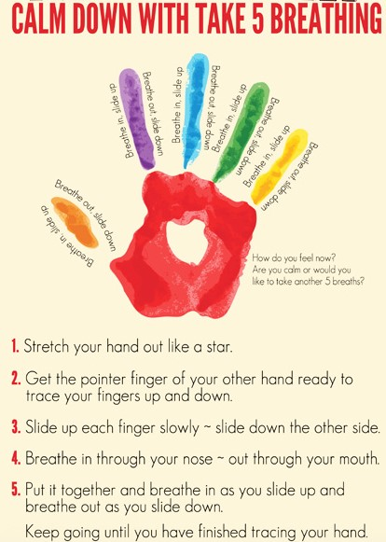



Monitoring a child or young person’s anxiety levels throughout the day is another way of supporting a proactive approach to a calmer household and more engaged child or young person. Monitoring could be observing or a verbal check in every few hours.

For some children who are finding verbal language challenging or are non-verbal, giving a number or using scaling instead of trying to describe or name an emotion can be helpful and less stressful. The incredible 5-point scale is one scale that can be used or adapted to support children and young people with Autism become aware of their emotions and also support them to understand the stage or level of their emotion.