Here are some wellbeing ideas for you to try at home.
Try to complete one activity per day.
WELLBEING ACTIVITIES | Did you like this activity?
Breathe: in through your nose for a count of 4 and out your mouth for a count of four. Repeat this several times throughout the day, particularly if you feel anxious or cross.

Create a free account on the Smiling Mind app.
This is a free Mindfulness App with a range of meditations and relaxation tracks for all ages from young children to adults.
Think about all the people and things that you have around you that are important to you and keep you safe. Talk about or draw them.

Write down 3 things each day that you are grateful for. It can be people, things and experiences – anything!

Can you create faces which show some different emotions? Look in a mirror how many different faces can you pull?

Use Google Earth to look up the following landmarks: Big Ben, The Eiffel Tower, The Leaning Tower of Pisa and The Statue of Liberty. What else can you find? Did you know that you can also explore under the sea and on the moon?! Write down 3 cool things you have found.
It is important to get fresh air, especially if you are feeling a little under the weather. Try the 5-4-3-2-1 grounding exercise when you are outdoors. Working backwards, find 5 things you can hear, 4 things you can see, 3 things you can touch from where you are sitting or standing, 2 things you can smell and one thing you can taste.

Listen: Put on your favourite piece of music and listen. What instruments can you hear? How does the music make you feel? Where in your body can you feel it?

Dance: Put on the radio and dance to the songs, play ‘Just Dance’ together on YouTube, create a ‘happy songs’ playlist.

Sing! Learn the lyrics to your favourite song.

Write down 7 things you can do to distract yourself when you become frustrated or angry.

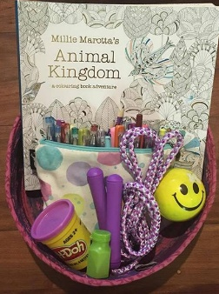
Make a calm down box. It’s a nifty little way to help children handle big emotions.
Possible items to add:
- colouring book and pens
- stress ball
- bubbles
- skipping rope
- playdoh
Use https://www.cosmickids.com/ to do some fun Yoga exercises. It is important to try and do some exercise while you are at home to keep your body and mind healthy

Find a safe, quiet space and read a book. Use what you can to make your space comfortable.
Read: share a story, talk about your favourite page, talk about the characters in the story
Listen to an audio book. There are several websites where you can access these for free: Librivox / Spotify (can be used on a free account) / Storyline Online.
Ask the adults at home how you can help. Everyone needs to work as a team at times like this, and they will appreciate your help.

Draw a ‘Circle of Control’ when you are feeling worried about something. Be realistic about the things you can and can’t control. I.e. You CAN’T prevent the coronavirus, but you CAN wash your hands and keep them out of your mouth and away from your face to keep yourself and your family as protected as possible.

Find a mirror and look closely at yourself. Make a list of all the things you are good at and the things that you like about yourself. What things make you special and valuable?
Imagine you have to pack all the important things in your life at the moment. Spend some time being mindful of the people, places, things and thoughts that are the most important. Talk someone through what you have chosen and explain why.
Do a bodyscan. Use the following link to talk you through how to do it: https://soundcloud.com/mindfulmagazine/body-scan-meditation-for-kids

Use the ‘WOW’ sheet. Write or doodle in and around the bubble letters, the things that amaze you! It can be nature, a person, an experience or an item.
Learn to draw. There are lots of drawing tutorial videos on YouTube.
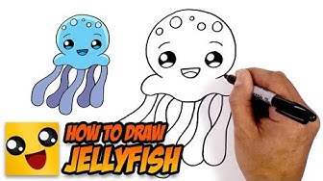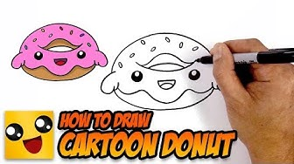
Use http://www.hellokids.com/r_12/drawing-for-kids to help you complete a drawing of your choice. Listen carefully to the instructions and complete the drawing to the best of your ability.
Drawing meditation: Choose an object, look at it very carefully for 60 seconds. Place the item under a cloth and see how well you can draw the item from memory! Do not worry if it isn’t very accurate, just try again with something else!
Go for a mindful walk. It is best to do this outdoors and so you might need to go with a parent or carer. Walk as slowly as you can for one minute. What things do you have time to notice now?
Each day listen to an inspirational talk! Which was your favourite? How did it change your thinking? https://www.lifehack.org/785441/inspiring-ted-talks-for-kids
Lay down and close your eyes. Listen to some Disney piano music. Try to to activity 1 at the same time. How does it make you feel? https://www.youtube.com/watch?v=5DiMoehAeOU
Listen to a mindfulness story called magic bubbles using this link: https://www.youtube.com/watch?v=SPpTqqHVRKQ
Use the ‘Smudges and Splatters’ and turn them into pictures!
Showing kindness to others is proven to help YOU feel better too! Can you think of something kind you can do for someone else in your home? Or send a lovely text message to a friend or family member.
Complete the ‘Mindful Colouring’ page. Try to notice what you are thinking about while you do so.
Use the following ‘Conversation Starters’ to have interesting chats with someone else in your home:

- What is your favourite memory?
- If you were to win the lottery, how would it change your life?
- What are you most proud of?
- What do you want to be doing in 10 years time?
- If you had £1000 to give away who would you give it to and why?
- What makes you happy?
- What would be in your ideal lunch box?
- What is the first thing you notice about people?
- What makes you laugh?
- If you were the Prime Minister, what would you change?
- Who inspires you?
- What is the best thing about being you?
Google some ‘No Cook Recipes’.
Make a family favourite meal together or prepare something new.
Games – play a board/card game together.
Adults and Teens
All the previous activities could be used or adapted for teens and adults. Find your favourite activity from the list above.
No matter what challenges we face, there are steps we can take to look after and improve our mental health and wellbeing. Visit:
https://www.nhsaaa.net/better-health/topics/mental-health-and-wellbeing/
Apps and websites to support mental health and wellbeing
https://www.nhsaaa.net/media/7680/apps_websites_help-mhw-final-july-2019.pdf
Play memory games
- Now you see it now you don’t
Have a tray with 10-20 objects on it and cover the tray with a cloth. Remove the cloth for 30 seconds. Memorise as many objects as you can in 30 seconds.
- I went and saw
Begin a sentence with “I went to …” and a location such as shop/zoo/theatre/. The first person completes the sentence e.g. ‘I went to the zoo and saw a camel’. The next person repeats and adds something of their own e.g. ‘I went to the zoo and saw a camel and a zebra’. Continue, as more animals are added the memory required is extended.
Get comfy. Relax and enjoy Netflix/Box Set together.

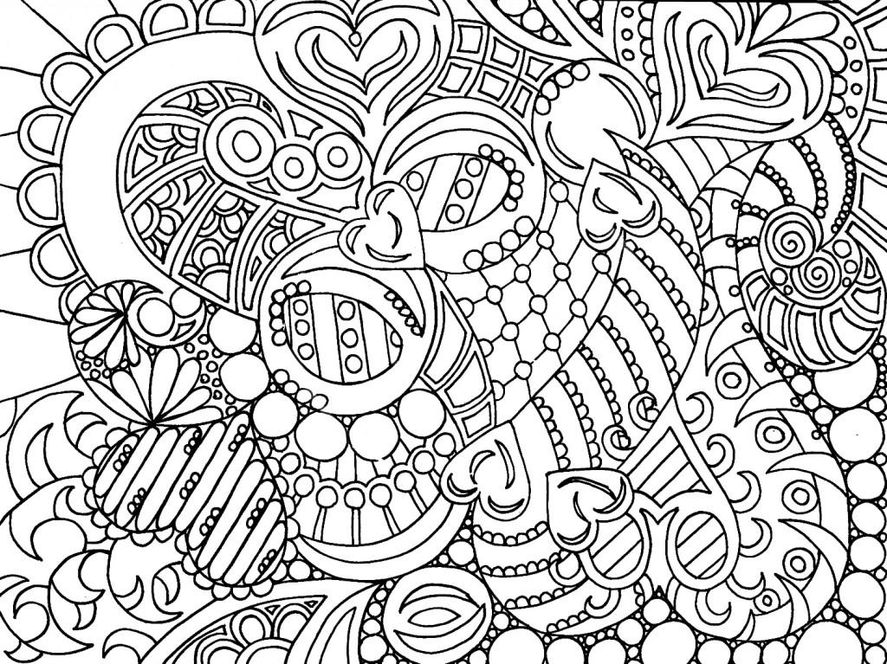

Mindful Colouring
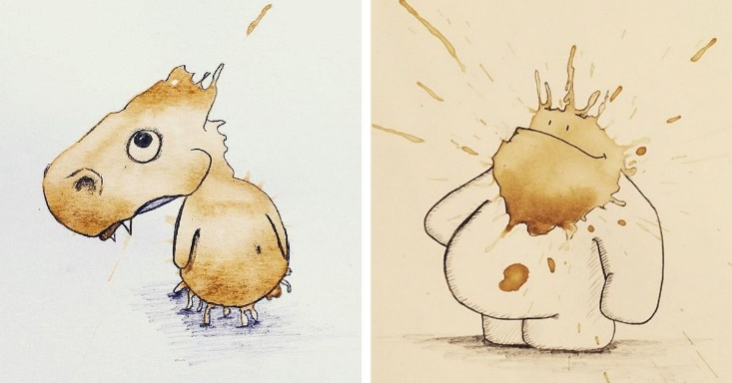
SMUDGES AND SPLATTERS!
There is an artist called Stefan Kuhnigk, who turns his coffee splatters and smudges into cute drawings!
Turn the smudges and splatters below into your own works of art!

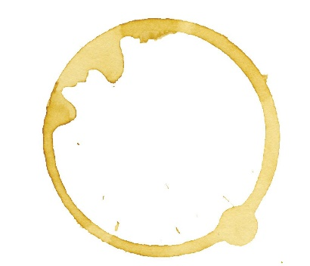

If an adult allows, let them help you make your own paint/tea splatters and turn them into pictures too!

