Mindfulness in the Early Years
(Activity Resource Pack) DRAFT
Created by
Ceri McMillan (Educational Psychologist)
Maria Fulton (Early Years Nurture Coordinator)
September 2019

What is mindfulness?
60 mindful minutes (Tina Rae)
Mindfulness is paying attention to here and now with kindness and curiosity.
The awareness that emerges through paying attention on purpose through the present moment non-judgementally, to the unfolding of experience moment by moment.
Mindfulness is:
~An approach to increase children’s skills to support them to develop the ability to soothe and calm themselves, to pay attention to themselves in the world and to think about and reflect on both their actions and their relationships.
~A practical set of skills.
~Known to have long-term benefits on our health and happiness.

Why mindfulness in the early years?
Mindfulness is considered an appropriate intervention for use within the nurture group context. Many of the children in the nurture groups need support to develop social and emotional skills and mindfulness can support this. For example, mindfulness can support children to be better able to focus and concentrate, increased self-awareness, improve impulse control and increase levels of calm.

Evidence
“Mindfulness training using age-appropriate activities to exercise children’s reflection on their moment-to-moment experiences may support the development of self-regulation by targeting top-down processes while lessening bottom-up influences…”
- Zelazo & Lyons (2012)

Flook et at al. (2015) found a mindfulness-based Kindness Curriculum for pre-school children promoted self-regulation and prosocial behaviour in young children.

The key aim is to introduce mindfulness which is an approach that increases children’s life skills by supporting them in the ability to both soothe and calm themselves. – Dr Tina Rae

“Suppose we went at a slow enough pace…to feel out bodies, play with children, look openly without agenda or timetable into the faces of loved ones…suppose we took time each day to sit in silence. I think if we did those things, the world wouldn’t need much saving “– Donella H Meadows

Guidance on how to use this resource
When to use mindfulness in the Early Years…
- When a child is showing distressed behaviour, child is offered a ‘calming activity’
- During transition times such as: Home to EYs establishment, nurture space to main-room, main-room to nurture space when child feels overwhelmed by main-room experiences.
- Flexibility in routine to allow on the spot mindfulness activities.
- Adapt these activities for the development stage of the children and for the needs of the group and individual within each nurture group.
- For each of the senses we recommend that you start each of the activities with a breathing exercise of your choice – making sure the children are calm and comfortable.

Please Note
- Some mindfulness programmes are too structured for young children due to their developing concentration skills.
- Young children like to revisit learning on a repeated basis, this facilitates the development of new skills.
- Children need concrete examples such as using a balloon to gain a sense of how it feels i.e. light, floaty etc. This facilitates the child’s understanding when using the balloon, as part of a mindfulness experiences.
- Children should be comfortable doing Mindfulness activities and should always have the option to opt out.
Mindfulness language toolkit.

~Body
~Breath
~Calm
~Concentrate
~ Comfortable
~Exercise
~Focus
~Meditation
~Mindful
~Mindfulness
~Name Feelings
~Notice
~Now
~Peaceful
~Relaxed
~Skills
~Still

Breathing exercises 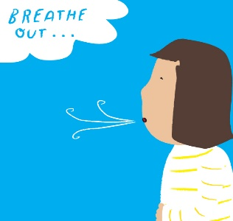
Beginner breathing exercise
- Suggestion of soft music to help the children get interested.
- You want to create a calm, peaceful and loving space so they start to get intrigued about what’s to come.
- Start by asking them to pretend they’re smelling something yummy, like a freshly baked cake, as they take a deep breath in, then to pretend they’re blowing out candles as they exhale.
- Keep the exercise short to begin with – for example, 5 times.
- Support children to focus on their tummy rising and falling.
Teddy Bear Meditation 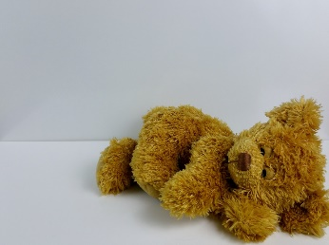
- Suggestion of a basket of teddies/soft toys in the room.
- Ask the children to lie down comfortably.
- Allow the children to select a soft toy and ask them to place it on their tummy.
- Ask them to breathe as normal and to notice the toy as it rises and falls on their tummy.
- Encourage them to be curious about how it moves up and down.
- Are they able to control it by making it go up and down more slowly, and how does this make them feel?

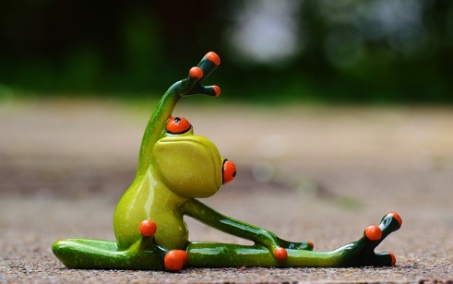
Body activities
Calm or Relaxed Lesson 19 Page 4-87
Please Note;
Prior to this activity visit PATHS Volume 1 Unit 1,2 and 4
~Unit 1 Lesson 1 Circle Rules Page 1-1
~Unit 1 Lesson 2 PATHS Animals Page 1-31
~Unit 2 Lesson 6-7 Basic Feelings Pages 2-19 2-58
~Unit 4 Lesson 14 Twiggles Learns to do Turtle Part 1 Page 4-1

PATHS Volume 1 Unit 4
Calm or Relaxed Lesson 19 Page 4-87
Aim of activity - To define the feeling “calm” or “relaxed”
- Introduce some facial cues and body postures associated with the feelings.
- To provide examples of different reasons for feeling calm or relaxed.
- To identify calm or relaxed feelings.
- To connect to the behaviour of calming down with doing Turtle with feeling calm or relaxed.

Drop Anchor
- Stand across from the children.
- Show them how to stand with their feet firmly on the floor about shoulder width apart.
- Ask the children to push down through their feet and feel the ground still beneath them.
- Ask them to notice how their leg muscles feel when they push down through their feet.
- Ask the children to notice different parts of their body – starting with their head and working down to their feet.
- Ask them to feel the weight of their body on the ground.
- Ask them to slowly look around and notice what they see and hear around them.
Eyes

Notice Five Things
Try playing this as a game – the ‘Notice Five Things’ game.
Note. Adapt this game to suit the developmental level of the child for example, 1- 5 objects.
- Modelling – look around and tell the child/children 5 things that you see.
- Then let each child have a turn.
- Start with familiar objects e.g. a chair, jacket, pencil etc, then move towards more detailed objects e.g. a circle on a book/ the car in the garage.
- Explain that this game is good for when you feel sad or angry.
~Play this game regularly to support the child to use this as a tool to calm down.
~For an extension of this task see 60 Mindful minutes #52 -The Game of Five
~You could also extend this task to a mindful walk – noticing 5 things whilst on a “mindful walk” to e.g. the town, the garden etc.

Observing mindfully

Please Note: lying down, focusing on breathing and closing eyes will need practice for the children to feel comfortable before continuing with the “eyes” element of this task.
- Ask the children to get into a comfortable space on the floor, lie down on the floor and put your hands on your tummy.
- Read out the following short script:
~” Close your eyes and feel your breathing in and out”
~ “Keep your eyes closed”
~” Can you hear the sounds in the room? Listen”
~” Slowly open your eyes and look around as if you’ve never been in this room before. What do you see? “
~” Choose something to look at and keep your eyes on it for 5/10 seconds”
- Count to 5/10 for the kids.
“1, 2, 3, 4, 5, 6, 7, 8, 9, 10”
Alternative - you may to use a bell to mark the end of the time mindfully observing. For example, “keep your eyes on it until you hear my special bell”.
Ears 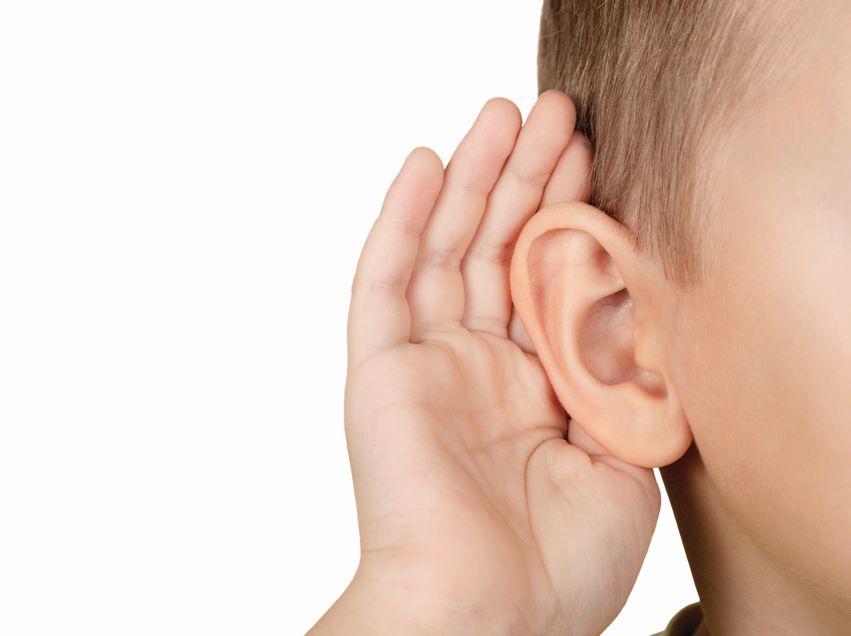

https://www.mother.ly/child/ease-your-anxious-child-6-simple-mindfulness-exercises-to-try-today
Listen to the Bell
This activity is an easy way for children to practice mindfulness – to focus and pay attention to what they hear.
You could use a bell, a set of chimes or a phone app.
- Choose a breathing exercise prior to this activity to get children calm and comfortable. Ask the children to put their hands on their lap.
- Tell the children that you will make the chosen sound and they should listen carefully until they can no longer hear the sound (30 secs to 1 min).
- Ask them to raise their hand when they can no longer hear the sound.

Alternative - ask the children to keep their eyes closed until the can no longer heard the sound.

http://lucysanctuary.com/16-games-to-encourage-attention-and-listening-skills

Guess the Instrument
You need:
A selection of different musical instruments (recommendation no more than 3) e.g. a bell, a shaker and a drum. A blanket to cover the instruments.

- Choose a short breathing exercise to get the children calm and sitting comfortably.
- Show the children each of the instruments.
- Let the children have a turn each to use the instruments.
- Cover the instruments with the blanket.
- Play the chosen instrument hidden under the blanket and give each child a turn to guess what the instrument is.
- You could give the children a turn each to play an instrument for their peers hidden under the blanket.
Nose 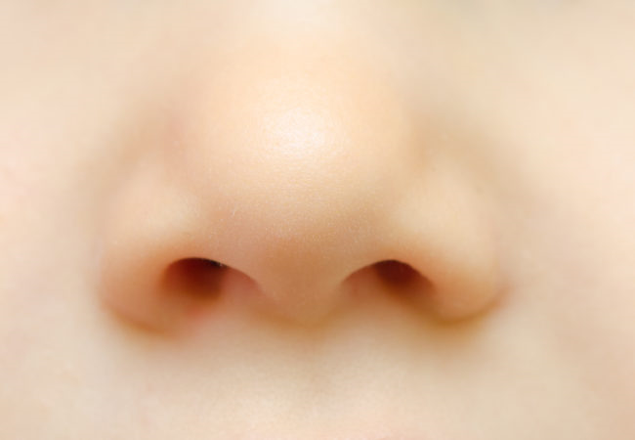
https://www.motherearthliving.com/health-and-wellness/mind-and-body/practice-mindful-smelling-ze0z1809zcoo

Smell and Tell
Mindful smelling experience for children.
N.B Please be aware of any allergy’s children may have to any of the materials used in this activity
- For this activity find three small containers that are a little bit bigger than a cotton ball and not too deep.
- Put in a couple of drops of calming oils or other scents on the cotton balls and place into the cup. Seal containers and make air holes for smelling. Try to use scents that children are familiar with. 1-3 scents maximum.
- Every child takes a turn at smelling one container at a time. Ask child to close their eyes (if comfortable) and smell until the count of 5 (encourage them to smell mindfully).
- Ask the children to share what person/place/thing the scent reminds them of.
Suggestions for scents -Mint, Chocolate, Vanilla, Strawberry
Calming oils - Lavender, Rose, Chamomile, Clary Sage

https://educationsvoice.wordpress.com/2017/02/03/mindfulness-in-the-classroom-using-play-dough-part-1/

Play Dough Meditation
Play dough has been known for its therapeutic properties. The squishing and pounding, pinching and moulding provides Kinaesthetic learning opportunity that can be used to enhance the development of mindfulness.
- Make your own play dough recipe adding 1-3 calming oils or other fragrances to the mixes. Again, try to use familiar scents. Option to add food colouring.
- Set the scene by having the children find a comfortable sitting position and put on some calming meditation music.
- Give the children a piece of the play dough each and ask (and support them) not to play with it, just to hold it in their hand.
- Then begin the meditation.
- Ask the children take 3 deep belly breaths.
- Ask the children to hold the play dough to their nose and notice the smell of the play dough – close their eyes (if comfortable) and count to 5.
- Encourage the children to smell mindfully.
- Allow the children to smell and play with the dough for a short while.
- Option to ask the children to name the smell.
- Complete the meditation by asking the children to put the play dough down and take 3 deep belly breaths to end.
- Option to allow the children to continue playing with the dough.
Mouth
N.B. Be aware of any allergies that children might have to the materials used in these activities.

http://www.teachstarter.com/gb/blog/classroom-mindfulness-activities-for-children-gb/
Mindful eats – Part 1
This is a great activity to bring attention to how mindlessly we sometimes eat! We often switch off when eating because it’s such a familiar action.
- Introduce this activity during the familiar time of snack time.
- Start off with 3 deep belly breaths and ask the children to choose a piece of snack.
- Adults should taste the foods with the children and model the tasting experience.
- Adult should support the children to label the tasting experience.
- Ask the children:
“what does it taste like?” “is it sweet?” “is it salty?” “is it sour?”
“what does the food feel like on your tongue”
“do you need to crunch it between your teeth?”
“how does your mouth feel when you’re eating this food?”
N.B You might not ask all these questions the first time you do this activity – you could build upon this activity step by step during snack time.
https://www.mother.ly/child/ease-your-anxious-child-6-simple-mindfulness-exercises-to-try-today

Mindful eats – Part 2
Following the same format as the experience above, part 1, introduce ‘one mouthful bite’.
Instead of offering the experience during the familiar snack time, introduce the experience at another time during the session.
- Set the scene as above and offer the children a ‘treat’ food to motivate their engagement such as: a small square of chocolate, a crisp, small marshmallow.
- Ask the child/children to choose a piece of food and prompt them to explore it. How it looks, smells and feels in their hand, then ask them to take a small bite and chew very slowly, (adult count to 5) noticing how the food feels in their mouth as well as how it tastes.
- As before, build up the questions step by step, with the adult labelling the language.

Further Resources
Breathing
Cosmic Kids Zen Den
https://www.cosmickids.com/category/watch/?video_category=mindfulness&changed=video_category
~Mini the Puppy
~Mine
60 Mindful Minutes Card Numbers
#1, 27, 21, 10, 8, 29
50 Mindfulness Activities for Kindness Focus and Calm Cards
#Start your day: Mindful Breaths
#Find Calm: Peaceful Place, Balance Breathing, Tummy ride, Happy Hum, Mind Bubbles.

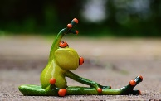Body
Silence Game
https://www.mother.ly/child/ease-your-anxious-child-6-simple-mindfulness exercises-to-try-today
60 Mindful Minutes Card Numbers
#4, 6, 11, 13, 19, 22, 23, 25, 26, 32, 40, 41
50 Mindfulness Activities for Kindness Focus and Calm Cards.
#Find Calm: Finding the Pause, Fist squeeze,
#Focus: Finger Fiddle.
#Open your Heart: Loving-Kindness, Name that Feeling.
#Reset and Relax: Squeeze and Release, Safe Keeping, Swinging Trees, Animal Dance, Rock, Roo and Rest.

Eyes
60 Mindful Minutes Card Numbers
#16, 14, 38, 42, 43, 44, 20, 52
50 Mindfulness Activities for Kindness Focus and Calm Cards.
#Focus: Sharp Eyes, Mental Snapshot.
#Visual searches i.e.

Ears
Cosmic Kids Zen Den
The listening game
https://www.cosmickids.com/category/watch/?video_category=mindfulness&changed=video_category
The cosy cat
https://www.youtube.com/watch?v=2TFuFd4iFOY&safe=active
50 Mindfulness Activities for Kindness Focus and Calm Cards.
#Focus: Open Ears
60 Mindful Minutes Card Numbers
#47, 17, 3, 2
Listening Lotto can be used for mindful listening.
http://lucysanctuary.com/16-games-to-encourage-attention-and-listening-skills.
No. 2. Go!
No. 11. Magic Sound
No. 14. That’s Wrong!

Nose
Tell me what you smell!
- ~Show photos of familiar places e.g. the park, a kitchen, McDonalds, the early years spaces.
- ~Ask the children to close their eyes and take themselves to that place in their heads and tell you what they think they might smell.
- ~Give the children a few examples before asking them to do this task themselves.
50 Mindfulness Activities for Kindness Focus and Calm Cards.
#Focus: The Nose knows.

Mouth
Tell me what you taste!
50 Mindfulness Activities for Kindness Focus and Calm Cards.
#Focus: Mindful Munch.

Additional Resources
~The Relax Kids 21 Day Plan – Calmer Classroom eBook
(Breathing and Body exercises)
Link~https://blissfulkids.com/fun-mindfulness-game-balancing-game/
~ ‘Boris Can Beat it’
~ICE Pack
~Kit Bag

References

50 Mindfulness Activities for Kindness Focus and Calm
60 mindful minutes (Tina Rae)
https://blissfulkids.com/fun-mindfulness-game-balancing-game/
Donella H Meadows
http://lucysanctuary.com/16-games-to-encourage-attention-and-listening-skills
http://lucysanctuary.com/16-games-to-encourage-attention-and-listening-skills.
https://educationsvoice.wordpress.com/2017/02/03/mindfulness-in-the-classroom-using-play-dough-part-1/
https://www.cosmickids.com/category/watch/?video_category=mindfulness&changed=video_category
https://www.cosmickids.com/category/watch/?video_category=mindfulness&changed=video_category
https://www.mother.ly/child/ease-your-anxious-child-6-simple-mindfulness-exercises-to-try-today
https://www.motherearthliving.com/health-and-wellness/mind-and-body/practice-mindful-smelling-ze0z1809zcoo
https://www.youtube.com/watch?v=2TFuFd4iFOY&safe=active
PATHS Volume 1 Unit 1,2 and 4
Zelazo & Lyons (2012)

