Worries about going to school

Everyone can feel worried about different things.

Sometimes we can worry about things a lot.



Sometimes we try not to do the thing we are worrying about, like going to school.

It is ok to feel worried, lots of young people feel a bit worried about going to school sometimes.


If you feel worried, it is OK not to know why you feel this way.



Feeling worried in my body

You might notice one or more of below happening in your body when you feel worried:





Sore tummy or having
‘butterflies’
Feeling sick
Dizziness



Feeling hot or cold Headaches Fast heartbeat





Fast breathing Sweating Shaking

Help to feel calm

When you notice any of these things in your body, try doing one of these things to help you feel calm:



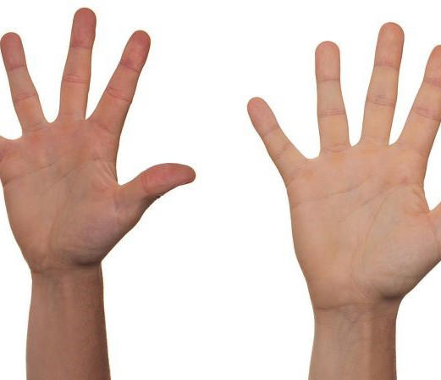

Speak to a friend or family member
Do some press ups, or if these are bit hard try star jumps or hopping
Practice muscle relaxation. Stretch and relax different body parts


Do some gardening Have a bath Listen to calming music





Drink cold water Write down or draw your worries
Do something with your hands

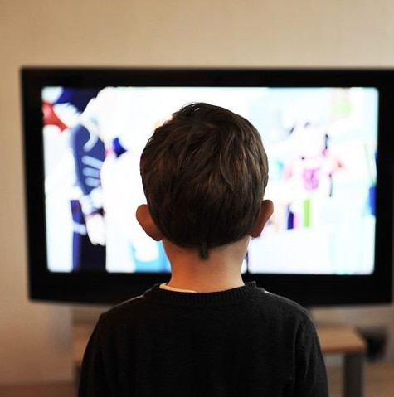

Distract yourself: Watch TV, paint your nails or walk the dog
Sit under a big, heavy blanket
Ask a family member for a hug



Squeeze and relax your hands
Squeeze or play with a
fidget toy
Suck on a sweet

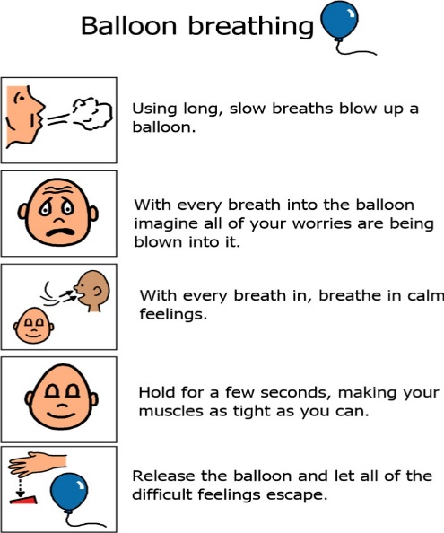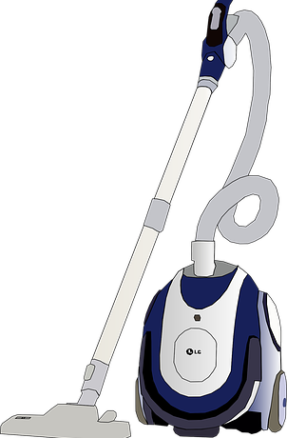
Practice deep breathing Do some hoovering Go for a walk

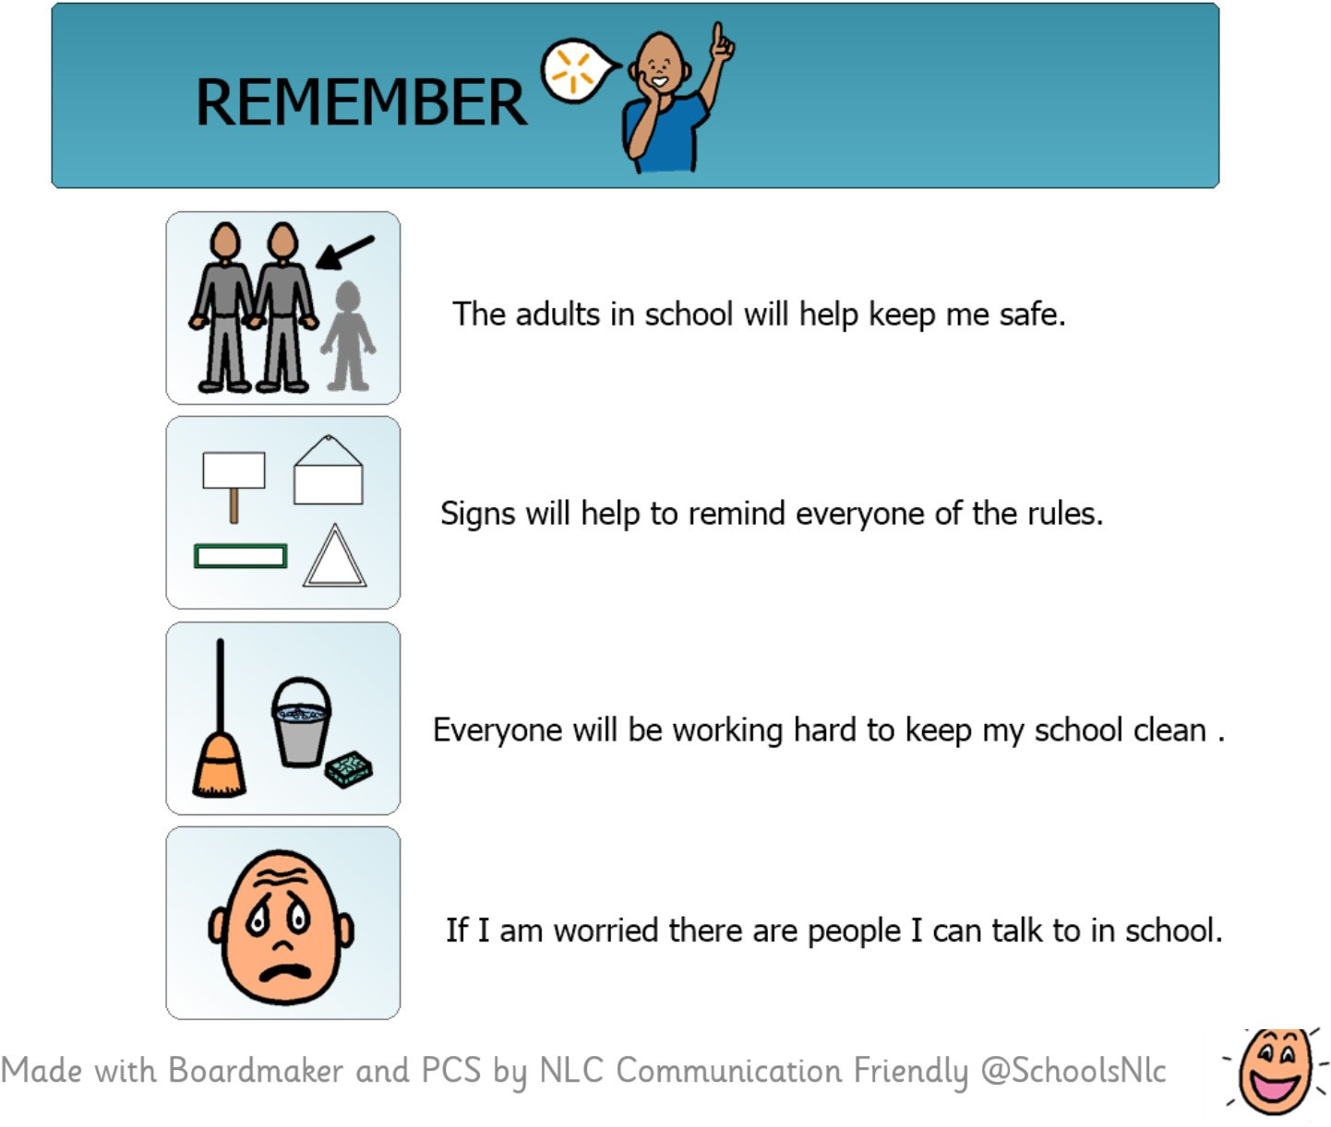

Support for returning after the summer holidays
Things to try in July with my parent or carer to help me prepare and worry less about going back to school in August:

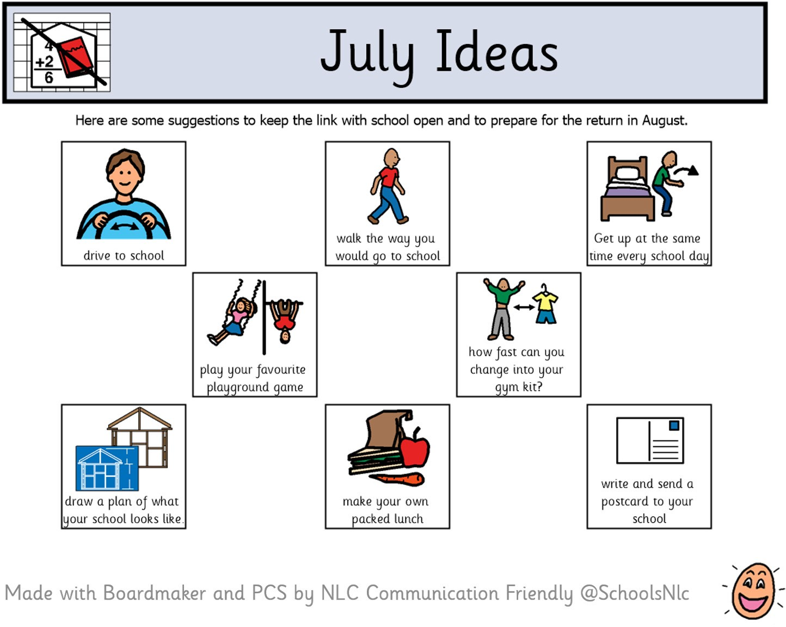

Things to try in August with my parent or carer to help me worry less about going back to school:

