Worries about going to school



What is anxiety?

Anxiety is a natural response in the body and mind that can happen in situations where we are unsure what is going to happen or when we feel in danger.


Anxiety can be helpful in new situations as
it keeps us alert or ready to see danger and act.

For example, it can help us remember to
look as we cross the road or remember to revise for a test at school.
Sometimes anxiety can be unhelpful when we worry about things that are not dangerous to us, or we worry so much we try to avoid things, like going back to school.

Everyone can feel anxiety about different things. There might be lots of different reasons why we can be worried about going to school.

If you are feeling worried, it is OK to not know why you feel this way.

Feeling anxious in my body
You might notice some of these feelings in your body when you feel anxious.

When you notice any of these things happening in your body, or you notice you feel worried, you could try some calming activities.

We have a list of ideas in the next section you could try.




Sore tummy or having
‘butterflies’
Feeling sick
Dizziness



Feeling hot or cold Headaches Fast heartbeat




Fast breathing Sweating Shaking

Things that can help you feel calm

Below is a list of things that could help you feel calm. Give them a try. You could write down or ask a family member to write down which ones are helpful for you.





Speak to a friend or family member
Do some press ups, or if these are bit hard try star jumps or hopping
Practice muscle relaxation. Stretch and relax different body parts


Do some gardening Have a bath Listen to calming music





Drink cold water Write down or draw your worries
Do something with your hands

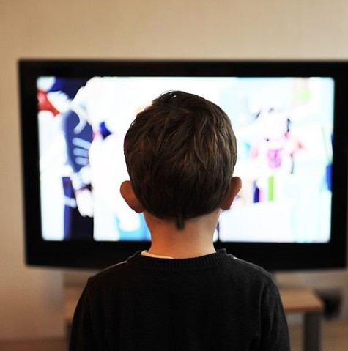

Distract yourself: Watch TV, paint your nails or walk the dog
Sit under a big, heavy blanket
Ask a family member for a hug



Squeeze and relax your hands
Squeeze or play with a
fidget toy
Suck on a sweet

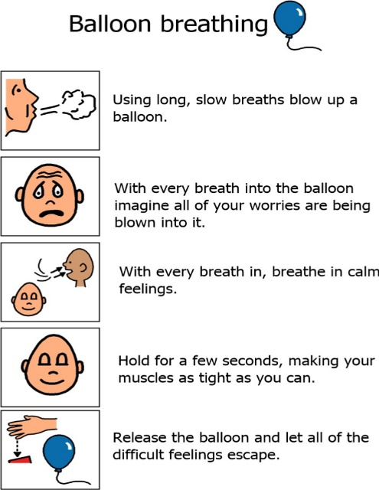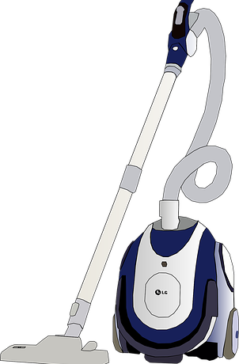

Practice deep breathing
Do some hoovering
Go for a walk

Worried Thoughts




Thoughts are the words we say to ourselves in our own heads. Thoughts can also be pictures or images.

Some people notice they have lots of thoughts running through their mind. Noticing when we have anxious thoughts and distracting ourselves can help.
If you notice you are having worried thoughts it can be helpful to write them down or draw them.

This can then help you and members of your family to think of things to do to try and help you overcome these worries.



When you notice you are having worried thoughts remember the list of calming activities you can do.

Common worries lots of young people have about returning to school following a period of absence
Below are some common worries young people have about going to school. Pick one of your worries and look at some of the ideas it might be helpful to try:

I worry when I do not know what is going to happen

It can be hard to cope when routines change quickly and unexpectedly.

- Some of you may like to get help from your parent or carer to help you make a planner of your week and activities to make your week more predictable.

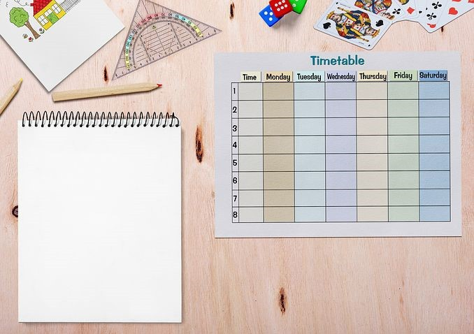

- Focus on the routines you know will stay the same, such as getting up and going to bed at the same time every day, brushing your teeth and getting dressed and having breakfast, lunch and dinner. Ask your parent or carer to help you think about which of your routines will stay the same.

I am worried I am behind in my schoolwork

- Lots of young people might worry about being behind if they have been off school.


- Make a list of all the things you have been able to do at home. This could be school exercises you have tried, or it may be a new skill you have learnt or got bet- ter at, like baking or painting. Ask your parent or carer to help you with this if you are not sure.

- Remember that you can talk to your parents or your teachers if you are finding
work hard when you go back to school.

I am worried school will be too difficult when I go back
- Think about all the times you have gone back to school after summer holidays. Sometimes it takes time to get used to changes in routine. Think about what was helpful for you to manage worries about going back to school in the past. Your parent or carer can help you think about this if you are unsure.

- Make a list of things you are looking forward to, even if they are small things. This could be being in your favourite class or speaking to your favourite teacher or class- mate.

- Remember that you can talk to your parents or your teachers if you are finding
work hard when you go back to school.

- Ask your parent or carer to help you plan some fun activities for your evenings and weekends when you are not in school.



I am worried about how I will get to school

- Speak to your parents or carers to make sure you have a plan for how you will get to school.

- It may help to practice your journey to school, especially if this is new. Ask your parent or carer to practice walking or driving you so you feel confident for your first day.

I am worried about not having any friends to talk to

- Lots of young people worry about friendships at school.

- Try texting or contacting a friend on social media before you go back to school. Your parent or carer can help put you in touch with your classmates too.

- Think of things you are looking forward to telling people at school about; you may have played a new computer game, watched a good film, seen a funny video online or tried a new TikTok trend.

