**Supporting the Mental Health and Wellbeing of Children and Young People in Your Care**​

​

**A Resource for Parents and Carers**​

Participant Workbook

Name: __________________________________________________________

Date of training: __________________________________________________

This booklet has been designed to help you whilst you are working through the e-module and can be downloaded or printed off at your leisure.

We encourage you to use this workbook and keep it somewhere safe to allow for easy access to its information and activities should you need them.

Progress Tracker

Please feel free to use this checklist to help you on your learning journey.

Part 1

|  |  |  |  |
| --- | --- | --- | --- |
| Section/ Area | Date | Completed (✓) | Understanding?  😄😐😒 |
| Defining mental health |  |  |  |
| Day in your life activity |  |  |  |
| Frame of reference |  |  |  |
| Mentally healthy environments |  |  |  |
| Mental fitness |  |  |  |
| Nurture |  |  |  |
| Empathy |  |  |  |
| Resilience and how to build it |  |  |  |
| Wellbeing action plan |  |  |  |
| Stress and anxiety |  |  |  |
| Reflective activity |  |  |  |

Part 2

|  |  |  |  |
| --- | --- | --- | --- |
| Section/ Area | Date | Completed (✓) | Understanding?  😄😐😒 |
| Shaky person/ stress activity |  |  |  |
| Normal teenage behaviour |  |  |  |
| Concerning teenage behaviour |  |  |  |
| Supporting your child |  |  |  |
| Your own mental health/ nurturing you |  |  |  |
| Daily wellbeing tools |  |  |  |
| Three good things |  |  |  |
| Problem solving and tackling stress |  |  |  |
| Reflection and evaluation |  |  |  |

Notes (what I’m confident with/ what I need more help with etc.):

Part 1

Defining mental health

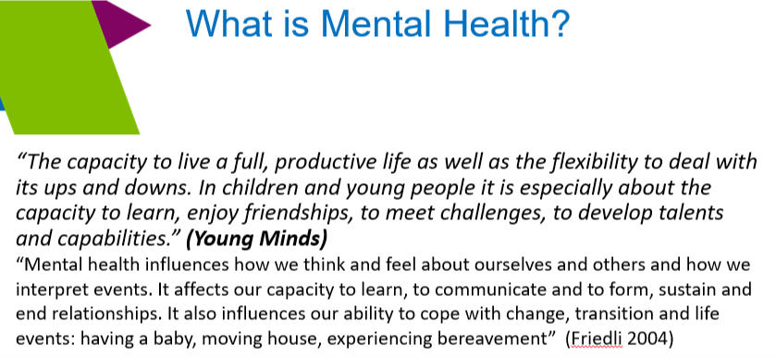

Write down what mental health means to you:



A Day in Your Life Activity

Feeling Good

Feeling stressed, low,

anxious or angry.

Frame of Reference

When it comes to how we respond to situations it can help to consider our own frame of reference. This relates to our values and beliefs and how they have been influenced by a range of things around us. By placing ourselves in the middle (e.g. in the form of a photograph) we can spend some time thinking about the factors that have made us who we are (these form the frame around us).

A good starting point could be thinking about how our behaviour and actions were influenced by those around us when we were younger e.g. ‘respect your elders’, ‘always tell the truth’, ‘you don’t get anything for nothing.’

Think about creating your own frame of reference below:

Mentally Healthy Environments

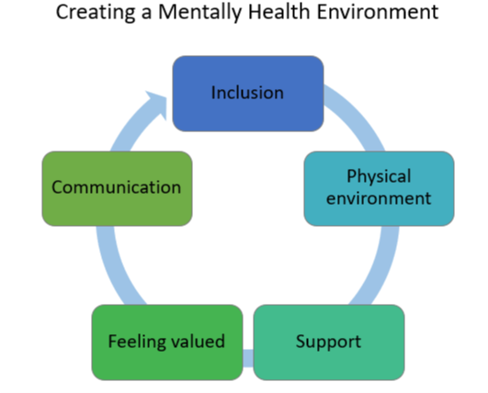 **Inclusion** – we feel we belong and are part of something. We are included in important decisions and our voice is heard.

**Physical environment** - our physical surroundings are positive and encourage us to lead healthy lifestyles. We are active and have access to necessities such as food and warmth.

**Support** – we know where to go when we need advice and guidance and know we won't be judged.

**Feeling valued** – our views matter and count for something. We know we are loved and are important.

**Communication** – we can manage our emotions and verbalise how we feel in a way that is calm and non-confrontational. When faced with a challenging situation we can work together to find a solution and avoid a situation escalating.

Consider each aspect of a mentally health environment and for each one, note down your thoughts in relation to how each one applies to you.

Nurture and Mental Wellbeing

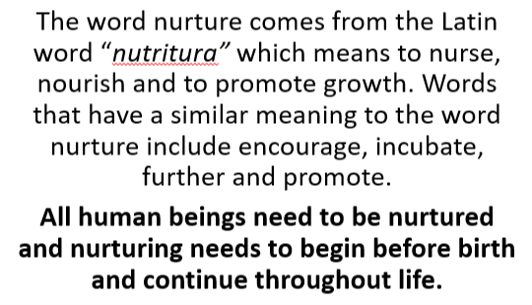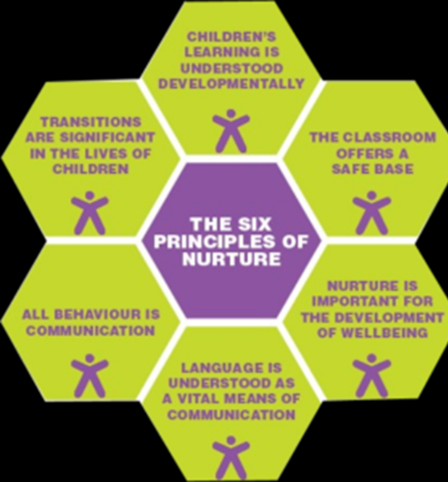

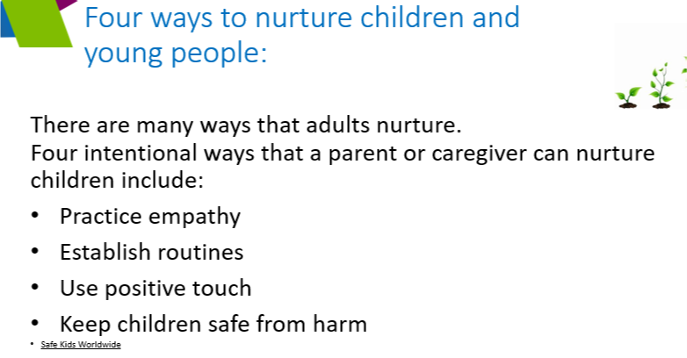Notes:

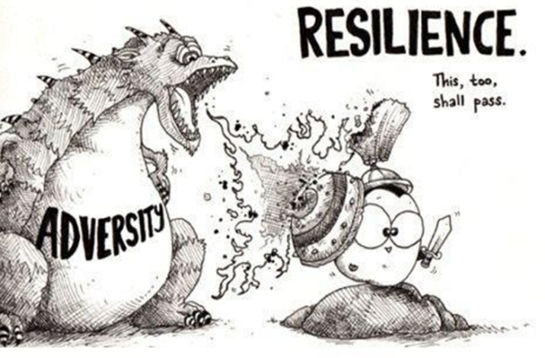Resilience is:

* Coping with adverse events
* Determination to see something through to its conclusion

Skill set needed for resilience

* Optimism
* Self-belief
* Flexibility
* Social support
* Emotional intelligence
* Problem solver
* Organised

Building Resilience:

* Opportunities for learning
* Using self-help resources
* Strong support networks
* Healthy lifestyle choices
* Positive affirmations
* Overcoming challenges

Write down other ways you can build

Resilience in the box. Do any of the above

Work for you? Can you think up some

Positive affirmations for yourself?

Wellbeing Action Plan

Below is a copy of the wellbeing action plan referenced on slide 19.

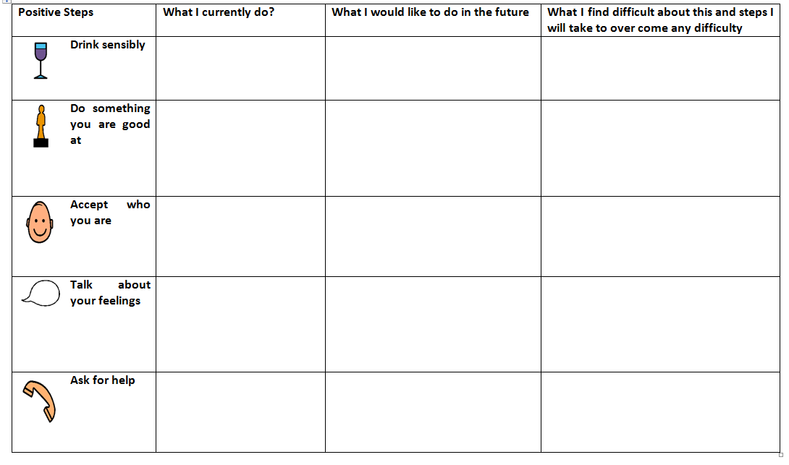Your needs may change over time and that’s okay – but make sure you prioritise your needs! They’re just as important as anybody else’s…and you can’t pour from an empty cup!

Stick to your plan and persevere!

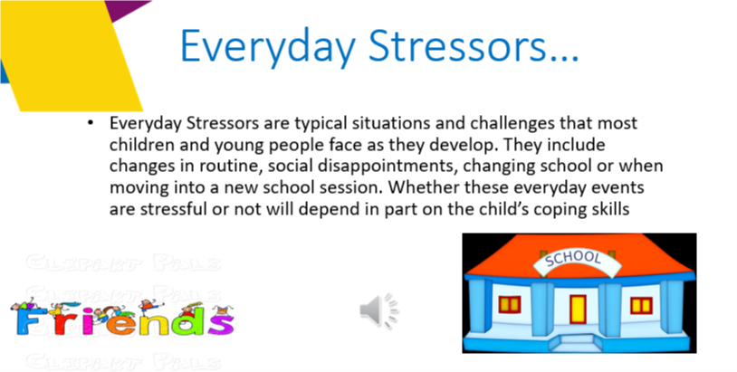

Think about the things that can cause you everyday stress and write them down. These could be tackled by using your wellbeing plan and if you’re not too sure what counts as a stressor for you then take a look over the Day in Your Life activity!

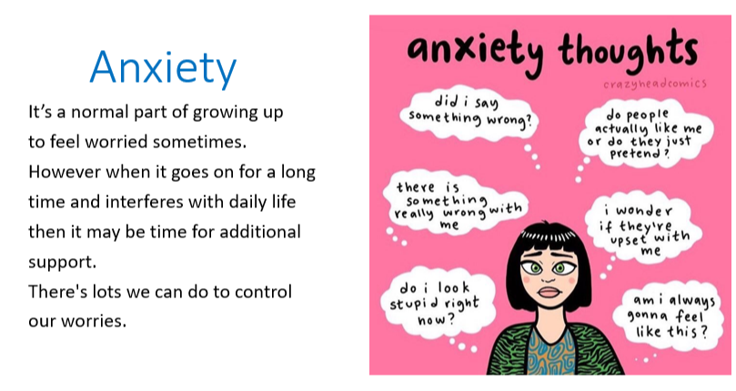

Think about your own experiences with anxiety. Make a list of them and write down how you dealt with them. It might help you to think about the things that made you anxious as a teenager. How did you cope?

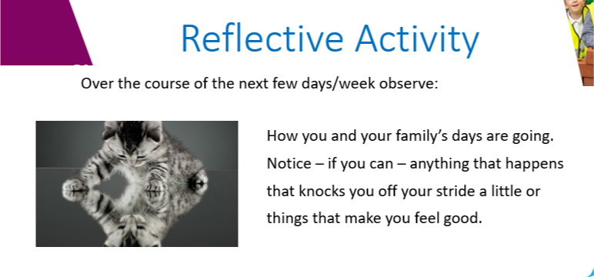

On the next page you will have the opportunity to note down any observations you made in relation to the reflective task opposite.