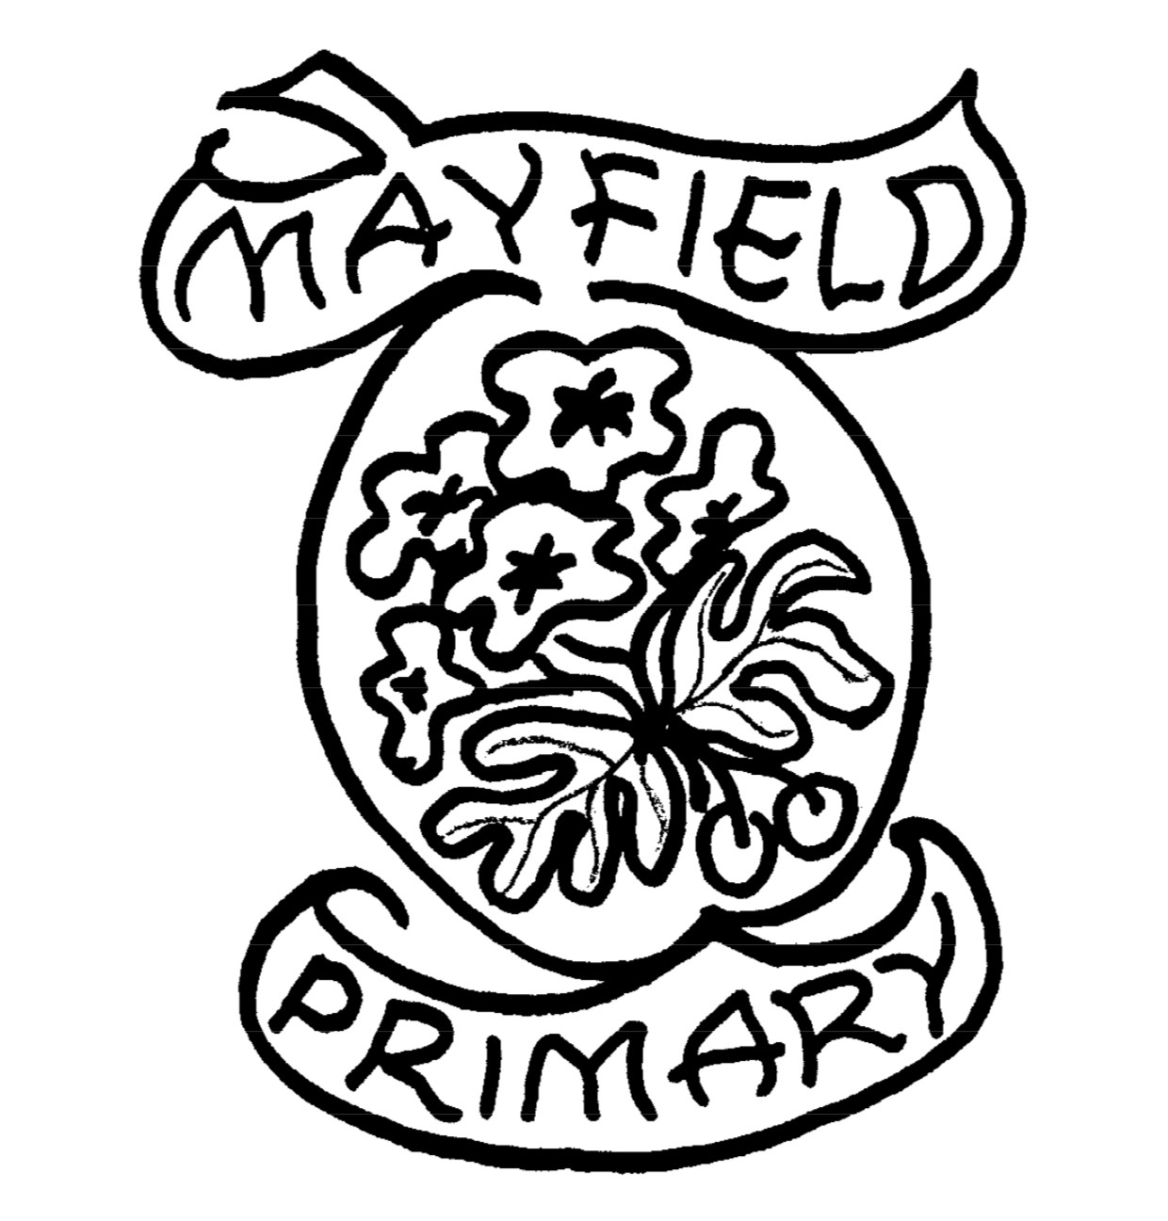

Mayfield Primary School
Digital Learning Policy

Mayfield Primary School and Early Years Class

Digital Learning Policy
In Mayfield Primary School we are fully committed to the use of Digital Technology to help develop, support and enhance the learning and teaching experiences of our pupils. We aim to develop pupils’ digital capabilities and ensure they are given opportunities to develop the knowledge and skills they need for lifelong learning and work. Digital Learning is, and will continue to be a focus in our School Improvement Plan. We are committed to embedding digital learning across our curriculum to enhance teaching and learning experiences. This policy aligns with the North Ayrshire Digital Learning Strategy, the Scottish Government’s Digital Learning and Teaching Strategy for Scotland, and the Curriculum for Excellence (CfE) frameworks, including the Education Scotland Technologies Benchmarks.
Our digital learning approach is underpinned by the following principles:
- Equity and Access: Ensuring all learners have access to appropriate digital tools and resources.
- Skills Development: Fostering digital literacy and computational thinking from an early age.
- Creativity and Innovation: Encouraging problem-solving, critical thinking, and collaborative learning through digital platforms.
- Safety and Responsibility: Promoting safe, responsible, and ethical use of digital technologies.

Rationale
In today’s times, digital technology is evolving at a significant rate. Children have access to such a wide range of digital technologies that education has to be prepared to move with the changes. Therefore, it is important that staff and pupils can confidently access a range of digital technologies in order to develop learning across the curriculum. We believe in staff using digital technologies across their practice as an engaging and effective learning and teaching tool and that pupils develop vital digital skills for lifelong learning.
‘All staff take responsibility for developing literacy, numeracy, health and wellbeing and digital literacy across the curriculum. Learners demonstrate these skills at a high level in a variety of meaningful contexts.’ (HGIOS 4 2.2 – Curriculum)
The term digital literacy can be used to describe the ability to use information and communication technologies to find, evaluate, create, and communicate information, requiring both cognitive and technical skills. Digital literacy can be developed in staff and pupils through the use of a range of digital technology resources and applications that now extend beyond just computers. IPads, Smartboards, Promethean Board, cameras and printers all fall under the term digital technology and it is important that learners are giving adequate opportunities to experience the different resources available to them.
In June 2016, the House of Commons published a document called the ‘Digital Skills Crisis’ which states that “almost 90% of new jobs require digital skills to some degree, with 72% of employers stating that they are unwilling to interview candidates who do not have basic IT skills.” The Scottish Government have also worked on their Digital Learning and Teaching Strategy which aims to develop skills and confidence in educators; improve access to digital technology for all learners; ensure that digital technology is a central consideration in all areas of the curriculum and empowers leaders of change to drive innovation in digital technologies. In consultation with the Children’s Parliament for Scotland, the government identified that learners (aged 8-11) feel that digital technology not only makes learning more fun, but that they would like to see it used more in the classroom. A survey carried out by Young Scot with over 250 children (aged 11-25) stated that young people felt that digital technology was an “important learning aid in the classroom” and “gave them a quick way to access information”.
In Mayfield Primary School, the use of digital technologies is embedded in daily practice and is central to effective teaching and learning. The school continuously provides professional development to ensure that all staff feel comfortable and enthusiastic when using digital technologies in the classroom.

Aims
- To develop staff and pupils’ confidence in using digital technology to find, evaluate, create, and communicate information.
- To promote the development of digital technology across the curriculum.
- To use digital technology to help close the attainment gap and raise attainment in literacy and numeracy.
- To educate staff and children on how to access and use the internet safely.
- To develop pupils’ abilities in using digital technology for learning, life and work.
- To work towards achieving the ‘Digital Wellbeing’ award.
Objectives
- To develop digital technology skills and cyber resilience in staff and pupils.
- To use the school’s ICT progression planner to develop digital literacy.
- To review and maintain the digital resources throughout the school.
- To use laptops, iPads, and IWB to support digital learning across the curriculum.
- To develop the use of GLOW, Seesaw, and internet according to NAC guidance.

Resources/Equipment
Hardware
In our school, we have a range of hardware throughout the school. Our head teacher, depute head teacher and class teachers all have HP laptops with docking stations. We have two desktop PCs in the office. All class laptops are connected to a Promethean board.
Every class has a class iPad which is used for digital teaching and learning as well as for keeping class Seesaws up to date. These iPads are connected to the school network and can also be used at home.
We have some portable disk drives which can be used for disks for the laptops. There is, on average, one between two classes.
We have 2 class-in-a-box: one which has 30 pupil laptops which have internet access, the other with around 19 laptops that can be used for word processing, PowerPoint or as additional support.
We also have a Lock ‘n’ Charge which houses 18 iPads that are all on the pupil network.
Both class-in-a-box and the lock ‘n’ charge are locked and kept in the locked rolling store at night. The keys are kept in the office.
We also have a class set of Micro-Bits which are currently kept with Miss Kerr.
All hardware is detailed and can be found on the school inventory.

Software
Most software needed can be accessed on the internet through websites or GLOW. Pupil laptops will only have access to NAC approved sites (e.g. Sumdog, Code.org, Topmarks etc) while staff laptops can access other websites for teaching purposes on the teacher network.
Clicker 7 has been bought with a licence for 10 laptops to use this software. One laptop will be set up with Clicker 7 and will be used as a pilot before staff training is offered throughout the school.
Internet access is available on most laptops and iPads and any connection problems are logged and passed on to IT.

Learning and Teaching
Progression Planner
The school’s ICT Progression Planner can be found on our GoogleDrive which shows the skills progression in ICT from Early Years to Primary 7 (Second Level). The progression planner links to the outcomes, benchmarks and state skills that the children will be working to develop at each stage of the school. Our ICT progression planners offer a wide range of important skills from electronic communication, collecting and analysing information, graphics and multimedia, controlling and programming and digital research.

Resources used to enhance digital learning and teaching include:
Seesaw – for uploading work, completing activities and homework
Glow – email, Teams, Microsoft Online
Microsoft Applications
Kahoot, Blooket
Sumdog, TTRockstars
Coding Applications
Green Screen
iMovie, iMotion, Book Creator
(Log in details are sent out for home learning at the start of each year. Staff have a secure copy of these and pupils do not share log in details with others)
Teachers plan and assess learning and teaching in accordance with the Experiences and Outcomes, and Benchmarks, and using our own Progression Planners.

Additional Support Guidance
Pupils with additional support needs will use appropriate technologies, identified by class teachers and support for learning teachers. Digital Technologies will be included in child’s plans where appropriate.
Resources are available to support children with additional support needs and staff will be provided with training where appropriate.
Current digital additional support tools include: Clicker7 and Rapid Readers

CLPL
All staff are offered training in using ICT to enhance learning. Training sessions will be delivered throughout the year and staff will be given regular ICT updates from the Digital Learning Coordinator. Any resources or course information will be distributed to staff and feedback will be given during collegiate meetings.

Partnerships and Communication
We provide a number of ways of communication with our parents/carers such as texts, Seesaw, Xpressions and the school website. We use our website to include documents such as our newsletters and important information for parents such as our school policies.
Each class have their own Seesaw journal which they use to upload work. This allows parents to keep up to date with what their children are learning about and the progress they are making.
Parents will be offered basic training workshops for using Digital Technologies for themselves and at home with their children. Workshops will be planned and provided by the Digital Learning Coordinator.

Internet Safety
How good is our school? (HGIOS) (fourth edition) was published in August 2016 and highlights effective self-evaluation as the starting point for school improvement. It supports schools to effectively evaluate their own practice and is a key aspect of the Scottish approach to school improvement. Under 3.3 Increasing Creativity and Employability it states:
'Children and young people are innovative, confident and responsible in the use of technologies and staying safe online. They critically examine and make informed choices about the use of digital technology to enhance and personalise learning in school and where appropriate, beyond the school day. They anticipate and respond to new opportunities and threats caused by developments now and in the future.'
All pupils will take part in Internet Safety Day each year to give them a refresher on how to stay safe online, cyber bullying, social media and sharing personal information. Class teachers may also plan responsive lessons on internet safety when appropriate. Google’s Be Internet Legends books are available for teachers to follow when teaching internet safety.
Children in primary 6 and 7 will also take part in CEOP training every year to teach them about online safety.
Internet safety guidelines are reviewed regularly and are in line with current government actions plans (Scottish Government’s National Action Plan – Internet Safety for Children and Young People).
The main aims of this action plan is to ensure:
- Children and young people are aware of their rights and responsibilities in the online world
- Children and young people are resilient and are equipped to help themselves and their peers
- Children and young people are able to identify when they, or their peers, are at risk, and know what to do if they spot something
Internet safety workshops will also be offered to parents to ensure parents and carers are equipped to guide and support their child’s online activity at home.

Digital Leaders
Pupils’ views will be represented by the Digital Leaders After School Club which runs in terms 1 and 3. The Digital Leaders will be responsible for organising whole school national events, sharing skills and knowledge and supporting staff and peers in the use of digital technologies.

Management of Resources
There are clear guidelines on the organisation, storage and use of iPads and laptops. Any issues that cannot be corrected by the Digital Learning Coordinator are passed on to IT. Timetables for the use and organisation of iPads and laptops will be created annually and shared with staff. Timetables will be reviewed termly and adapted where necessary.

Strategic Alignment
- North Ayrshire Digital Learning Strategy: We support the local authority's objectives to develop digital skills, enhance access to technology, and integrate digital learning across the curriculum.
- Curriculum for Excellence (CfE): Digital learning is embedded within the CfE's four capacities: successful learners, confident individuals, responsible citizens, and effective contributors. The Technologies curriculum area provides a framework for developing digital skills and understanding.
- Education Scotland Technologies Benchmarks: Our teaching practices align with the national standards set out in the Technologies Benchmarks, ensuring progression and consistency in digital learning experiences.

Review
This policy will be reviewed regularly in relation to school needs, National and local developments and best practice.
This policy was reviewed in June 2025 and will be reviewed again in 2026.

Acceptable Use Policy
Refer to North Ayrshire Council.

Conclusion
This Digital Learning Policy reflects our commitment to providing a dynamic and inclusive learning environment where digital technologies enhance educational experiences and outcomes. By aligning with national and local strategies, we aim to prepare our learners for a digitally connected world.

