**Mayfield Primary School**

**And Early Years Class**



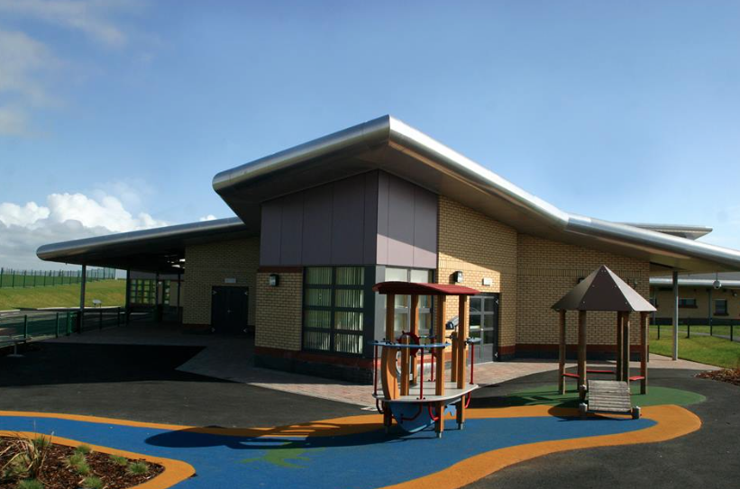

**First Aid Policy**

First Aid at Mayfield Primary School

In Mayfield Primary School and Early Years’ class we strive to keep all children as safe as possible when they are in our care. We carry out formal and informal safety inspections on a regular basis to ensure the premises meets the safeguarding and welfare requirements. Two workplace inspections are completed annually and these results are forwarded to NAC. Risk Assessments are carried out for any activities that staff feel may pose a risk.

We have a number of first aiders within the school and Early Years class. A list of current first aiders can be found on the medical wall and in Appendix 4. We ensure that training is renewed every 3 years and these trained team members administer basic First Aid treatment and complete the necessary records.

Staff follow procedures at all times to ensure that any incidents are kept minimal and managed effectively to keep our children and stakeholders safe. Parents’ emergency contact numbers, child allergies and emergency medical/care plans are kept securely but within easy access to relevant staff.

Within the school, the principal first aider is responsible for ensuring the first aid boxes are maintained and medical records (including care plans) are kept up to date. She will contact parents/carers 3 to 4 weeks before medications expire to remind them that a replacement is required. She also meets with parents/carers if a child requires medicine at school to complete the administration of medicine form. This is then countersigned by a member of the SMT and securely filed.

First aid kits are stored out of the reach of children, but in a place easily accessible to staff members. The first aid points are clearly displayed to let staff and users know where they are located. Anti-bacterial sprays (to clean surfaces) and absorbent powder for body fluids are stored in the medical room. If a child is sick the janitor is informed immediately and he will isolate the area and clean it thoroughly. If a child has had a toileting accident, two members of staff will take the child to the disabled toilet. The child is encouraged to clean himself/herself (and helped if necessary) and given clean underwear. The parent/carer is phoned to inform them and given the opportunity to come up to assess whether the child should remain in school.

A defibrillator is located in the main reception area of the school. This is maintained regularly by one of the first aiders.

If an accident occurs:

* Re-assure the injured child while making sure that the other children are safe.
* Radio/contact a First Aider - giving clear instructions as to your location.
* Remain with the injured person until the first aider arrives.
* Depending on the injury sustained, a qualified first aider will administer the necessary First Aid or radio for another First Aider to provide support. If the injury is serious or the first aider is concerned, she will inform SMT, request an ambulance (if necessary) and ensure the parent/carer is contacted.
* The first aider is responsible for ensuring that **ALL** incidents requiring treatment, **no matter how minor**, are recorded on the Accident Record form (appendix 1).
* Each child’s report is confidential, and other children involved in the incident will not be mentioned on the form or discussed.
* The form should be filed securely within the medical room filing cabinet and retained by the first aider for three years after the incident date.
* If the injury is minor, the first aider will then complete the ‘notification to parent/carer’ form and send this home with the child. (see appendix 2)
* In the case of a head bump or more serious injury, the first aider will phone the parent/carer and give them the option of coming to the school to assess the injury. If the child remains in school, the first aider will monitor the child closely throughout the day and if any concern arises immediately consult with SMT (and if required paramedic).
* If a child requires to go to hospital, the child will be accompanied by the parent where possible. However, if a parent is not available, a member of the SMT and a first aider will take the child to hospital. The parent will either meet their child at the school or go directly to the hospital.
* If a child’s injury results in a hospital visit or further medical treatment, the electronic Health and Safety Incident Reporting form MUST be completed. A copy of this should be printed for our records and then forwarded to Corporate Health and Safety at NAC.
* This form should also be completed for ‘a near miss or incident caused by a property defect’.)
* A summary of these procedures has been created and is displayed in the Medical Room, main office and playroom for easy reference. (Appendix 5)

Accidents Off-site:

* A risk assessment should be undertaken prior to the children leaving school.
* Staff member should have a mobile phone and copies of completed permission slips (which contain parent contact details.)
* A First Aider should be present.
* First Aid kit and any medication required during the trip should be taken by the first aider.

Existing Injuries

* If a child arrives at school with a serious existing injury (ie broken bone), parents/carers must inform the school. A member of the SMT will discuss the injury with the parent/carer and child, and then complete a risk assessment which should then be signed by the parent/carer.
* If the child requires any medication to be administered at school, the parent/carer will meet with the principal First Aider to complete the administration of medicine form (see Appendix 3).
* If any staff member is concerned about a pupil with an existing injury, SMT should be informed immediately.

Early Years Class

The above protocol should be carried out within the Early Years Class with the amendments/ additional steps noted in Appendix 6.

Appendix 1 Accident Record

Appendix 2 Notification to parent/carer

Appendix 3 Administration of medicines

Appendix 4 List of current First Aiders and date of certificate renewal

Appendix 5 Summary flow chart

Appendix 6 Additional Requirements for EY children

Updated November 2016