**Mayfield Primary School**



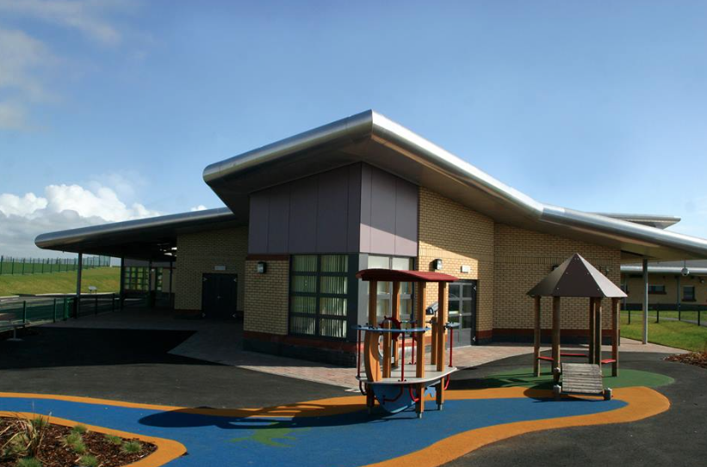

**Anti-Bullying Policy**

This policy is in line with North Ayrshire Council Standard Circular M6 Anti Bullying Policy.

Underpinning this policy are the vision and values of Mayfield Primary School.

**Our Vision**

Working within a safe, secure and caring school, we aim to provide all pupils with challenging, broad and engaging learning experiences that promote creativity, curiosity, and encourage a high level of success and achievement. This will lead to excellence and quality in their education.

**Our Values**

* Teamwork
* Respect
* Achievement
* Inclusion and Equity
* Nurture

The implementation of this policy will take into account the Equalities Act (2010).

**Rationale**

The school policy on bullying is quite firmly set within the context of our Promoting Positive Behaviour policy, however, as it is a much more serious aspect of misbehaviour, it merits separate mention.

Bullying is a serious problem, which frequently remains undetected and thrives on this fact. As a result it can seriously affect the health, happiness and educational development of the victim, thereby causing considerable stress.

*Most researchers now agree that what distinguishes bullying from other types of undesirable behaviour is the effect it has on the victim. Victims will be significantly hurt or upset and will not be able to defend themselves effectively.*

Andrew Mellor Anti-Bullying Network

A whole-school approach to preventative education ensures that the curriculum, school policies, pastoral support and the school ethos, complement each other to create an environment that helps to prevent bullying behaviours.

The purpose of this policy is to:

* give a clear signal that bullying has no place within Mayfield Primary School
* define bullying
* define the roles and responsibilities of the adults dealing with bullying behaviour
* help children manage their lives and relationships in positive and non-aggressive ways
* promote good citizenship
* provide information that will be shared with pupils, staff and parents

**Aims**

We aim to:

* Help pupils adopt a positive attitude to school and their own wellbeing to enable them to become successful learners, confident individuals, responsible citizens and effective contributors
* Stop specific instances of bullying, repair relationships and to support all the people involved in bullying behaviour
* Use the curriculum as a means to educate pupils about, and prevent, bullying
* Enable pupils to respond to challenging situations positively
* Keep all of our pupils at Mayfield, safe and happy

**Context and Content**

**Definition**

The term “bullying” covers a wide, complex field of behaviours and is therefore not easy to define. It can be physical, verbal or psychological.

The anti-bullying organisation “Respect Me” describes bullying as taking place in the context of relationships. It is:

“a variety of behaviours……that can make an individual feel hurt, threatened, frightened and left out. Bullying behaviour can harm people physically or emotionally and, the threat may be sustained over time, typically by actions, looks, messages, confrontations, physical interventions, or the fear of these.”

People who experience bullying behaviour fear that this will happen again and feel powerless to prevent it. This can leave a person feeling vulnerable.

While children tease each other, fall in and out with each other, have arguments, stop talking to each other and disagree about what they like and don’t like, this is a normal part of growing up and should be distinguished from bullying. However, where it leads to a child saying that they feel threatened or unsafe in their environment, these concerns should be taken seriously and investigated.

**Key Points**

* Bullying is the wilful, conscious desire to hurt, threaten or frighten someone else - the misuse of power in order to hurt others.
* Bullying can be short or long term, covert or overt.
* All bullying is aggression, either physical, verbal or psychological, but not all aggression is bullying.
* Bullying can involve name-calling, teasing, being ignored and/or having rumours spread about you
* For some, bullying behaviour is legitimate. In their out of school world they are bullied or encouraged to bully others by someone.
* The values of the school must be used to tackle the issues raised.
* Tackling bullying, including cyberbullying, is part of making Mayfield a happy place for everyone.

**Cyberbullying**

Cyberbullying is when someone bullies others using electronic means. This might involve social media, messaging services on the internet, chatrooms, emails, pictures/videoclips, viruses, accessed on a mobile phone, tablet or gaming platform. The behaviour is usually repeated.

One of the biggest differences between cyberbullying and face-to-face bullying is that it can be hard to get away from. Young people could be bullied anywhere, anytime – even when they’re at home.

Cyberbullying

* can reach a vast audience in a matter of seconds
* has the potential to draw in large numbers of people
* takes ‘repetition’ to a different level, with hurtful comments and images being shared multiple times
* has the potential to impact at any time of day or night
* can offer a degree of anonymity to the perpetrator
* can be difficult to police and to punish

There are very few children that have not been impacted in some way, either as the perpetrator or the victim. There is often some form of evidence e.g. screen shot, text message.

**Bullying and Equality**

Bullying is often associated with various prejudices related to characteristics which set a group out as different in some way, such as a person’s race, disability, gender, religion, or sexual orientation.

The Equalities Act (2010) places duties on schools to eliminate unlawful discrimination, victimisation and harassment and to promote equality of opportunity and good relations between persons of different groups. It specifies certain groups with “Protected Characteristics”. The Protected characteristics related to schools are:

* Disability
* Race
* Religion or belief
* Sex
* Sexual orientation
* Gender reassignment
* Pregnancy and maternity

Other groups to whom the intentions of the Act apply include young carers, Looked After Children, asylum seekers and the economically disadvantaged.

At Mayfield Primary, staff are proactive in identifying any incidents of bullying related to the protected characteristics. Please refer to North Ayrshire Council’s Anti Bullying Policy for more examples on types of bullying to which different groups may be subjected.

**Effects of Bullying**

While there are various methods enabling children to report bullying behaviour, some incidents may not be reported. It is important, therefore, to be aware of signs of possible bullying, in order that effective responses to potential damaging effects, are made.

Bullying can have short and long-term effects on the physical and mental wellbeing of children:

* **Fear**: feelings of fear, anxiety, low mood and low self-worth
* **Low self-esteem**: one of the most common impacts of bullying and can have quite damaging effects on quality of life
* **Poor performance**: not only school work but performance outwith school (for example leisure activities) can be affected
* **Truancy**: school attendance can be affected the longer the problem persists
* **Reduced aspirations**: constant negative and destructive comments can drive individuals down and affect aspirations
* **Strained relationships**: caused by blame or guilt
* **Violence to others**: children who are constantly taunted, antagonised, physically, emotionally or verbally abused can become the aggressor
* **Eating disorders**: may develop as a response to taunts
* **Self Harm:** is often used as a way of coping with difficult feelings
* **Suicide**: the ultimate impact of bullying – this is not common but does occur

**Mayfield’s Strategies to Prevent Bullying**

A whole-school approach is vital in ensuring that our proactive strategies are successful. It is very important that this policy is viewed within an ethos that promotes positive attitudes towards self and others, and that the curriculum supports it. Strategies used to educate pupils, prevent bullying and develop pupil skills include:

* Assemblies focussing on anti-bullying messages, promoting equality and diversity and tackling discrimination.
* Using Circle Time, PAThS, drama, role-play, social stories within the Health & Wellbeing and RME curriculum, to help pupils understand the feelings of bullied children, to practise the skills they need to avoid being bullied, and to explicitly teach emotional literacy, assertiveness and resilience. Pupils need to know who they can turn to if they experience bullying.
* Whole-school work on Rights Respecting Schools. Worry Boxes in all classes to allow pupils to confidentially communicate with the teacher
* Use of the SHANARRI wellbeing indicators as a focus for well-planned activities
* CEOP Training to ensure children know how to keep themselves safe online
* Use of the Nurturing principles and Restorative Practice
* Place2Be Counselling based in school
* Playground buddies (training for pupils by Active Schools’ Coordinator)
* Improved supervision in playground
* Parent information leaflets and workshops
* All adults, staff and parents, setting the best example to pupils by showing respect and valuing all in our school community.

**Staff Responsibilities**

However good our preventative work is, it is important to have clear procedures in place to respond effectively to reports or observations of bullying behaviour.

If a staff member at Mayfield encounters bullying behaviour they should:

* Remain calm and avoid an emotional reaction
* Reassure the victim and offer help, advice and support
* Make it clear to the pupil who is bullying that you disapprove of their behaviour, but don’t make judgements and avoid labelling which can be unhelpful
* Take action as quickly as possible and discuss with a member of the senior management team (SMT). A decision will be taken about the most appropriate person to deal with the incident.

Staff member dealing with a reported incident should:

* Take the incident or report seriously and investigate thoroughly
* Have a restorative conversation with the pupil who is displaying bullying behaviour and encourage them to see the victim’s point of view. This may involve both parties with the staff member acting as a mediator.
* Inform parents/carers, and work in partnership with them in decision-making regarding supports and sanctions
* Arrange Counselling with school Place2Be service for all parties, if appropriate
* Consider supports from outside agencies e.g. school nurse, social services, police
* Explain any sanctions clearly and agree these with the pupil who is displaying bullying behaviour and their parent/carer
* Liaise with class teacher and arrange curriculum input if necessary
* Monitor the ongoing situation through check-ins with both the victim and the pupil who was bullying
* Identify triggers/flashpoints and inform colleagues if the incident arose from a situation where everyone should be vigilant e.g. unsupervised toilets or cloakroom areas.
* Improvements should be made using lessons learned.

**Parent/Carer Responsibilities**

A parent/carer should report any incident of bullying to their child's teacher or member of the SMT. They should also encourage their child to do so. The school will investigate and do all it can to minimise any further inappropriate behaviour recurring. This can include a range of strategies to suit the particular circumstances and parent/carers can be involved in discussions to agree an appropriate way forward. Remember that what the school is trying to do is to gather evidence, which establishes that bullying has occurred, and then to find a lasting solution that ensures the child is no longer bullied at school.

**Pupil Responsibilities**

Our pupils worked together during a Circles Assembly to deepen their understanding of:

What is bullying?

What to do if you think you are being bullied

What to do if you think someone else is being bullied.

Their discussions were recorded and the notes collated. An Anti-bullying leaflet – ‘Advice for Pupils By Pupils’ was created. See Appendix 1. This clearly outlines pupil responsibilities.

**Reporting and Recording**

* Inform the senior management team of all incidents of bullying, even if it is felt that the situation has been dealt with satisfactorily
* Parents/carers will be informed of all bullying incidents and will be fully involved in a plan of action moving forward
* All bullying incidents should be logged by the teacher in the Chronology folder. The SMT are required to log all incidents via the Seemis ‘Bullying and Equality’ tab (and also in Seemis Pastoral Notes if appropriate). The SMT should also record the incident on the Bullying log which is stored securely in the Head Teacher’s office.
* If bullying is related to a protected characteristic under Equalities legislation, then the incident should also be logged within the Equalities folder located securely in the Head Teacher’s office and reported to the appropriate North Ayrshire Education & Youth Employment Officer. Racist Incidents should be recorded on the Reporting Form found in Appendix 2 of Standard Circular M6.

**Monitoring of Policy**

The implementation of this policy will be evaluated through whole-school self-evaluation, involving all stakeholders, to ensure it is having an impact in achieving its aims.

**November 2016**

**Appendix 1** Sources of Advice and Guidance

**Appendix 2** Alleged/Confirmed Racist Incident: Investigating/Reporting Form

**Appendix 3** Mayfield Primary Pupil Leaflet ‘Anti-bullying Advice for Pupils by Pupils’

**Appendix 1**

**Sources of Advice and Guidance**

|  |  |
| --- | --- |
| **Respectme – Scotland’s Anti-Bullying Service** | [www.respectme.org.uk](http://www.respectme.org.uk/)  Tel. 0844 800 8600  Email: enquire@respectme.org |
| **Childline** | [www.childline.org.uk](http://www.childline.org.uk/)  Tel. 0800 1111 |
| **ParentLine Scotland** | http://www.children1st.org.uk/help-advice/for-parents-and-carers/  Tel. 08000 28 22 23 |
| **CBBC**  An internet survival guide for primary age children. Tips and tricks you’ll need to stay safe online, beat the cyber-bullies and become a super-surfer. | <http://www.bbc.co.uk/cbbc/curations/stay-safe> |
| **Thinkyouknow**  Contains sections for different age groups, with informative animations for 5-7 year olds. Provides useful information for parents and carers. Useful site to download a ‘safety button’ children can use. (Google ‘Hector’s World Safety Button) | [www.thinkyouknow.co.uk](http://www.thinkyouknow.co.uk) |
| **Safekids**  Tips for keeping safe online, and managing cyber bullying | www.safekids.com |
| **Child Exploitation & Online Protection Centre**  Useful advice for schools and parents | [www.ceop.gov.uk](http://www.ceop.gov.uk/) |
| **Digizen**  Information for schools and parents on responsible use of technology | [www.digizen.org.uk](http://www.digizen.org.uk/) |
| **Show racism the red card**  Tackling racism through high profile footballers | <http://srtrc.org/>  Tel. 0191 257 8519  Email: info@theredcard.org |