Loudoun Montgomery Primary School and Early Years
Digital Newsletter
June 2019

Remember to click to download and swipe to read our digital newsletter
Welcome to our June Newsletter

I can hardly believe that it is now June and only three weeks of the schoolyear to go.
April and May have been very busy at Loudoun Montgomery Primary and Early Years.

We have welcomed our new Primary 1 pupils at the first Induction day and we are looking forward to seeing the children and their parents and carers again on Monday 10th June at 9:30a.m..

Pupils moving from the Early Years to Primary 1 will continue to have opportunities to visit Primary 1.

Primary 7
Primary 7 pupils have all had transition visits to their new secondary school and they are now better prepared for their move in August.
The pupils were all delighted to receive their Leavers’ Hoodie. Thanks again to the Friends of Loudoun Montgomery who made a generous donations towards the cost. The school also contributed to the cost. I am sure you will have noticed the children wearing these with pride.

Outdoor Space
The children are continuing to enjoy using the M.U.G.A. We were also delighted to be asked to be part of the Official Opening of the Community Allotment. A number of pupils have already enjoyed working in the allotment and the Gardening Committee are busy planning and planting in the raised beds.

School Improvement
The school improvement plan is now well underway. Together we have reviewed the curriculum and have considered carefully What? How? and Why? we deliver the curriculum at our school.

We are also reviewing the school vision, values and aims that everyone must have ownership of. We would be very grateful if you could complete the ‘Questions of the Week’ which will be sent home with your child on Monday 10th June and returned to school by Friday 14th June 2019. It is very important that we capture everyone’s views and I thank you in anticipation for your support.
Water Bottles
Every child will be issued with a water bottle on the first day of school in August. I hope this information is helpful.
Visits
P4/3, P5/4 and P6
Tuesday 11th June 2019
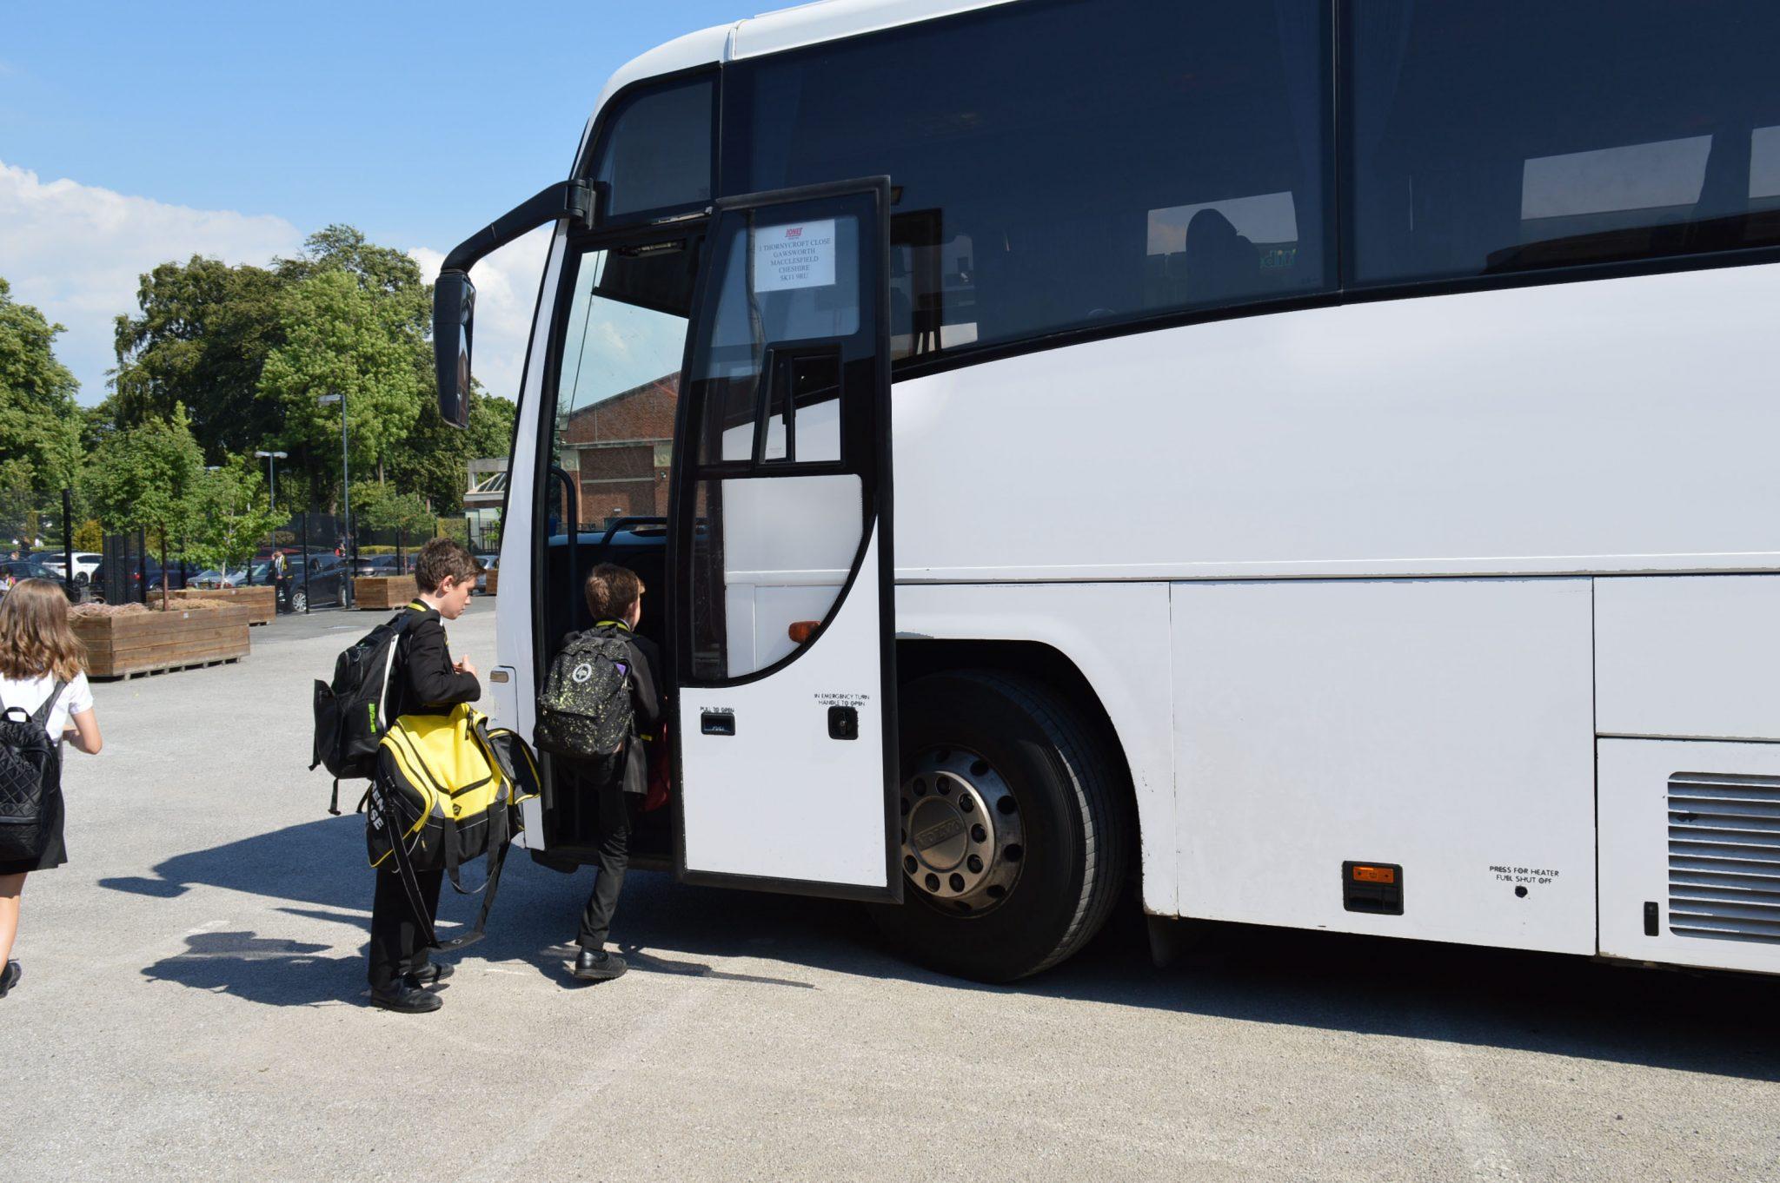
Venue: Science Centre

Primary 1
Monday 17th June 2019
Venue: Kelburn Country Park
Primary 3/2
Monday 17th June 2019
Venue: Vikingar, Largs

Arrangements for all visits
- All children require to be at school by 9:00a.m. as the coach is leaving promptly.
- All children require to wear school uniform.
- If your child is not entitled to a Free School Meal, they will require a packed lunch.
- No money to be taken on the visit as there will be no opportunity to visit shops.

Primary 7 will be provided with a Leavers Party on Thursday 27th June. The children can bring their own clothes to change into after lunch. School uniform is required for the Service in the morning.

Early Years Visits
The Early Years Visits take place on the 19th and 20th June.
Separate information has been issued from the Early Years staff.

Early Years
We are delighted to have appointed Mrs Tracey Stevenson as our new Early Years Manager. Mrs Stevenson will join our team on Monday 1st July 2019.

We are also in the process of appointing a new Senior Early Years Practitioner and we will keep you updated with the progress of this appointment.

Early Years Places Session 2019-2020
We are aware that parents and carers are keen to receive information about their allocation of places. As soon as we have confirmation from North Ayrshire Council, we will distribute the information immediately.

Early Years Outdoor Area
Well done to Mrs Waddell and the team, along with parents and carers for their development of the Early Years garden, which has included a Mud Kitchen, kindly built by Mr McKie based on the ideas of the children.
The Early Years children are also enjoying the opportunity to visit the allotment.

Sun Protection
Hopefully some good weather may be returning. Please make sure that you apply sunscreen to your child before school and Early Years.
Pupils will be learning outdoors regularly, so it would be helpful if they have a filled water bottle each day.
Sports’ Day
We are looking forward to the Sports’ Day on Monday 10th June at 1:45p.m. We are keeping our fingers crossed that the sun is shining.
All children require to wear their sports clothes to school and to wear appropriate trainers or gym shoes to run outdoors on the grass.
All children will be supervised by their class teachers. Parents and carers are welcome to come along and support the children and an area will be provided for spectators.
We appreciate that everyone likes to capture the moment, but NO photographs should be taken within the school grounds. School staff will be photographing the event and following the strict photographic permission rules.
All children will be provided with water and fruit.

Health Week
We had a very successful Health Week and the children enjoyed the range of activities, which included visits from the Fire and Rescue Service, Zumba, Healthy Eating activities, Fruit tasting, football, dance and the daily mile, to name a few.
Digital Learning Week
Well done to all the children and staff who participated enthusiastically in the Digital Learning Week. Pupils and staff learned a lot and were able to try out some fabulous technology such as the Virtual Reality Headsets.

Please check your child’s head regularly. Please tie back long hair and follow treatment advice on any preparation issued by your local pharmacy to treat head lice. Please speak to the local pharmacist in the chemist to ensure the correct treatment is provided.
Head Lice
We understand parents’ concerns when their child has head lice. Unfortunately other than issuing reminders to parents, like this, we are not permitted to treat children directly. We also respectfully remind everyone that head lice can be caught from anyone and not just at school.
The School Nurse, Elaine Richardson, can also be contacted on 01294-213124.

Staffing Update
We are sad to say goodbye to Mrs Hands who will be moving on to her new post at St John Ogilvie PS from Monday 17th June. We wish her well in her new post and are grateful for her contribution to Loudoun Montgomery. We are also delighted to welcome back Mrs Johnston who will be returning from her Maternity Leave on Tuesday 18th June.

We are also sad to be saying farewell to Mr Craig who is leaving at the end of term to take up his new post as Principal Teacher at Glencoats Primary in Paisley and we wish him well in the next step in his career. We will also be saying farewell to Mrs Malcolm at the end of term. We are very grateful to both members of staff for their contribution to the life and work of Loudoun Montgomery Primary School.

Staffing - Session 2019-2020
We are delighted to be welcoming three new teachers to Loudoun Montgomery Primary in August 2019.
Miss Tognini
Miss Thomson
Mrs Peakman

Attendance
Thank you to everyone who has made a huge effort to improve their attendance and timekeeping.

The table below is a little reminder of the importance of being in school every day and on time.
Attendance Percentage | Days Attended Each Year | Number of Days Absent Over the Whole Year | Weeks Off (approx.) | Or  Put Another way
100 | 190 | 0 | 0 | Your child has not missed a thing
95 | 180.5 | 9.5 | 2 | Your child has missed 1 day every 4 weeks
90 | 171 | 19 | 4 | Your child has missed 1 day every 2 weeks
85 | 161.5 | 28.5 | 6 | Your child has missed 3 days every 4 weeks
80 | 152 | 38 | 7.5 | Your child has missed 1 day per week
75 | 142.5 | 47.5 | 9.5 | Your child has missed ¼ of the teaching in 1 year
70 | 133 | 57 | 11.5 | Your child has missed 3 days of every 2 weeks
65 | 123.5 | 66.5 | 13.5 | Your child has missed 1 ¾ days per week
60 | 114 | 76 | 15 | Your child has missed 2 days per week

Please do not hesitate to contact me via the School Office if you have any questions or concerns. I will always be happy to assist.

Kind regards,

Miss J Robertson
Head Teacher

Dates for the Diary
10.06.19 | Primary 1 Induction at 9:30a.m.
10.06.19 | Question of the Week Task  ‘School Vision, Values and Aims’ issued
11.06.19 | P4/3, P5/3, P6 Visit to the Science Centre
14.06.19 | Question of the Week Task  ‘School Vision, Values and Aims’ to be returned to school
17.06.19 | P1 Visit to Kelburn Country Park, Largs
17.06.19 | P3/2 Visit to Vikingar Centre Largs
19.06.19 and 20.06.19 | Early Years Visits  Information distributed separately from Early Years specific for each child
27.06.19 | End of Term Service at Fullarton Connexions at 11a.m.
27.06.19 | Primary 7 Leavers’ Party at 1:30p.m.
28.06.19 | School closes at 1:00p.m.

