

**Education Service**

**LAWTHORN PRIMARY SCHOOL & EARLY YEARS CLASS**

**Improvement Plan**

**2025-2026**





**Vision, Values and Aims**

***OUR VISION: OUR VALUES:***

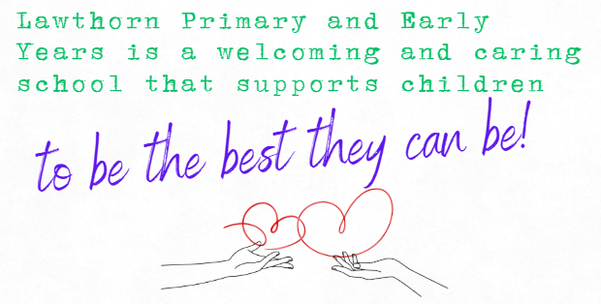 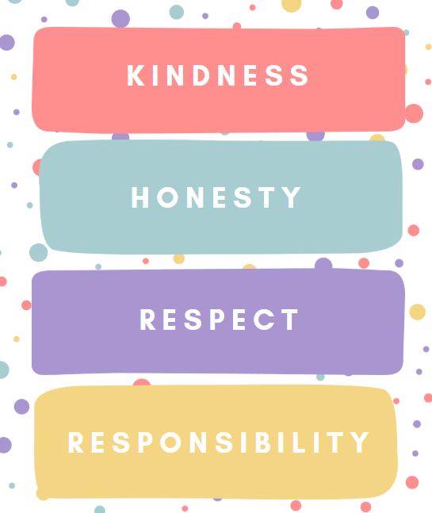

***AIMS:***

* *To provide a high-quality learning environment which promotes excellence and equity and enables our children to become successful learners, confident individuals, effective contributors and responsible citizens.*
* *To celebrate the talents and achievements of all children to enable them to achieve their full potential.*
* *To work in partnership with parents, carers and our whole school community to maintain a positive school community, where everyone is respected, included and nurtured*
* *To promote empowerment, leadership and collaboration at all levels.*

**EDUCATION SERVICE: IMPROVEMENT PLAN SUMMARY 2023/4 – 2025/6**

The Education Service Improvement Plan is aligned to the 5 priorities of the National Improvement Framework. Individual establishments should create their own plan under these 5 priorities, based on rigorous self-evaluation and analysis of performance evidence. Stakeholders should be fully engaged in the development of the plan. In the diagram below, the orange boxes show the thematic areas under each priority which the service intends to focus on in the year ahead.

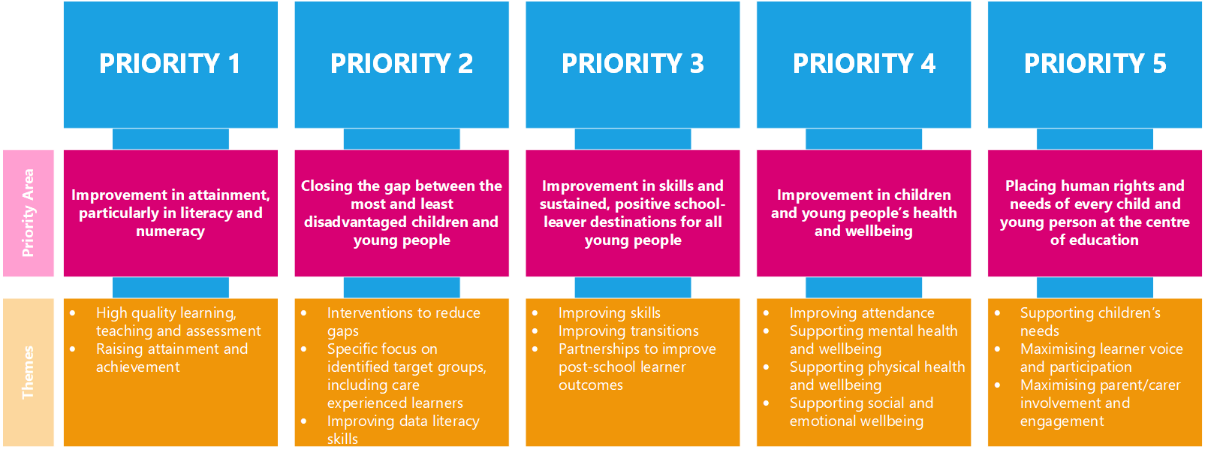

|  |  |  |  |
| --- | --- | --- | --- |
| **PRIORITY 1** | | | |
| **Strategic Objective:**  To ensure high quality learning and teaching across the curriculum | | | |
| **Select the KEY drivers for this improvement priority** | | | |
| **Education Service Priority**  *Please select the relevant service priorities* | **NIF Drivers of Improvement**  *Please select up to three NIF drivers* | **How Good Is Our School 4**  *Please select up to three quality indicators for this priority* | **Quality Improvement Framework for ELC settings**  *Please select up to three quality indicators for this priority* |
| 1. Improvement in attainment, particularly literacy and numeracy  3. Improvement in skills and sustained, positive school-leaver destinations | 2. Teaching and practitioner professionalism  4. Curriculum and assessment  5. School & ELC improvement | 2.2 Curriculum  2.3 Learning, teaching and assessment  1.2 Leadership of Learning | **3.1 Play and learning**  **3.1 Plan and learning**  **3.3 Learning, teaching and assessment** |
| **Rationale for Change**  Our current self-evaluation using How Good is Our School (4th Edition) and How Good is Our Early Learning & Childcare indicates Level 4 – **good** - for Learning, Teaching and Assessment (QI 2.3). To progress to **very good - Level 5**, we aim to build greater consistency and depth in our pedagogy across the school.  P4 – P7 have been developing Deep Learning Pedagogies focused on the 6Cs, while the Infant Department and EYC have been embedding Play Pedagogy. To ensure progression and coherence, these approaches now need to be aligned within a **whole-school, skills-based framework**.  Staff confidence has grown through professional learning and collaboration, but evidence from pupil voice, classroom observations and a recent Care Inspectorate visit to our EYC, suggests that learners are not yet consistently leading their learning. There is a need to increase opportunities for **inquiry-based, interdisciplinary learning** and to promote **greater learner agency** across the school & in the EYC Care Inspectorate advised that ‘planning processes could be enhanced further by recording more clearly where children's ideas and interests have informed play and learning’ and ‘children would benefit from more planned provocations that sparked their interests and enabled them to explore, discover, solve problems and consolidate learning through play’.  This priority will focus on unifying pedagogical approaches, strengthening skills progression, and empowering pupils to take ownership of their learning. This priority will be led by PT PEF. | | | |

|  |  |  |  |  |  |
| --- | --- | --- | --- | --- | --- |
| PRIORITY 1: Action Plan | | | | | |
| Pupil Outcomes | **Implementation Plan** | **Timescales/**  **Responsibility** | **Measurement of Impact** | **Analysis & Evaluation of Progress** | **Cost**  **(PEF)** |
| *Specifically, what will change for our learners?* | *How will we achieve this?*  *What do we plan to do?* | *What are our timescales? Who will lead?* | *How will we know the change is an improvement? Can you quantify this?*  *What data will be collated and analysed to demonstrate progress? Consider baseline data.* | *How do we know that the experiences & outcomes for learners have improved? What does the data tell us which demonstrates impact?* | *Please enter the cost to the nearest £* |
| Learners across the school and EYC will experience consistent high-quality learning and teaching across all curricular areas.  Children will develop transferable skills including creativity, collaboration, communication, and critical thinking (6Cs).  Early Years children will benefit from play experiences that are better informed by high-quality observations, leading to more meaningful planning & target setting. | **Progression Framework for Deep Learning (6Cs)**   * Develop clear progression pathways from Early to Second Level using age-appropriate success criteria for each of the 6Cs. * Collaborate with staff from Early to Second level to co-construct examples of what progression looks like in practice.   **Teaching and Learning Policy**   * Develop and implement a whole-school Teaching and Learning Policy to ensure shared expectations, consistency, and high-quality pedagogy.   **Professional Learning and Collaborative Planning**   * Facilitate professional learning opportunities on inquiry-based approaches. * Use collegiate time for shared planning, moderation, and evaluation of learning and teaching practices.   Early Level specific actions:   * Deliver training on high-quality observations in play. * Develop shared understanding and exemplars of observation and documentation. * Review current planning, tracking and target setting in EYC to ensure it is responsive, clearly links to observations, and reflects children’s interests and developmental needs. | **PT PEF/ Whole Staff Consultation (June 26)**  **PT PEF/ P1 Teachers/ HT (March 26)**  **PT PEF/ HT (ongoing Aug 25 – June 26)**  **HT (ongoing Aug 25 – June 26)** | **Classroom Observations** based on HGIOS4 2.3: Learning, Teaching & Assessment.  * **Pupil questionnaire based on How Good is OUR School (part 2): Theme 2, Our Learning & Teaching** |  | ***£6,522.46 (PEF PT enhancement)***  ***£14,452.12 (0.2 class teacher)*** |
| Learners will take more leadership of their learning through inquiry-based and interdisciplinary experiences.  Pupils will demonstrate increased confidence, engagement, and independence in their learning. | **Inquiry-Based Learning and Interdisciplinary Learning**   * Review and redesign IDL topics to align with real-world contexts and deep learning competencies.   **Learner Voice and Leadership**   * Embed use of floorbooks from EY – P7 * Develop provocations that stimulate curiosity, creativity and collaboration during play and learning from Early to Second Level. | **PT PEF/ HT (Aug 25)**  **All Staff (Aug 25 – June 26)** | * **Floorbook Samples and Moderation** showing evidence of high quality learning opportunities and pupil voice. * **Pupil questionnaire based on How Good is OUR School (part 2): Theme 2, Our Learning & Teaching** * **Early Level planning** shows clear child-led learning with provocations linked to observed interests. |  |  |
| Increased opportunities for STEAM learning will enhance problem-solving and digital literacy. | **STEAM Curriculum Integration**   * Develop a dedicated room within the school to facilitate STEAM learning opportunities. * Assign a teacher with expertise in STEAM focussed on leading and co-delivering engaging, interdisciplinary STEAM learning across the school. * Develop ongoing partnerships with local organisations or STEM Ambassadors to provide hands-on learning opportunities. | **PT/ STEAM Teacher (Aug 25 – June 26)** | * **STEAM Participation within Floorbooks** to show development of STEAM across the school. * **Staff Confidence Baseline & Evaluations** reflecting on changes in practice and impact on learners. |  |  |

|  |  |  |  |
| --- | --- | --- | --- |
| **PRIORITY 2** | | | |
| **Strategic Objective:**  To improve behaviour and relationships across the school and Early Years Class | | | |
| **Select the KEY drivers for this improvement priority** | | | |
| **Education Service Priority**  *Please select the relevant service priorities* | **NIF Drivers of Improvement**  *Please select up to three NIF drivers* | **How Good Is Our School 4**  *Please select up to three quality indicators for this priority* | **Quality Improvement Framework for ELC settings**  *Please select up to three quality indicators for this priority* |
| 4. Improvement in children and young people's health and wellbeing  5. Placing human rights and needs of every child and young person at the centre of education | 3. Parent/carer involvement and engagement  6. Performance information  Choose an item. | 3.1 Ensuring wellbeing, equality and inclusion  2.4 Personalised support  Choose an item. | **4.2 Wellbeing, inclusion and equality**  **1.2 Staff skills, knowledge, values and deployment**  Choose an item. |
| **Rationale for Change**  Although our May 2024 Parent Survey showed that 96% of parents agreed behaviour in school is good, concerns were raised by the Parent Council in September 2024 around bullying and the clarity of our anti-bullying policy. In response, we engaged the support of Brian Donnelly, a Behaviour and Relationships Specialist, to support staff, pupils, and parents in understanding bullying behaviours and their impact.  Follow-up surveys showed most staff and pupils viewed behaviour and relationships positively, however, 21/57 parents felt that the school did not deal with challenging behaviour effectively. In addition to this, our recent Care Inspectorate reported a need to ensure ‘children's engagement with staff, and their learning experiences are consistently positive with reduced disruptions’.  We therefore decided to continue our work with Brian Donnelly into 2025 to develop a refreshed, values-based Positive Relationships Policy. While many strengths existed across classes, we identified a need for a consistent whole-school approach to language, expectations, and behaviour management strategies. We recognise the importance of continued improvement and will focus on:   * Embedding consistent language and expectations across the school; * Equipping children with strategies to manage relationships; * Providing clear guidance and support for parents and carers.   A strong, consistent approach will help all pupils feel safe, respected, and supported—contributing to a positive learning environment and improved outcomes. | | | |

|  |  |  |  |  |  |
| --- | --- | --- | --- | --- | --- |
| PRIORITY 2: Action Plan | | | | | |
| Pupil Outcomes | **Implementation Plan** | **Timescales/**  **Responsibility** | **Measurement of Impact** | **Analysis & Evaluation of Progress** | **Cost**  **(PEF)** |
| *Specifically, what will change for our learners?* | *How will we achieve this?*  *What do we plan to do?* | *What are our timescales? Who will lead?* | *How will we know the change is an improvement? Can you quantify this?*  *What data will be collated and analysed to demonstrate progress? Consider baseline data.* | *How do we know that the experiences & outcomes for learners have improved? What does the data tell us which demonstrates impact?* | *Please enter the cost to the nearest £* |
| Our children will experience a supportive and nurturing learning environment, where strong, positive relationships with peers and staff promote emotional well-being and engagement. Children will demonstrate more consistent positive behaviour, leading to improved focus, cooperation, and readiness to learn. | **Implementation of our New Behaviour and Relationships Policy:**   * **Communicate the Policy Clearly**: Share the policy with staff, children, and parents to ensure a shared understanding and collective commitment to positive relationships and behaviour. * **Develop a Parent-Friendly Version**: Create an accessible and engaging version of the policy for families, enabling them to support and reinforce expectations at home. * **Provide Practical Guidance for Families**: Develop and share interactive videos offering advice, strategies, and information to help parents and carers support children’s emotional regulation and positive behaviour. * **Promote a Consistent School-Wide Approach**: Create displays throughout the school that reinforce our core values and ensure consistency of language and expectations across all settings. * **Enhance Behaviour Monitoring**: Review and strengthen tracking procedures to monitor behaviour trends across the school and Early Years Class (EYC), enabling timely, targeted support where needed. * **Engage Expert Support**: Work with Brian Donnelly, Behaviour & Relationships Specialist, to provide tailored professional development and targeted interventions that support staff and children’s readiness to learn. | **Aug 2025 (HT)**  **Sept 2025**  **(HT & Brian Donnelly)**  **Sept 2025 (Brian Donnelly)**  **DHT (Aug 2025)**  **DHT (Nov 2025)**  **HT/ DHT (Aug – Dec 2025)** | We will measure the impact of the new Behaviour and Relationships Policy by tracking improvements in behaviour, relationships, and engagement across the school and Early Years Class (EYC). Progress will be demonstrated through a combination of quantitative and qualitative data:  **Baseline and Ongoing Behaviour Data**   * We will compare pre- and post-implementation questionnaires to identify improvements. * We will monitor recorded incidents to identify trends.   **Pupil Voice and Wellbeing Measures**   * We will use our annual wellbeing SHANARRI survey and focus groups to gather pupil feedback on how safe, respected, and included they feel in school.   **Staff and Parent Feedback**   * Collect staff and parent/carer feedback through surveys or evaluations following policy sharing, training sessions, and video resource use to assess understanding, confidence, and consistency of approach.   **Consistency of Language and Expectations**   * Conduct learning walks and observations to assess the visibility of values-based displays, and the consistency of language and responses used by staff in line with the policy. |  | ***£5000 (Brian Donnelly)***  ***£24,113.69 (PEF PSA to provide wellbeing interventions)*** |
| Our children will develop an understanding of equality, recognising and valuing individual differences.  Children will be empowered to challenge unfairness, show empathy towards others, and build positive, respectful relationships, contributing to a more equitable and respectful school community. | **Thematic Assemblies to Build Awareness:**   * Create an annual assembly plan which identified a clear focus on equality and children’s rights * Work with pupil leadership groups to deliver a series of assemblies focused on specific needs and equality, such as Other World Religions, Down’s Syndrome Awareness Day, neurodiversity, dyslexia, gender equality, and anti-racism, to build empathy, challenge stereotypes, and celebrate differences.   **Anti-Bullying Education and Policy Launch:**   * Launch our updated Anti-Bullying Policy * A whole-school focus anti-bullying during Anti-Bullying Week. * Develop visual strategies for children to help them manage relationships and playground situations. * Develop top tips/ supports for parents in how to support children who are being bullied/ are bullying others   **Embedding UNCRC and Global Goals:**   * Raise awareness of the United Nations Convention on the Rights of the Child (UNCRC) and the Sustainable Development Goals through curriculum planning and school assemblies. | **DHT (Aug 2025)**  **DHT (Aug 2025 – June 2026)**  **DHT (Aug - Nov 2025)**  **Brian Donnelly/ DHT (Nov 2025)**  **DHT (June 2026)** | We will measure impact on learners’ experiences and understanding and will monitor progress using the following data and indicators:  **Assembly Reflections and Pupil Voice**   * Collect reflections from pupils through pupil focus groups   **Anti-Bullying**   * Monitor and record any incidents of bullying (via SEEMiS and school logs) evidence reductions over time.   **Floorbook Monitoring**   * Review floorbook content to track how UNCRC and the Global Goals are embedded in learning across the school and Early Years Class. |  |  |
| Individuals and small groups will demonstrate improved social and emotional wellbeing, engagement, confidence and progress through involvement in focused interventions and tailored strategies. | **Enhancing Targeted Support for Wellbeing and Readiness to Learn:**   * **Clarify the Role of the Targeted Support Teacher** Define responsibilities, establish clear planning and tracking systems, and ensure targeted interventions are well-coordinated and monitored. * **Staff Training**   Provide professional learning on Emotion Coaching and managing challenging behaviours, trauma informed practice and readiness to learn   * **Upskill Pupil Support Assistants** Deliver targeted training to enable PSAs to support specific interventions such as LEGO Therapy, Change and Loss, and Let’s Introduce Anxiety Management (LIAM). | **DHT/ Targeted Support Teacher (Aug 2025 – June 2026)**  **DHT/ TST/ Brian Donnelly (Aug – Dec 25)**  **DHT (Aug – Dec 2025)** | **Measuring Pupil Progress**   * Tracking Meetings will show improvements in progress and achievement. * Pre- and post-intervention data, including: * Boxall Profiles * Pupil questionnaires and voice * Teacher observations * Evaluation of individual targets   **Behaviour Incident monitoring**   * Reduction in behavioural incidents and emotional dysregulation will be monitored   **Staff Training Evaluation**   * Pre- and post-training questionnaires will measure improvements in staff confidence and understanding of key strategies such as Emotion Coaching and trauma-informed practice. |  |  |

**This should only be completed for aspects of your PEF spend not included within your Improvement Plan priorities.**

|  |  |  |  |  |  |
| --- | --- | --- | --- | --- | --- |
| **PEF contact - HT or DHT with responsibility for the plan:** | | |  | | |
| **Carry forward:** | £0 | **Total Allocation:** |  | **Total:** |  |

|  |  |  |  |  |  |  |
| --- | --- | --- | --- | --- | --- | --- |
| PEF Action Plan | | | | | | |
| Poverty Related Gap | **Pupil Outcomes** | **Implementation Plan** | **Timescales/**  **Responsibility** | **Detail of Spend** | **Measures of Impact** | **Analysis & Evaluation of Progress** |
| Provide details of the gap or barrier you wish to address. | Specifically, what will change for our learners? | What do we plan to do to achieve this outcome? | What are our timescales?  Who will lead? | Record cost & provide concise detail of what this entails. | How will we know the change is an improvement? Can you quantify this? What data will be collated and analysed to demonstrate progress? Consider baseline data. | What does the data tell us? How well is evidence from self-evaluation analysed to improve pupil outcomes? How is the spend contributing to narrowing our attainment gap? |
|  |  |  |  |  |  |  |
|  |  |  |  |  |  |  |
|  |  |  |  |  |  |  |
|  |  |  |  |  |  |  |