

LAWTHORN
PRIMARY SCHOOL
& EARLY YEARS CLASS

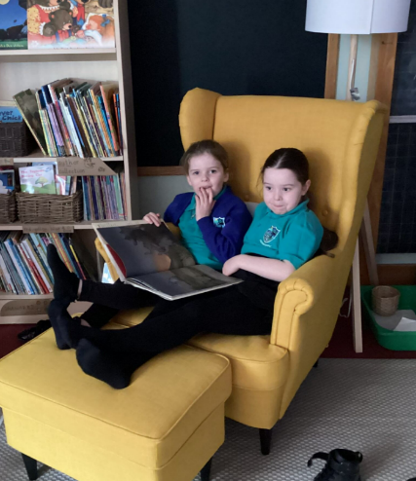
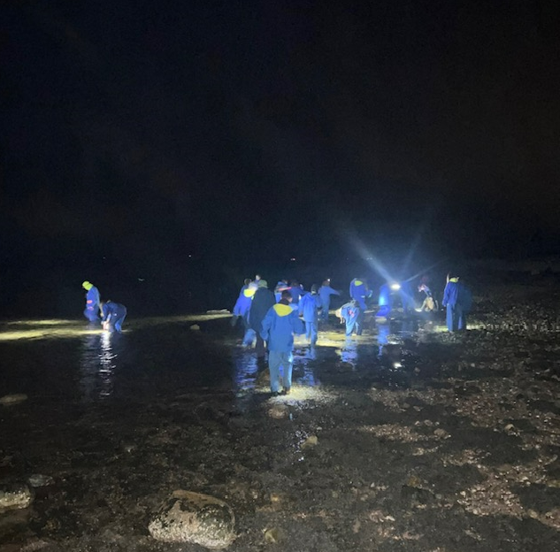
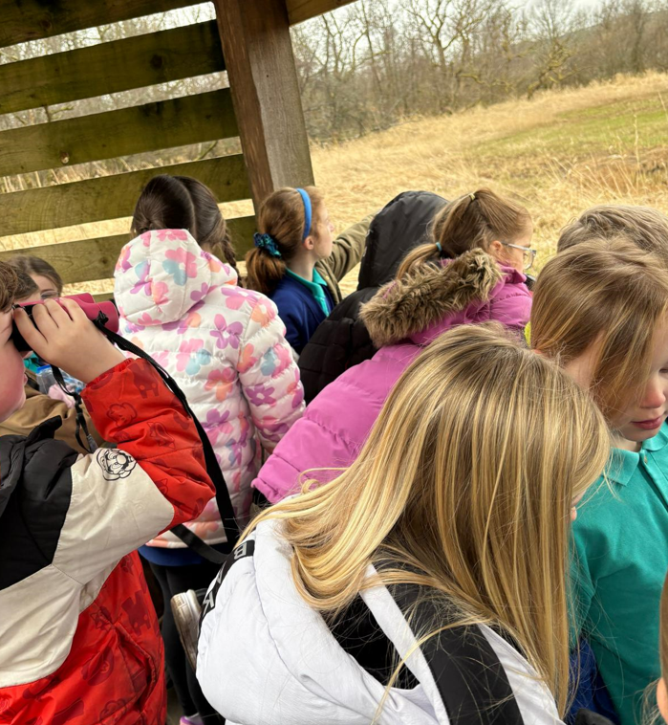
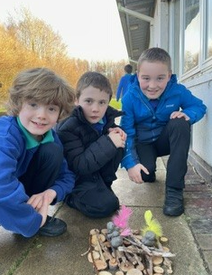
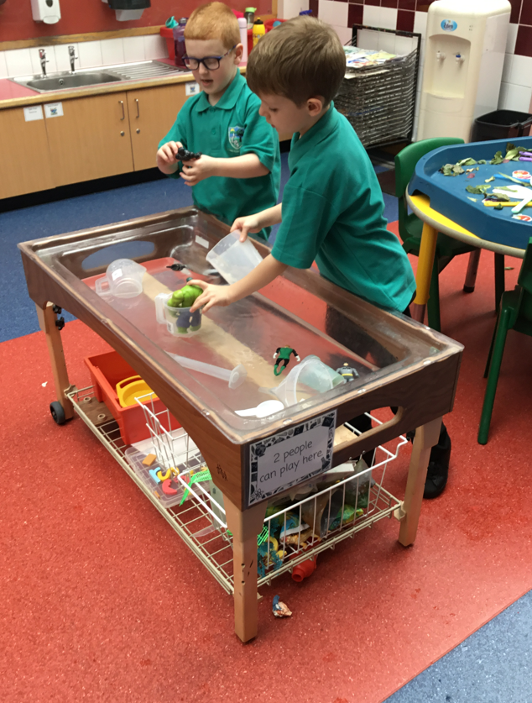
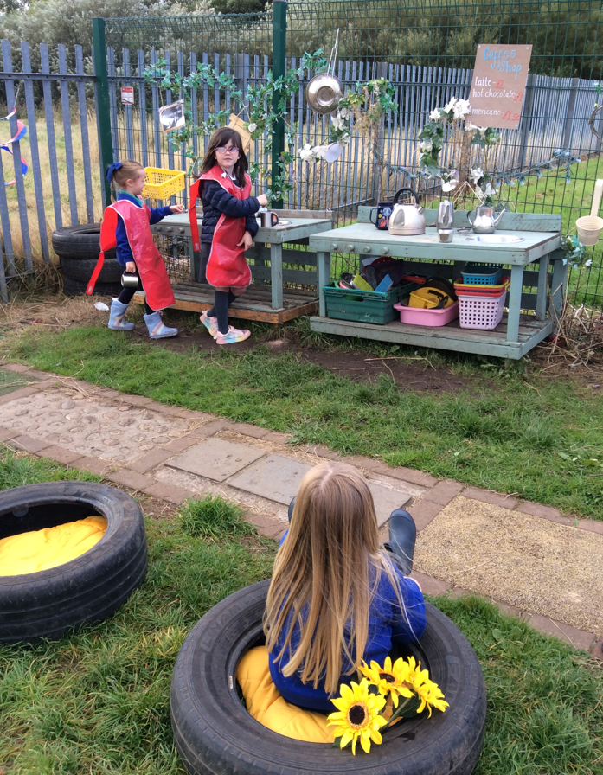
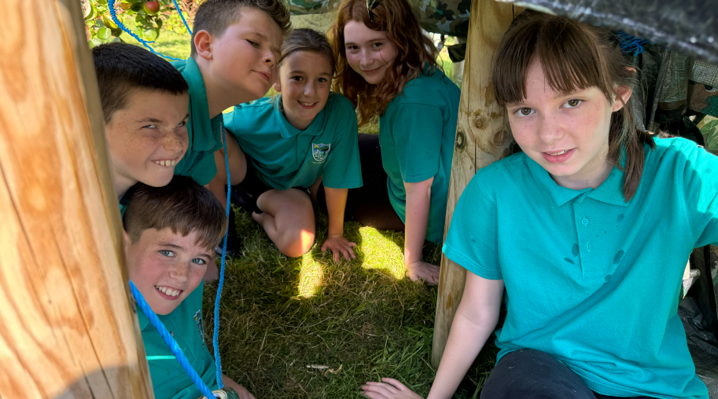
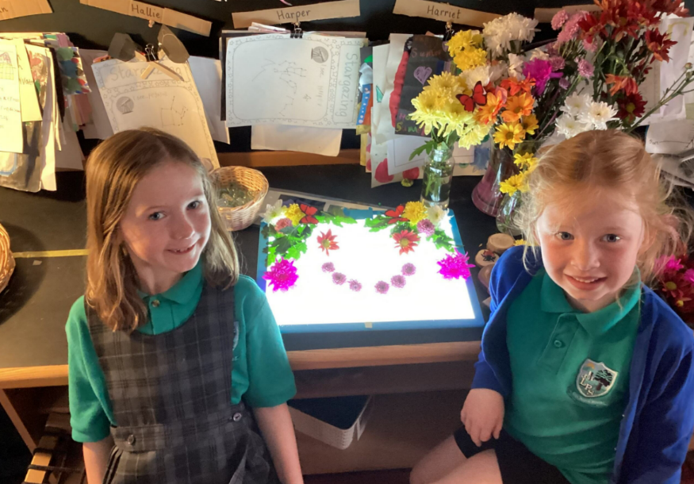

INFORMATION LEAFLET
FOR PARENTS & CARERS
August 2025

Message from the Head Teacher

Dear Parents/Carers,

A warm welcome to Lawthorn Primary School & Early Years for session 2025-2026! If you are already part of our school community, welcome back and if you are new to Lawthorn Primary School & Early Years, I would like to extend a warm welcome; we look forward to getting to know you and your child.

At Lawthorn Primary School, our vision is to nurture, inspire and support our children to be the best they can be, and we place a strong emphasis on our school values of kindness, honesty, respect and responsibility. We are proud of our nurturing ethos, our high quality learning environment and our fantastic children and staff.

The following guidance serves as a reminder to our existing families and, I hope, useful information for new families. If, however, you find there are unanswered questions after reading this guidance, please do not hesitate to get in touch.

I wish you all a happy and successful year!

Yours sincerely,
Miss S. Grossart

OUR STAFF

Leadership Team
Head Teacher: Miss Sandie Grossart
Depute Head Teacher: Mrs Carissa Hyndman
Principal Teacher: Mr Paul Flannigan
Mr Hugh English (PEF)
Senior Early Years Practitioner: Mrs Alison Linton

Class Teachers
Primary 1A: Miss Sarah Jane Steadman/ Mrs. Helynn McCallum
Primary 2/1: Mrs. Elaine Walker
Primary 3/2: Mrs. Erin King/ Mrs. Rebecca Garman
Primary 3: Mrs. Patricia Wilson
Primary 4A: Mrs. Erin McGregor/ Mrs. Helen Brown
Primary 4B: Miss Jasmin Rugg/ Mrs. Susan Reid
Primary 5: Miss Lyndsay Bunce
Primary 6/5: Mrs Katie Montgomery
Primary 6: Miss Hayley McLaughlan
Primary7A: Miss Amy MacKenzie
Primary 7B: Mr. Paul Flanagan/ Mrs. Tracy Kerr
Targeted Support: Mrs. Elaine Wilson
STEAM teacher: Mrs. Elaine McLachlan

EYC Staff
Senior Early Years Practitioner: Mrs. Alison Linton
Early Years Practitioners: Ms. Nicola Stewart
Miss Toni Coyle
Miss Sheree Grayston
Early Years Assistant: Miss Georgina Burns

Support Staff
Pupil Support Assistants: Mrs. Nikki Barbour
Mrs. Ashley Brisbane
Miss Arianne Harley (1-1 support)
Miss Courtney Lockhart
Mrs. Kirsty McCann

Mr. Michael Rogerson (PEF)
Miss Emma Tree
Mrs. Lorraine Williamson

Office Staff:
EBAs: Mrs. Margaret Anderson
Mrs. Laura Anderson
Miss Nikita Valentine

Janitor: Mr. David Fulton

Dining Supervisor: Mrs. Karen Porte

Partnership Working
Senior Manager: Mrs. Kirsty Carson
Educational Psychologist: Mrs. Claire Cunningham
School Nurse: Mrs. Misty McDonald
Cluster Schools: Greenwood Academy
Dreghorn Primary
Elderbank Primary
Glebe Primary
Springside Primary


SCHOOL HOURS

Start time: 9am
Finish time: 3pm

- Supervision will be available in the school playground from 8.45am each day.
- In the instance of adverse weather conditions before 9am, pupils will have access to classrooms and will be supervised by classroom assistants.

DROP OFF & COLLECTION
To limit the risk to all, we ask that our families adhere to the following guidance when dropping off and collecting pupils from school:

On dropping off pupils, parents and carers are asked to….
- Ensure children are dropped off promptly at 9am
- Remain out with the playground gates
- Please refrain from waiting around once your child has entered the school gates

On collection of pupils, parents and carers are asked to…
- Ensure children are collected promptly at 3pm
- Remain out with the playground until 2.50pm
- If possible, and to limit congestion, only one parent/carer should enter the school grounds
- Please refrain from waiting around once your child has exited the school
- On entering the playground, remain at a distance from exit doors to enable children to leave the building safely
- Ensure all P1 – P5 pupils are collected by an adult. If parents are happy for P4 and P5 pupils to walk home alone, they must provide written permission. Pupils in P1 – P3 are not permitted to walk home alone.


TRAVELLING TO SCHOOL
As always, we encourage children to walk to school, however, if you are travelling by car, the safety of our children must remain paramount. If you are entering our carpark, is essential that you remain vigilant at all times, travel slowly and do not park on zig zag lines, corners, or outside the school gates. We also politely request that parents do not enter the staff carpark at the side of the school.

For those parents who are happy to drop and go, we ask that you drop off your child in the ‘Drop and Go’ zone in front of the school building. Supervisory staff will be present in the school carpark and playground to ensure that your child enters the building safely. Please do not park in the ‘Drop and Go’ zone if you intend to exit your car. If you wish to escort your child to the school gate, please park in a designated parking space.

ATTENDANCE & LATE COMINGS

One of the most significant indicators of success in school is a high attendance rate. For most pupils, attendance should be at, or near 100%. The table below illustrates the impact of low attendance over a period of time.

Attendance Percentage | Over a 4 Week Period this would be: | Over 1 School Year this  would be:
100 | 0 days | 0 days
95 | 1 day | 9.5 days
90 | 2 days | 19 days
85 | 3 days | 28.5 days
80 | 4 days | 38 days
75 | 5 days | 47.5 days
70 | 6 days | 57 days
65 | 7 days | 66.5 days
60 | 8 days | 76 days



REPORTING ABSENCE
Should your child be late into school, they should enter via the main school office. If your child is unwell, please contact the school on 01294 224548 before 9am. If we do not receive notification of your child’s absence, we will contact the main carer. Absence can be reported to the school via our Safer Schools App.

In line with North Ayrshire Policy, pupil attendance is monitored on a monthly basis, and should this be consistently below 90%, the school will contact you to discuss possible supports to improve attendance.

PLAYTIME & LUNCHTIME
Playtime and lunchtime for all pupils from August 2023 will be as follows:

 | TIME
PLAYTIME | 10.45 – 11.00
LUNCHTIME | 12.30 – 1.15


SNACKS & WATER BOTTLES
We encourage a small healthy snack such as fresh fruit, raisins or crackers (no nuts please). Water is permitted throughout the school day and will be stored outside classrooms. Children may bring their own water bottle, filled from home. This may be refilled at the water chillers at appropriate times of the day. Fizzy drinks and energy drinks are not permitted in school.


SCHOOL MEALS
Pupils in P1 – P5 are entitled to a free school meal. If you wish your child to have a school meal, you must sign up to ‘I Pay Impact’ by visiting www.ipayimpact.co.uk and entering your child’s account reference. If you do not have an account reference, please email OnlineCashlessQueries@north-ayrshire.gov.uk. Once registered, children will be able to order their school meal. We encourage parents to complete the ordering process with their child. A menu is available online at: https://www.north-ayrshire.gov.uk/education-and-learning/school-meals/school-lunches.aspx.


PACKED LUNCHES
Pupils having a packed lunch will eat in our open area. Please ensure that your child’s packed lunch box is clearly labelled with your child’s name and class. Please note that fizzy drinks and energy drinks are not permitted and we ask that parents do not put nuts in their child’s lunchbox as we have pupils and staff with nut allergies across the school. Thank you!


PLAYGROUND
 | CLASSES | LOCATION
ZONE 1 | P1 (and P7 play leaders) | Outside P1/2 open area
ZONE 2 | P2 – P4 | Infant doors to red benches
ZONE 3 | P5 – P7 | Red benches to P6/7 doors
ZONE 4 | Rota of P5 – P7 pupils | Grass pitch (weather dependent)
Our playground will be split into 4 different zones as detailed below.

As our grass pitch can become very muddy in wet weather, the trim track and pitch will only be used in dry conditions.

Classroom assistants are allocated to each zone to supervise play. First aiders are available in our playground to support.


SCHOOL UNIFORM
At Lawthorn Primary School we are often complimented on how smart our children are. We encourage all pupils to be excellent role models and ambassadors for our school and encourage them to wear school uniform in school, at all times. Research shows that uniform is important for a variety of reasons:

- Security: Intruders are easily identified
- Appearance: Uniform presents a high standard for pupils and the school as a whole.
- Concentration: When children are dressed in their uniform, their focus and concentration increases.
- Bullying: Pupils are less likely to be bullied because of their clothing.

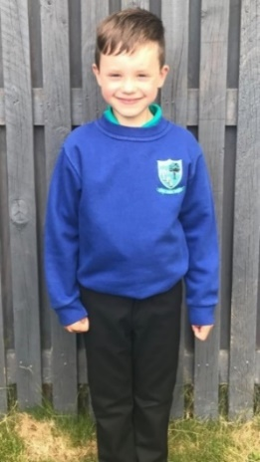
We ask that parents and carers support us in promoting school uniform. The table below highlights the dress code for school uniform and undesirable items of clothing.

Lawthorn Primary Dress Code | Undesirable Items of Clothing
Royal blue sweatshirt | Hoodies/ Fashion jumpers or sweatshirts
White shirt & tie or jade polo shirt | Any other colour of t-shirt/ polo shirt
Grey, black or navy trousers or skirt | Tracksuit bottoms or jeans

Please note that clothing, school bags or lunch boxes which may cause offence or provoke others are not permitted. Specific examples of these include football tops, scarves, schoolbags or lunch bags or tops with inappropriate or offensive slogans. Hoodies will not be permitted in class (with the exclusion of our P7 uniform hoodies) and we ask parents to support us with this. Thank you!

Please ensure all clothing is labelled with your child’s name. A ‘Lost Property’ box will be located in the janitor’s room for any items that become separated from their owner.

PURCHASING SCHOOL UNIFORM
As an Eco School we encourage parents and carers to use our supply of recycled uniforms. A small selection is held in our entrance area, however if you are looking for a specific size, please speak to the school office.
For parents/carers wishing to purchase uniform please use the following link: https://ayrshireuniforms.co.uk
Please note that orders placed throughout the year have to be collected in person from the shop.


SCHOOL BAGS
As space in our classes and cloakrooms is limited, P1 – P3 children are only required to have a book bag to transfer homework and correspondence between school and home.
P4 – P7 children may bring a small schoolbag. Schoolbags will be stored in cloakrooms and therefore any money or personal items should be removed before entering the classroom. Please note that we will provide all necessary stationery and equipment required for use in class. We ask that children do not bring any personal toys or games to school to avoid risk of loss or damage.

All children from P1 – P3 will receive a book bag and gym bag when they start school. If your child’s bag is lost or damaged, please speak to a member of office staff.

PE SAFETY
For health and safety reasons all children must wear suitable clothing for PE. This consists of shorts and t-shirts with soft shoes for indoor activities. For ease of changing, we advise that children in P1 – P3 wear trousers or a skirt and a polo shirt on PE days. We adhere strictly to health and safety guidelines and pupils must remove any item that may cause danger, i.e. metal buckles, jewellery. These items are the responsibility of the pupil. Long hair should be tied back. If you have any questions about particular items of clothing, please speak to the class teacher.

COMMUNICATION FROM HOME TO SCHOOL
At Lawthorn we pride ourselves on having an ‘open door’ policy. This means that we encourage parents and carers to speak to staff should they have a question or concern. The first point of contact should be the class teacher. However, if the matter is more urgent, then please contact the school office who will put you in contact with an appropriate member of the management team.


METHODS OF COMMUNICATION

Telephone: You can contact the school on: 01294 224548.

Email: You can contact the school using the following email address: lawthorn@ea.n-ayrshire.sch.uk

COMMUNICATION FROM SCHOOL TO HOME
As an Eco School, we aim to reduce the amount of paper correspondence and instead we will continue to use email to communicate with parents and carers. We will also use the Safer Schools App to share weekly announcements and send reminders. Our Digital Leaders have created a short video on how to download the app onto your phone. Please scan the QR code below to access this:



Please ensure the school office has up to date contact details and email addresses for all parents, carers and emergency contacts. Thank you!

OTHER INFORMATION

MEDICATION

If your child requires any medication, please inform us ASAP. We are unable to administer medication unless you have completed a consent form and the medication provided must have a prescription label with your child’s name and the required dosage.

HANDWASHING

Good hand hygiene is encouraged throughout the school day and children will have access to both hand soap and hand sanitiser. Due to the drying nature of the hand sanitiser, we encourage children to moisturise their hands when they return home. However, if you would prefer to provide your child with their own hand cream in school, they may keep this in their personal tray. If you wish to do this, please ensure it is clearly labelled with your child’s name.

USE OF MOBILE PHONES
Children are not permitted to use mobile phones or smart watches during school hours and if possible, we ask that these remain at home. If it is essential that your child brings a mobile phone to school, these will be collected at the beginning of each day and taken to the school office for safekeeping.


OUTDOOR CLOTHING
Our children will have a number of opportunities to learn outdoors throughout the school year. We therefore ask that all children come prepared each day with a suitable outdoor jacket and shoes.

SUPPORTING EACH OTHER
I am extremely proud of our school community and it is important that we continue to work together to support our children. Every child is unique and may need support in different ways, and some more than others. We ask parents and carers to be considerate of this.
If you have any concerns about your child, or would like to make us aware of any change of circumstance, please do not hesitate to get in touch and please be rest assured that every situation is treated with the utmost confidentiality.

Thank you for your continued support!
Miss S. Grossart
Head Teacher

KINDNESS HONESTY RESPECT RESPONSIBILITY

