A Selfie in Isolation!

We are currently living through a unique moment in history! We’re experiencing lockdown, home-schooling, coming together as a community and a whole new bunch of emotions too! Self-isolation and the situation we
are in will have its ups and downs. Let’s give ourselves something to look back on by taking a ‘selfie in
isolation!’. You can complete it as a family or on your own – it’s your choice! Stay safe. Stay together. Stay
at home.
I’ve been staying at home Life in lockdown means…
since…
*
* *
*

I have enjoyed… I miss…

* *
* *
* *

My self-isolation highs are… My lows have been… I am thankful for…

* * *
* * *
* * *
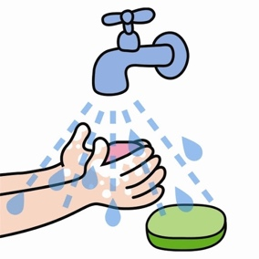

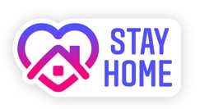
A Selfie in Isolation Instructions

Pictures
- Double click the middle of the black box with the white trim.
- Click the insert option at the top of the screen, then picture and then from file to upload one from your computer.
- You can choose more than one if you like.
- Click on the picture and use the box around the it to make it smaller or bigger by moving the squares in or out.

Text
- Double click beside each bullet point and begin to type.
- You might need to make your text a smaller to fit it all in. You can do this by using the A with the arrows beside the font on the tool bar.
- The text should be the same colour as the starter for each section. Feel free to change the colours to make it unique.
- To change the colour, use your mouse to highlight the part you want to change and use the little A with a rectangle of colour under it tool on the tool bar to choose your colour.

