A Selfie in Isolation!

We are currently living through a unique moment in history! We’re experiencing lockdown, home-schooling, coming together as a community and a whole new bunch of emotions too! Self-isolation and the situation we

are in will have its ups and downs. Let’s give ourselves something to look back on by taking a ‘selfie in

isolation!’. You can complete it as a family or on your own – it’s your choice! Stay safe. Stay together. Stay

at home.

I’ve been staying at home Life in lockdown means…

since…

\* Only being allowed out for essentials

\* 16th March 2020 \* Schools and businesses being closed

\* Food shopping being stressful

I have enjoyed…

I miss…

\* Spending time with my family

and Keeva \* Seeing friends and family

\* Reading and drawing. \* My class

\* The lovely sunshine. \* Costa Lattes and McDonalds

My self-isolation highs are… My lows have been… I am thankful for…

\* Pyjama days \* Not being able to give my Gran a cuddle. \* The fabulous NHS and Key Workers!

\* Family time \* Worrying about friends and family. \* My amazing friends and family!

\* Talking to my class on Teams \* Not seeing my class every day. \* Supportive colleagues,

pupils and parents!



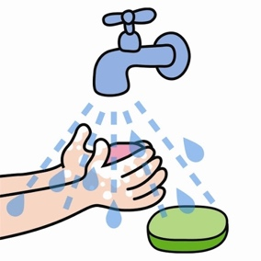

#lockdownbirthdays



