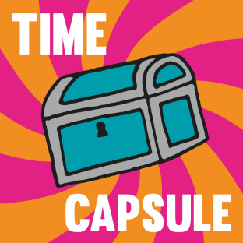
Time Capsule Challenge!

Can you and your family create a Time Capsule to help you remember this extraordinary time? Here are some ideas to get you started. You can put your own ideas into The Time Capsule to make it unique to your family!

- Write a letter to your future self and include your age, who your friends are, your favourite TV programmes, songs and books. Write about what is happening in your own words and tell your future self about how you are feeling right now. Talk about what you would like to be when you grow up and five things you want to do when you are an adult.
- Get a Newspaper – if safe to do so! Cut out articles you think would be important to look back on, or print out online articles.
- Include a drawing of your family or maybe even make a family tree!
- Draw a floor plan of your home.
- Record the weather forecast for the month of April 2020.
- Collect the packaging of your favourite food and drink.
- Take some Pictures. Print out some images taken on the day you create the capsule and pop them in.
- Illustrate and give instructions for your favourite family game during this time of lockdown.
- Find a recent grocery receipt or on-line shopping bill.
- Package it all up and lock away for years to come!

