A Guide for Parents

Sign in to Glow

Visit the Glow sign in screen: https://glow.rmunify.com/
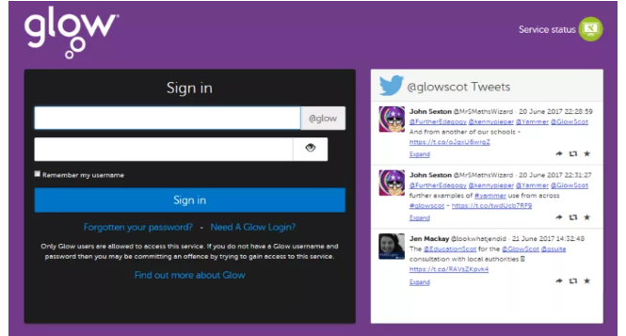
Enter your child’s username and password in the boxes shown (clicking the eye icon allows you to see your password as you type it in) then click ‘Sign in’.
Please note: If you log in to Glow using the Glow RM Unify screen it will automatically add the @glow. If you don’t see this you can add the @glow to the end of the address yourself.
When you log in to Glow, you will see a Launch Pad like this:
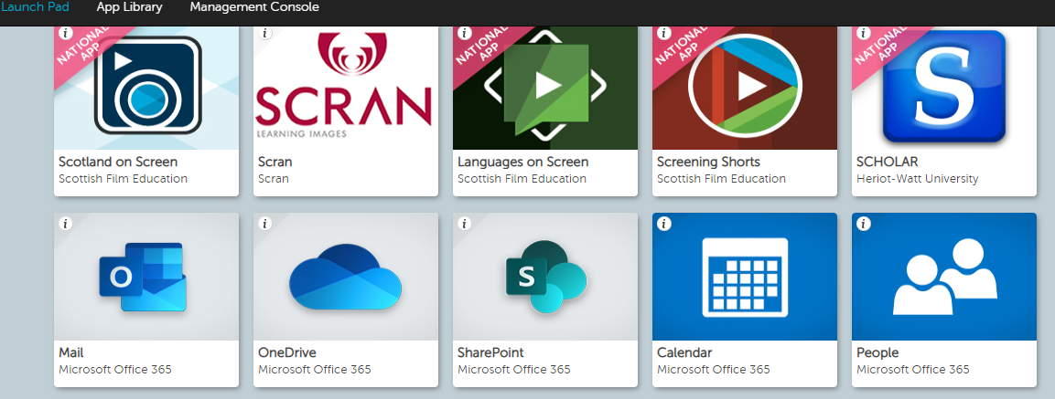
Click on the Sharepoint Tile to access ‘Pupil Pages’
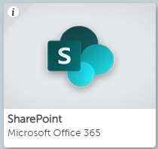
Click on ‘Pupil Pages’ to access the Digital Learning pages
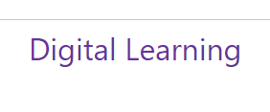
Click on Digital Learning to access our Digital Learning Pages. Here you will find weblinks to help your child with their Home Learning activities.
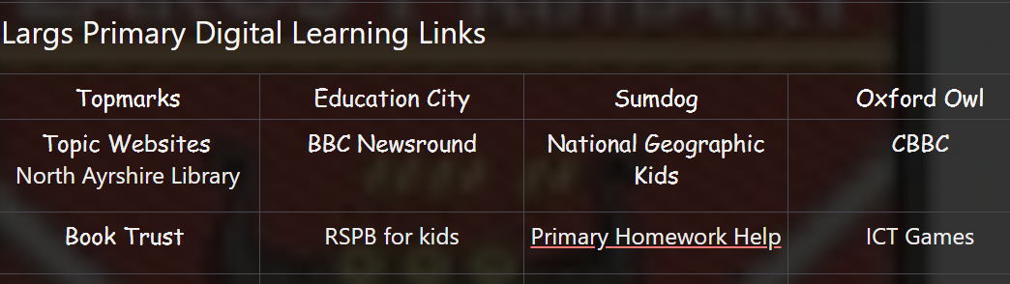
On the left hand side you will find the ‘documents’ tab. There is a copy of all the Largs Primary Home Learning Packs within the documents section.
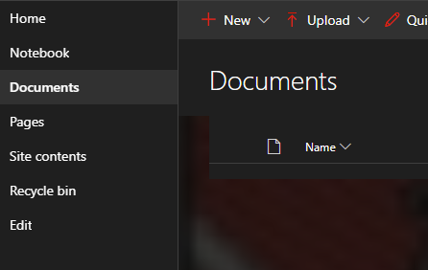
By using the Launch pad you can also access your child’s email account if you wish to upload photos/documents showing completed learning activities for your child’s teacher to see.
Simply
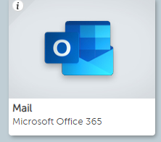
Click on the ‘Mail’ Tile
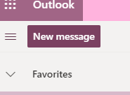
Click on ‘New message’
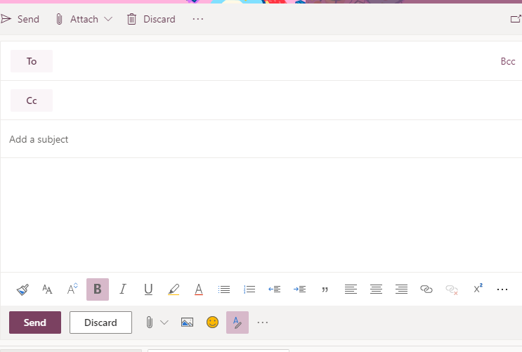
You can use the email to attach files/photos or simply to give your child’s teacher information about the activities they have completed!

