Largs Campus Library 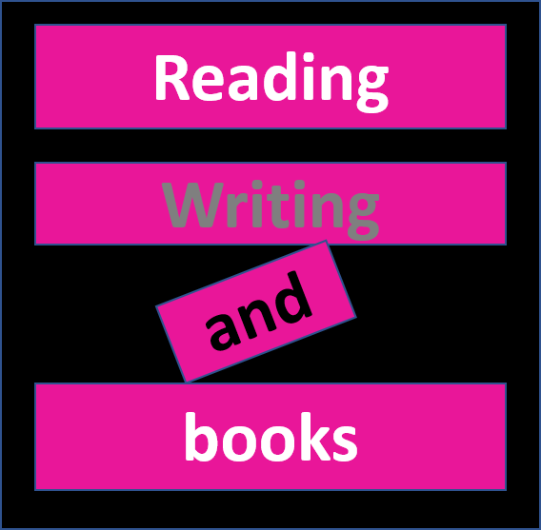

Designing a book jacket

Think about a FICTION book you have been reading recently. Your task is to design a new cover for the book to make it more attractive to potential readers.

Your cover must include the following:

A blurb

A very short introduction telling you something of the story to whet your appetite without giving the ending away. Leave your readers guessing! At the end of it, say how good you think the story is.

An illustration

Design an illustration for the cover of your book. It should remind you of one of the scenes in the book.

Standard Details

Title of the book; author; publisher, and so on.

An example:

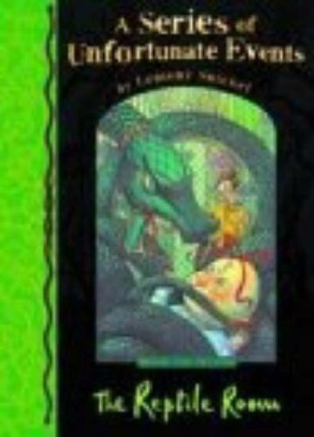
Blurb
Publisher
ISBN
Price
Now design your own on the next page:

