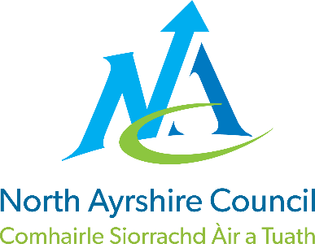
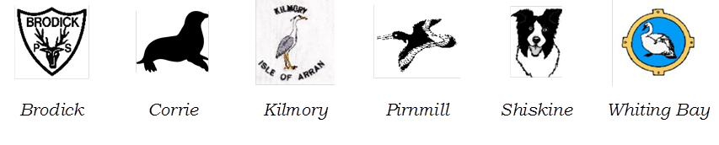
Brodick, Corrie, Kilmory, Pirnmill, Shiskine, Whiting Bay Primaries & EYC

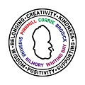

STANDARDS AND QUALITY REPORT
June 2026
This report will inform you of the school’s progress and achievements in the last session and let you know about our plans for 2025-2026.
I hope that you find it helpful and informative.

Allison Conner

Head Teacher

OUR SCHOOL
Our ‘six school’ family is made up of pupils from the communities of Brodick, Corrie, Kilmory, Pirnmill, Shiskine and Whiting Bay villages. All children transfer to Arran High School after P7 and we work together closely to ensure a smooth transition.

We currently have 190 primary age and 33 early years pupils within the 6 schools.

We are proud of our welcoming, caring and nurturing ethos throughout our schools, and our experienced staff teams work very hard to ensure that every child reaches their potential. We enjoy great relationships with our community partners and have opportunities to visit amazing places, both indoor and out, around our beautiful island of Arran.

OUR VISION, VALUES AND AIMS
We have recently renewed our school vision. This vision holds across all our schools on the Isle of Arran. Parents were invited to take part in a consultation exercise this session.
Our Isle of Arran Vision is to be ‘An Island of Excellence’.
Our Aims
- To create safe, vibrant schools where every child feels valued and leaves with many happy memories.
- To nurture individuals who will care for themselves, each other, the island and wider world they live in.
- To provide excellent, engaging and challenging learning that will nurture each child's potential.
- Create responsible citizens who have the skills for life, self-belief and ambition to make a difference in the future.
- To inspire our children to be independent, resilient lifelong learners.

We are currently developing individual School Values.
This will be launched as part of our School improvement Plan at the start of Session 26-27.

ATTAINMENT & ACHIEVEMENT
Clear Tracking and Monitoring processes operate across the 6 Arran Schools. Pupil progress from EY to P7 pupils is tracked 3 times a year in Oct Feb and June. Pupil progress is discussed across the school year in Attainment Conversations held between Early Years Practitioners, teachers and Senior Leadership Team. Staff are now fully involved in these processes and these changes are leading to improved outcomes for all learners.

Literacy
Talking & Listening
Almost Primary 1 learners have achieved Early Level in Listening and Talking.
The majority of all Primary 4 learners have achieved First Level in Listening and Talking.
Almost all Primary 7 learners have achieved Second Level in Listening and Talking.

Reading
Most Primary 1 learners have achieved Early Level in Reading.
Most Primary 4 learners have achieved Early Level in Reading.
Almost all Primary 7 learners have achieved Early Level in Reading.

Writing
Most of all Primary 1 learners have achieved Early Level in Writing.
The majority of all Primary 4 learners have achieved First Level in Writing.
The majority of all Primary 7 learners have achieved Second Level in Writing.

Numeracy
Almost all Primary 1 learners have achieved Early Level in Numeracy.
The majority of all Primary 4 learners have achieved First Level in Numeracy.
The majority of all Primary 7 learners have achieved Second Level in Numeracy.
Pupils with Additional Support Needs are supported and continue to work towards achieving their identified targets. This is well managed through the Staged Intervention Process.
Attendance
Attendance average has slightly increased from 93.75% to an average of 94% this school year. This is above the NAC average of 92%. We continue to encourage high attendance through key messaging regarding the impact of lost learning time to parents and pupils. The continued unreliable ferry service does impact on the length of absence for pupils as families travel to the mainland for key appointments.

WIDER ACHIEVEMENT Session 2025-26
Pupils from across our 6 schools have regularly experienced a wide range of extra-curricular opportunities this year. These quality experiences support the rural isolation that exists for our island pupils As a result, many pupils are developing skills and achieving success. Here are some highlights:
Arran Sports Hall Athletics Festival - Auchrannie Games Hall - 2nd October
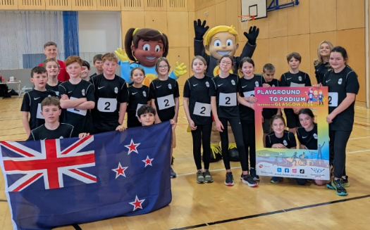
Sports Hall Athletics Heats - The Portal, Irvine - 4th November
Day of Dance - Auchrannie Games Hall - 26th November
Sports Hall Athletics Finals - The Portal, Irvine - 2nd December
Arran Primary Netball Tournament - Arran High - 17th March
Arran Primary Swimming Gala - Auchrannie - 5th May
PAN Ayrshire Sports Hall Athletics Finals - Kilmarnock Athletics Arena - 14th May
Arran Primary Football Festival - Arran High - 18th June

Other Active Schools Programmes have included:

- Extra-curricular programme
- Move and Improve leadership programme delivered to P6&7s to deliver lunchtime clubs
- Free swimming tuition for all P1-7s to support the completion of the Swim Teachers qualification
- Targeted Outdoor Education programme for P6 pupils
- International Women's Day taster sessions involving club delivery
- World Cup Ambassador programme - celebrating and promoting the competition and trip to Hampden
- Commonwealth Games Ambassador programme - celebrating and promoting the competition, delivering clubs, assemblies and organising club taster sessions in their school

Extra-curricular stats (lunchtime and after-school participation):

Full year 2024/25 - 92%
Term 1&2 (2025/26) - 82%
Term 3 (2025/26) - 89%
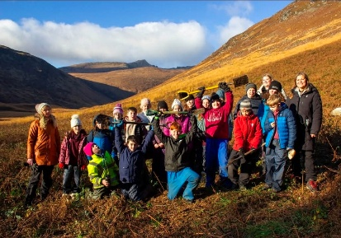
Curricular:
Sustainable Education:

As part of our Sustainability September initiative, Arran Eco Savy worked with pupils in classes across our 6 schools and supported pupils learning of sustainability. As a result, our pupils have learned about the impact Climate Change is having on our own local environment e.g. the wild fires of Glen Rosa and increased storms. Glen Rosa Tree Planting Project, Nov 25: The project developed further with a collaborative project with Arran Ranger, Eco Savy and education. All P6/7 pupils walked to Glen Rosa with Arran Ranger and successfully planted tree in fire damaged area.
Think About Plastic: Pupils in all our 6 Schools learned what actions some of our well-known local businesses on the island do to reduce and eliminate plastic use. We work collaboratively with the Arran Tap to educate our learners on what they have to so to ensure we are a sustainable island.
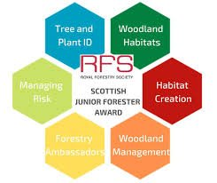
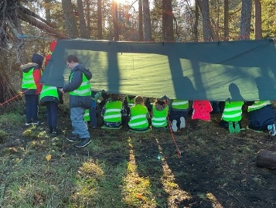
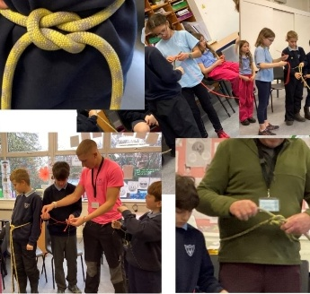
Outdoor Learning: All P6/7 pupils in Brodick and Shiskine School participated and gained the Scottish Junior Forester Award. Grant funding secured to enable for OWL trained group to work alongside teachers to support them to develop confidence and skills. All learners worked with their teachers and successfully undertook the Scottish Junior Forester Award as part of the project. Teacher training session also delivered.
In Creative Arts: Farm, Field, Fort: Moving with Drumadoon
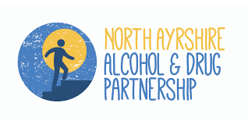
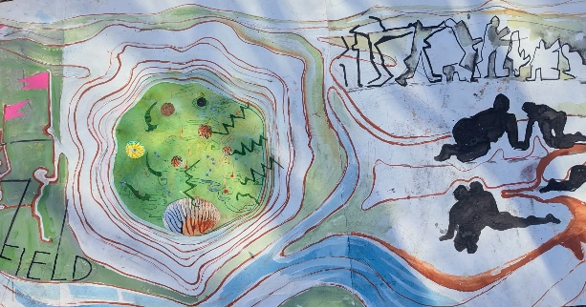
As part of Arran, Still Rising - the Clyde Bioregion Artist Residency – led by the dance artists in residency in partnership with Archaeology Scotland and Drumadoon, the children from Shiskine, Pirnmill and Kilmory Primary Schools learned about the archaeology of Drumadoon. In October 2025 the children went on a field trip in the form of an experiential journey through the archaeological and rewilding landscape of Drumadoon Estate. Inspired by this visit the children then went om to work with residence creative dancers to create a show case dance performance at Shiskine Village which was attended by parents and the community - ‘Farm Field Fort: Moving with Drumadoon’. The children were awarded the Heritage Hero Detective Award from Archaeology Scotland. This has been a unique project for all children across the P1 -7 classes and has allowed pupils to express their learning of the landscape via a creative medium.
In Health and Wellbeing:

All P6 and P7 pupils have learned about alcohol and drug through the Champions for Change program. All P7s participated in a further the Drug and Alcohol Awareness session as part of the 3 day S1 induction days in June. Staff attended a training session delivered by North Ayrshire Drug and Alcohol, Partnership. This was very positively received. We had hoped to deliver the same session to parents. This was cancelled due to ferries.
We continue to raise awareness of Dwarfism across in our 6 schools on the island through planned Assemblies and in class raising awareness lessons. Through our continue work with Tom at Sport Dwarfism Sports Association we are continuing to support all children by creating an inclusive environment for all.
P7s pupils came together for a series of Promoting Positive Masculinity learning experiences. Children learned together from well-established island male role models and learned the importance of mutual respect between in promoting positive lifelong relationships.
Connected Learning Experiences
We look for creative ways to support learners from our smallest schools in their transitions to larger learning communities. This year we have continued the partnership learning between Corrie and Pirnmill Schools through the well planned Together Days. The children continue to build friendships and benefit from learning in larger groups in planned learning time together. A few individual P7 pupils from smaller schools have joined up with the Brodick and Whiting Bay classes for a day a week learning before they attend the P7 Youth Cabin on Thursday evening. This is supporting their transition to Arran High School very well.
Our youngest learners met together to experience McDougalls Theatre performance this year. They also met and held the 1st Island EY Sports Day together in June.
And more…
- Almost all schools have raised funds through school fairs.
- Christmas Shows or enterprise events were held by all schools and our EY settings. These were very well supported by our local communities.
- School libraries and visiting touring library for small schools and EY seeing continues to support a wide range of books being made available to include diversity, achievement and titles chosen by children.
- All island P7 pupils enjoyed a Leavers celebration meal at Little Rock Cafe, followed by golf at no cost.
- P5-7 Pupils have opportunity to learn pipes, drums, clarsach and fiddle at no cost, with transport provided.
- Pupils performed on the stage at the annual Arran Music Festival at Whiting Bay Hall.
- 45 P7 pupils from all 7 island schools attended the 4 day Arran Outdoor Education Residential Trip in March. This supported transition to Arran High School very well.

HOW SUCCESSFUL HAVE WE BEEN IN IMPROVING OUR ESTABLISHMENT?
Priority 1
High quality learning, teaching and assessment will be evident in all our classes, for all pupils. Learners will know what they are learning, how they are progressing, and what their next steps to improve. They will receive quality feedback that helps them achieve this. Children will talk confidently about learning in regular Learning Conversations.
Priority 2
Learners will be engaged and motivated in their learning. A wide range of environments and creative teaching approaches are used including play, the outdoors and digital technology.
QUALITY INDICATORS
Provide your evaluation & brief summary statement for each of the 4 core QIs
QI 1.3 Leadership of Change | Evaluation | 4 Good
The Head Teacher is creating a culture of ambition, change and improvement across the 6 schools. Staff welcome the change. There is collaboration, support and an eagerness by almost all staff to particulate fully in the change. Change is being delivered through the setting of clear expectations, training and the creation of staff leadership roles. All staff including EY staff are taking on leadership roles within the school. This in its earliest stages. Pupils take on leadership roles through House Captain, Digital Leaders and Sports Ambassador roles. Staff are fully involved in these changes and leading the changes with positivity and enthusiasm. Examples of this include an EY staff member leading the Junior Forest Award for our youngest EY pupils. All PSAs are now fully trained on 5 /10 Minute Boxes. As a result, individual pupils are developing their reading skills. Our staff Digital Leaders have supported the use of effective technology across the schools. We plan collaborative approaches to professional learning cross island/ cluster. These include moderation activities/pods/trios/professional discussion and presentations across cluster. Collegiate sessions are delivered by teachers for teachers/ PSAs e.g. Digital Technology, PSA interventions. Staff are empowered to take on leadership roles across the school/ cluster.
We are now in our 2nd year of renewed approaches to Moderation, Tracking and Monitoring. As a result, teachers and EY staff are new used to discussing pupil progress regularly and discussing and planning ways to increase attainment further.

Our quality assurance calendar is now well established. There are regular and planned quality assurance activities where we observe pupil learning and discuss pupil learning with pupils themselves. As a result, we know how are doing and what improvements are required to make further improvements.

Strong leadership has set a clear direction and expectation of the culture of inclusion across the schools. Spaces have been created and class environments reviewed to ensure a calm, welcoming environment. Clear direction on establishing new authoritative boundaries to staff has resulted in a culture of inclusion across all schools. Almost all pupils needs are being met. There is still work to do. Our next steps is to increase expectation of all learners so that all learners achieve their fullest potential.

We are working to develop our approaches of effective Self-Evaluation opportunities by all stakeholders. Currently there is high engagement by EY parents, this is less for parents of P1-7 parents. Our next step is to further develop pupil SE through HGIOURS. We will work to explore ways to increase parental engagement in Seld evaluation little and more regularly.
There is still work to do and we will continue to explore ways to measure impact of the initiatives we plan and implement.

QI 2.3 Learning, Teaching & Assessment | Evaluation | 3 Satisfactory
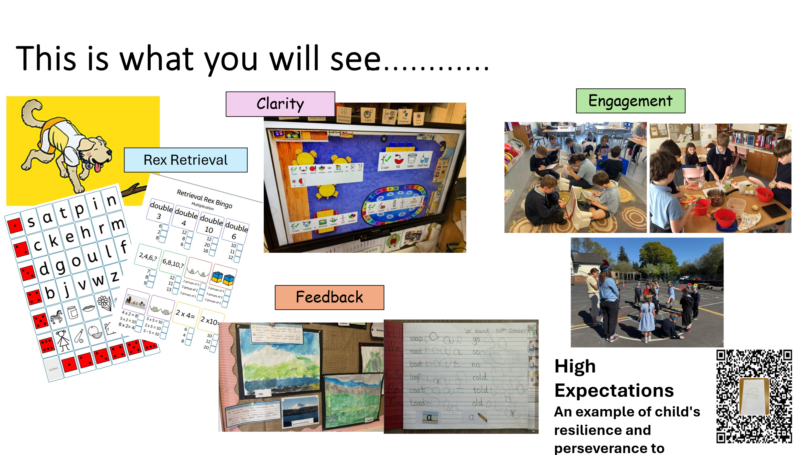
We have taken steps to improve our approaches to learning and teaching and are seeing improvements in the consistency delivered across the school. Almost all teachers have participated in high quality teaching pedagogy through Judy Pitt Collegiate and INSET training. The focus is on pace/clarity/feedback/Retrieval. There is still work to do.
Learners enjoy a high-quality EY learning environment that offers continuous provision to support individuals in their learning journey. We have reviewed all areas of the school environment and created calm, more nurturing learning spaces. Children are taking pride in these spaces and showing responsibility and pride in their learning spaces.

We have introduced consistency of expectations for routines/readiness to learn and work expectations. Almost all staff across the 6 schools have a shared understanding and reference these with pupils. We will continue to implement this approach across all 6 school next session.
Digital technology is used by almost all learners to share their learning with home. Parents like this as it informs them of pupil progress. Digital technology is enhancing learning and teaching in the majority of classes. We see high learner engagement levels when technology is used effectively to reinforce learning.
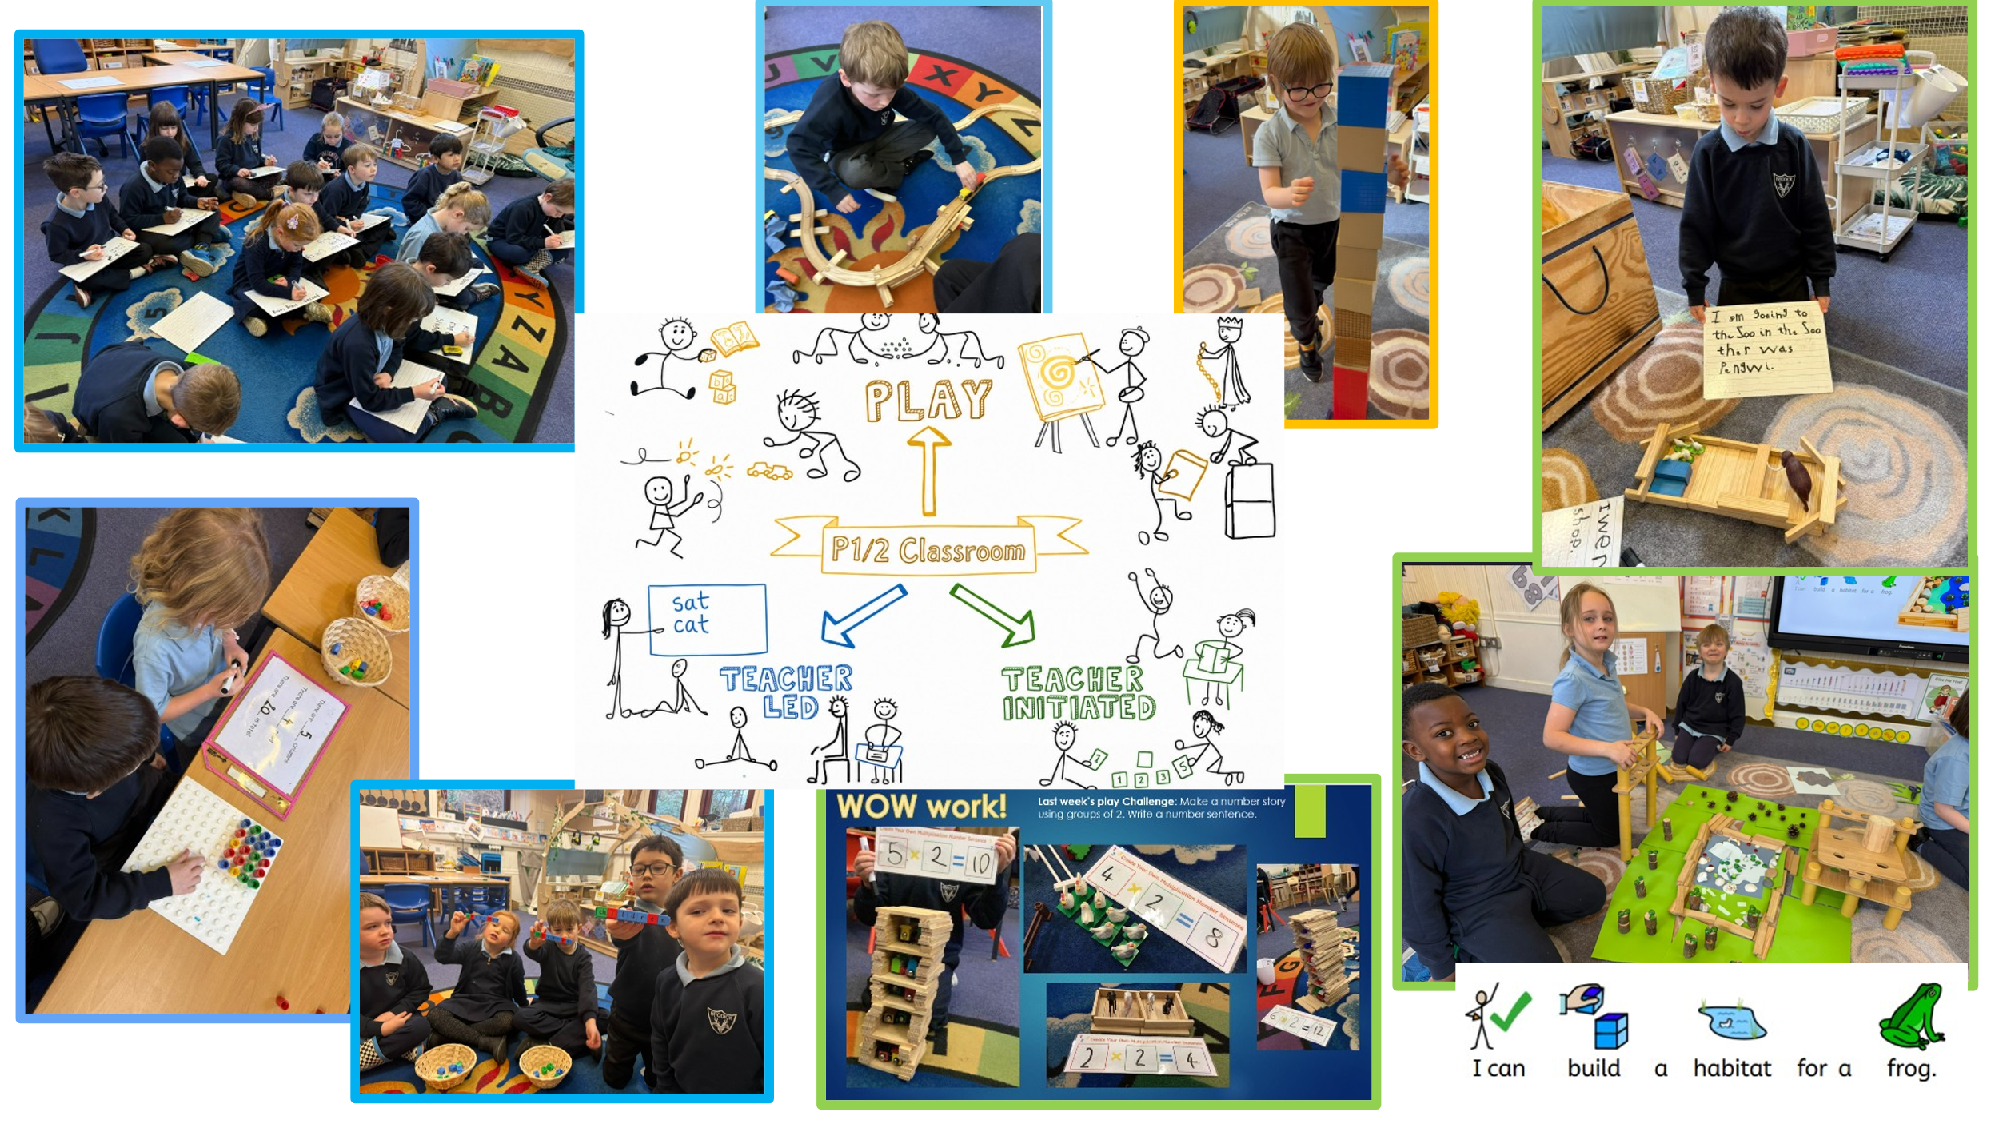
Individual Learning Targets – are working well in EY. All children are set Individual Learning Targets. Key worker staff know their pupils very well and take steps to plan meaningful experiences that link with targets.
P1-7 – Individual learning target jotters were introduced this year. Children are gaining confidence in recording their progress through their targets. These targets triangulate with T-charts.
PLAY – For the youngest P1,2,3 learners, we offer a balance of teacher led, child led and teacher-initiated activities. Staff confidence in our approach is high. NAC authority has supported this work.
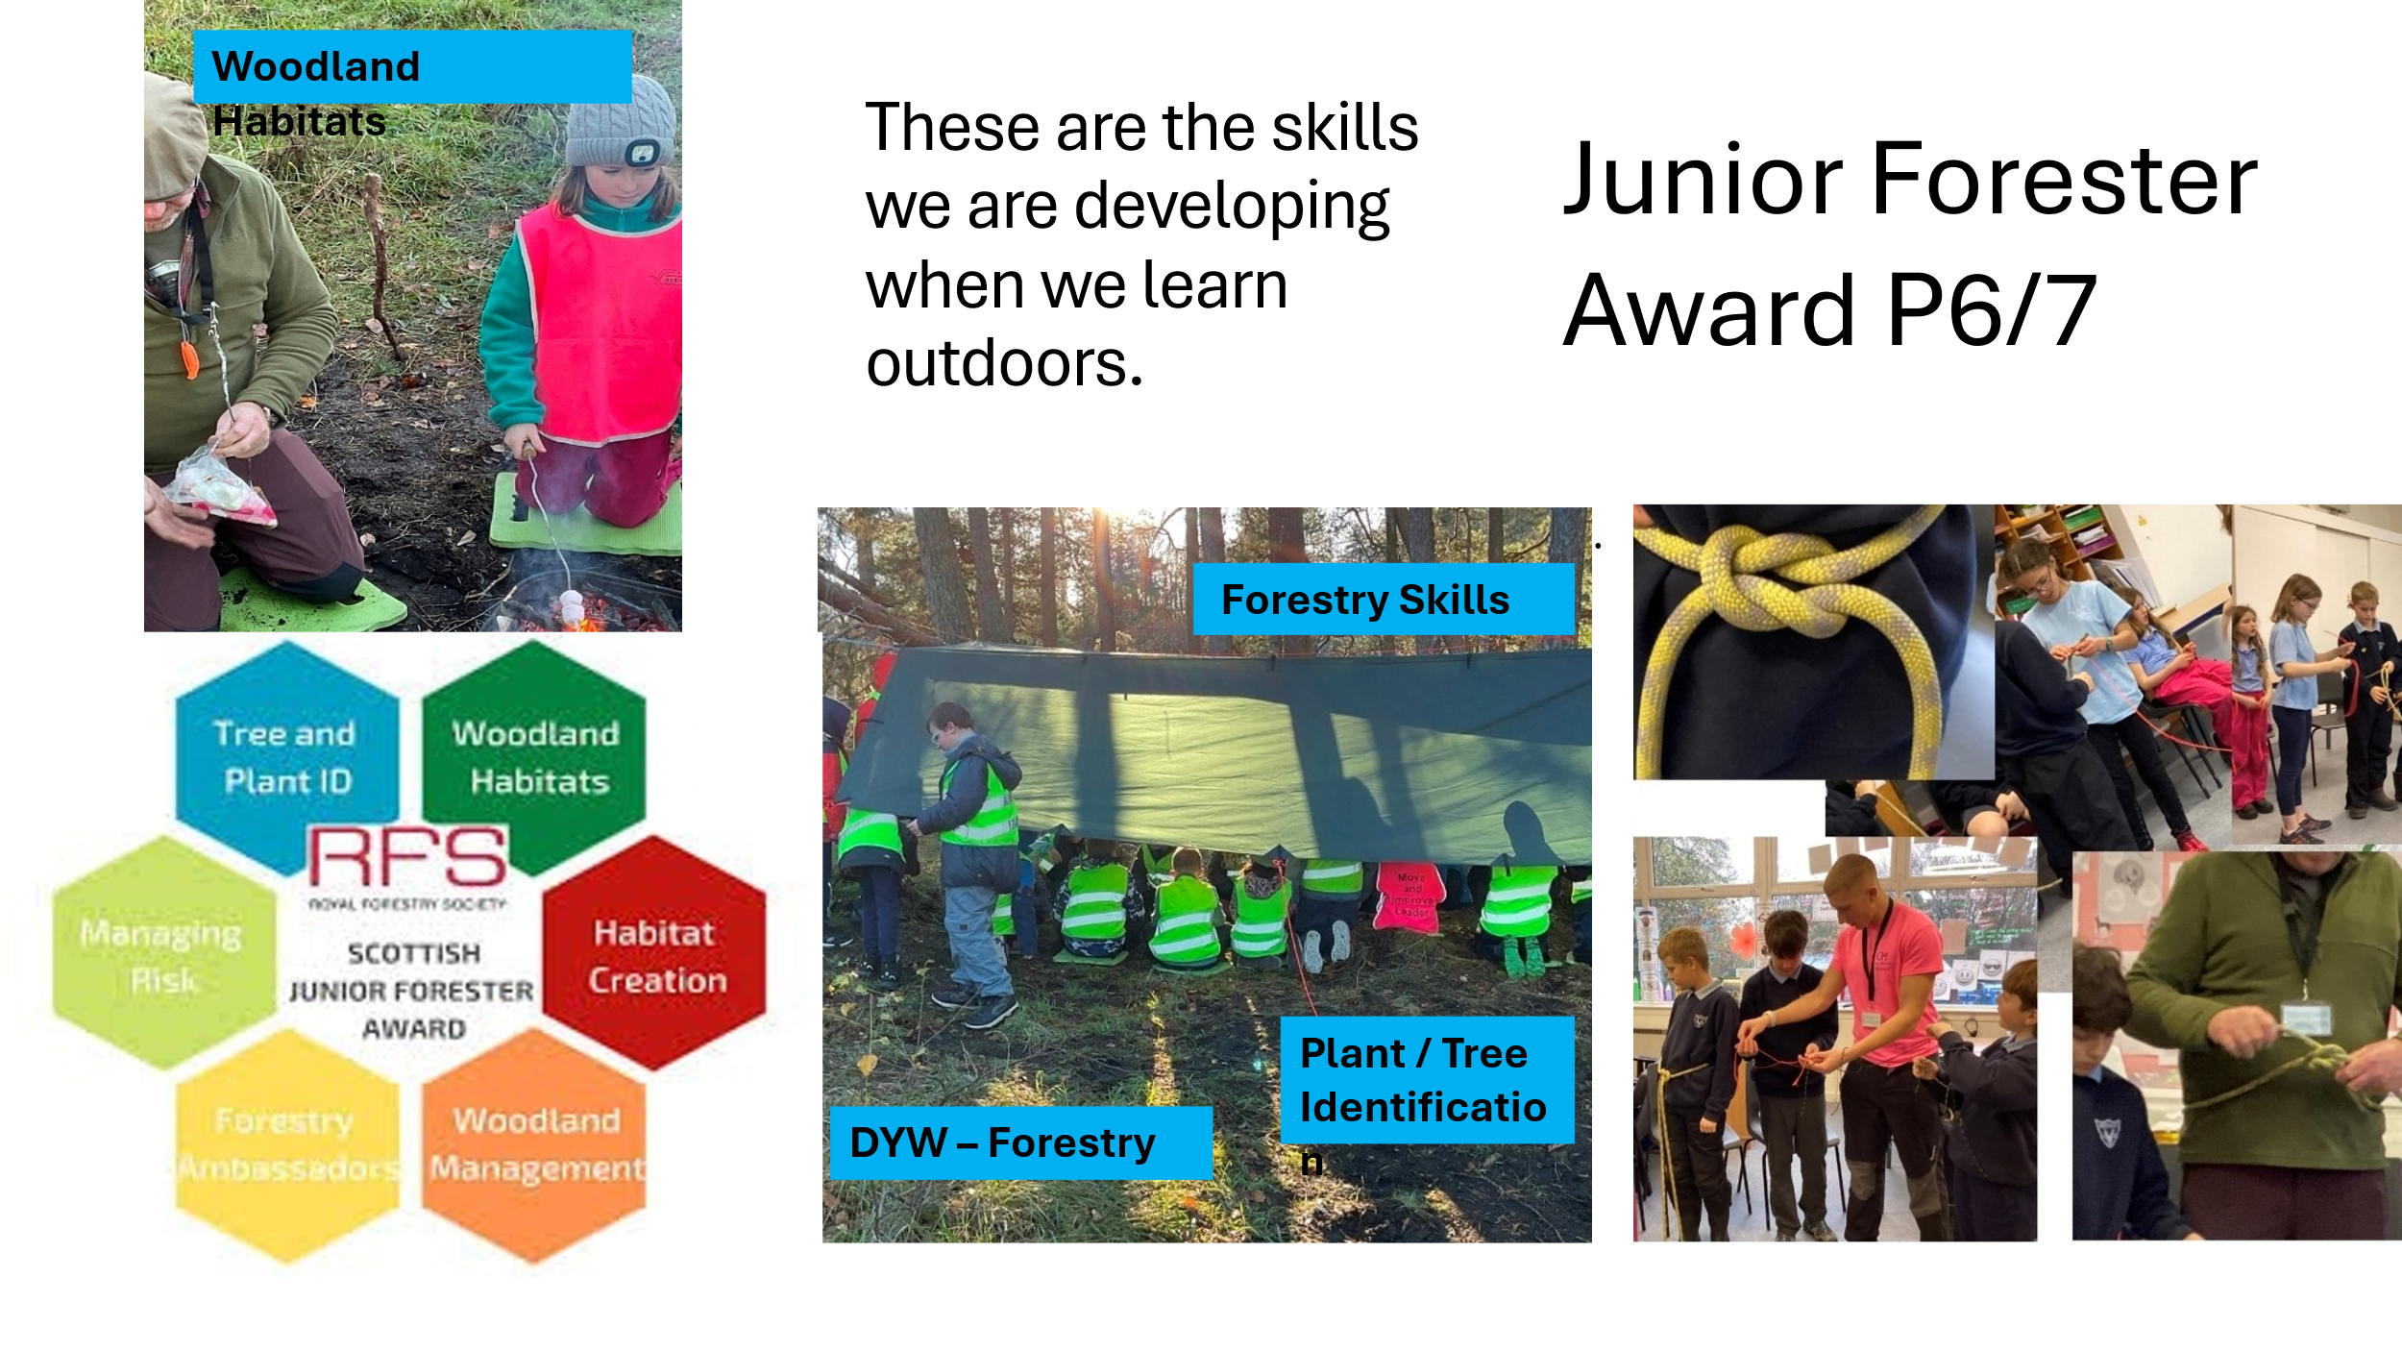
Almost all pupils experience outdoor learning – all classes access outdoors. 2 P6/7 classes have gained the Junior Forester Award.
Next steps include: To timetable outdoor learning consistently for all classes nest session. To continue to embed teaching pedagogy approaches to ensure pace, challenge, clarity, retrieval and feedback.
QI 3.1 Ensuring Wellbeing, Equality & Inclusion | Evaluation | 3 Satisfactory
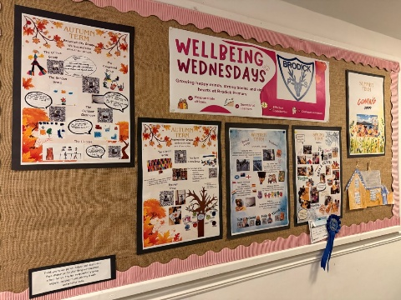
Our Wellbeing Wednesday sessions at Brodick School provide whole school focus on mental/social/physical wellbeing. Pupil voice and choice is included. Pupils enjoy working in mixed age groupings. This is supporting their collaboration and communication skills. Parental involvement has resulted in the sharing and teaching of skilled baking and art learners. Learning has centred around the responsibility of the environment. looking after our mental wellbeing, hobbies and outdoor learning.

PEF money used to fund PSA for one day per week. impact of PSA absence

Children’s needs are being supported through well planned and targeted intervention. Target pupils are identified through effective use of data. Pupi progress is recorded through effective use of T-Charts.
Communication passports highlight individual pupil need. These lay out pupil needs and supports required – all staff know about these passports and use them to support individual pupils.
Staff CLPL and training provided by TST to share interventions, resources and Microsoft Accessibility Tools for supporting pupils –particularly those with literacy difficulties.
Pupil attendance has been closely monitored and parent partnership meetings held. These have led to supports to and intervention for individual pupils. As a result, attendance for several pupils has increased.

All P7 pupils on the island attended a series of lessons at Arran High School. The theme of Positive Masculinity was delivered through the Be Me project and explored topics Understanding Influences, Resilience and communication.

All P7 pupils have participated in Marcus Rashford ‘You are a Champion’ series of learning which centred on theme of developing mental resilience, lifelong learning, and a positive attitude.

Rights Respecting Schools Silver Award was gained Sept 2024. As a result, we can see that almost all learners are aware of their rights and the part we play in ensuring our rights are met. Our next step is to achieve Gold status. A revised Promoting Positive Relationships Policy has been launched and will further support staff to create positive relationships with learners. 2 staff members have been trained to deliver this to the wider school staff through train the trainer approach.

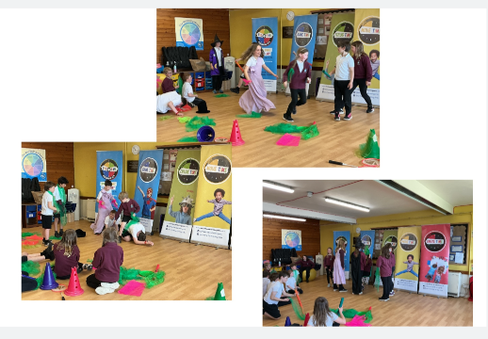
Steps have been taken to plan events that support the geographical isolation of our schools in the island. Examples of this include P4/5 Sho Time drama experiences. Our youngest learners joined together for the highly enjoyable McDougall’s Drama performers. Experience of drama and theatre would not otherwise have been possible.

QI 3.2 Raising Attainment & Achievement | Evaluation | 4 Good
​Our new Tracking and Monitoring system is in its 2nd year of implementation. All pupils are tracked 3 times a year in Oct, Feb and June. Teachers discuss pupil progress together and they are developing a shared understanding of pupil progress. The validity and reliability of data is now more accurate. This is supporting us identify trends and set next steps to raise attainment. Attainment conversations are held. Staff find these useful as they held identify pupils who are on track, not on track and those exceeding expectations. Supports and strategies are then identified to support next steps and ensure progress in learning. Teachers know who their care experienced, looked after and accommodation and Young Carer pupils are and take steps to support them.

​Processes and systems to track and analyse individual and cohort attainment in literacy and numeracy across EYC and P1-P7 cohorts are now established. Increased moderation is improving teacher judgment in making more accurate tracking levels. Teachers meet together with stage partners to moderate evidence and discuss levels achieved. Targeted Support Teacher assessment data shows almost all/ most of pupils working with TST have made expected levels of progress.
We have introduced an Assessment Fortnight 3 times a year. Oct Feb June. This is supporting teacher judgments and is leading to increased confidence in making professional judgements about how well children and young people are learning and progressing. Teachers are using summative assessment data gathered in assessment fortnight along with classwork linked to benchmarks to evidence individual ACEL levels for all learners. We will revise the calendar further to ensure consistency of approach.
Data relating to vulnerable groups and those not meeting expected levels is extracted and used to plan targeted support. T Charts were introduced in session 25-26 to highlight supports required for individual learners. PSAs work alongside pupils in the delivery of T Chart interventions. Progress is shared and recorded. 2 newly appointed Targeted Support Teachers have provided training to PSAs on a range of targeted intervention supports including 5 minute box. All pupils who access the Targeted Support Teachers and PSA support are making progress towards their learning targets.
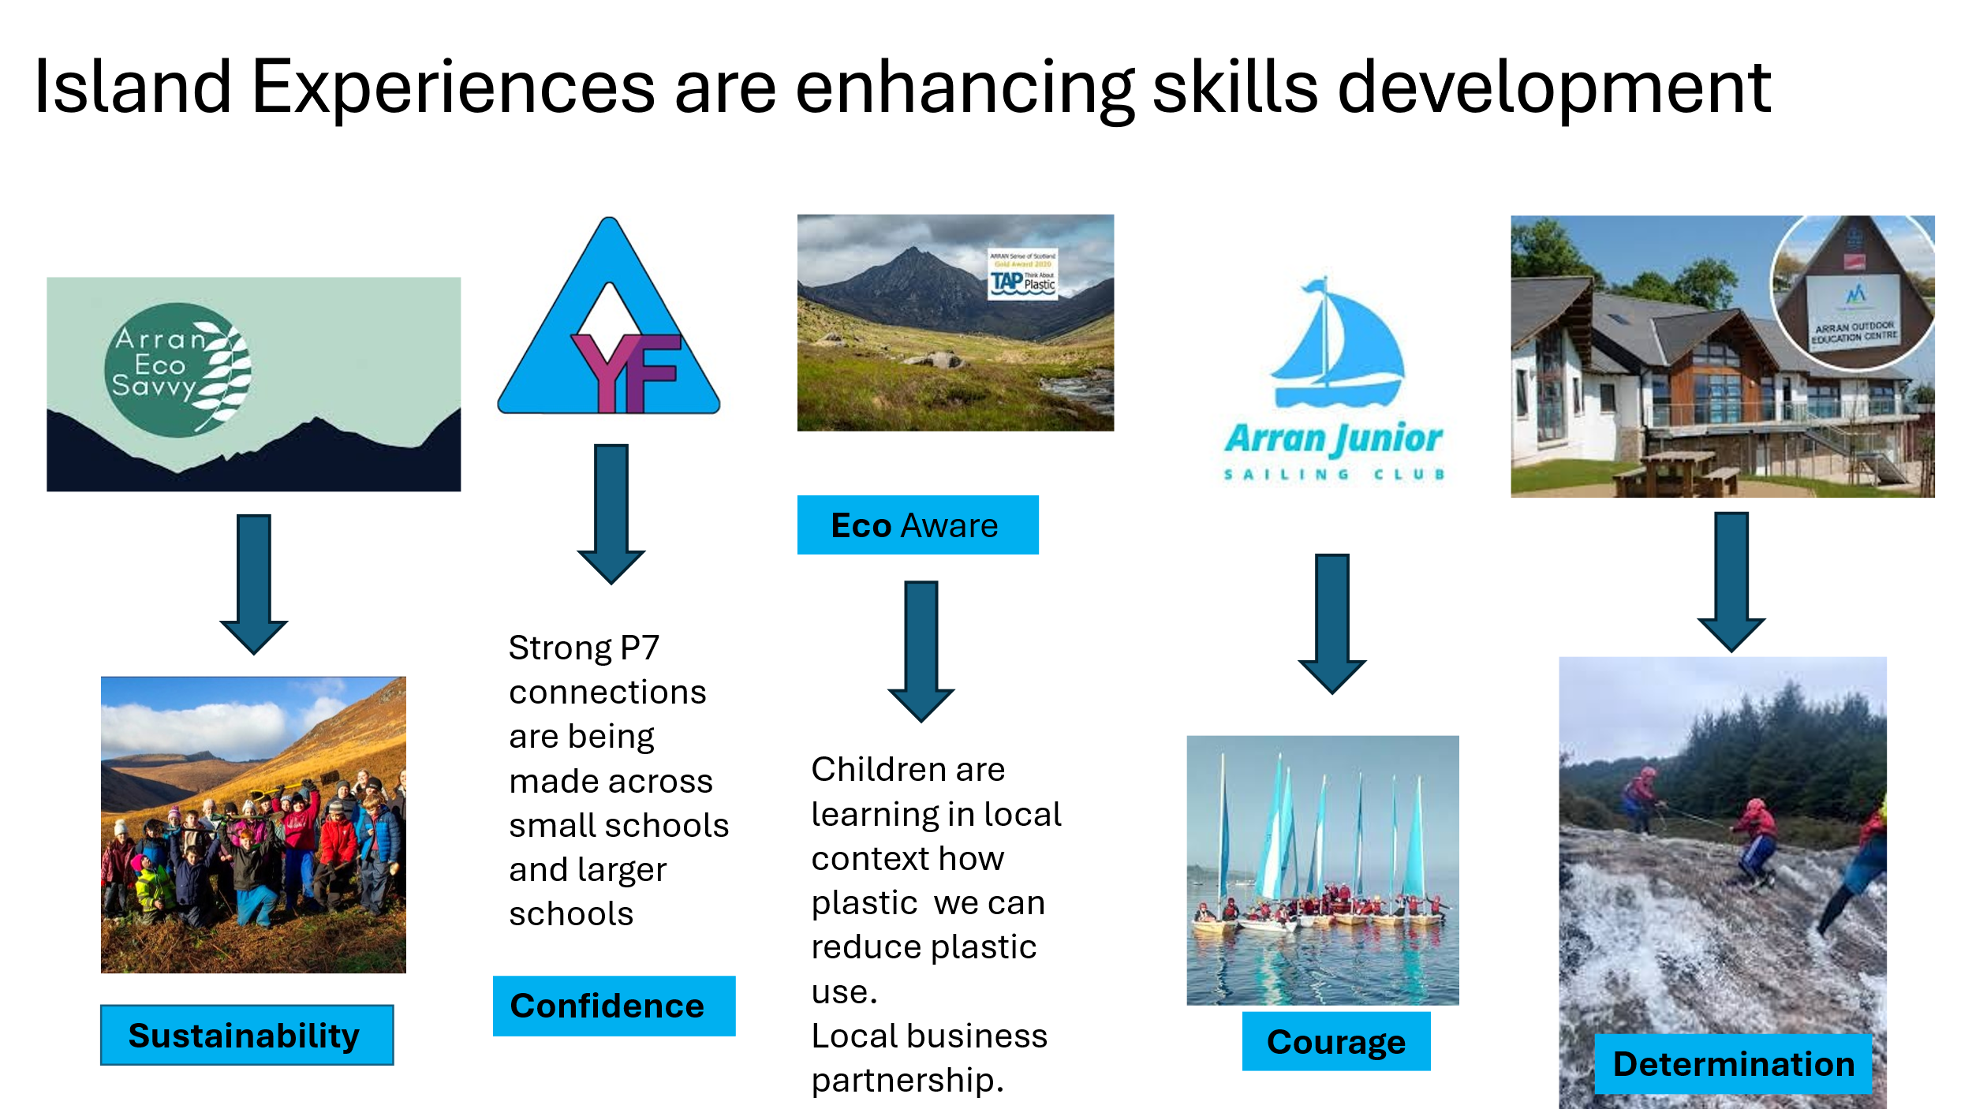
A new Early Years Framework and Trackers was launched this year. As a result, high levels of staff interaction and engagement with the curriculum trackers are leading to confidence among staff. They know individual learning targets and plan high quality provision.
There are high levels of very positive Parental/ Community Engagement. Regular Stay and Play sessions. Library visits. Eco Savy composting project. Montrose House intergenerational project. Learning experiences are enhanced using strong local partnership links.
PUPIL EQUITY FUNDING
Provide evaluative statements about how the school used PEF and what impact this has had on improving outcomes for children and young people.

Our Pupil Equity Fund (PEF), monies allocated by the Scottish Government to help schools close the attainment gap, enabling us to focus on Getting It Right For Every Child. We know our children well and use our pupil equity fund to ensure children are able to make progress in a nurturing learning environment.
In 2025/26 we used PEF for the following:
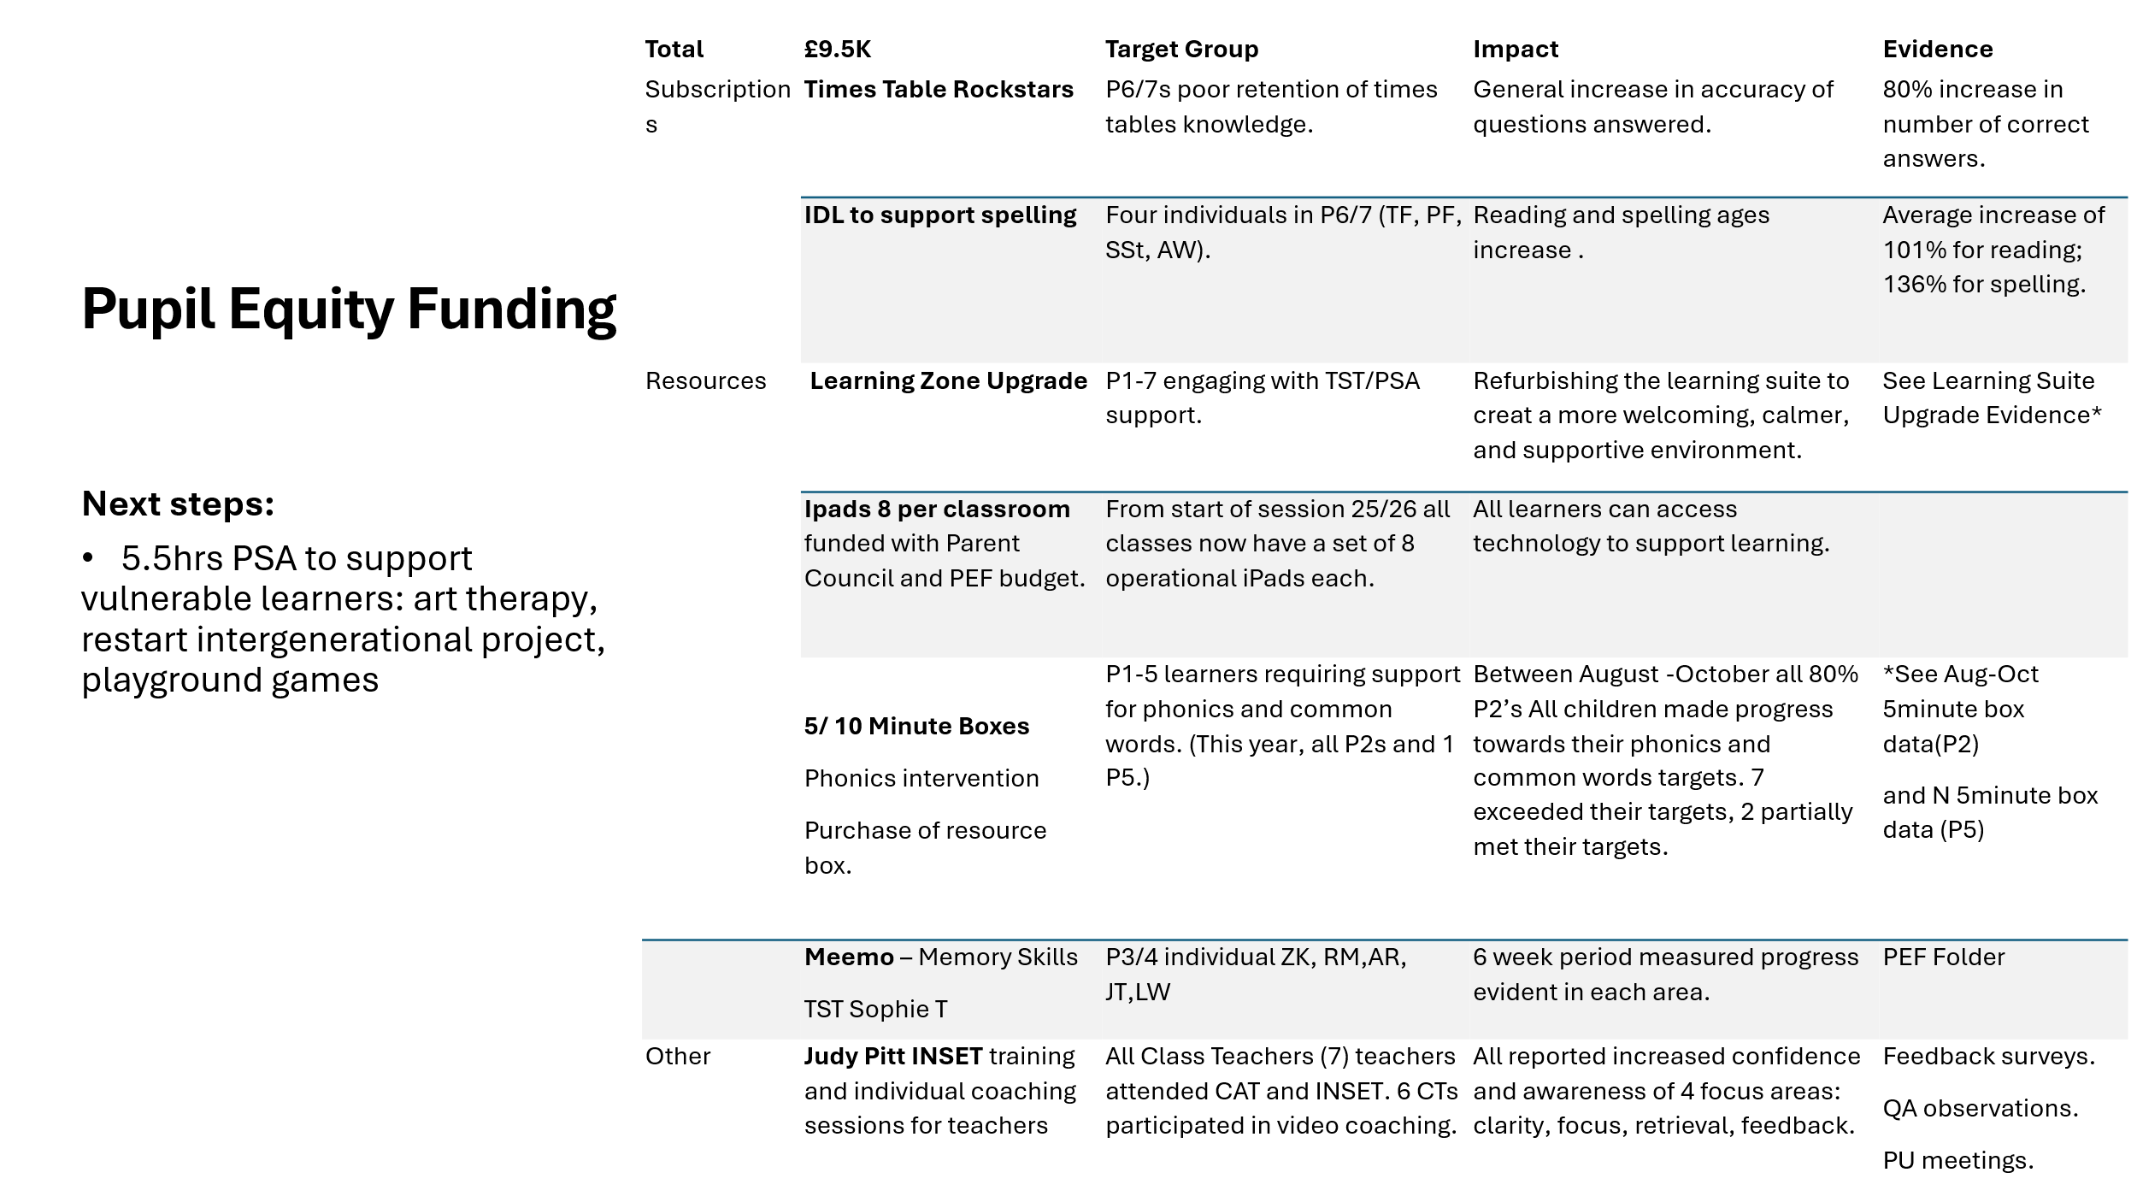
Subscriptions
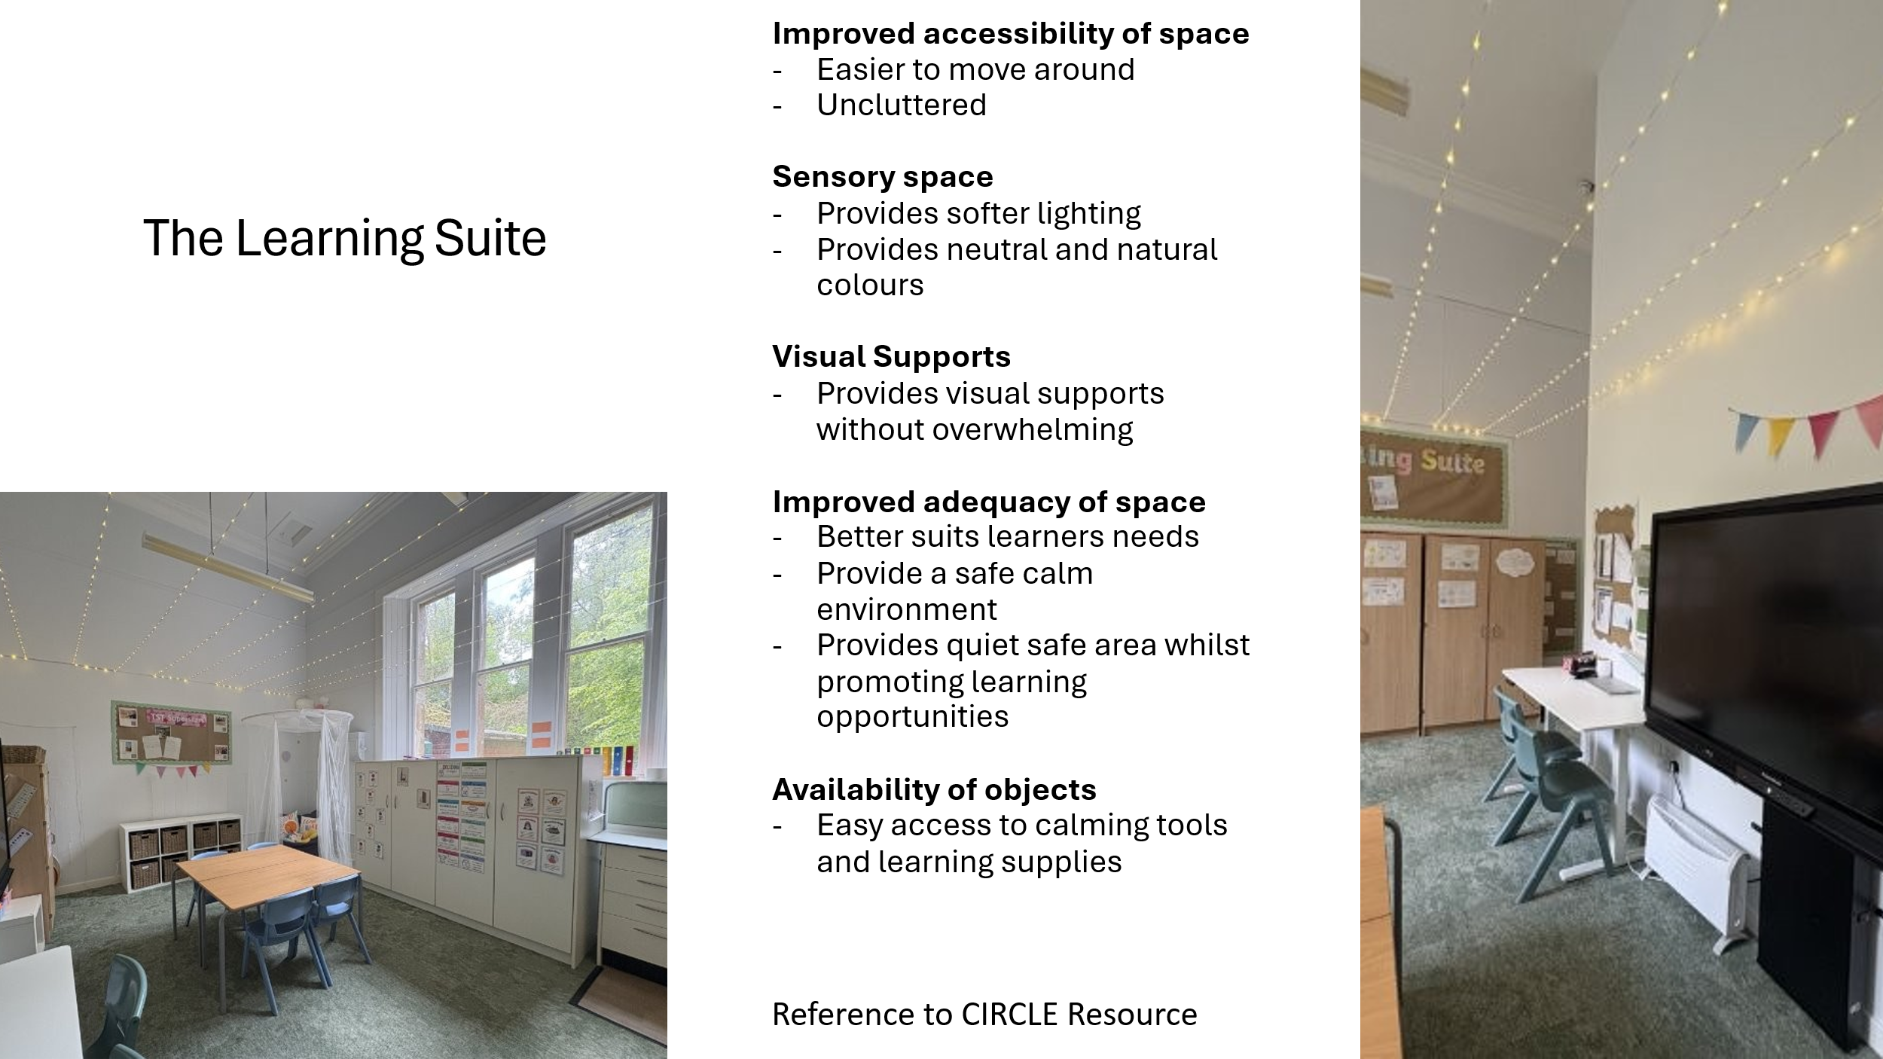
The purchase of software licences is provide exciting and engaging activities for all children to improve Literacy and Numeracy skills e.g. Times Table Rockstars – Target group P6/7s poor retention of times tables. IDL to spelling, Meemo to support memory skills of P3/4 class.
Resources:
2 calm, nurturing learning zone classrooms have been created - The Discovery Room and Learning Zone. All pupils accessing these learning spaces do so willingly. Learning engagement levels are high. All children like using these spaces.
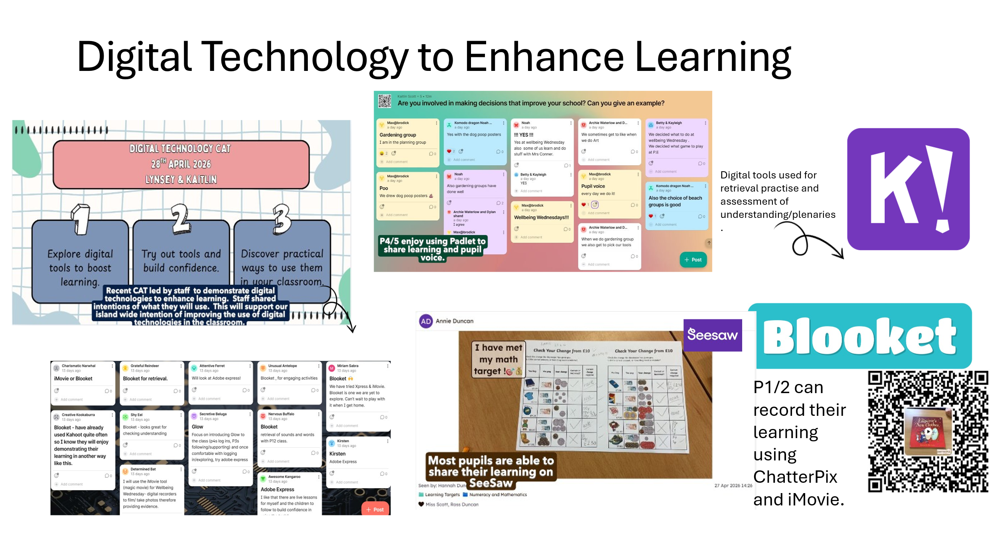
Classrooms across the 6 schools have been upgraded and environments neutralised to support inclusion. All children and staff report the changes are supporting all learners. This work continues.
All learners access digital technology daily. This is enhancing learning, teaching and learn engagement levels. We will continue to invest in digital technology across the 6 schools.
5/10 Minute Boxes​ Phonics – All PSAs have been trained to deliver short intervention work with individual learners. Between August -October all 80% P2’s all identified individual children made progress towards their phonics and common words targets. 7 exceeded their targets, 2 partially met their targets
Training: Almost all Class Teachers attended collegiate and INSET training from Judy Pitt consultant. 6 CTs participated in video coaching. All reported increased confidence and awareness of 4 focus areas: clarity, focus, retrieval, feedback.
Next Steps
Staffing – we have employed a 5.5hrs PSA to support vulnerable learners: children worked on art therapy, restart intergenerational project, playground games

IMPROVEMENT PLAN PRIORITIES 2026-27
PRIORITY 1: Improving learning outcomes for all
Plan 1 - To create a Numeracy Strategy that supports the consistent delivery of numeracy across our settings from EY, P1 to P7. In addition, we will focus on P7 learners and adopt and follow the STEM SPACE numeracy project to raise attainment in P7 learners in Brodick and Whiting Bay Schools.
Plan 2 – To create a Literacy Strategy that supports the consistent delivery of numeracy across our settings from EY, P1 to P7. In addition, we will focus on P4 learners at Whiting Bay and Brodick Schools and adopt and follow the national writing program CYPIC.
PRIORITY 2: Supporting needs, wellbeing, equality and inclusion
Plan 3 - Vision and Values: We will ensure that all learners and staff have high expectations and culture of ambition exists across our schools. This will be reflected in the revised aims and values of our schools. Positive Relationships and Behaviour between pupils and staff will be evident across all EY to P1- P7 settings.
Plan 4 – Outdoor Learning: All learners across EY to P1- P7 settings experience quality outdoor learning lessons as part of regular planned learning time. This will support the delivery of the curriculum and contribute to individual pupil H&WB.
PRIORITY 3: Building a self-improving service
PLAN 4 - Pupils and Staff will lead improvement and change across our schools from EY and P1-P7. These changes will impact positively on our children. There will be planned opportunities for pupils, staff and parents to engage in the self-evaluation of key focus areas: Maths, pupil H&WB.

