Name_____________ Date________

**Self reflection** questions

**VOLLEYBALL** performances

Consider the following questions and tick the appropriate box ✓

|  |  |  |  |  |
| --- | --- | --- | --- | --- |
|  | Always | Usually | Sometimes | Never |
| **Physical Factors** |  |  |  |  |
| Are my skills performed accurately? |  |  |  |  |
| Are my skills performed with consistency? |  |  |  |  |
| Do I know what to do tactically? |  |  |  |  |
| Is my communication with team mates clear? |  |  |  |  |
| Do I move quickly with control? |  |  |  |  |
| **Mental Factors** |  |  |  |  |
| Am I able to concentrate for the full performance? |  |  |  |  |
| Do I give my best for the full performance? |  |  |  |  |
| Do I make the right decisions? |  |  |  |  |
| **Emotional Factors** |  |  |  |  |
| Do I get nervous about my performance? |  |  |  |  |
| Do I feel confident about my performance? |  |  |  |  |
| Do I continue to give 100% even after an error? |  |  |  |  |
| Am I able to stay calm? |  |  |  |  |
| **Social Factors** |  |  |  |  |
| Do I follow the rules of the game? |  |  |  |  |
| Do I work well with my team mates to achieve success? |  |  |  |  |

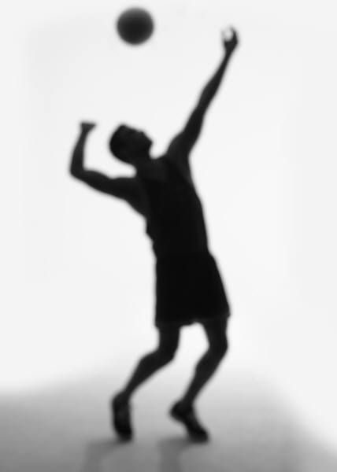Name_______________ Date_________

**Observer reflection** questions

**VOLLEYBALL** performances

Consider the following questions and tick the appropriate box ✓

|  |  |  |  |  |
| --- | --- | --- | --- | --- |
|  | Always | Usually | Sometimes | Never |
| **Physical Factors** |  |  |  |  |
| Are skills are performed accurately? |  |  |  |  |
| Are skills are performed consistently well? |  |  |  |  |
| Does the performer knows what to do tactically? |  |  |  |  |
| Is communication with team mates is clear? |  |  |  |  |
| Does the performer move quickly with control? |  |  |  |  |
| **Mental Factors** |  |  |  |  |
| Is the performer able to concentrate for the full performance? |  |  |  |  |
| Does the performer give their best for the full performance? |  |  |  |  |
| Are appropriate decisions made? |  |  |  |  |
| **Emotional Factors** |  |  |  |  |
| Does the performer appear to get nervous during their performance? |  |  |  |  |
| Does the performer appear confident about their performance? |  |  |  |  |
| Does the performer continue to give 100% even after errors? |  |  |  |  |
| Is the performer able to stay calm? |  |  |  |  |
| **Social Factors** |  |  |  |  |
| Are the rules of the game are followed? |  |  |  |  |
| Does the performer work well with team mates to achieve success? |  |  |  |  |

Please comment on any specific area of the performance; __________________________________________________________________________________________________________________________________

Name_______________ Date_________

**General Observation Schedule**

The following observation schedule should be completed by someone in your class or your teacher – They **need to be aware of the success criteria** for each skill so that they can make an effective judgement on the success of the action. This ensures greater reliability.

**Place a tick**  **in either the successful or unsuccessful column each time the skill is performed.**

C**alculate your percentage of success** and discuss the results.

|  |  |  |  |
| --- | --- | --- | --- |
| Skill/technique | Successful | Unsuccessful | % of success |
| **Serving** |  |  |  |
| Underarm |  |  |  |
| **Attacking** |  |  |  |
| Tip |  |  |  |
| Spike |  |  |  |
| Attack volley |  |  |  |
| **Defending** |  |  |  |
| Dig pass |  |  |  |
| Volley pass |  |  |  |
| **Setting** |  |  |  |
| Volley pass |  |  |  |
| Dig pass |  |  |  |
| **Court movement** |  |  |  |

Name_______________ Date_________

**Specific Observation Schedule - Spike**

The following observation schedule should be completed by someone in your class or your teacher. Watch the performer repeatedly and then **only** **tick the criteria that are consistently carried out (most of the time) by the performer.**

**Criteria that are left blank will highlight areas that need attention to make the whole skill more successful.**

|  |  |  |
| --- | --- | --- |
| Phase of action | Model performance criteria | My performance |
| **Preparation** | * Approach begins when ball is half way to you * Last two steps are right/left - jump or left/right wing back * Plant heels, – jump * Both arms s knees bent * Swing arms forward and up * Push up into air |  |
| **Action** | * Contact ball with fully extended arm * Contact ball in front of hitting shoulder * Contact ball with heel of the hand * Contact ball on lower back * Roll fingers over the top of the ball * Flex wrist as fingers roll |  |
| **Recovery** | * Eyes on ball throughout contact * Bend knees on landing |  |

Name_______________ Date_________

**Specific Observation Schedule -Volley**

The following observation schedule should be completed by someone in your class or your teacher. Only t**ick the criteria that are consistently carried out (most of the time) by the performer. Criteria that are left blank will highlight areas that need attention to make the whole skill more successful.**

|  |  |  |
| --- | --- | --- |
| Phase of action | Model performance criteria | My performance |
| **Preparation** | * Move to the ball and square shoulders to the target * Feet shoulder width * Bend arms and legs * Hands held 6 inches above forehead – fingers spread * Look through the “window” formed by hands |  |
| **Action** | * Contact ball at its “lower back” * Receive ball into fingers and thumbs * Extend arms and legs toward target * Push through the ball in one movement |  |
| **Recovery** | * Continue to extend arms fully * Hands finish pointing at target * Transfer weight toward target |  |

Name_______________ Date_________

**Specific Observation Schedule - Dig**

The following observation schedule should be completed by someone in your class or your teacher. Only t**ick the criteria that are consistently carried out (most of the time) by the performer. Criteria that are left blank will highlight areas that need attention to make the whole skill more successful.**

|  |  |  |
| --- | --- | --- |
| Phase of action | Model performance criteria | My performance |
| **Preparation** | * Move to ball and join hands together * Feet shoulder width apart one in front of other * Body low with knees bent * Extend arms - forearms facing up – Thumbs run parallel * Lock out elbows * Back straight * Eyes track the ball towards forearms |  |
| **Action** | * Receive ball in front of body * Extend legs * No arm swing * Transfer weight forward * Contact ball away from body * Slant arm “platform” toward target * Watch ball contact arms |  |
| **Recovery** | * Keep hands joined * Elbows remain locked * “Platform” follows ball to target * Transfer weight toward target * Watch ball to target |  |

Name_______________ Date_________

**Specific Observation Schedule - Serve**

The following observation schedule should be completed by someone in your class or your teacher. Only t**ick the criteria that are consistently carried out (most of the time) by the performer. Criteria that are left blank will highlight areas that need attention to make the whole skill more successful.**

|  |  |  |
| --- | --- | --- |
| Phase of action | Model performance criteria | My performance |
| **Preparation** | * Feet in “comfortable stride” position * Weight evenly distributed * Shoulder square to net * Hold ball at waist height * Hold ball in front of body * Use open hand * Eyes on ball |  |
| **Action** | * Swing arm back * Transfer weight to rear foot * Swing arm forward * Transfer weight to front foot * Contact ball with heel of hand at waist height * Contact ball below the centre at the back |  |
| **Recovery** | * Swing hand forward in direction of the net * Transfer weight fully to front foot * Move onto the court |  |

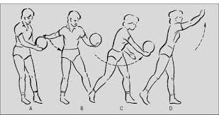Name_______________ Date_________

**Specific Observation Schedule - Block**

The following observation schedule should be completed by someone in your class or your teacher. Only t**ick the criteria that are consistently carried out (most of the time) by the performer. Criteria that are left blank will highlight areas that need attention to make the whole skill more successful.**

|  |  |  |
| --- | --- | --- |
| Phase of action | Model performance criteria | My performance |
| **Preparation** | * Focus on the attacker * Wait with hands at shoulder level * Spread fingers * Knees bent and begin to raise hands |  |
| **Action** | * Jump just after attacker jumps * Hands shoulder width apart * “Penetrate” into opponent’s court * Withdraw hands after contact * Return to floor on both feet |  |
| **Recovery** | * Bend knees on landing * Turn away from net to look for ball |  |

[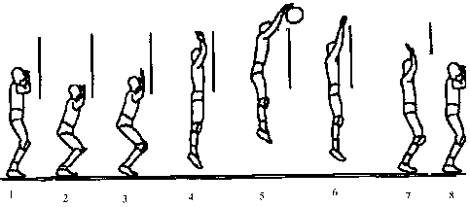](http://www.google.com/url?sa=i&rct=j&q=&esrc=s&frm=1&source=images&cd=&docid=jSzaKFEtrxqoMM&tbnid=YIx4wR0zIDYkSM:&ved=0CAUQjRw&url=http://www.sportunterricht.de/lksport/kuarbeit1.html&ei=RrmFU_vxNIG27QbghoCICw&bvm=bv.67720277,d.ZWU&psig=AFQjCNEGB0owKgeXGNZmiyPW2PxOELXwSg&ust=1401358959793043)Name_______________ Date_________

**Specific Observation Schedule - Tip**

The following observation schedule should be completed by someone in your class or your teacher. Only t**ick the criteria that are consistently carried out (most of the time) by the performer. Criteria that are left blank will highlight areas that need attention to make the whole skill more successful.**

|  |  |  |
| --- | --- | --- |
| Phase of action | Model performance criteria | My performance |
| **Preparation** | * Approach begins when ball is half way to you * Last two steps are right/left - jump or left/right – jump * Both arms swing back * Plant heels, knees bent * Swing arms forward and up * Push up into air |  |
| **Action** | * Contact ball with fully extended arm * Contact ball in front of hitting shoulder * Fingertips only * Contact ball on lower back half * Direct ball over the net to drop |  |
| **Recovery** | * Keep eyes on ball throughout contact * Bend knees on landing |  |