Music Apps and Online Musical Resources for Children with ASN
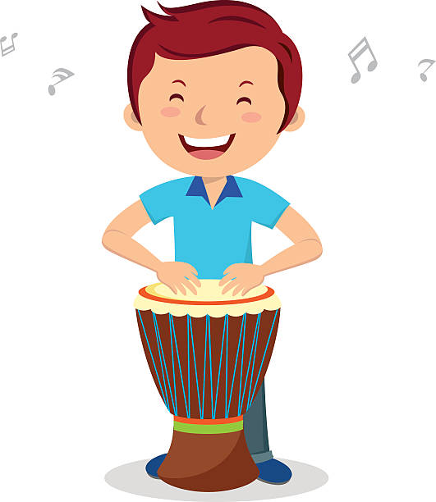
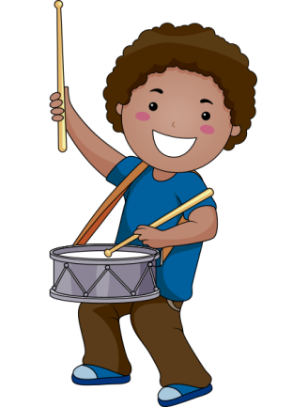
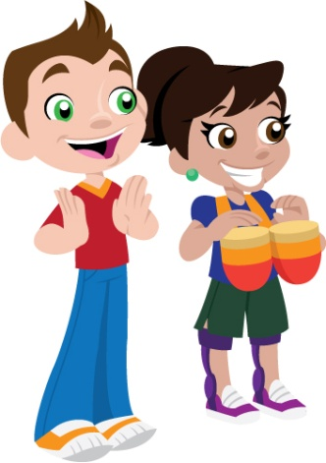

Music-making Apps and Resources
- Loopimal – fun and accessible app for iPhone/iPad which teaches children how to make music through building sounds using animals and loops.
- Bandimal – another fun creative music composer, for iPhone/iPad.
- Loopesque Kids – circular piano/looping wheel with engaging sensory graphics, patterns and peaceful sounds.
- GarageBand – powerful app for iPhone and iPad that features a range of musical instruments and a recording studio, so you can create your own music.
- Music Maker Jam – similar to GarageBand, but for Android users.

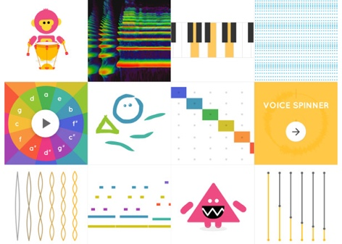
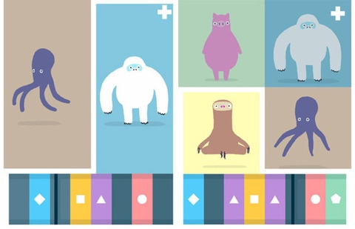
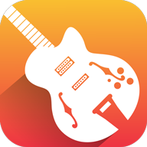

- Chrome Music Lab – very accessible range of sensory music-making experiments which work with Google Chrome browser across all platforms, making music learning fun.

- Teaching Music with GarageBand for iPad: community edition – a free resource for teachers, parents and carers who want to make music and get creative over the next few months. (A higher level of cognitive processing is needed for this resource).

Musical Instrument Apps
- Mini Piano Lite – simple free piano app for Android with a range of sounds.
- Finger Piano Plus – free piano app for iPhone and iPad with a range of sounds and songs to play along to.
- Kalimba Real – kalimba (African thumb piano) app for Android.
- Kalimba Real – Kalimba (African thumb piano) app for iPhone/iPad.
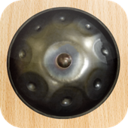
- Hang Drum – hang drum app for Android.
- Hang Drum – hang drum app for iPhone/iPad.
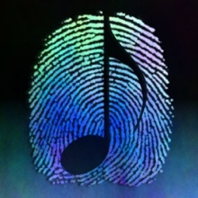

- ThumbJam – powerful app for iPhone/iPad with a wide range of real instrument sounds which you can play in a broad variety of styles.
- DrumJam – percussion and drum sounds to explore for iPhone/iPad.
- REAL DRUM – drum-kit app for Android.
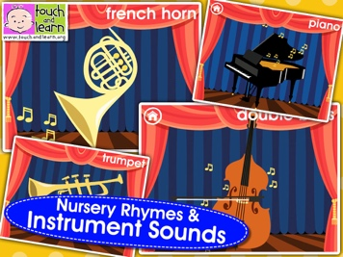
- Bebot – friendly animated robot synth.
- Peekaboo Orchestra Lite – an introduction to the instruments and sounds of the orchestra for children. Available for iPhone/iPad and Android.

Sensory Music Apps
- Bloom – calming visualisations and soundscapes created by ambient composer Brian Eno. This version is for iPhone/iPad.
- Bloom: 10 Worlds – this version of Bloom (see above) is for Android.
- Singing Fingers – app for iPhone/iPad which explores finger-painting with sound.

- Gravitarium – beautiful particle animation patterns and sounds created through touch. For iPhone/iPad.

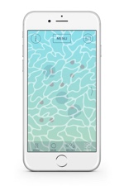
Music and Wellbeing
- Cove – an app that allows you to create music to capture your mood and feelings. Like a mood journal but using music instead of words to express how you feel. Currently being trialled in the NHS.

Nursery Song Apps
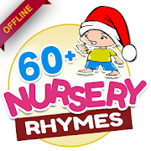
- Storybook Rhymes Volume 1 – free interactive app featuring favourite nursery rhymes, available for iPhone and iPad.
- Nursery Rhymes Free App – app featuring over 60 nursery rhymes, available for Android.

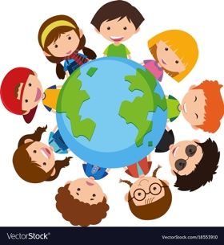
Song Resources
- Beth’s Notes Plus: Find Songs – fantastic, well laid-out resource of songs, grouped into a wide range of categories.
- Mama Lisa’s World – Children’s songs and rhymes from around the world.

Music Concerts and Performances
*Check the location/time zones of live-streamed concerts to calculate the UK start time. Time Zone calculator
- Concerts online - Various concerts held without audiences to stream online for people having to stay at home - list of live streaming concerts
- Free Opera - Dates confirmed until the end of March. Check the website via the link for future dates to be added.
- Free Chamber music - Live streaming.
- Berlin Philharmonic orchestra - Live streams and performance archive.
- Announcements/lists - of worldwide performances being streamed.
- Livestream concerts list - artists and bands.
- Bands and artists - streaming performances.
- Full-length concerts - watch online free.
- Celebrities performing on social media.
- Facebook Virtual Choir - Duet with a choir online.

