PE
Warm Up
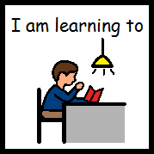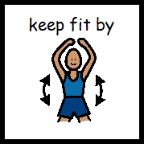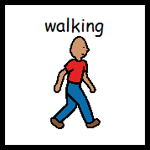
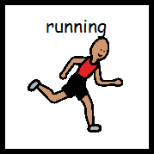
- Encourage putting their hand to their chest to experience their resting heart rate.
- Begin by walking. We usually walk for the length of a pupils choice of song(Eye of the Tiger, 99 Red Balloons, 500 Miles, are a few examples of music used in the past but anything goes!)
- When song finishes move onto running, again for the length of a song.
- Encourage putting hand to chest again to experience heart rate again now that they have warmed up.

Ball Skills
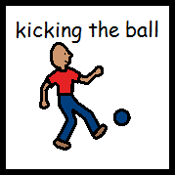
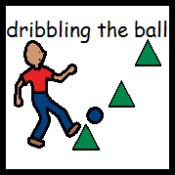
Kicking the ball
- Small kicks – for short distances. Repeat 5 times.
- Big kicks – for long distances. Repeat 5 times.
- Set up a target or goal and encourage pupil to kick to the target or goal. Repeat 5 times.
- Kick the ball back and forth to another person. Repeat 5 times.
- Set up 5 or 6 cones or markers of any kind. Dribble the ball through the cones or markers 5 times.
- Put the skills together, dribbling the ball through markers then scoring a goal. Repeat 5 times.

Cool Down
Cool Down
- Running. Again for the length of a song.
- Walking. Again for the length of a song.

