Leaf Maths
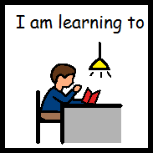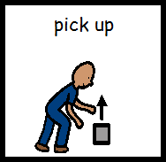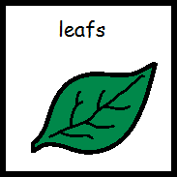
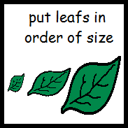
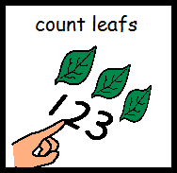
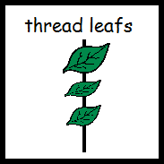
Leaf Maths

- Go out for a long walk

- Collect leafs – lots of different shapes and sizes

- When you get home put the leafs in order of size

- Count the number of leafs you have collected

- Thread leafs onto string or a shoe lace or ribbon or similar to make leaf bunting.
This develops hand eye coordination and pincer grip of fingers

