Sensory Workout
I am learning about the days of the week through my senses.
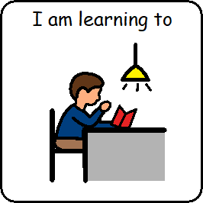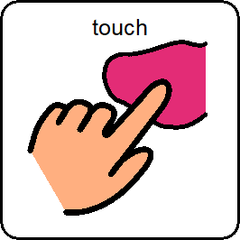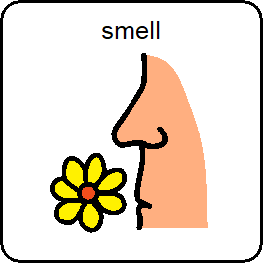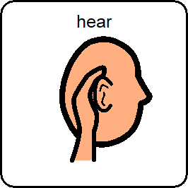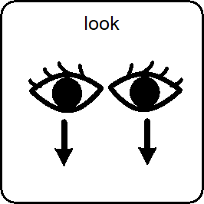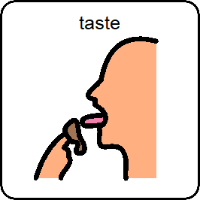
- Each morning the girls participate in a sensory workout.
- There is a taste, touch, smell, sound and colour in a box for each day of the week.
- The same taste, touch, smell, sound and colour is explored on the same day of the week each week.
- This is building up an awareness that there is a certain taste, touch, smell, sound and colour for that particular day and it the same experience on that day each week.
- Please exchange any of the items in the table for whatever you have at home and make up your own box for each day consisting of a smell, taste, sound, touch and something to look at.
Sense  Day | Sight -  Colour | Touch | Sound | Taste | Smell
Monday | Pink | Rough | Whistle | Blackcurrant | Blackcurrant
Tuesday | White | Cold | Bell | Apple | Apples
Wednesday | Blue | Hot | Drum | Orange | Oranges
Thursday | Silver | Smooth | Maraca | Summer Berries | Strawberry
Friday | Yellow | Squashy | Xylophone | Lemon | Lemon

