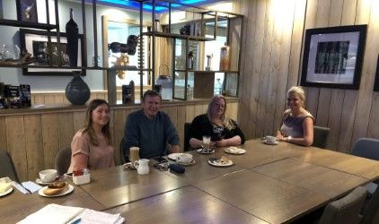

Recently we hosted three drop in meetings for the new ASN campus and we were pleased to be joined by some of our families and partners. Over a coffee and a sandwich we were able to discuss how plans for the new school were progressing and get some suggestions and ideas. I wanted to share with everyone what was discussed with those who attended.

JUNE 2019

 ASN CAMPUS ‘COFFEE AND CONVERSATION’ FEEDBACK

**Points raised:**

* We had some discussion around naming our school. Most parents felt it should be something completely different, as should the uniform. Suggestions for names will be sought from everyone in the near future including our young people. Suggestions will then be put to elected members. We will invite uniform companies to our next meetings to see what is available.
* Some parent raised concerns around safety and security in the school grounds. Suggestions were made around fire doors. A representative from the planning team will be invited to the next meeting to answer questions in more depth.
* We discussed start and finish times as these vary among the present schools. Suggestions were made regarding a staggered day and a junior and senior timetable. Consideration will be given to this and we will see what is feasible.
* Everyone is very keen for the building to be used to support our families’ outwith school hours. Parents would like to participate in after school family clubs and have opportunities to access the facilities such as the swimming pool and sensory rooms.
* Some parents are looking for volunteers to establish a fundraising group across the schools.
* Communication was raised as a concern. In addition to the campus twitter and website, a campus school app will be offered in the new session to allow consistent communication to be shared.
* Potential services in the new school were discussed. Parents would like there to be support from trained medical staff as opposed to

ipsum dolor

* Children missing out as there are a wider range of needs to be met.
* Timings of the day in the new school.
* Transportation of children if they have longer to travel.

Please come along to our next ‘Coffee and Conversation’ in the new session and contribute to your child’s school and explore these in more detail. Date and time will be posted on our twitter page:

**@ NAC_asncampus**

**TOP THREE THINGS PARENTS ARE EXCITED ABOUT..**

**THREE THINGS PARENTS ARE MOST WORRIED ABOUT..**

* A new state of the art building!
* Links with Auchenharvie and opportunities for challenge and support to achieve more.
* Potential opportunity for their child to be more active in their learning as a better environment with more staff can potentially offer more.

first aiders. Access to speech and language and physio would be welcomed.

* Parents would appreciate if family learning support and counselling services could be offered. They have heard of this being effective in other schools and would like this to be considered. Mrs Rose has arranged a meeting with the Family Learning Team to pursue this. It has now been decided that counselling support will be provided.
* Specialist subject staff in the new school are viewed as being important and this will be part of future staffing discussions.
* Current transport arrangements were discussed and suggestions for improving experiences for our children and young people in the future were aired. More planning and consultation for this will take place at a later date and communication will follow.
* We discussed furniture and resources currently used in school. Parents would like Items that were fundraised or gifted to be transferred.