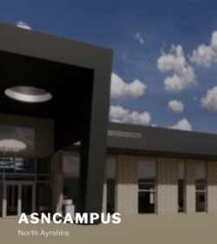

## Follow us on twitter @NAC_asncampus

May 30th

Drop in from 7 – 9 p.m. at Corsehill Primary School, Kilwinning for a cheese and wine.

Drop in from 11- 1.00 p.m for a coffee and sandwich at the Riverside Hotel Irvine.

Drop in from 12-2.00 p.m. for a coffee and a hot roll at the Brisbane Hotel Largs

May 22nd

I would like to let everyone know that I have officially taken up post as the Head Teacher for the new school. Over the last few weeks I have been spending time across all of our ASN schools meeting staff and your children. What an absolute pleasure that has been and I feel privileged to be working with such a fantastic team of children, young people and adults. Remembering everyone’s names at the moment is still tricky!

What I would really like to do now is to have an opportunity to meet with as many of you as I can. I feel, as I am sure you do too, there is lots to chat about! Over a coffee I’d like to update you on the build and listen to your views about the new facilities the school will have, the transport of our children, additional services to have, future events, further parent engagement, investing in a school app and not forgetting the name for our school. Opposite I have listed some times and locations for us to meet up. I have tried to use a variety to hopefully suit as many of you as possible. If you are able to come along to a meeting it would be very much appreciated.

Welcome Everyone

NAC ASN CAMPUS

# Your Views Matter!

# Please take the opportunity to discuss the way forward!

If you can come along, please contact your child’s current school to help me confirm numbers for catering purposes. Look forward to seeing you!

June 5th

### Calendar

This newsletter is to inform families, friends and carers about the progress we are making towards moving to our new school.

PARENTAL ENGAGEMENT NEWSLETTER 1

May 2019