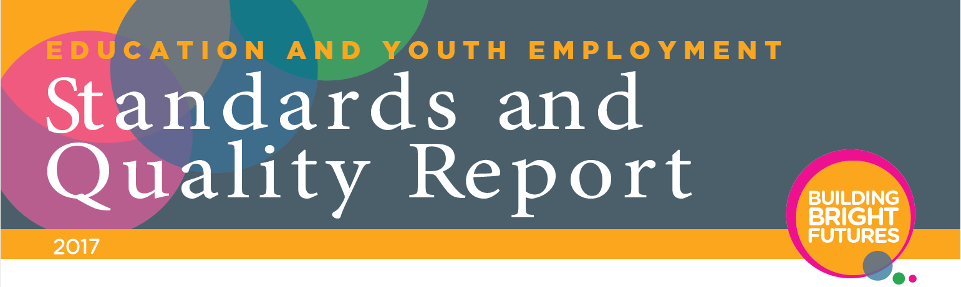

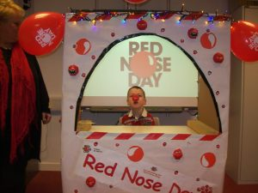**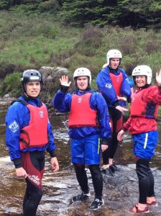**

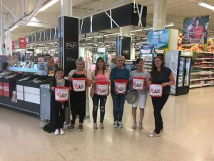**Haysholm School**

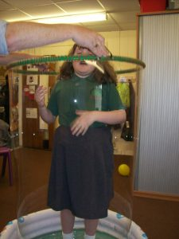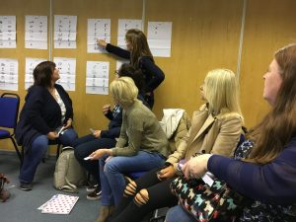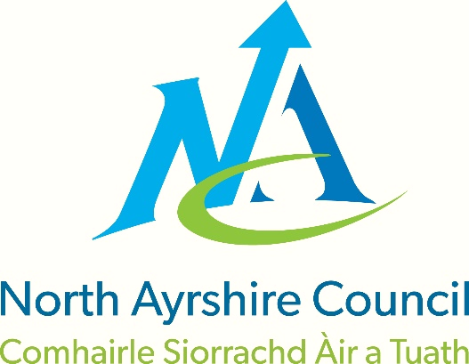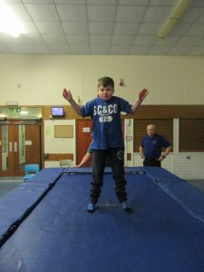



[SCHOOL BADGE]

|  |  |  |  |  |  |
| --- | --- | --- | --- | --- | --- |
| **I:\ESPUBLIC\Edadmin\Logo\NAC_LOGO_2014_FULL_COLOUR.jpg** | **North Ayrshire Council** | | | |  |
| **Education & Youth Employment: Standards & Quality Report** | | | |
| **Establishment:** | HAYSHOLM SCHOOL | **Session:** | 2017/18 |

|  |
| --- |
| **Our school:**  Haysholm is a non-denominational school for pupils aged 5-18 with severe and complex additional support needs. We are part of the Irvine Royal Integrated Community School cluster. Our catchment area extends to the Garnock Valley.  Our current role is 25, 18 primary aged pupils and 7 secondary aged pupils all of whom have a SEEMIS wellbeing assessment and an Individual Educational Programme. The needs of children attending our school are wide ranging with over two thirds now having a diagnosis of Autism Spectrum Disorder. 37.5% of our learners are in receipt of a clothing grant.  The staffing consists of a Head Teacher, Principal Teacher, 5 teachers, 1 instructor, 3 Early Year’s Practitioners and 11 Classroom Assistants. A Senior Education Support Assistant, a Janitor, cleaner and a Catering assistant also contribute to the smooth running of the school. Active Schools Instructors and North Ayrshire Leisure support health and wellbeing activities. We have established curricular links with other schools, which promote all aspects of social inclusion. As well as having close links with the community and local businesses, we have a strong Parent Council. A multi-disciplinary team of visiting professionals supports our children, parents and staff.  The accommodation is all on one level. All areas are fully accessible by everyone. The school grounds are extensive and have been developed to ensure our learners have access to rich outdoor learning experiences.  Our vision is based on ensuring our children and young people develop the skills to enable them to be as functionally independent as possible and to be fully included and accepted in the community in which they live and learn. To this end, communication and maximizing independence lies at the heart of our curriculum to ensure that learners are empowered to exercise the right to be able to make choices and understand and make sense of the world around them. A significant aspect of this work is for our children to be able to transfer communication and life skills to their home environments and relevant real-life contexts within the local community. |

**How successful has the school been at improving excellence and equity?**

*The positive behaviour course in school was good as a refresher and to get you thinking, take in new information and pass it on to kids and staff.*

*Classroom Assistant*

*The positive behaviour course has helped upskill our less experienced staff on the use of proactive strategies and the importance of protocols.*

*Early Year’s Practitioner*

|  |  |
| --- | --- |
| **School Priority 1: Continuation of a culture based on GIRFEC and use of wellbeing indicators to drive improvements and improve outcomes for our children and young people.** | |
| National Improvement Framework Priority  Improvement in children and young people’s health and wellbeing | How Good is Our School? (version 4) Quality Indicator  2.1 Safeguarding and child protection  3.1 Ensuring Wellbeing, equality and inclusion |
| Progress, impact and evidence:  Our children and young people are kept safe. There is a strong, robust and proactive response from staff when concerns are identified and raised. Staff working with children know and understand the wellbeing indicators; they use them to assess wellbeing and take appropriate and necessary action in accordance with local authority and national Guidance. All learners have an active wellbeing assessment opened in the new SEEMIS wellbeing application; parents have been actively involved in contributing to the assessment process. Parents know who the Named Person is and how to access support when they require it. Information about GIRFEC has been routinely shared with parents via; the school blog, during parents evenings and through termly newsletters. Annual review meetings have a clear focus on the health and wellbeing of each child and young person.  The school has made good progress in improving approaches to promoting positive behaviour this session. Whole school training has been provided on EQUALS unit: Supporting Inclusive Practice: A Positve Approach to Behaviour Management for Pupils with Special Educational Needs and on Nurture. Selected staff have continued to access CALM theory and Physical Intervention training on a rolling basis. All staff effectively use class meetings, peer assessment and video to reflect on how incidents of behaviour have been managed and to make improvements. This has led to a more consistent approach across class teams in supporting and de-escalating behaviour. Children and young people have detailed profiling and support planning within their Individual Education Programmes to ensure their behaviour needs are well met. The Pan-Ayrshire Managing Myself core curriculum planner has been introduced and is helping staff to develop targets for children and young people in being able to self-regulate with the appropriate level of support. The Promoting Positive Behaviour Quality Improvement Team has recently updated the school’s Behaviour Support Policy to ensure a focus on positive and nurturing relationships.  Our new Food and Health Theme planner was rolled out across the school this session, this has led to learners being offered a broader and more cohesive learning programme from Primary 1 to S6. Senior learners achievements in Food and Health contexts are being accredited through appropriate National Qualifications. Pan-Ayrshire snack and lunch routines and cookery core curriculum planners have supported staff in being able to identify and plan appropriate next steps for children and young people to develop their skills, knowledge and understanding through relevant contexts linked to Food and Health. Evidence of progression is being gathered through observational statements, short-term tracking and photographs contained within learning journey files and National Qualification folders. The health and wellbeing quality improvement team have begun to develop a Food Desensitisation framework for children and young people who have limited variety in their diet to increase sensory tolerance of non-preferred foods through a graded approach. | |
| Next Steps:   * To continue to develop practice in line with the new Children’s Act Scotland (2014) and local authority and national guidance. * To continue to embed nurturing and relationship based approaches to promoting positive behaviour. * To continue to develop our Food Desensitisation framework and programme. * To continue to review and update behaviour support planning within Individual Educational Programmes to ensure a focus on wellbeing and the use of proactive strategies. | |

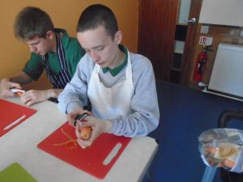

*I am so delighted with the progress that my wee boy has made in eating stuff at lunch-time, I would never have thought he would have looked at never mind eaten chicken curry*

*Parent*

*My child can now prepare a simple snack for himself at home, this is great progress.*

*Parent*

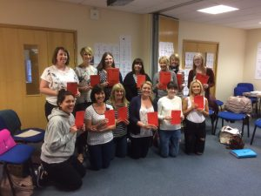**How successful has the school been at improving excellence and equity?**

*All training courses were very helpful, they gave me a good sound base for working in the school. They helped to improve my interactions and communication with the children, especially Watch your language and Intensive Interaction New Classroom Assistant*

|  |  |
| --- | --- |
| **School Priority 2: Enrich the quality of learners’ experiences and attainment in Communication/Literacy** | |
| National Improvement Framework Priority  Improvement in attainment, particularly in literacy and numeracy. | How Good is Our School? (version 4) Quality Indicator  2.2 Curriculum  2.4 Personalised Support  3.2 Raising Attainment and Achievement |
| Progress, impact and evidence:  Staff have continued to attend a variety of Communication Training courses this session developing their skills, knowledge and understanding in the use of communication approaches including; Talking Mats, Makaton Enhancement, PECS Awareness, In-House training on Intensive Interaction and Watch your Language and AAC on-line modules. This is positively impacting on learners as their learning needs are being met using a range of communication approaches including; objects, symbols, signing and switches. Learning Rounds have identified that there is a more consistent and appropriate use of a wide range of alternative approaches to communication which are helping children in the school to engage more readily in their learning, to make choices and to experience independence. Children and young people are developing their receptive, expressive and social communication skills as evidenced through quarterly reports, target tracking, annual reports and learning journey files. Teaching staff are engaging more with Pan-Ayrshire Tracking progress document to describe progression resulting in more comprehensive termly and annual reports being prepared for parents and carers.  Some parents have attended in-house courses on ‘Watch your language’, ‘Intensive Interaction’ and  ‘Use of Visuals at home’; this has led to increased confidence in supporting development of communication  at home. During annual review meetings the majority of parents are comment positively on their child’s  progress in communication and language development. Some partners including Transport contractors  have attended basic Makaton training. This has led to improved communication with our children and  young people.  Planning for the delivery of literacy has been refreshed and improved. The school has a clear overview for the delivery of literacy across learning. Discrete literacy is planned through the curriculum and all children and young people have next steps set for Communication and Language development. The Pan-Ayrshire Communication pre-requisites framework was introduced to help staff assess and plan for next steps within Individual Educational Programmes. Teaching staff have a better understanding of the stages in communication development for children with severe and complex additional support needs including the fundamentals of communication. | |
| Next Steps:   * To continue to improve planning and assessment of and for next steps in communication and language within Individual Educational Programmes ensuring appropriate personalised pathways. * To continue to develop a clear rationale for the planning of literacy across the Broad General Education. * To continue to embed communication rich pedagogies in all classes ensuring consistency across the school and supporting development of skills across home and community contexts (PEF). | |

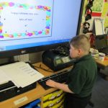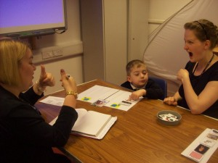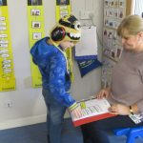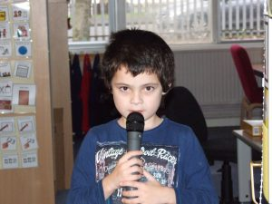

*I am really proud how far E has come over the year. She has worked hard in all areas, especially her communication, which will continue to grow and help her. Well done!*

*Parent*

*I cannot believe how much my wee boy has come on, his speaking is a lot clearer and better. I am super proud of his progress.*

*Parent*

**How successful has the school been at improving excellence and equity?**

|  |  |
| --- | --- |
| **School Priority 3: Improve the quality of learners’ experience across the curriculum focussing on learning for sustainability.** | |
| National Improvement Framework Priority  Improvement in children and young people’s health and wellbeing | How Good is Our School? (version 4) Quality Indicator  2.2 Curriculum  3.1 Ensuring wellbeing, equality and inclusion |
| Progress, impact and evidence:  *Learning for Sustainability permeates all areas of our curriculum and provides our pupils with meaningful contexts in which to develop skills for life-long learning. Acting Principal Teacher*  At the beginning of the session the Head Teacher and Principal Teacher undertook an audit of  Learning for Sustainability using Education Scotland guidance to identify actions to take forward.  The Acting Principal Teacher continued to attend national learning for sustainability networking  meetings organised by Education Scotland as a forum to discuss, share practise and bring back  ideas to school for implementation.  Teachers throughout the school routinely plan a variety of Learning for Sustainability activities including; ’50 Things to Do Outdoors’, citizenship, Eco, Rights Respecting schools and enterprise activities. Learners actively contribute effectively to the ethos of the life of the school and wider community. Outdoor learning experiences are having a positive impact on the mental health and wellbeing of some of our children and young people, as evidenced by reduction in challenging behaviours and anxiety levels leading to a higher level of engagement in learning across the school day.  Learners are supported to lead assemblies to share their learning at whole school level. Learners’ experiences have supported them in developing an understanding of citizenship, enterprise and rights respecting schools at their own level through being involved in a variety of meaningful, relevant and active experiences. Evidence of participation in learning for sustainability activities and recognition of achievement is documented within learning journey files. A range of local, national and international charities have benefitted from funds raised by learners this session.  Macintosh HD:Users:gribbens:Desktop:learning for sustain.jpgMacintosh HD:Users:gribbens:Desktop:50 things to do.jpgMacintosh HD:Users:gribbens:Desktop:CHAS.jpgThe Learning for Sustainability Quality Improvement Team have continued to improve school grounds and have recently secured funding of £5000 to purchase and erect a new greenhouse through Tesco Bags for Help scheme. The North Ayrshire Get Connected Team has further improved our school grounds to include; an outdoor class, painted playground games, new raised planters and benches and willow screening to attach items for small parts play.  Macintosh HD:Users:gribbens:Desktop:fundraising.jpg | |
| Next Steps:   * To achieve Rights Respecting Schools Level 1 Accreditation and further raise staffs’ understanding and learners’ awareness of children and young people’s rights through the SCCYP 7 Golden Rules for Participation. | |

*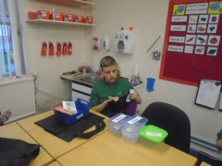*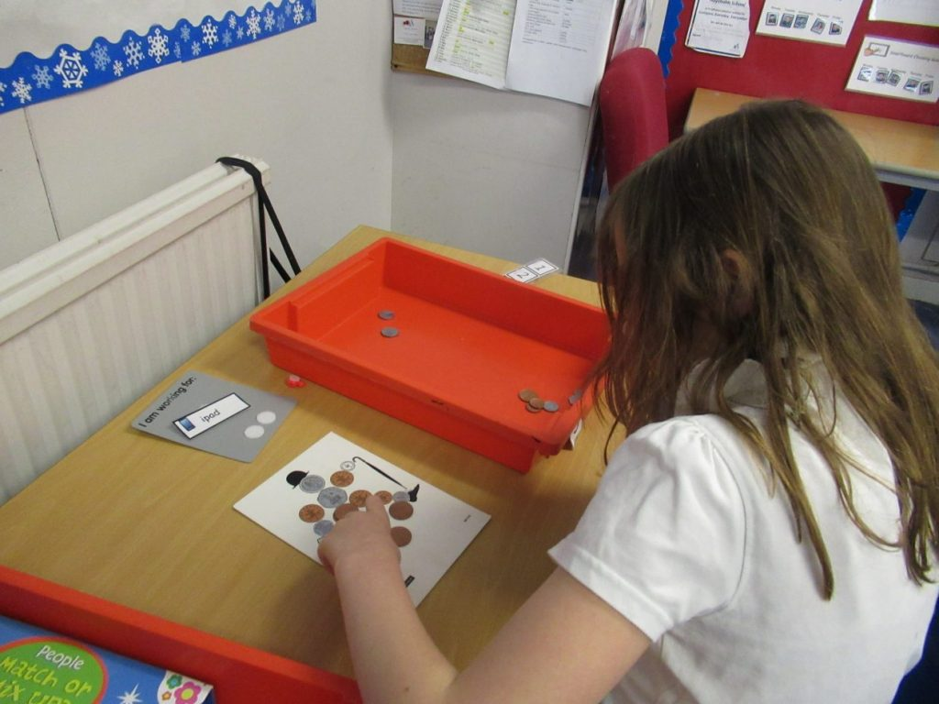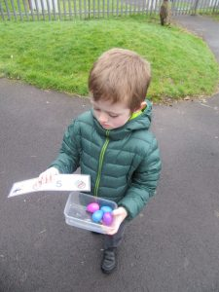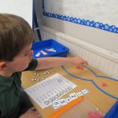**How successful has the school been at improving excellence and equity?**

*My wee boy understands the routines for shopping now when we visit the supermarket. If he has chosen a toy for being a good boy, he will ask for money to pay for it by himself.*

*Parent*

|  |  |
| --- | --- |
| **School Priority 4: Enrich the quality of learners’ experiences and raise attainment in numeracy** | |
| National Improvement Framework Priority  Improvement in attainment, particularly in literacy and numeracy. | How Good is Our School? (version 4) Quality Indicator  2.2 Curriculum  2.3 Learning, teaching and assessment  3.2 Raising Attainment and Achievement |
| Progress, impact and evidence:  The school has a clear overview for the delivery of numeracy across learning. Staff devised a financial  capability framework to support planning of financial numeracy next steps. Senior phase learners  have achieved a National Qualification in Handling Money. Life skills mathematics is now a core subject  area offered within the Senior phase. Teaching staff are becoming more confident in planning discrete  numeracy based on Curriculum for Excellence experiences and outcomes. All children and young  people have next steps set for Understanding and Relating to the Environment/Mathematics detailed in  their Individual Educational Programmes. Teachers track and evidence progress of numeracy through  short term target tracking, termly and annual reports. Evidence of progression in numeracy skills is demonstrated in learning journey files.  Following a visit to a sector-leading Early Years centre who achieved a Scottish education award for numeracy across learning the school invested money from its budget to refresh resources and programmes to support the delivery of numeracy including; EQUALS programmes of work, digital learning software, active numeracy tasks including those for outdoor learning. One member of staff attended the Nurturing Number Sense Training at the Professional Learning Academy and the North Ayrshire Early Years Numeracy Framework has been implemented providing a clear pathway for some pupils. | |
| Next Steps:   * To continue to develop a clear rationale for the planning of numeracy across the curriculum ensuring appropriate personalised pathways for learners within Individual Educational Programmes and breadth of experiences through curriculum planning. | |

*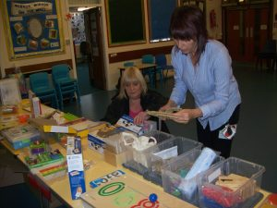*

**What is our capacity for continuous improvement?**

|  |  |
| --- | --- |
| **Quality Indicator** | **School’s Evaluation** |
| 1.3 Leadership of change | Good |
| 2.3 Learning, Teaching and Assessment | Good |
| 3.1 Ensuring wellbeing, equality and inclusion | Very Good |
| 3.2 Raising attainment and achievement | Good |

|  |
| --- |
| **Overall Capacity For Improvement – strengths and next steps**  Overall, the school has a very good capacity for improvement.  Strengths   * Positive, nurturing ethos within the school. Staff focus very well on ensuring that children and young people are put at the centre and are safe, healthy, achieving, nurtured, active, respected, responsible and included. * The promotion of independence and life skills through the 4 contexts of learning. * Children and young people’s active involvement in a breadth of learning experiences both in and out of the class. * Consistent and appropriate use of a wide range of alternative approaches to communication which are helping children in the school to engage more readily in their learning, to make choices and to experience independence.   Next Steps   * Continuation of a culture based on GIRFEC and use of wellbeing indicators to drive improvements and improve outcomes for our children and young people. * To continue to support active collaboration and engagement with parents, including family learning. (Take forward actions from PEF) * To continue to develop and embed creative, active and communication rich approaches to teaching and learning. * To continue to develop effective approaches to moderation of a Broad General Education developing staff’s understanding of assessment and shared standards. * To continue to enrich the quality of learners experiences and raise attainment in literacy, numeracy and health and wellbeing. |