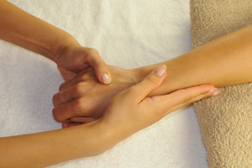
Hold arm in place with one hand and gently rub in massage medium with the other, all the way to the elbow. Continue, changing hands, massaging up the arm to the elbow.

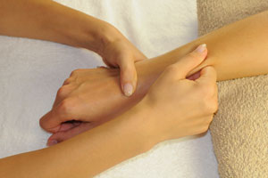

Use your free hand in a gentle squeezing motion to tease the muscles from the wrist to just beneath the elbow. Swap hands and repeat.

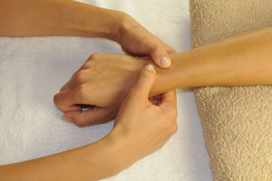
Use your thumbs to lightly brush the surface of the back of the hand. As your thumb moves toward the base of the wrist, increase the pressure of this movement.

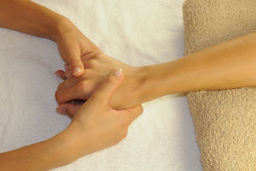
With the thumb of your free hand, apply slightly firmer pressure than before between the bones of the wrist. Move slowly towards the base of the hand.

Continue this motion.

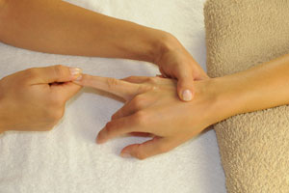
Use your free hand to massage each finger individually. Give the finger a gentle twist in both directions and then quick pull to finish. Repeat this process on each of the fingers as well as the thumb.

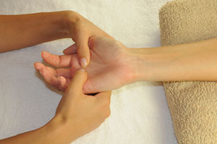
Now, let's turn to the other side of the hand. Use your thumbs to apply pressure throughout the palm. The base of the thumb is an important area to devote some attention to.

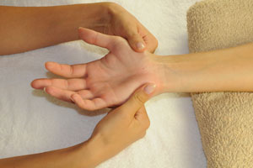

Use your thumbs to gently massage the base of the palm.

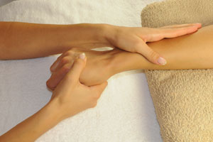
You're almost done. We just need to apply a few more light motions in order to give the whole process a gentle finish. Move your hands slowly around the hand and arm and finish by moving your hands all the way down the arm to the fingers where you should gently let go. Finally, switch to the other arm and begin the process anew.

