Welcome back after the October holiday week. I hope everyone had a good time.

MINIBUS OUTINGS & ‘SNACK HEALTHY PROGRAMME’

Please continue to send in your child’s class outing & Snack Healthy money for the term. As this is a 10 week term, please send in:-

Outing Money

£15 for the term
or
£1.50 each week
Snack Healthy Money

£6 for the term
or
60p each week




I have been monitoring the cost of the purchases for snack healthy and have decreased this amount from £1 per week to 60p per week for this term.

Please continue to send in 50p each Friday for the “Good For You” Tuckshop.

NOVEMBER LOCAL HOLIDAY


Local Holiday: Friday 13 and Monday 16 November

PERSONAL CARE – WIPES


Could I ask that 4 packs of wipes – Pampers or Johnsons, if possible, be sent in with pull-ups for this term.

IN-SERVICE DAY : MONDAY 19 OCTOBER

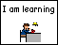
Staff from Haysholm School visited Willowbank school and joined with colleagues pan-Ayrshire to attend a training day on the use of Sensory Technology delivered by Richard Hirstwood. Richard has been in the sensory field for 30 years during which he has supplied training and advice to parents and professionals. The focus for the day was making the best use of sensory technology to enhance literacy and numeracy experiences.

FUNDRAISER – MACMILLAN CANCER CARE


I am delighted to announce that we have raised a grand total of £64 for Macmillan Cancer Care through hosting a special day on Friday 9 October. We had a non-uniform day, a tasting game and Krispie Cakes for each pupil who participated.

PARENT COUNCIL MEETING


Our next Parent Council Meeting will take place in school on Wednesday 21 October at 9.45 a.m. All parents/carers are welcome to attend.

PARENT SUPPORT GROUP
The next Parent Support Group will take place on Wednesday 4 November at 10.00 a.m. The Support Group meets at Castlepark Early Years Centre, Carron Place, Castlepark, Irvine. Please go along and enjoy an informal get-together and a cuppa!

HALLOWE’EN PARTY


The Pupil Council has helped to make choices about party games and food to have at their Hallowe’en Party. It will be held on Friday 30 October. Costumes can be sent in for your child to change into.

CHRISTMAS SHOPPING EVENING : Thursday 12 November (6.30 pm to 8.00 pm)


This year we are hoping to have 20 stalls at our annual Christmas Shopping Evening organised by the Parent Council. It will take place on Thursday 12 November from 6.30 p.m. to 8.00 p.m. Please come along and bring friends and family to support this event

GETTING IT RIGHT FOR EVERY CHILD IN HAYSHOLM SCHOOL


On 28 October at 11.00 a.m. the school will host a GIRFEC briefing session for parents/carers. Our children and young people will participate in this event and demonstrate the links between a Curriculum for Excellence and the Wellbeing Indicators. Karen McIntyre from the Children & Families Disabilities Social Work Team will join to provide information on GIRFEC. If you have any questions about GIRFEC or the North Ayrshire Child Assessment & Plan please do not hesitate to come along and join us at the event.

GIRFEC QUESTIONNAIRES

Thank you to all parents who completed the GIRFEC questionnaires during our recent parents’ evening. The questionnaires have provided very positive feedback. You can find out what parents have said under the parent’s tab on Haysholm Glow Blogs. This information is featured in the Evaluation of Questionnaires category. We very much appreciate any feedback you can provide us with and we use it as part of our ongoing quality assurance process.

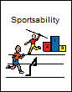
HEALTHY & ACTIVE

This year at the Festival of Sport which was held at Ayrshire Athletics Arena learners joined with a range of activities including dance, judo and rugby. A range of schools attended enabling our children and young people to experience sports with a wider peer group outwith school.
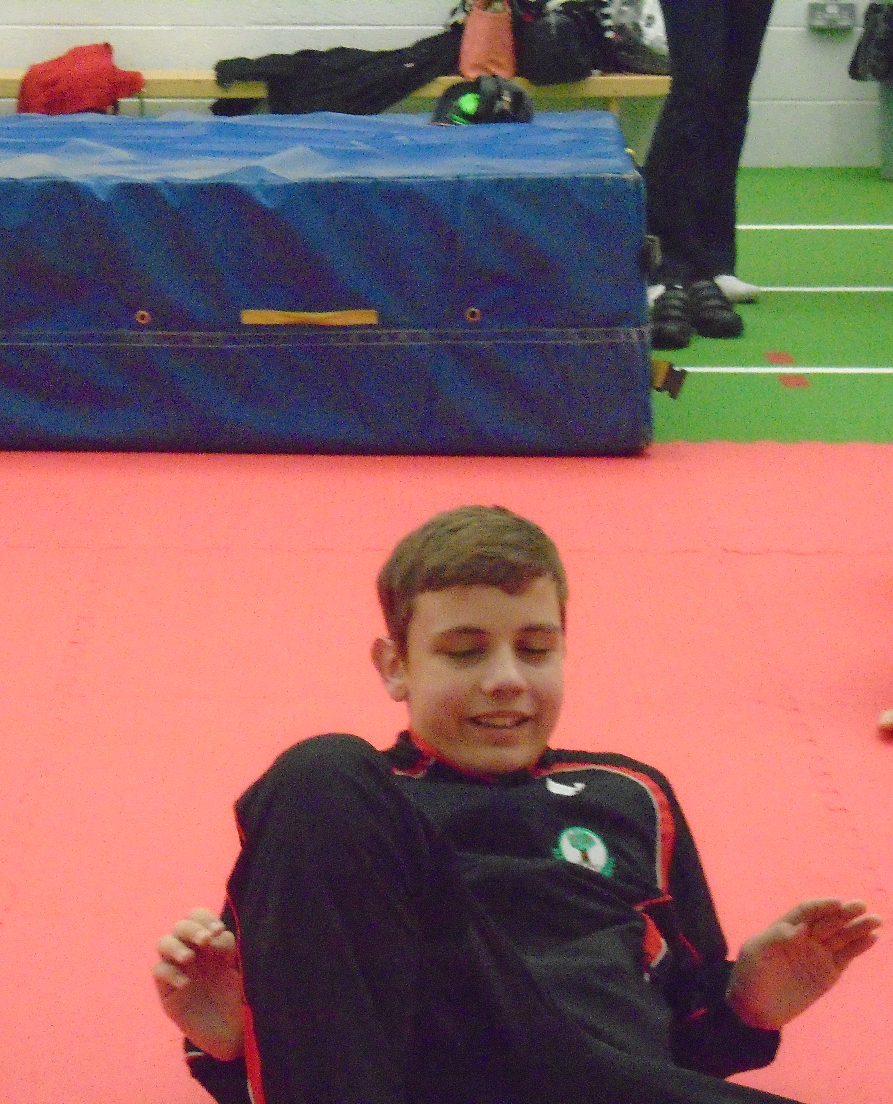
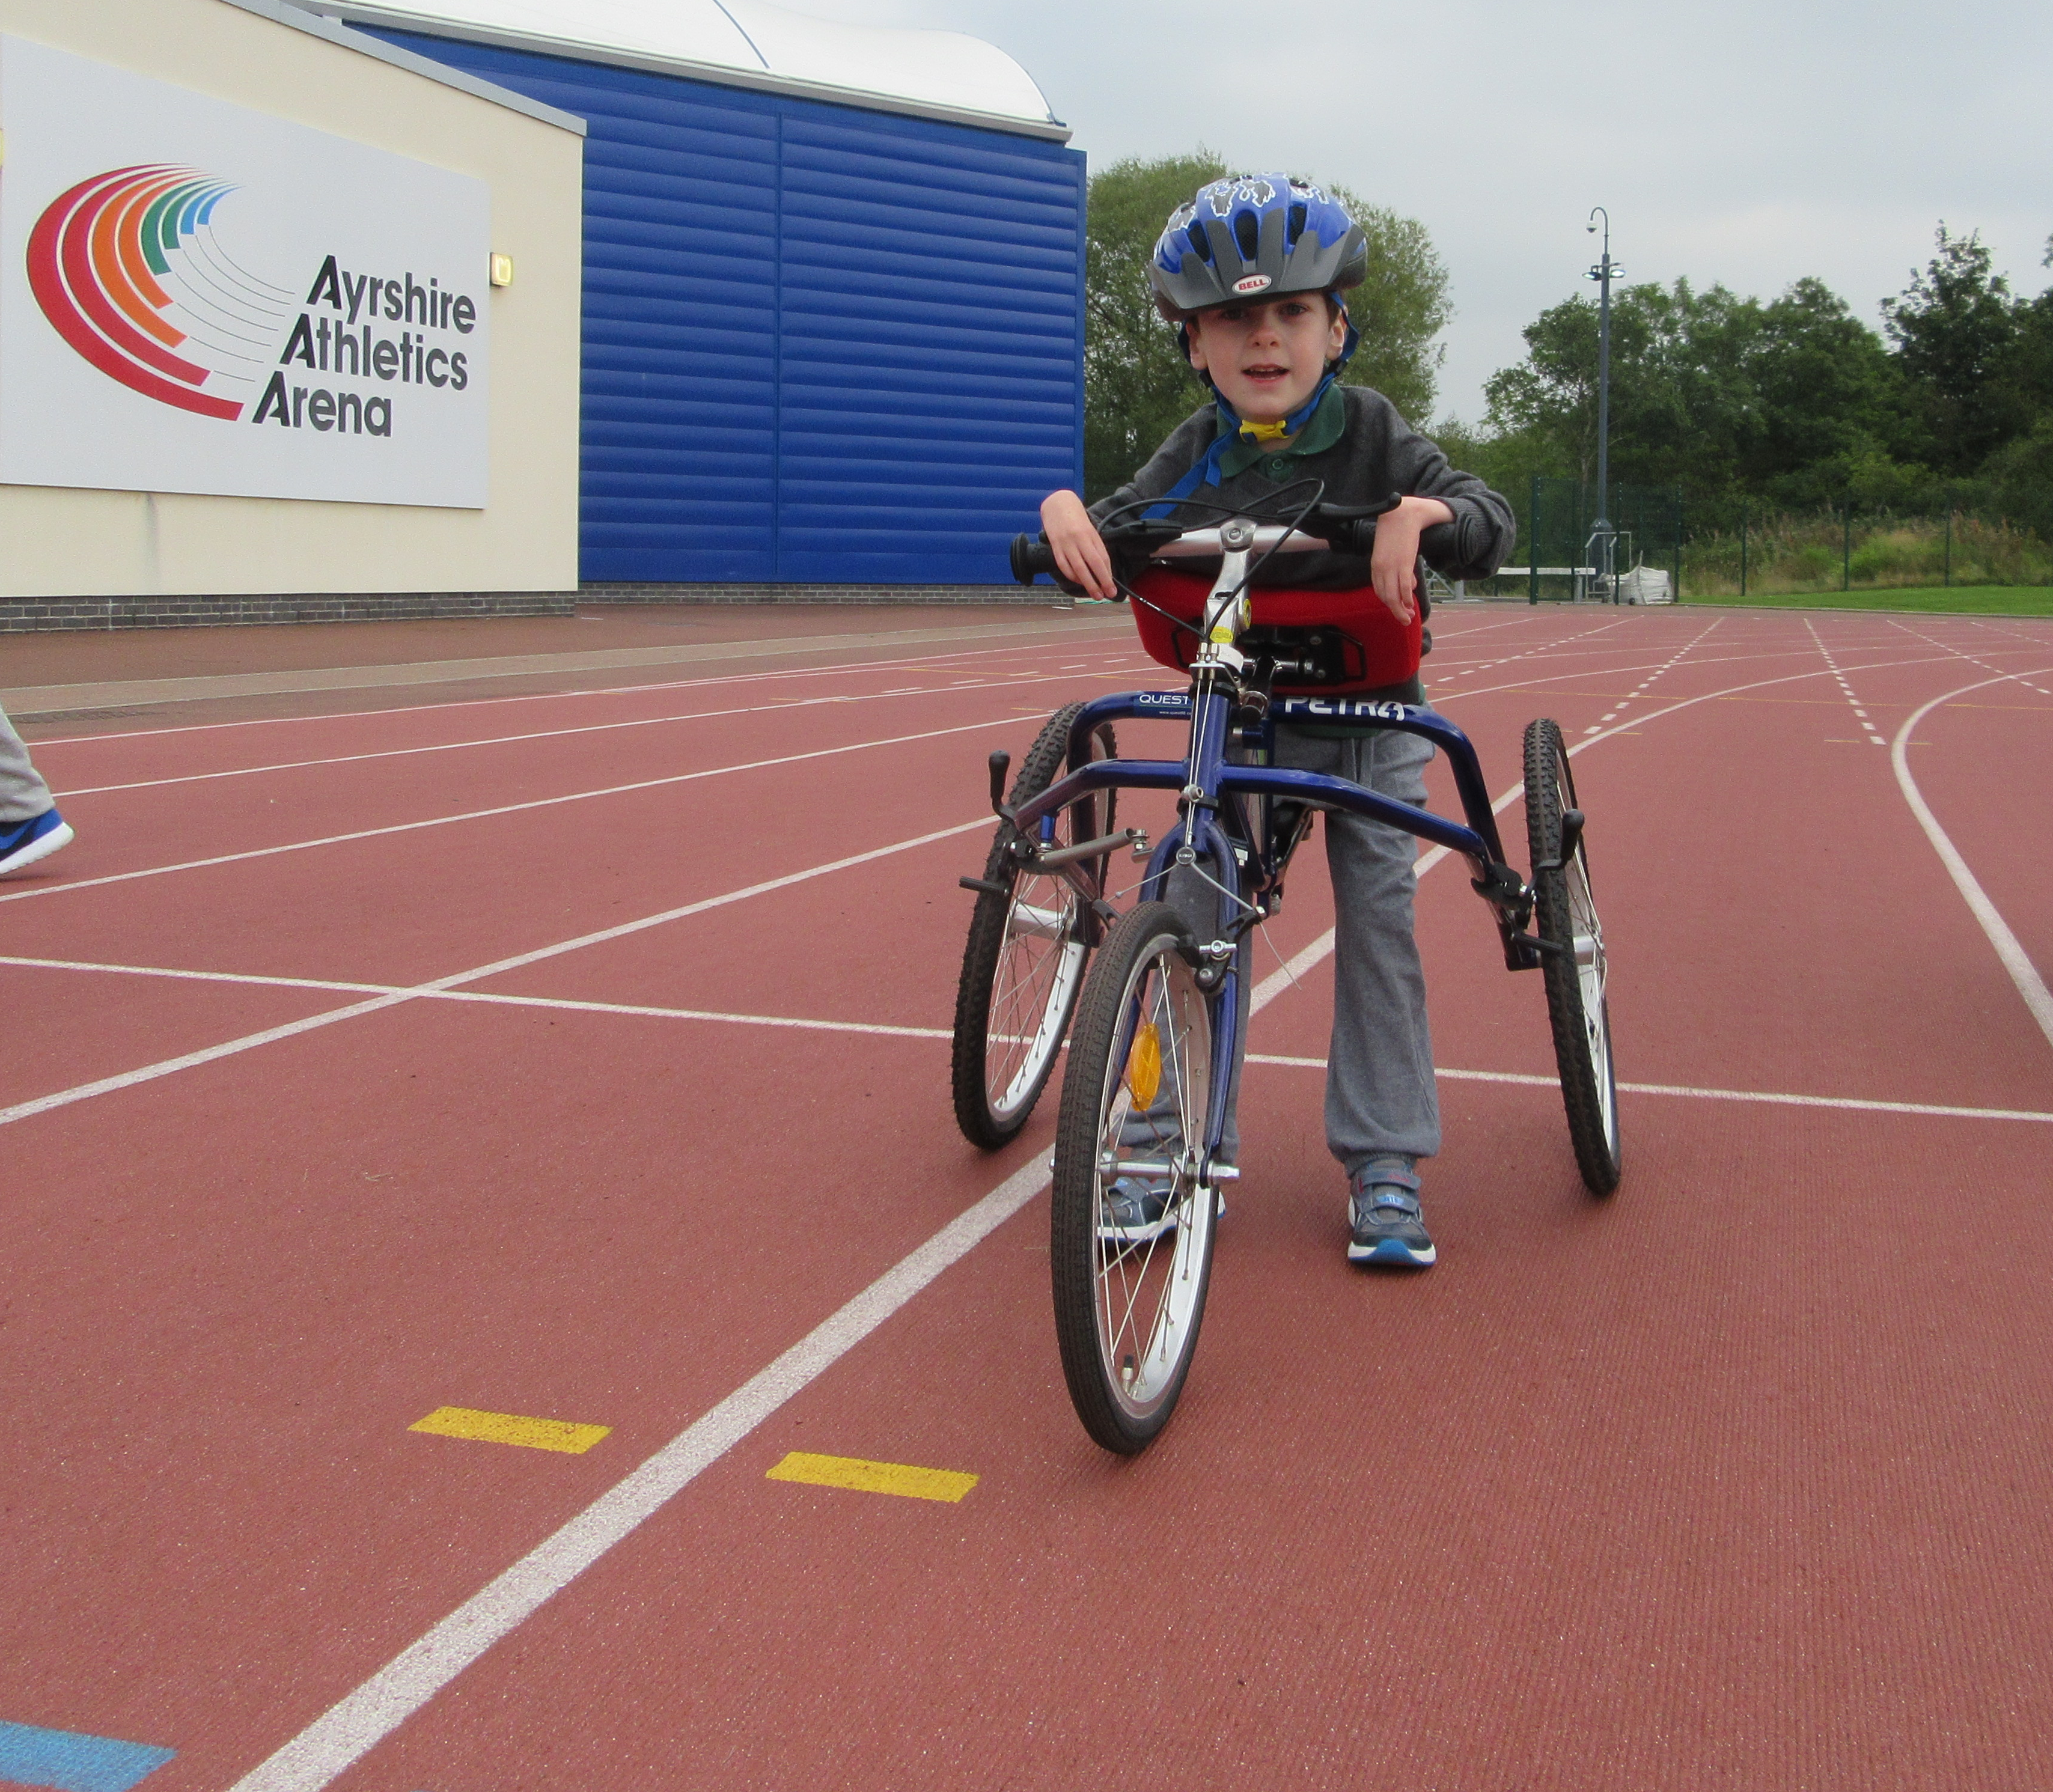
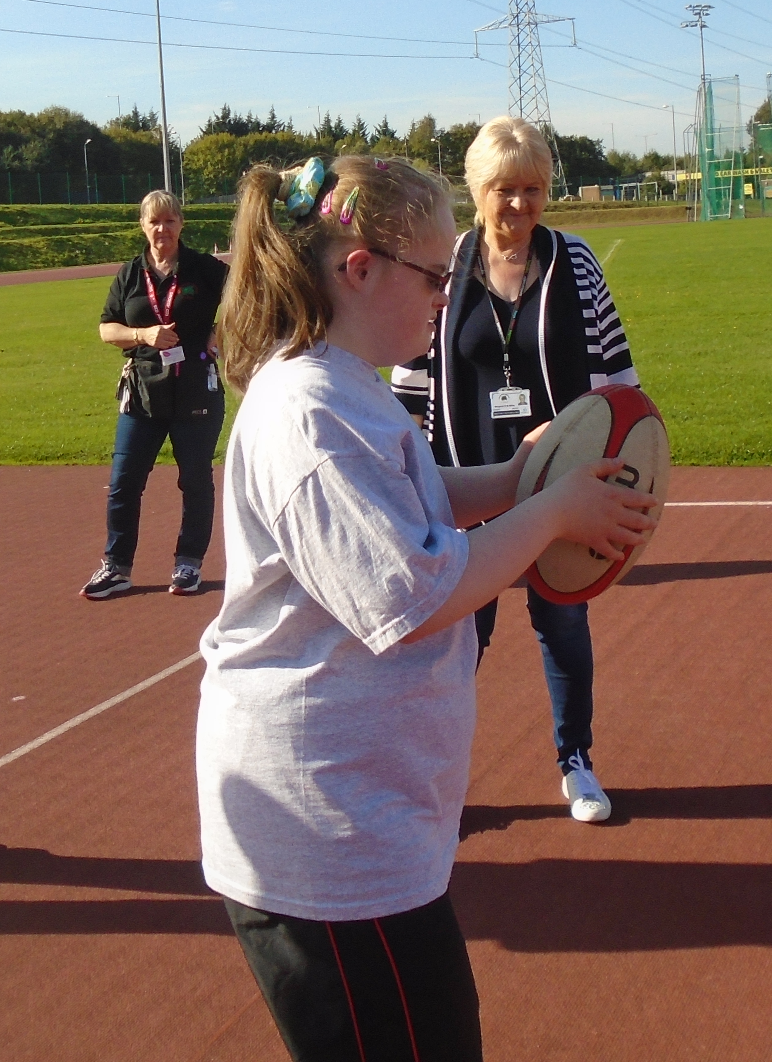

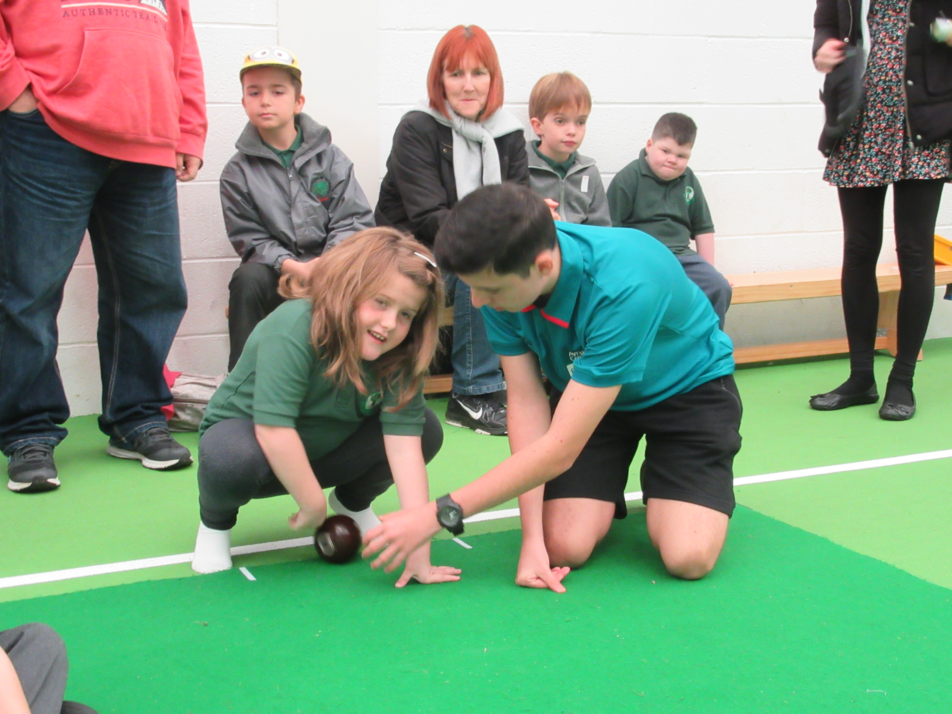
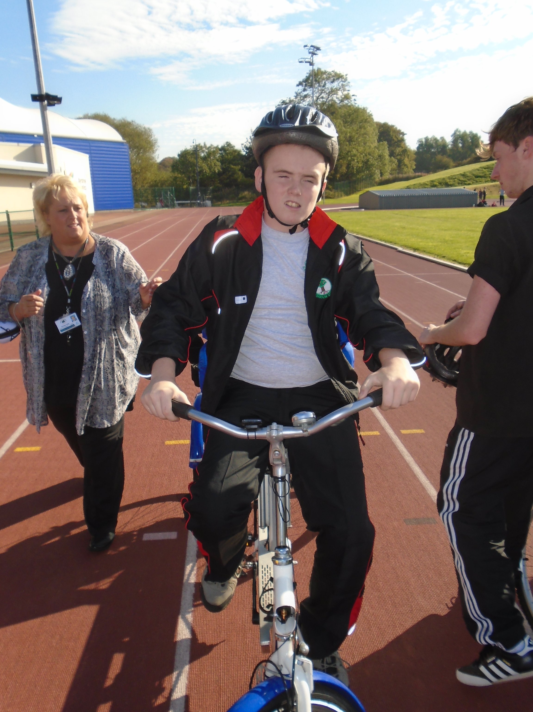
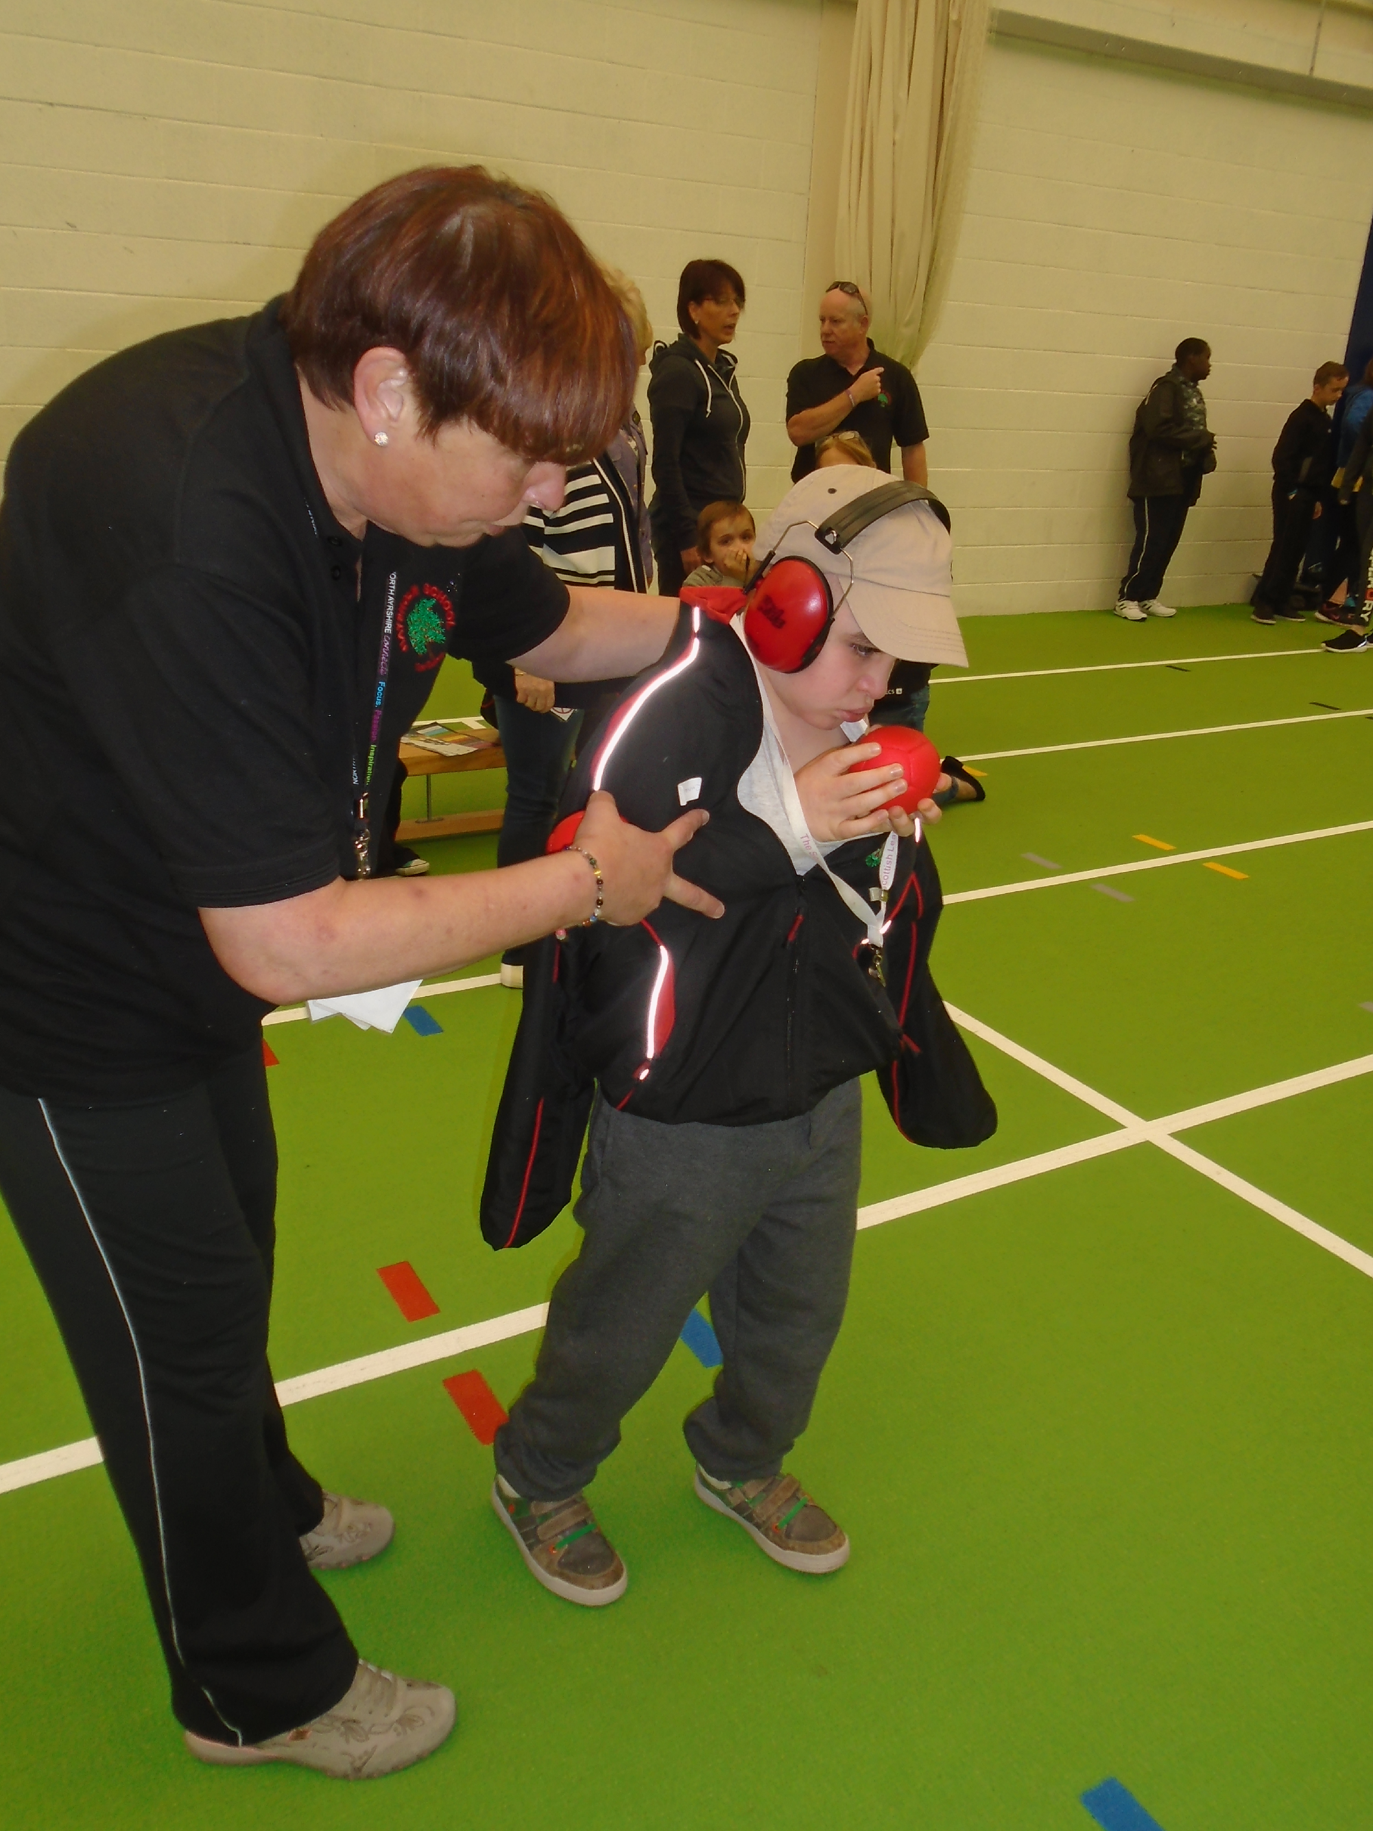

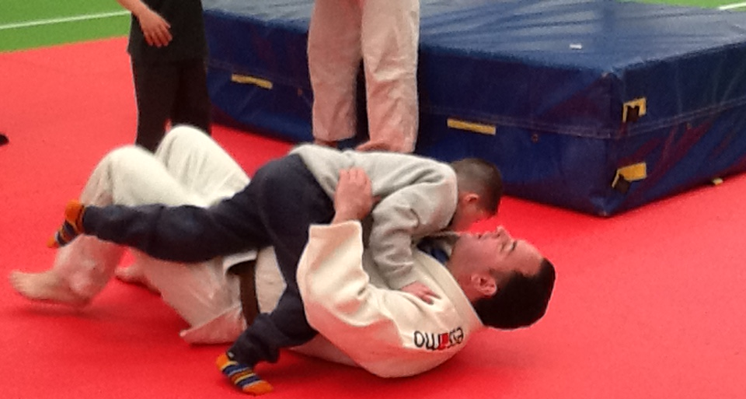
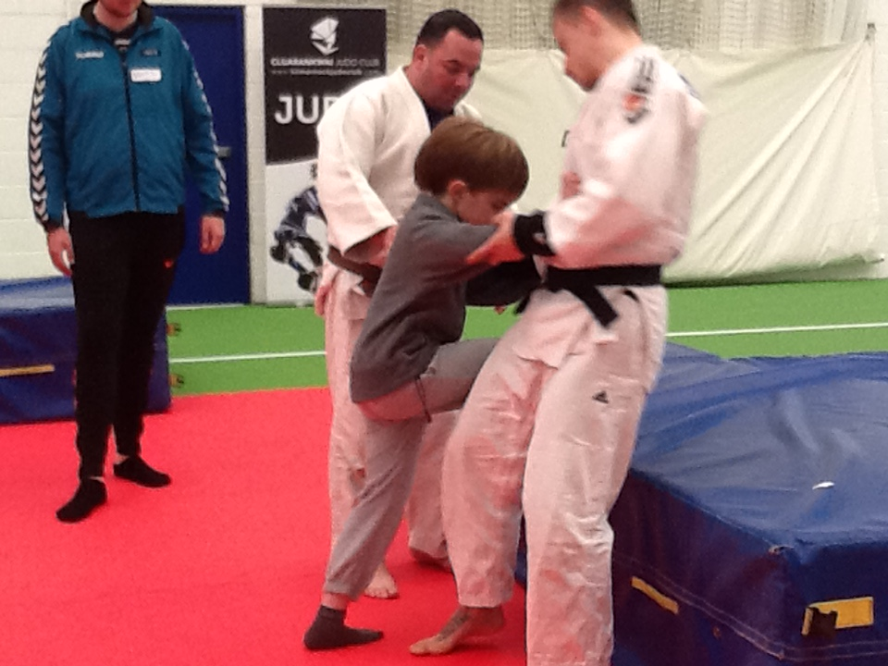

ENTERPRISE : CHRISTMAS FAYRE – FRIDAY 27 NOVEMBER

We have decided to host our Christmas Fayre on an earlier date this year – Friday 27 November. I will contact you after the October holiday with more details.

RAGBAG COLLECTION

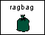
Once again you have the opportunity for a clearout! Ms Clark and Bute class will take charge of this initiative. Please send in any unwanted, good quality, clean and dry clothing, paired shoes, handbags, wallets, ties, etc.

40TH ANNIVERSARY CELEBRATIONS


In January 2016 we will celebrate the school’s 40th Anniversary. There is a working group within the school planning the event. This group is being led by Mrs Millar who has worked in the school for 38 years. Selected Senior pupils attended Hillhouse Quarry to choose a standing stone to place in the front grounds of the school. The theme for learning in January will be ‘Celebrations’ and each class will perform a dance at the special Service to be hosed at St Mary’s Church in Irvine. We will keep you informed of preparations in future newsletters.

ILLNESS

Cold/Flu Symptoms – If you child is unwell, especially with a heavy cold, please keep him/her at home until he/she is fit to cope with school. This will help to avoid the spread of infection to other pupils and staff.

Gastrointestinal Infections – If you child has diarrhoea and vomiting you should keep him/her at home for 48 hours after symptoms have resolved. This advice has been provided from Ayrshire & Arran Health Board.

Yvonne Gribben
Head Teacher

