

**A Brief Introduction to GIRFEC,**

**SHANARRI, and “My World”**

Getting It Right For Every Child (GIRFEC) is the Scottish Government’s drive to improve outcomes for all children. The aim is that all children in Scotland are given every opportunity to develop to their full potential to become confident, responsible, and productive members of society.

*Curriculum for Excellence* refers to this as the *Four Capacities* which aim to enable every child to become a:

* successful learner
* confident individual
* responsible citizen
* effective contributor

In order to meet these goals, an agreed definition of *wellbeing* has been created. It is summarised in the *Wellbeing Wheel*.

[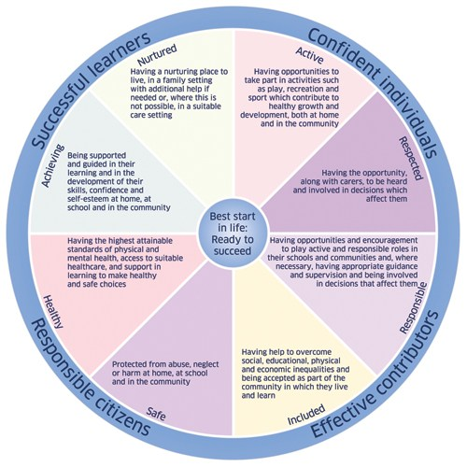](http://keithareaparentcouncils.org/wp-content/uploads/2014/10/WellbeingWheel.jpg)**SHAN ARRI**

The acronym SHANARRI is formed from the eight indicators of wellbeing:

* Safe
* Healthy
* Achieving
* Nurtured
* Active
* Respected
* Responsible
* Included

**Child Assessment and Plan**

All of these wellbeing indicators are necessary for a child or young person to reach their full potential. They are used to record observations, events and concerns and as an aid to creating an individual plan for a child. The plan is known as ‘The Child’s Plan’. From Session 15-16, all children and young people who attend an additional Support Needs school in North Ayrshire and will have a Child Assessment and Plan. The Child Plan will be stored electronically on a system known as SEEMIS. Teacher’s will be able to upload observations about a child’s wellbeing to a ‘Whiteboard’ on the child’s plan and they will upload long term targets for your child linking them to each of the wellbeing indicators. The Wellbeing indicators will be used as an assessment tool to drive forward target setting.

**Named Person**

You and your child will have the right to support from a Named Person if you need it. The Named Person at Haysholm school will be Mrs Gribben. If you need help with a particular issue or you have a concern that is impacting on your child’s wellbeing, Mrs Gribben can liaise with other professionals from health or social services to get you and your child the right help at the right time.

**My World Triangle**

[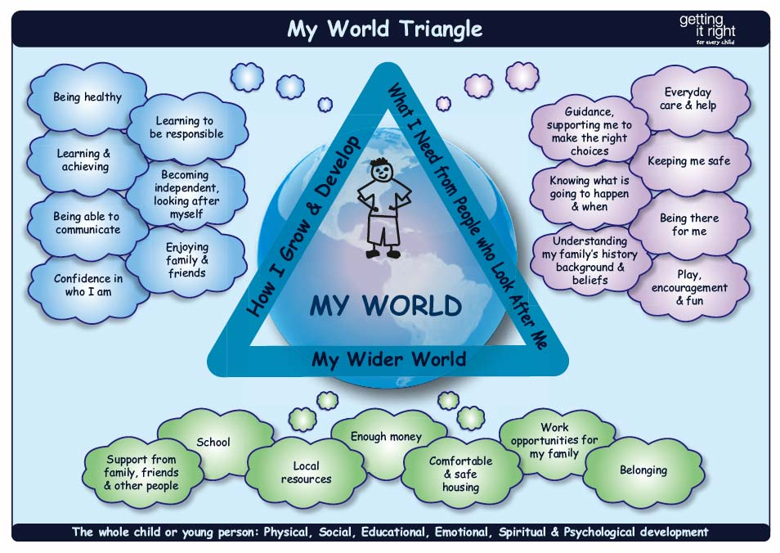](http://keithareaparentcouncils.org/wp-content/uploads/2014/10/MyWorldNew.jpg)

The *My World* triangle is a pictorial representation of an assessment tool used with individual children to determine which of their needs are being met, and where support is needed. It can be used as a useful reminder of what children and young people need from their family, friends, school, and society generally. This information is currently contained within your child’s Individual Educational Programme.

For more information, visit Haysholm Glow Blogs where you will find a link to GIRFEC North Ayrshire on the Useful Links section under the For Parents tab. Alternatively visit:

<http://www.gov.scot/Topics/People/Young-People/gettingitright>