Welcome back after the October holiday week. I hope everyone had a good time.

NOVEMBER LOCAL HOLIDAY


Local Holiday: Friday 14 and Monday 17 November

MINIBUS OUTINGS


Please continue to send £1.50 each week for your child’s class outing or £15 for the term.

PERSONAL CARE – WIPES


Could I ask that 4 packs of wipes – Pampers or Johnsons, if possible, be sent in with pull-ups for this term.

‘SNACK HEALTHY’ PROGRAMME


Thank you to all parents who have already signed up to the programme. You no longer need to send in snacks for your child. A 2 week programme has been devised using Government advice on Healthy Eating for Schools. The programme runs Monday to Thursday and costs £1 per week (charge in mainstream schools is 40p per day). As well as children and young people receiving a healthy snack it aims to broaden the range of foods eaten by the pupils. The classes will also participate in a rota and take responsibility for:-

      - Collecting money
      - Setting out snacks
      - Preparing daily menus, etc.

This will contribute to the development of literacy, numeracy and life skills.

CHRISTMAS SHOPPING NIGHT : Thursday 6 November (7 p.m. – 8.30 p.m.)


This year we are hoping to have 20 stalls at our annual Christmas Shopping Evening organised by the Parent Council. It will take place on Thursday 6 November from 7.00 p.m. to 8.30 p.m. Please come along and bring friends and family to support this event.

HAYSHOLM SCHOOL ELECTIONS


In Term 1 we held school elections to vote for members of the Eco Committee, Pupil Council and School Captains. The following are the results.

School Captains




Craig Collins Ryan Thomson

Arran Class Bute Class

Eco Committee





Darren Lawson Peter Larsen Gary Marlow Conor McTaggart

Arran Class Arran Class Arran Class Bute Class

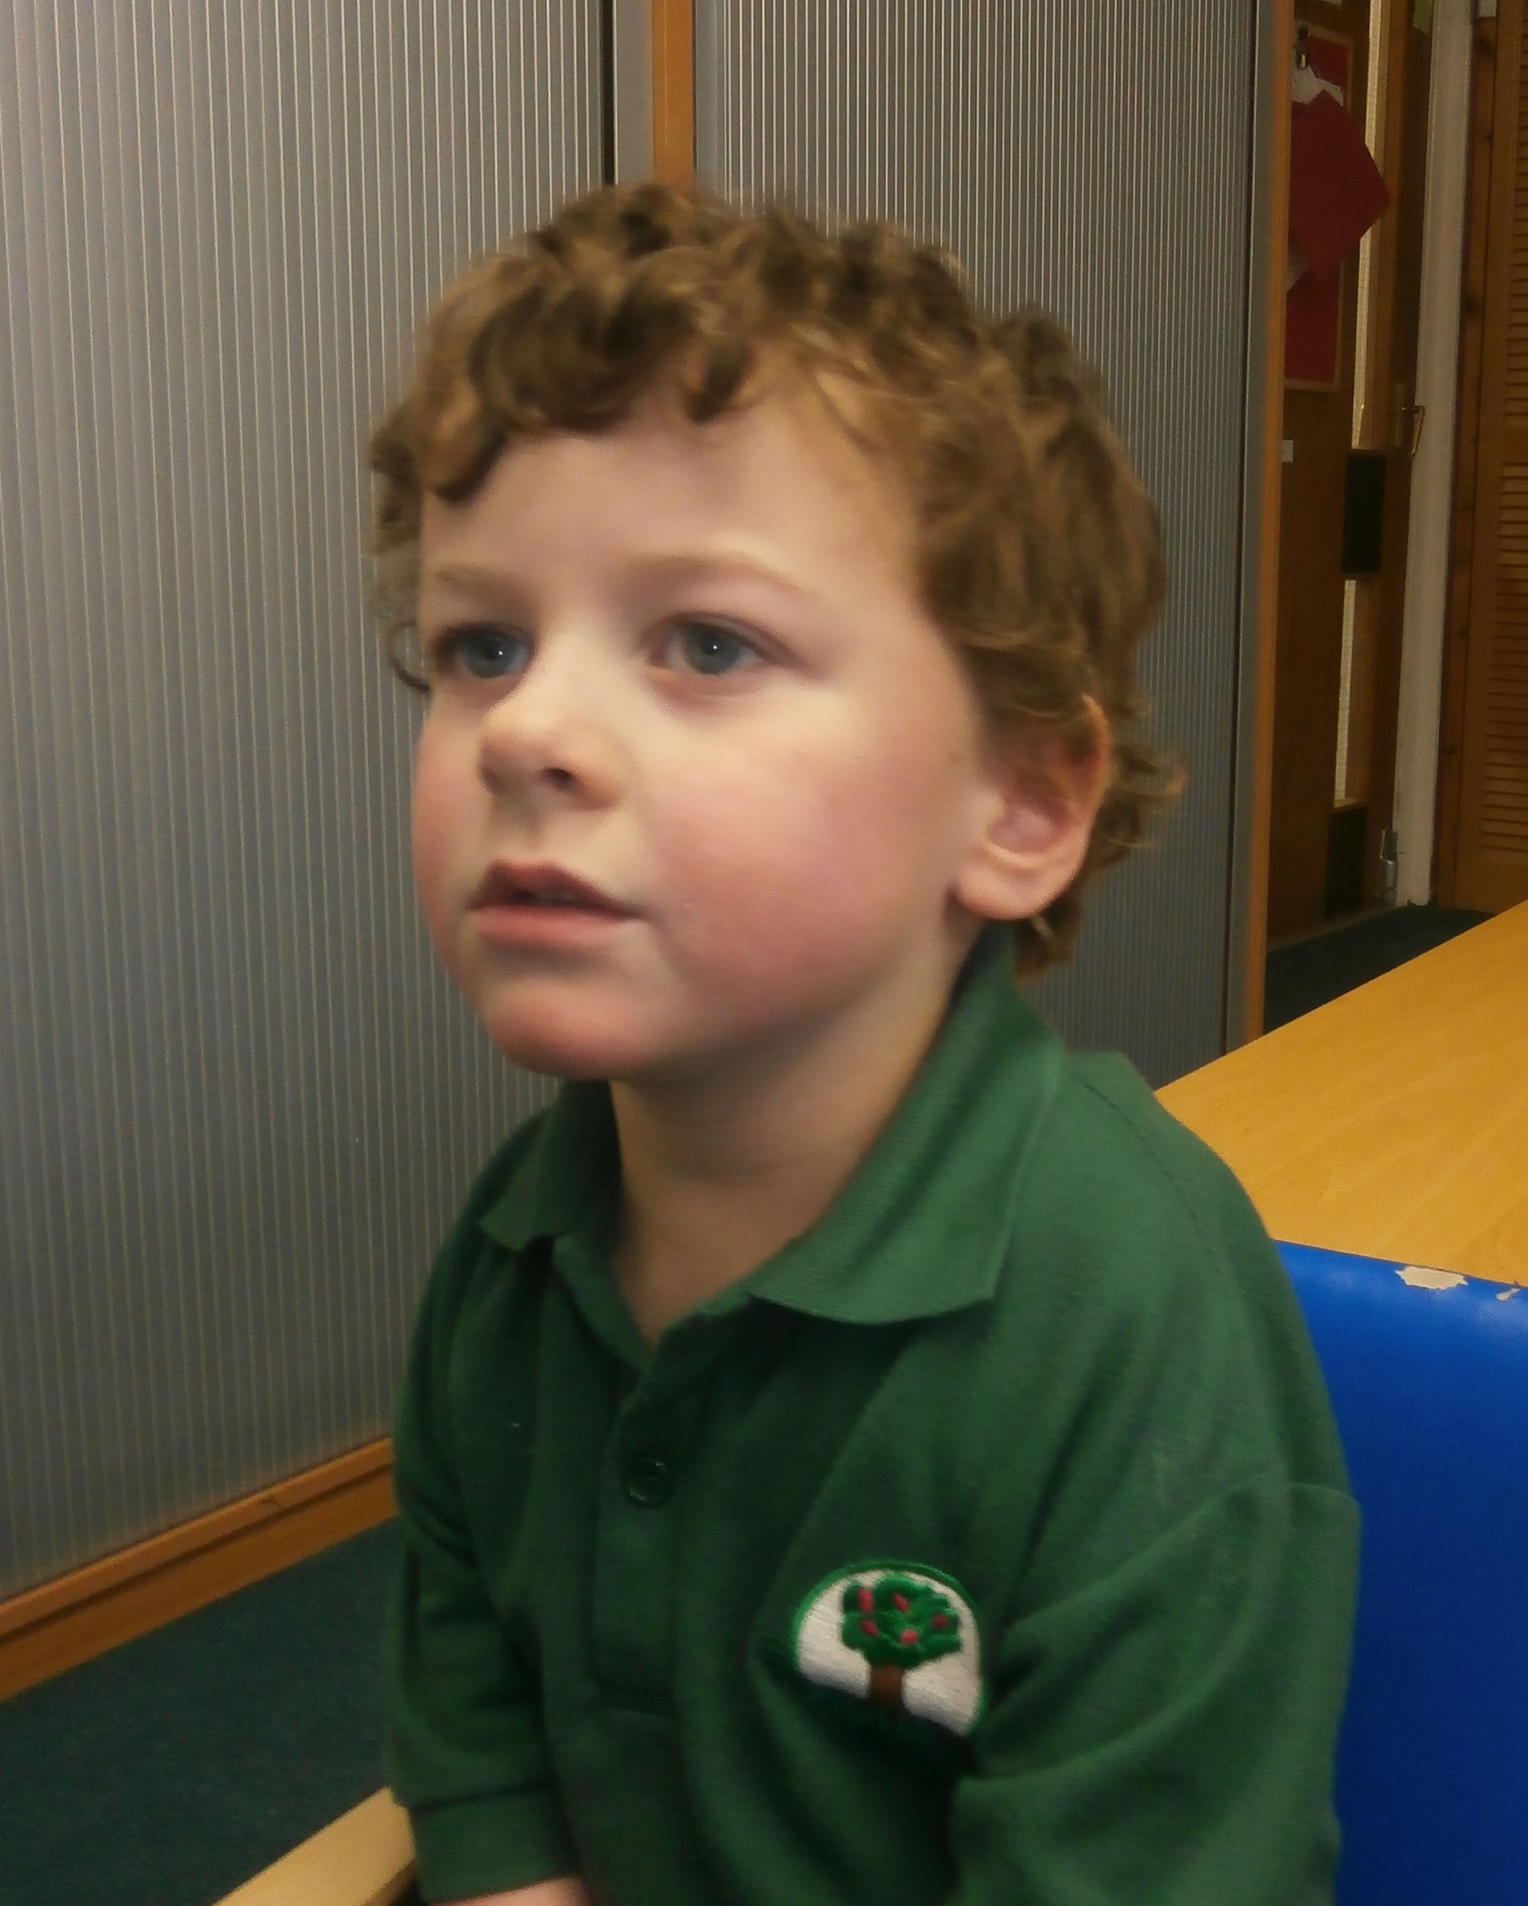

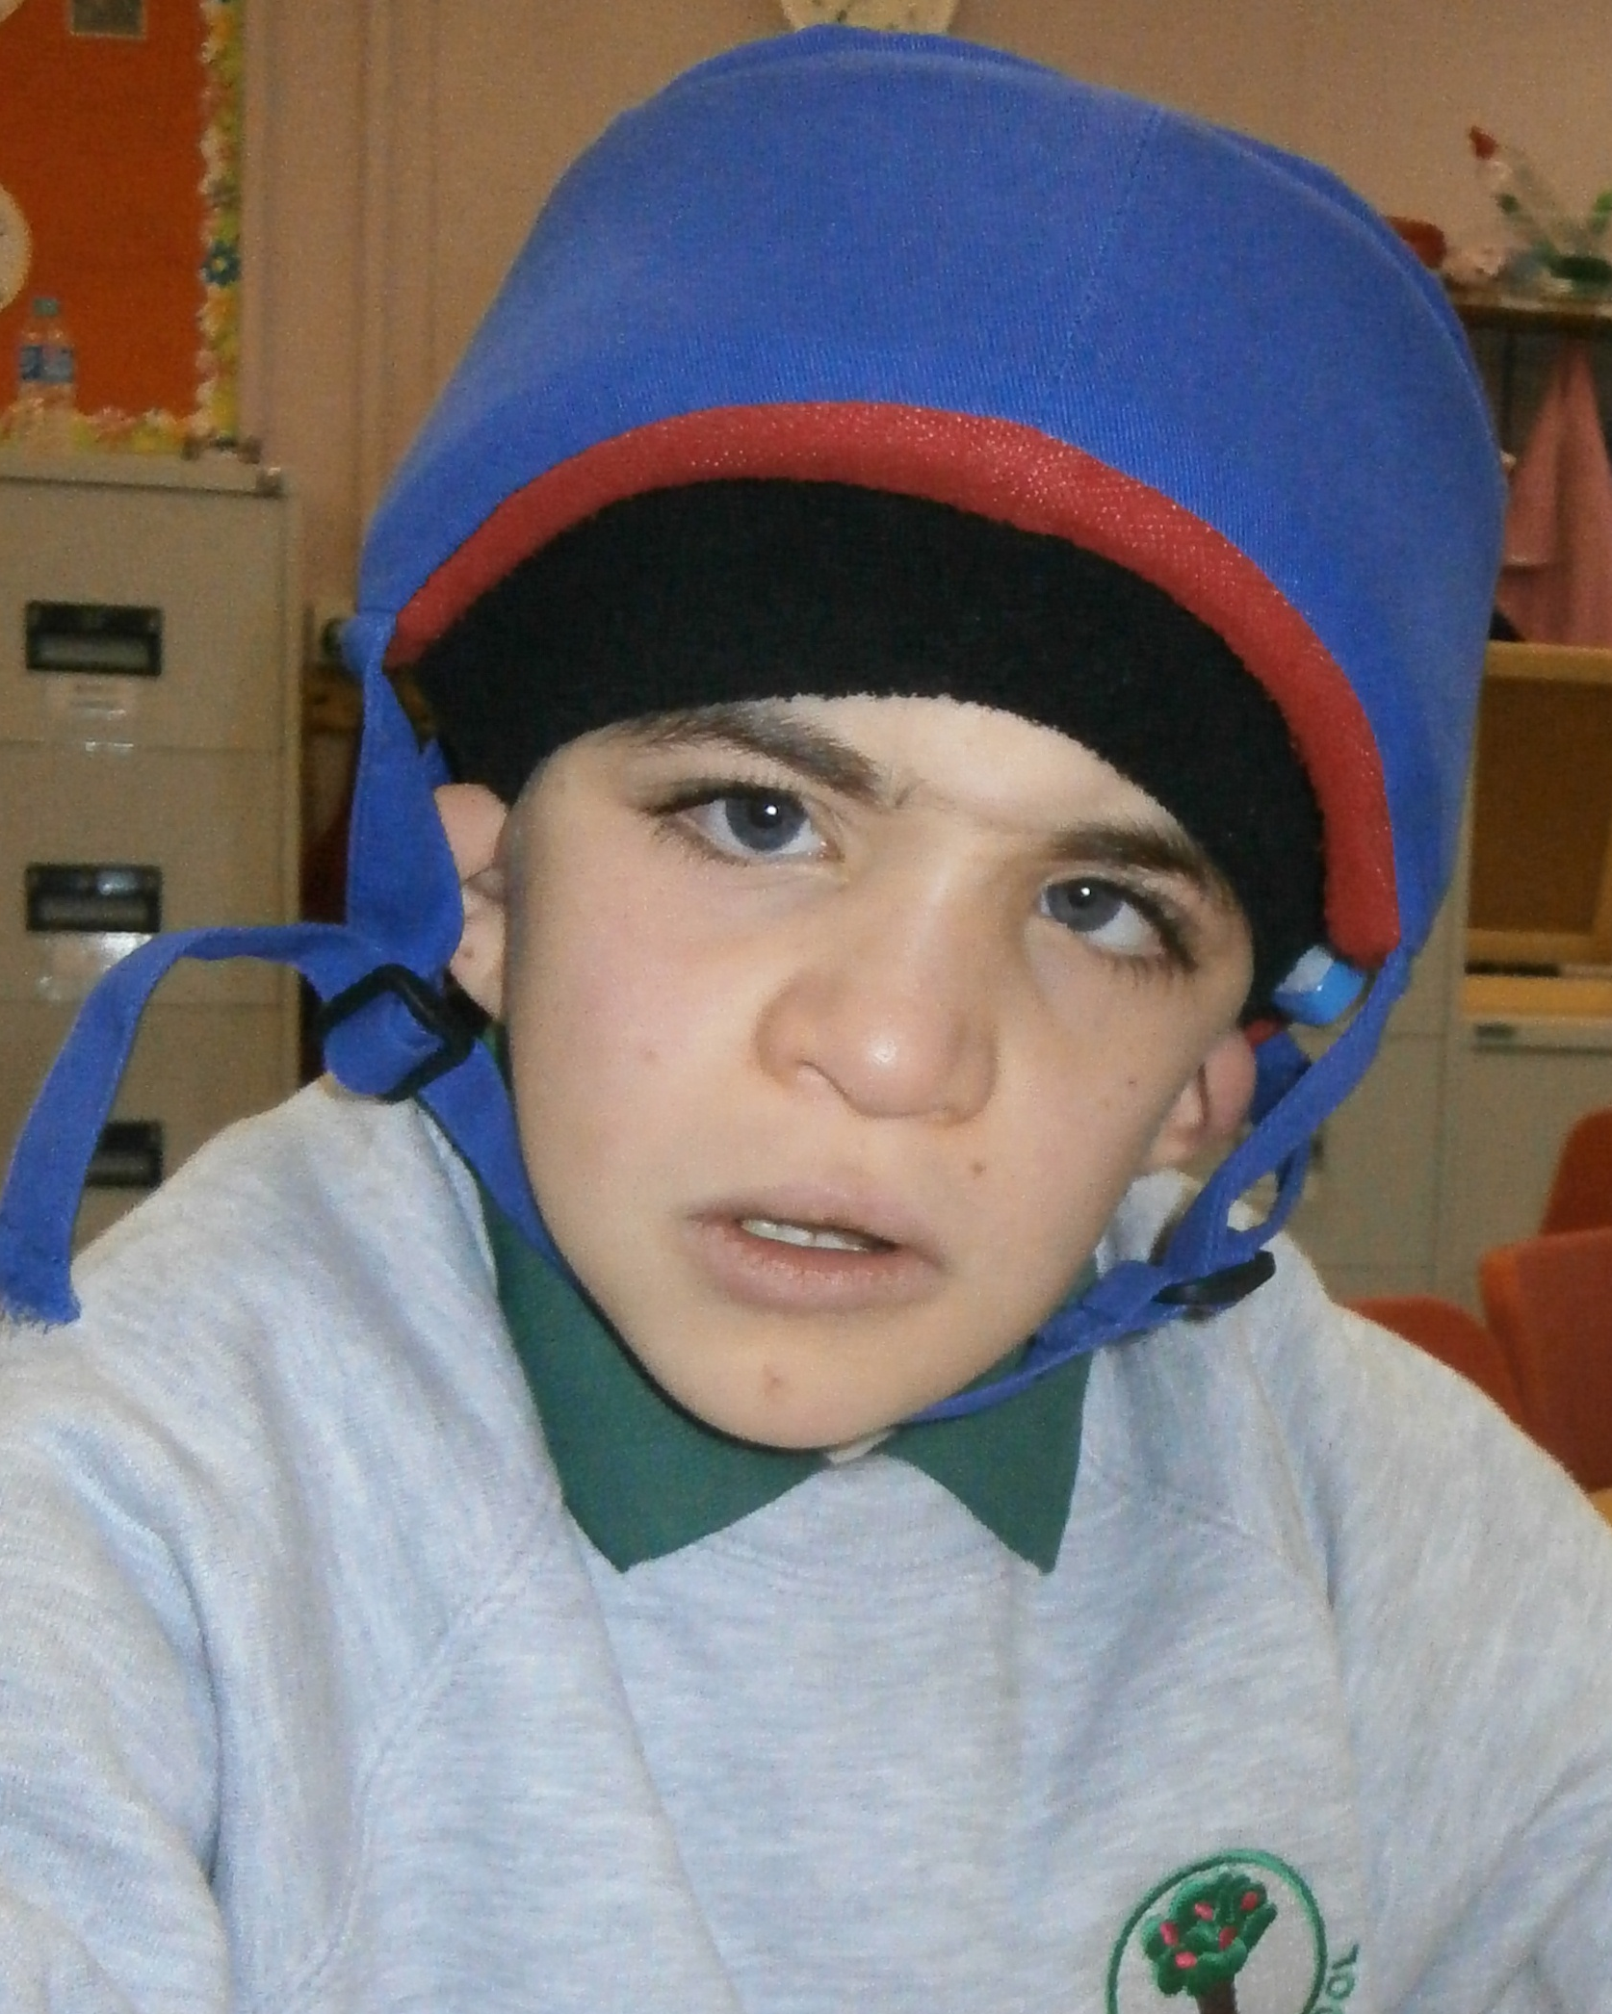

Cameron Hales Esme McNeill Charlie Kennedy

Skye Class Mull Class Jura Class

Pupil Council


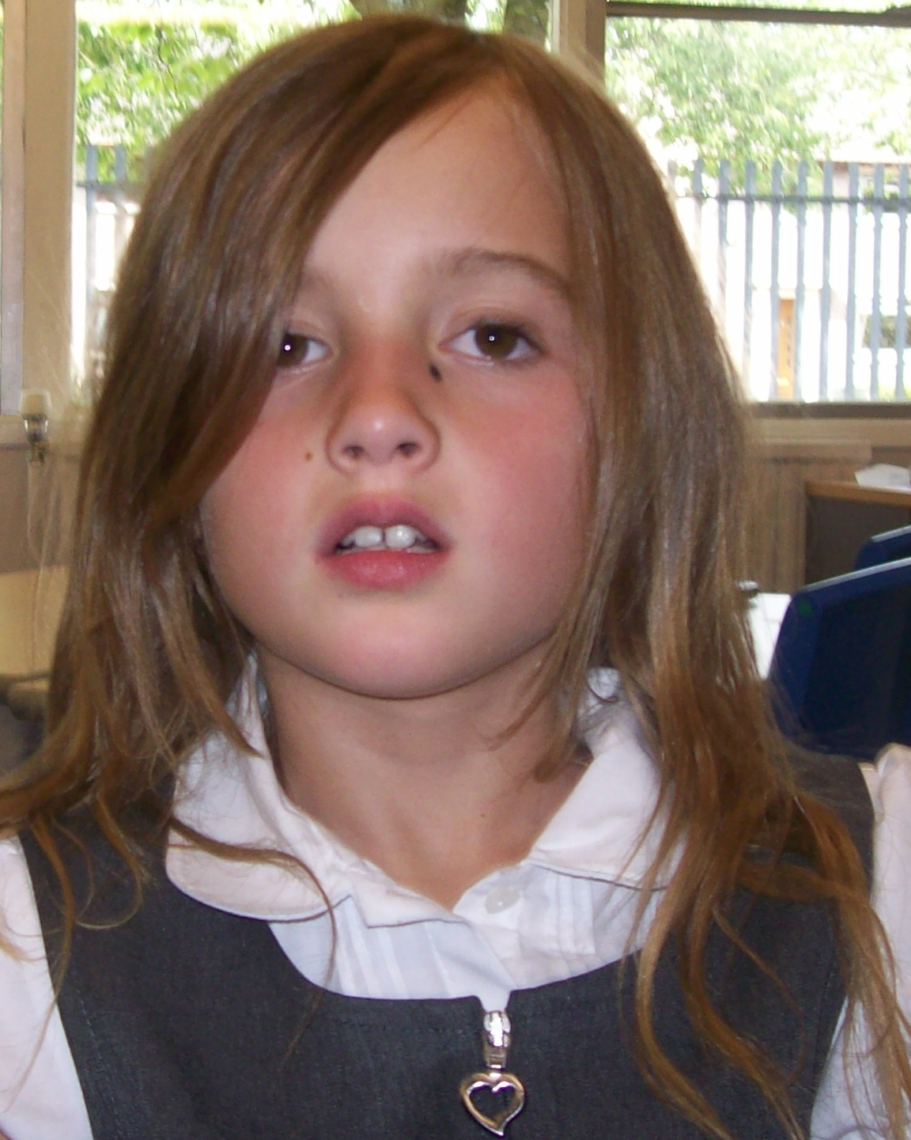


Kai Reid Sarah Sharkey Kingsley Cocozza

Skye Class Jura Class Mull Class




Rachel Bell Ryan Holland

Arran Class Bute Class

SCHOOL TRANSPORT


If you have any concerns or issues regarding your child’s transport to and from school please do not hesitate to contact me to discuss. It is my task to log any issues raised with the transport hub.

HALLOWE’EN PARTY


The Pupil Council has helped to make choices about party games and food to have at their Hallowe’en Party. It will be held on Friday 31 October. Costumes can be sent in for your child to change in to.

ARRAN CLASS FUNDRAISING

I am delighted to announce that Arran Class raised a grand total of £132 for Macmillan Cancer Care through hosting a tea party for invited guests. Well done!

RAGBAG COLLECTION

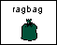
Once again you have the opportunity for a clearout! Miss McHarg and Arran class will take charge of this initiative. Please send in any unwanted, good quality, clean and dry clothing, paired shoes, handbags, wallets, ties, etc. by 30 November.

PARENT COUNCIL MEETING


Our next Parent Council Meeting will take place in school on Monday 10 November at 9.45 a.m. All parents/carers are welcome to attend.

The Parent Council would like to welcome 3 new parent members – Janice Kennedy, who joined a few months ago, and Stuart Cooper and Ashley McConnell who joined at the recent AGM Meeting.

PARENT SUPPORT GROUP
The next Parent Support Group will take place on Wednesday 5 November at 10.00 a.m. The Support Group meets at Castlepark Early Years Centre, Carron Place, Castlepark, Irvine. Please go along and enjoy an informal get-together and a cuppa!

IN-SERVICE DAY : MONDAY 20 OCTOBER


A funding bid was secured to train staff in Sherbourne Developmental Movement. This approach will enhance the delivery of PE programmes to our children and young people. As part of our school improvement this session we are further developing PE programmes to ensure that all of our learners are accessing 2 hours quality PE per week.

MAKATON

As a school we have made the decision to use Makaton instead of BSL as our signing system. Most staff have recently completed a 6 week introductory course. Makaton is now widely used in early years centres and post school destinations, e.g. Fergushill Interlink. I have attached some information about Makaton for your information.

ILLNESS
Cold/Flu Symptoms – If you child is unwell, especially with a heavy cold, please keep him/her at home until he/she is fit to cope with school. This will help to avoid the spread of infection to other pupils and staff.

Gastrointestinal Infections – If you child has diarrhoea and vomiting you should keep him/her at home for 48 hours after symptoms have resolved. This advice has been provided from Ayrshire & Arran Health Board.

Yvonne Gribben
Head Teacher

