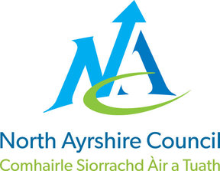
North Ayrshire Council
Education and Youth Employment
INSERT SCHOOL NAME HERE
Photography Permission Form
Dear Parent/Carer
We like to take photographs of the children in our school to celebrate a variety of activities. All photographs that include children will be to support the child’s learning, celebrate their achievements or show the exciting things that happen during their time at school. We may use these photographs in school handbooks, newsletters, in classroom/corridor displays, on our website or on the school’s Twitter/Facebook pages. We may also make video/ webcam recordings of events.
Learning Journeys and Records of Achievement are used to mark your child’s progress throughout school. These are often sent home or are created online on secure online platforms such as Glow. Photographs of individuals, groups or classes of children may appear in these records.
We have whole class photographs taken by an external company on an annual basis. These photographs are only available in print form and are ordered via the school.
We may send photographs to the news media, or our school may be visited by the media who will take their own photographs or film footage. Pupils will often appear in these photographs. The news media may use the photographs in printed publications (including local or national newspapers), on televised news programmes or on their website. In this situation, permission from the school will always be sought and no full names will be used.
Pupils going on trips will have additional photographic permission sought before the date, to cover outside agencies taking photographs that they may subsequently use on their Twitter/Facebook pages, eg. The Science Centre, The RSPB
To comply with Data Protection Law, we need your permission before we can photograph or make any recording of your child. We have included further information about the actions we will take to keep data safe and secure.
It is recommended that you read these before completing the attached consent form.
Yours sincerely,

INSERT HT NAME
To indicate whether you give consent or not, and to agree with all the conditions of use, please tick the boxes to indicate your agreement, sign and date the form and return to the school.
- I give permission for my child’s photograph to be used within school for display purposes | 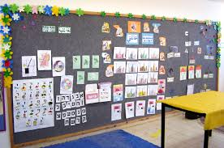  Yes No
- I give my permission for my child’s photograph to be used in Learning Journeys/Records of Achievements belonging to other children | Yes No
- I give permission for my child’s photograph to be used in other printed publications | 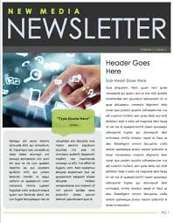  Yes No
- I give permission for my child’s photograph to be used on the school website | 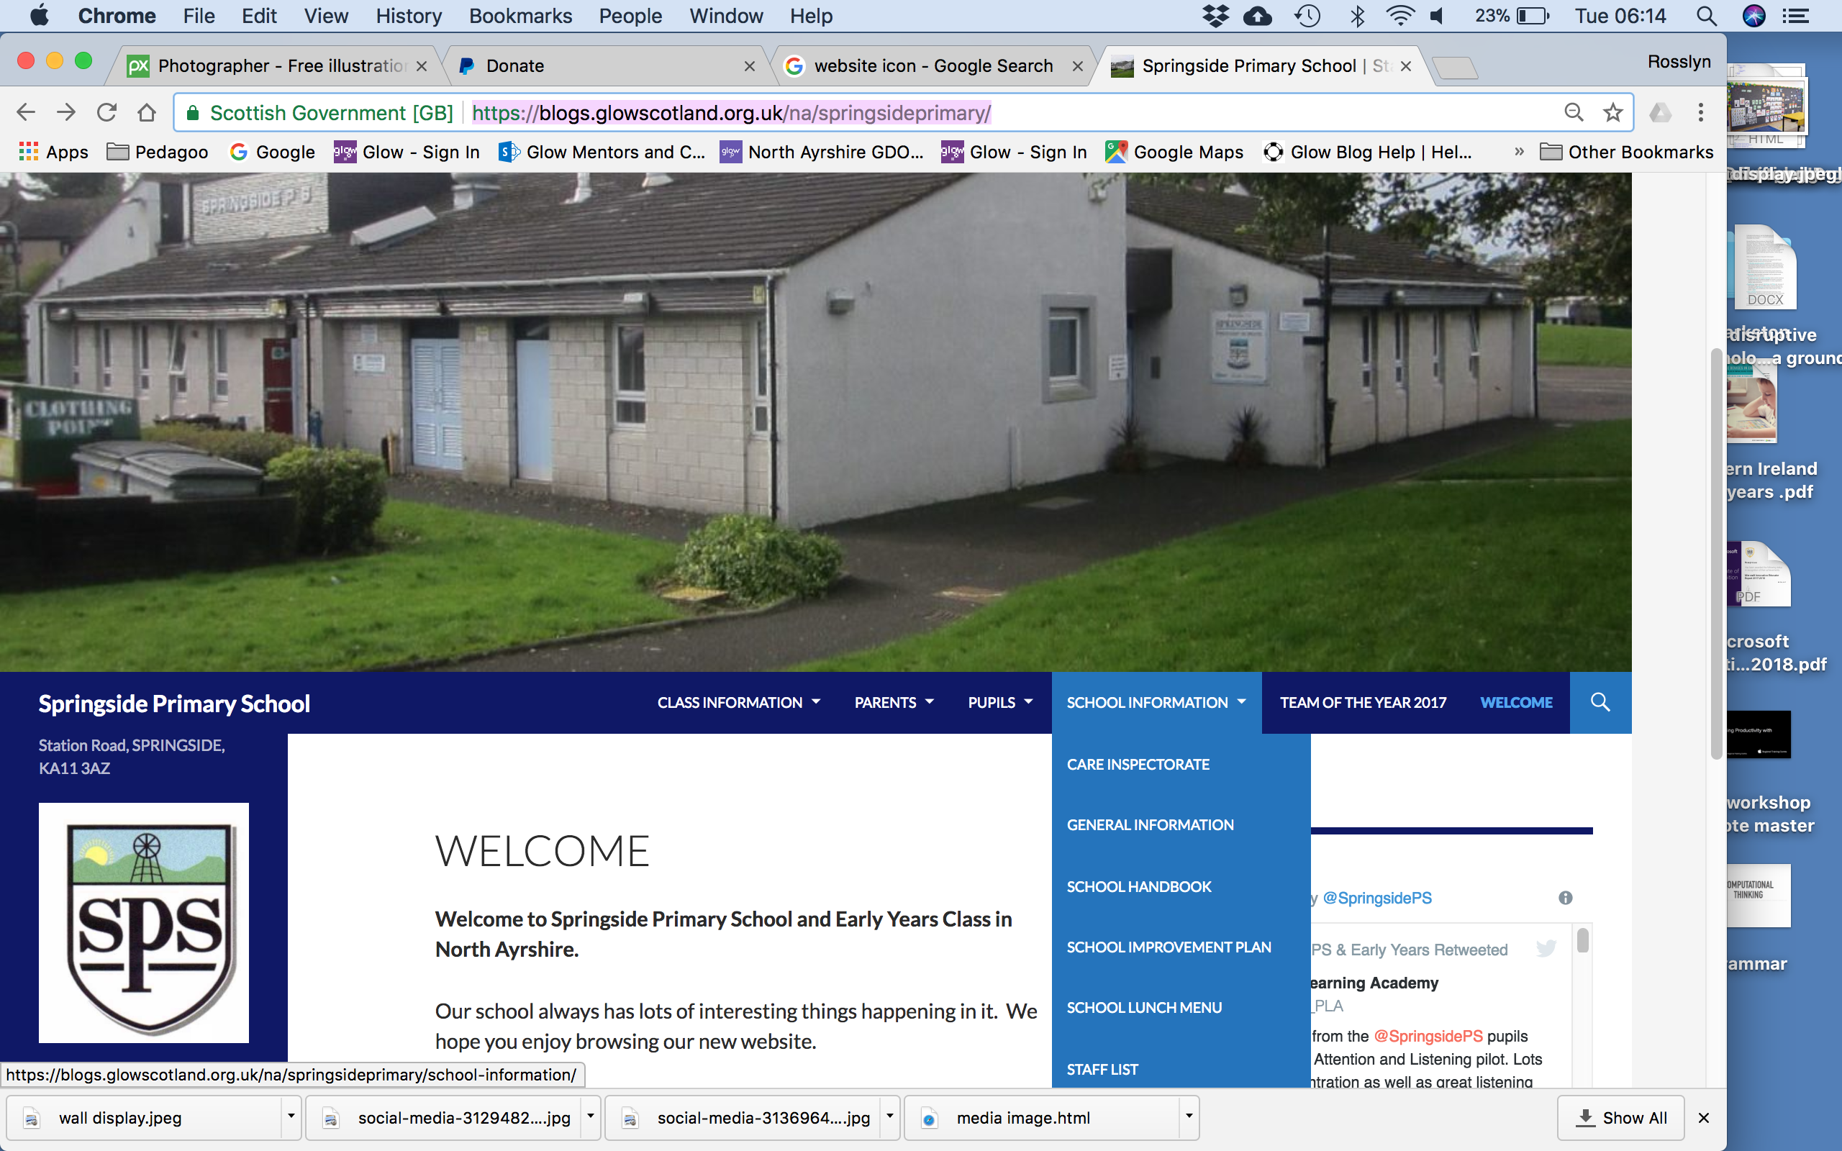  Yes No
- I give permission for my child’s photograph to appear in the media | Yes No
- I give permission for my child to have an official school photograph taken | Yes No
- I give permission for my child to have a photograph taken for their Young Scot Card | 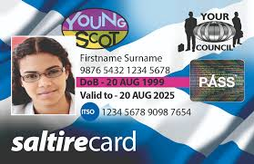  Yes No
- I give permission for my child’s photograph to be used on the school’s social media sites - Facebook/Twitter | Yes No

I acknowledge that this form covers photographs taken by other North Ayrshire Council staff eg. Libraries, Education Resource Service, possibly for use on their Twitter/Facebook pages.

I have read and understood the conditions of use.
Name of Child: Class:

Name of parent/carer:
Signature of parent/carer: Date:
Actions in relation to social media filming and photography
We will not:
- use the name of a child in accompanying text or photograph caption if we use photographs of individual pupils or groups
- re-use any photographs or recordings after your child has officially left this school. Historic photographs will remain on our school website, on display in the school and on social media feeds
- retweet or share photographs of pupils taken by personal accounts this includes staff / parents / carers and pupils
We will:
- only take photographs of pupils on school cameras, school mobile phone or school tablets.
- take photographs of pupils which don’t specifically identify them or their name. We will ask for special consent for prize giving ceremonies and award presentations, where the name of the pupil will be public
- only use official school accounts to post photographs of pupils
- store physical photographs securely in a locked cupboard and digital photographs will be stored on an encrypted computer or school server
- always let parents / carers / assembled guests know on arrival and the start of an event that they are not able to take photographs of pupils other than their own child. We will use the statement:
“We request that you do not take pictures of our pupils / guest speakers for any purpose including social media.”
- keep all social media consent forms up-to-date, reviewed annually and securely stored
- only use photographs of pupils who are suitably dressed to reduce the risk of such images being used inappropriately
- make every effort to ensure that we do not allow photographs to be taken of any children for whom we do not have permission or who are ‘at risk’ or disallowed from having their photographs taken for legal or social reasons
- take all reasonable measures to ensure the photographs are used solely for the purposes for which they are intended
- only use photographs of activities that show the school and children in a positive light. We may use group or class photographs or footage. Children will not be individually named
- use group or class photographs or footage with very general labels, such as ‘a science lesson’ or ‘making Christmas decorations’
Conditions of Use
1. This form is valid for one year or until a subsequent form completed and signed by the parent is submitted. It is your responsibility to write to the school if you wish to withdraw consent at any time.
2. We recognise that parents, carers and family members may wish to record events such as school plays and sports days. Unfortunately we cannot allow this as there may be children in the school who are under Child Protection and cannot, under any circumstances be photographed.
3. Websites and social media platforms can be viewed throughout the world and not just in the United Kingdom where UK law applies.

Information Rights
If you would like to learn more about your information rights or have a concern about the processing of your child’s personal data, you can view further information on how we handle data and find out how to contact our Data Protection Officer, on our website at:
https://www.north-ayrshire.gov.uk/privacy-policy.aspx

