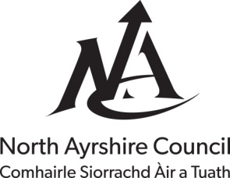

North Ayrshire Council
Education and Youth Employment

VPP Request Form

Instructions
- Identify the details and number of apps you wish to purchase.
- Enter the budget details
- Identify the iPads you wish the app to be downloaded to and take a note of the serial numbers (These can be found in SETTINGS-GENERAL-ABOUT)

School
Contact
Name of App
App Developer
Cost Per App |  | No. Required |  | Total Cost
Budget Details
Account Number |  |  | Cost Centre
iPad Serial Numbers
Please email completed form to Rosslyn Lee at rosslynlee@north-ayrshire.gov.uk

What next?
- You will receive email notification confirming the apps have been purchased centrally and downloaded to the requested iPads. Please allow 28 days for this to be completed.

