Greenwood Academy
Building Our Curriculum
Introduction of 10-minute Health and Wellbeing/Registration for all pupils
As part of Greenwood’s Covid-19 recovery and in response to meeting the needs of all pupils, we have introduced a health and wellbeing check-in each morning. This means that every young person meets with a key adult daily, before learning begins, so that supports can be put in place first thing if required.
Rationale
A curriculum should meet the needs of pupils and should be adaptive, flexible and under review to provide what pupils need. Since returning from lockdown many pupils have struggled to engage in learning and have required to speak to a key adult about home, school and community issues. A readiness to learn conversation centred on wellbeing before they engage in learning can make a huge difference to a young person. Advice about social/peer interactions, learning, exams can develop resilience in a young person and allow them put strategies into place first thing in the morning so that they can better engage with school throughout the day. Supporting pupil regulation first thing in the morning can help engagement in learning from period 1 and builds a trusting, strong relationship with the key adult.
The key adult will play their part in sharing expectations and their expertise will allow a greater focus on readiness to learn, attendance and personal pupil targets. They will also deliver pupil inputs in response to community issues such as litter, anti-social behaviour and other external influences that affect our school community. The key adult will have an overview of the young people’s health and wellbeing and can monitor this, along with the Guidance Teacher, on a daily basis.
As part of the curriculum review, we have explored different ways of offering health and wellbeing support but the daily interaction, first thing in the morning, allows early interventions to be put in place. It allows us to engage other partners first thing in the morning if required (partners – school nurse, school counsellor, Health & Social Care Partnership etc.), rather than having our young people worry throughout the day. We believe it is the most effective way of providing this support to all pupils.
Health and Wellbeing/Registration will support pupils to understand our school values and help us to promote the wellbeing indicators.

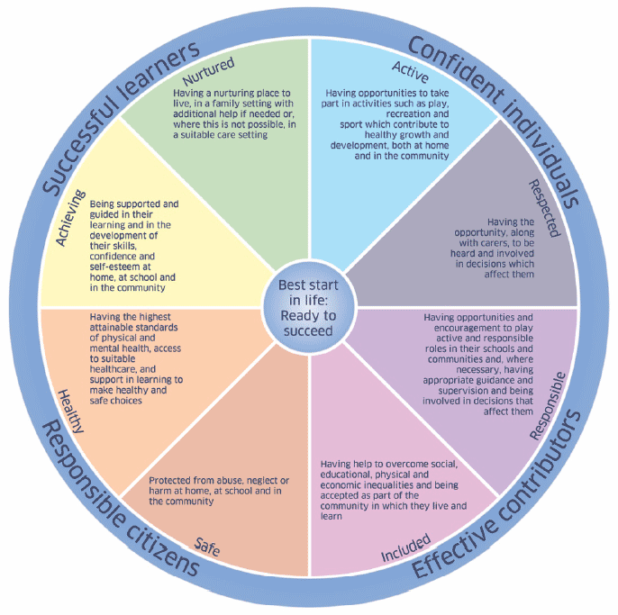

Expectations:

- Pupils/Staff follow the Core Standards for Positive School Ethos and Effective Learning. The pupils are in class for 10 minutes and should follow the agreed routines that are expected period 1-7.

- The slides are shown to the pupils during the time allocated. Discussion, debate and reflection are encouraged to ensure that the pupils fully understand the content of the slides and their importance on their wellbeing, safety and development.

- As a key adult with regular contact, it is important that teachers use the 10 minutes at the beginning of the day to promote wellbeing, uniform and ensure pupils have equipment for the day ahead. Any concerns should be passed onto Guidance teachers discretely.

- If the slides are covered at the beginning of the week then extend into the following activities (list not exclusive) –

- Personal reading, S1-3 should have a library book in their bag.
- Revisit previous slides for reinforcement.
- Look at BBC News and engage with one of the news stories.
- Seek their views and ask for feedback. Feel free to share their feedback on a particular topic with the Year Head/Guidance teacher.
- Further relationship building activities.
- Show pupils websites to promote independent learning and revision - https://www.bbc.co.uk/bitesize or https://www.e-sgoil.com/
- Ask pupils ‘What would you do if…’ to promote discussion and check understanding
(saw someone being hurtful/unkind to someone, someone approached you online that you didn’t know, you were falling behind in a subject etc.)

