Greenwood Academy
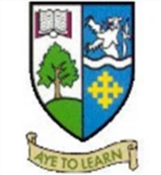
Building Our Curriculum Rationale

What informs our Curriculum in Greenwood Academy?

There are a number of national and local priorities shaping our curriculum rationale. Central and still relevant to our curriculum structure are documents such as the Building the Curriculum series, the CFE Briefing Papers and Curriculum for Excellence Benchmarks.

Key links/documents
- Benchmarks – The Curriculum for Excellence Benchmarks set out clear statements about what learners need to know and be able to do to achieve a level across all curriculum areas.
- Experiences and outcomes (often called Es+Os) are a set of clear and concise statements about children's learning and progression in each curriculum area. They are used to help plan learning and to assess progress.
- Principles and practice - The principles and practice documents are essential reading for practitioners as they begin, and then develop, their work with the statements of experiences and outcomes.
- Building the Curriculum - The 'Building the Curriculum' document series provides advice, guidance and policy for different aspects of Curriculum for Excellence including: the curriculum areas assessment; and developing skills for learning, life and work.

In 2017, the Scottish Government published the National Improvement Framework outlining key national priorities. The document outlines a vision for Excellence through raising attainment, ensuring that every child achieves the highest standards in literacy and numeracy and the right range of skills, qualifications and achievements to allow them to succeed. Achieving equity by ensuring every child has the same opportunity to succeed is also part of the vision and very much part of our whole school vision.

Key priorities of the National Improvement Framework.

- Improvement in attainment, particularly in literacy and numeracy.
- Closing the attainment gap between the most and least disadvantaged children.
- Improvement in children and young people’s health and wellbeing.
- Improvement in employability skills and sustained positive school leaver destinations for all young people.

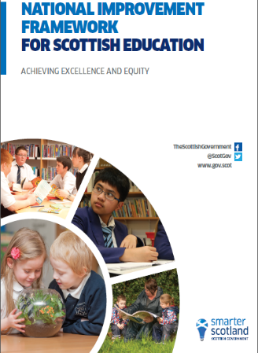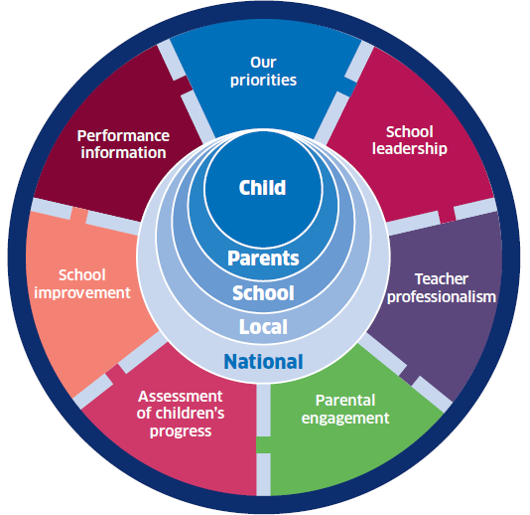
More locally our curriculum is informed by the school vision and our values.
Our Values

Our Aspirational Statement

Pupils at Greenwood Academy will receive high quality feedback to support them to become effective learners. Pupils will fully engage and take responsibility for their own learning. They will feel confident to challenge themselves and be determined to achieve success and develop key skills. Teachers will facilitate learning conversations and actively participate in moderation activities which develop professional practice to enhance pupil outcomes. Progress will be tracked within classes, departments and across the school to ensure timely interventions if required. We will work in partnership with health professionals and other partners to ensure pupils receive support and are motivated to learn.

The Structure

Curriculum for Excellence is divided into two phases: the Broad General Education and the senior phase. The Broad General Education begins in early learning and childcare (at age 3) and continues to the end of S3 (the third year of secondary school). Its purpose is to develop the knowledge, skills, attributes and capabilities of the four capacities of Curriculum for Excellence:
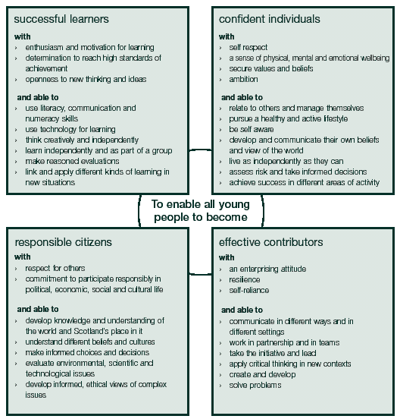

It is designed to provide the breadth and depth of education to develop flexible and adaptable young people with the knowledge and skills they will need to thrive now and in the future. It aims to support young people in achieving and attaining the best they possibly can.
During the Broad General Education, children and young people should:
- achieve the highest possible levels of literacy, numeracy and cognitive skills
- develop skills for learning, skills for life and skills for work
- develop knowledge and understanding of society, the world and Scotland's place in it
- experience challenge and success so that they can develop well-informed views and the four capacities.

There are eight curriculum areas: expressive arts, health and wellbeing, languages (including English, Gàidhlig and Gaelic learners and modern languages), mathematics, religious and moral studies, sciences, social studies and technologies.
Each curriculum area is planned using experiences and outcomes. These describe the knowledge, skills, attributes and capabilities of the four capacities that young people are expected to develop.

Transition from Primary to Secondary
Strong curriculum links are developed across our Education Group through our Improvement Plan and Moderation Plan. Our Curricular Transition Programme involves regular visits by P6 and P7 pupils to the secondary and by secondary staff in a number of departments visiting Primary Schools to work with pupils.
Curriculum for Excellence includes four contexts for learning:

- Curriculum areas and subjects
- Interdisciplinary learning
- Ethos and life of the school
- Opportunities for personal achievement.

Curriculum for Excellence Benchmarks set out clear statements about what learners need to know and be able to do to achieve a level.

Learning in the Broad General Education may often span a number of curriculum areas (for example STEM). This is likely to be in the form of themed or project learning which provides children and young people opportunities to show how skills and knowledge can be applied in interesting contexts. The term often used for this is interdisciplinary learning.

During S3, we prepare young people to make a smooth transition from Broad General Education Experiences and Outcomes into courses leading to qualifications, other awards and work-based learning, as appropriate to their needs. Although formal qualification courses will not begin before S4, learning which takes place in the Broad General Education contributes to learning for qualifications without compromising the entitlement to a Broad General Education in S3. This means that some National 4 or National 5 Unit Outcomes or Assessment Standards may well be overtaken in S3.

Skills Development

Throughout the curriculum there is a particular focus on supporting skills development and helping young people prepare for the world of work. Through our focus on developing higher order thinking skills and skills for life, learning and work we are committed to delivering a curriculum which promotes creativity.

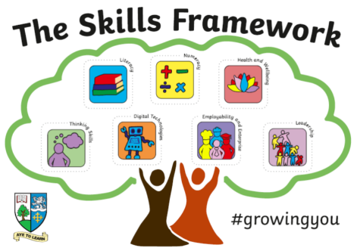

Our Wider Achievement Programme promotes the development of key skills and puts community engagement and outdoor learning at the centre. We provide regular, frequent, enjoyable and challenging opportunities for all young people to learn outdoors throughout their school career and beyond. Teachers embed outdoor learning in the curriculum so that learning in the outdoor environment becomes a reality for young people.

Throughout the Broad General Education and Senior Phase pupils learn about the world of work and job possibilities and which makes clear the strengths and skills needed. Real-life contexts are brought into the classroom (e.g. STEM) and staff develop skills and attributes for employment. Pupils receive career information, advice seminars and workshops from Skills Development Scotland Careers Advisor and Pupil Support Teachers. They are supported with job applications, CV writing and interviews. High quality work placements, work visits or work shadowing opportunities are available and many of our Business Partners provide flexible work placements to meet the needs of individual young people.

Senior Phase

The Senior Phase will cover 3 years with exit points as appropriate to individual pupil aspiration and plans. In S4 of the Senior Phase pupils will study up to 7 subjects including Maths and English to ensure all pupils leave the Senior Phase with a qualification in these two areas at the highest level they are capable of. In S5/6 pupils will study up to 5 subjects or timetabled experiences each year at an appropriate level. Breadth will be further enhanced by viewing S4-S6 as an integrated phase as pupils build on their qualifications over the three years. Breadth will also be achieved through ensuring a number of achievements, personal development and vocational opportunities are offered as an integrated part of the curriculum.

All learners are entitled to experience a senior phase where they can continue to develop the four capacities and achieve qualifications. The flexibility of Curriculum for Excellence has allowed us to develop new progression pathways to ensure we meet the needs and aspirations of all of our young people. This includes new pathways to motivate groups of learners delivered in partnership which includes neighbouring schools, colleges and other education providers. This ensures a broader range of progression pathways and access to a wider range of qualifications, including those with a direct application to employment.

All young people in Scotland have an entitlement to a senior phase of education which:

- provides specialisation, depth and rigour
- prepares them well for achieving qualifications to the highest level of which they are capable
- meets the needs of individuals or groups of learners with additional support needs (often a more customised curricular programme designed to ensure full entitlement)
- continues to develop skills for learning, skills for life and skills for work
- continues to provide a range of activities which develop the four capacities
- supports them to achieve a positive and sustained destination

Greenwood Academy also offers bespoke pathways to meet pupil needs –

- Nurture
- Green Gym
- STEM
- Flexible Pathways
- School-College Courses
- Foundation Apprenticeships
- Open University Courses

Health & Wellbeing

Health and wellbeing (HWB) underpins our curriculum, ensuring that young people develop the knowledge and understanding, skills capabilities and attributes which they need for mental emotional, social and physical wellbeing now and in the future. Working with partners, we take a holistic approach to promoting HWB, one that takes account of stage of growth, development and maturity of each individual, and the social and community context. Pupils can expect the learning environment and every teacher to support them to:

- Develop self-awareness, self-worth, respect for others and responsibility for learning (next steps)
- Meet challenges, manage change, build relationships and manage risk
- Experience personal achievement and build resilience/confidence to make informed choices
- Understand and develop physical, mental and spiritual wellbeing and social skills (Healthy Lifestyle)

Progression Pathways are being developed for each curricular area.

Parental Engagement

The importance of full consultation and engagement with parents is extremely important. Work on our senior phase pathways began in October 2015 with extensive consultation within the school community. Information evenings were held to explain our planned approach and the proposed model. We have a very strong and supportive Parent Council and we work closely with them to continue to reflect on our curriculum.

Monitoring the Effectiveness of Our Curriculum

We use How good is our school? (4th edition) to evaluate our work, to support professional discussion and reflection and to help plan for improvements. In particular, Quality Indicator 2.2 Curriculum has key features of effective practice and challenge questions which help with planning, evaluating and improving the curriculum.

