

**Education Service**

**Gateside Primary School & Early Years**

**Improvement Plan**

**2025-2026**





**Vision, Values and Aims**

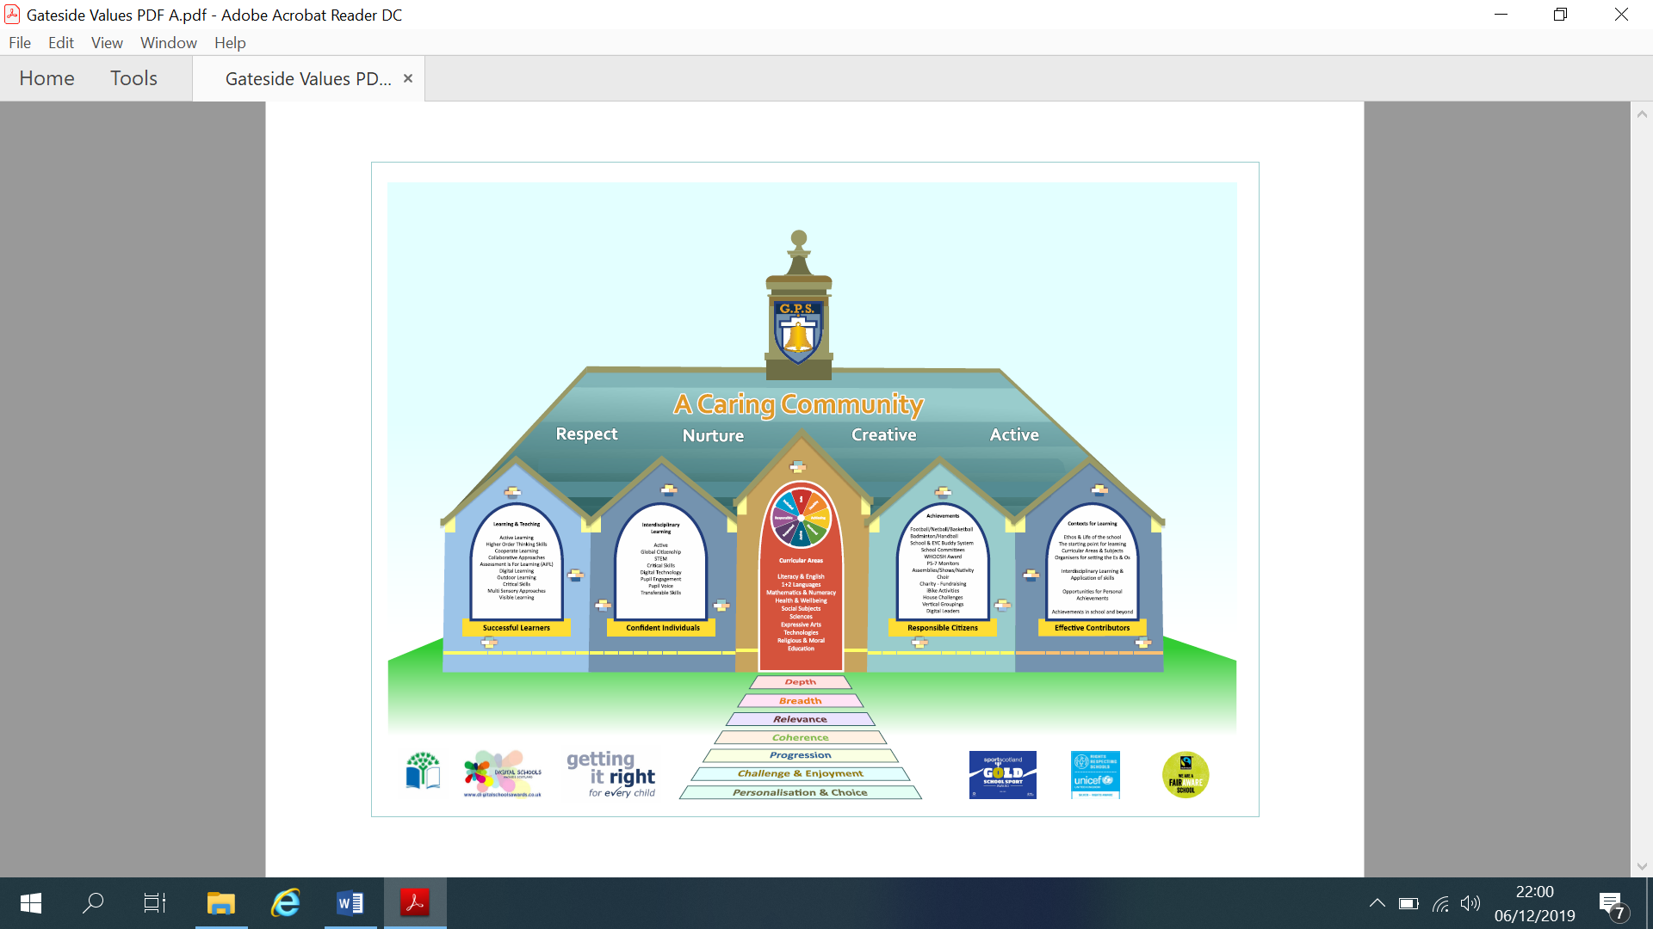

**EDUCATION SERVICE: IMPROVEMENT PLAN SUMMARY 2023/4 – 2025/6**

The Education Service Improvement Plan is aligned to the 5 priorities of the National Improvement Framework. Individual establishments should create their own plan under these 5 priorities, based on rigorous self-evaluation and analysis of performance evidence. Stakeholders should be fully engaged in the development of the plan. In the diagram below, the orange boxes show the thematic areas under each priority which the service intends to focus on in the year ahead.

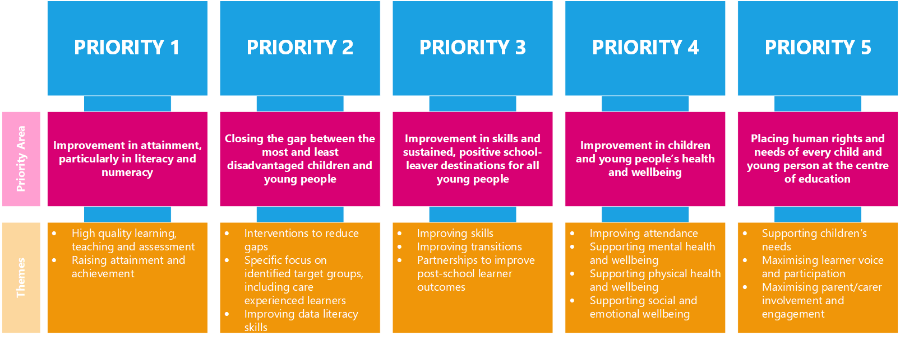

|  |  |  |  |
| --- | --- | --- | --- |
| **PRIORITY 1** | | | |
| **Strategic Objective:**  **To improve attainment in Literacy & Numeracy through identifying and sharing best practice and pedagogy to promote high quality learning, teaching and assessment (NAC Priority 1).** | | | |
| **Select the KEY drivers for this improvement priority** | | | |
| **Education Service Priority**  *Please select the relevant service priorities* | **NIF Drivers of Improvement**  *Please select up to three NIF drivers* | **How Good Is Our School 4**  *Please select up to three quality indicators for this priority* | **Quality Improvement Framework for ELC settings**  *Please select up to three quality indicators for this priority* |
| 1. Improvement in attainment, particularly literacy and numeracy  Choose an item. | 2. Teaching and practitioner professionalism  5. School & ELC improvement  4. Curriculum and assessment | 2.3 Learning, teaching and assessment  2.2 Curriculum  3.2 Raising attainment and achievement | **3.1 Play and learning**  **Curriculum**  **4.3 Children's progress** |
| **Rationale for Change**  *Attainment data this session highlights numeracy and writing attainment, especially for P3, 4 & 6 as areas requiring intervention.*  *In numeracy, there are significant reductions in attainment for most stages and in particular at P2. A return to focusing on developing daily number sense, play based provocations and a re-focus on the progression pathways to refresh approaches to teaching numeracy , alongside building in further assessments at key points, will aid teachers in planning next steps for learners to enhance progress.*  *In P3, there is a 17.1% gap between reading and writing attainment and in other stages this varies from around 8% to 12%. Whilst staff CLPL and fun daily writing activities have increased*  *engagement and enjoyment in writing over this session (survey results), staff now need to embed this practice consistently to further impact on attainment. PEF resources will be invested to support and improve reading & writing attainment (PSA). Maintaining reading for enjoyment, opportunities to read for many purposes and to different audiences alongside PLA interventions for talking and listening will enhance attainment in literacy.* | | | |

|  |  |  |  |  |  |
| --- | --- | --- | --- | --- | --- |
| PRIORITY 1: Action Plan | | | | | |
| Pupil Outcomes | **Implementation Plan** | **Timescales/**  **Responsibility** | **Measurement of Impact** | **Analysis & Evaluation of Progress** | **Cost**  **(PEF)** |
| *Specifically, what will change for our learners?* | *How will we achieve this?*  *What do we plan to do?* | *What are our timescales? Who will lead?* | *How will we know the change is an improvement? Can you quantify this?*  *What data will be collated and analysed to demonstrate progress? Consider baseline data.* | *How do we know that the experiences & outcomes for learners have improved? What does the data tell us which demonstrates impact?* | *Please enter the cost to the nearest £* |
| Learners will experience regular re-visits to concepts in numeracy and mathematics through number sense activities/language and pedagogy. Taught numeracy strategies will be consistent across the school. | Staff will have opportunities to attend a range of CLPL sessions both in-house and via PLA to focus on the delivery of numeracy strategies.  Training on number sense (PSAs), the use of manipulatives and 2nd level Numeracy planner.  Refresh SEAL/Number Sense/NAC numeracy framework | Beith/Gateside/Moorpark Numeracy working party/PLA by June ‘26 | Quality Assurance - Classroom observations, exit passes, learning walks.  Increased staff confidence in teaching numeracy and mathematics – data from pre-post training evaluations.    Pupil focus group feedback.  Attainment data – universal & targeted |  | Approx £1700 |
| Pupil’s progress in Numeracy will be enhanced through the use of new numeracy assessments to support teachers’ professional judgement. | Numeracy assessments will be created and integrated into pathways /planning. | Beith/ Gateside/ Moorpark SLT - Moorpark PT lead; working party.  June 2025 -26 | Numeracy pathways are enhanced with relevant assessments to support teachers professional judgements.  Attainment in Numeracy & Mathematics will increase by at least 5% in P3, P5 & P7. |  | Approx £1000 for resources |
| Identified learners will benefit from targeted support for numeracy / literacy. | Through assessment, targeted interventions and collaboration e.g. TST/CTs, staff will use STINT process to support learners progress. Use systems and strategies e.g. Word / Number works, Talk boost, Boosting Reading, Toe by Toe, 5 Minute Box etc. to target need.  Use Circle/SCERTS assessments to target support/actions. Sensory Circuits / Dyscalculia strategies shared.  Refresh SEAL/Number Sense/NAC numeracy framework  Targeted intervention plans to support identified learners. Using I can toolkit, talk boost, word/maths works and phonological awareness experiences. | CT/TST/CAs/SLT from Aug ’25  SEYP /EYP | Use data to predict progress or closing of the gap. Pupils requiring additional support will reduce by 2%.  The majority of targeted pupils will be working at expected levels by June 2026  Pupil focus groups will be able to articulate the skills they are learning.  Observed engagement and support in appropriate environments – visuals, displays, manipulatives etc.  Data from phonological awareness trackers, I can trackers and milestone attainment trackers will show progression and improvement. Progression will also be shown on Seesaw journals. |  | Approx £700 for resources |
| Consistent use of agreed SHORs, Talk for Writing / PM Reading/Writing for all pupils in a dyslexia friendly environment.  Embed new Phonic books using Science of Reading strategies in P1 to allow increased accessibility, pace and progression. | Refresh Dyslexia Friendly School principles and access training to ensure accessibility for all. PSA training @PLA  Share practice and embed Science of Reading / phonic strategies for P1 | All teaching staff (Beith & Gateside) | Pupils will have had increased opportunities to read aloud / write in other contexts |  |  |
| Pupils will experience taught listening & talking strategies and be able to demonstrate their learning in a variety of settings. | Undertake Oracy training (PLA) to enhance teaching of Listening & Talking skills. | All teaching (Beith & Gateside) staff Jan ‘26 | Monitor T& L results – gather evidence from Class Obs/Tracking meetings. |  |  |

|  |  |  |  |
| --- | --- | --- | --- |
| **PRIORITY 2** | | | |
| **Strategic Objective:**  **To improve and enhance digital learning to equip educators and our children and young people with the knowledge and skills to thrive in an increasingly digital educational environment.** | | | |
| **Select the KEY drivers for this improvement priority** | | | |
| **Education Service Priority**  *Please select the relevant service priorities* | **NIF Drivers of Improvement**  *Please select up to three NIF drivers* | **How Good Is Our School 4**  *Please select up to three quality indicators for this priority* | **Quality Improvement Framework for ELC settings**  *Please select up to three quality indicators for this priority* |
| Choose an item.  3. Improvement in skills and sustained, positive school-leaver destinations | 2. Teaching and practitioner professionalism  4. Curriculum and assessment  Choose an item. | 1.2 Leadership of Learning  2.2 Curriculum  3.3 Increasing creativity and employability | **1.2 Staff skills, knowledge, values and deployment**  **3.1 Plan and learning**  Choose an item. |
| **Rationale for Change**  We are aware of the need to create and support children to become responsible digital citizens, with enhanced potential for creativity and innovation, who are digitally literate and can succeed in life, learning and work. We aim to enhance learning and teaching for all learners, ensure equitable access for all and develop learner independence with greater digital opportunities for collaboration and communication. | | | |

|  |  |  |  |  |  |
| --- | --- | --- | --- | --- | --- |
| PRIORITY 2: Action Plan | | | | | |
| Pupil Outcomes | **Implementation Plan** | **Timescales/**  **Responsibility** | **Measurement of Impact** | **Analysis & Evaluation of Progress** | **Cost**  **(PEF)** |
| *Specifically, what will change for our learners?* | *How will we achieve this?*  *What do we plan to do?* | *What are our timescales? Who will lead?* | *How will we know the change is an improvement? Can you quantify this?*  *What data will be collated and analysed to demonstrate progress? Consider baseline data.* | *How do we know that the experiences & outcomes for learners have improved? What does the data tell us which demonstrates impact?* | *Please enter the cost to the nearest £* |
| Pupil’s digital learning will be enhanced as practitioners engage with digital technologies to improve learning, teaching and assessment. | Digital Literacy will be introduced, staff skills audit and pathways used to ensure progression and consistence of practice.  Cluster staff will work together to plan HQA activities and share assessment outcomes to moderate practice.  Training opportunities for staff identified through audit to learn new and enhance existing digital skills. | Sept In-Service pm – Cluster DHTs  Audit by June 2025  Training program established by Sept ‘25  Cluster Moderation– 12th Nov & 28th Jan | Pre - post questionnaires for staff / pupil evidence improved skills / confidence.  Staff will feel more confident in planning and assessing digital literacy / progress.  Pupils will be able to use digital tools to enhance their learning/skills.  Classroom observations, focus groups and /or learning walks to evidence impact for learners. Pre-post questionnaire/feedback |  | £1500 |

|  |  |  |  |
| --- | --- | --- | --- |
| **PRIORITY 3** | | | |
| **Strategic Objective:**  **Prioritise and promote the positive health and wellbeing of children & young people, through rights based learning and close partnership working to remove barriers to learning.**  **Implement / Embed skills progressions to support our play and skills based curriculum through the four contexts for learning, ensuring meta-skills are explicit and progressively taught across all areas. Review in line with Curriculum Improvement Cycle, Deep Learning and Progression Pathways (NAC Priority 3)** | | | |
| **Select the KEY drivers for this improvement priority** | | | |
| **Education Service Priority**  *Please select the relevant service priorities* | **NIF Drivers of Improvement**  *Please select up to three NIF drivers* | **How Good Is Our School 4**  *Please select up to three quality indicators for this priority* | **Quality Improvement Framework for ELC settings**  *Please select up to three quality indicators for this priority* |
| 5. Placing human rights and needs of every child and young person at the centre of education  4. Improvement in children and young people's health and wellbeing | 2. Teaching and practitioner professionalism  4. Curriculum and assessment  6. Performance information | 1.3 Leadership of change  3.1 Ensuring wellbeing, equality and inclusion  3.3 Increasing creativity and employability | **3.1 Play and learning**  **Curriculum**  **4.2 Wellbeing, inclusion and equality** |
| **Rationale for Change**  Pupils require continued support with their mental health and wellbeing more than ever. In order to learn and retain learning, our learners need to feel safe, valued and nurtured.  We require a ‘back to basics’ approach, where learners, and meeting their needs appropriately, are at the heart of everything we do. Supporting staff to provide high quality, appropriate environments suited to learners needs, have restorative conversations, de-escalating, redirecting, co-regulating with learners and being able to support them to access their learning e.g. visuals, sensory circuits, SCERTs plans, nurture/safe spaces, trusted adults etc.  Pupils benefit from targeted and whole school nurture practices enabling better engagement and learning (achievements and progress from prior levels of attainment). Children’s rights are embedded and learning about our rights and values is woven into our curriculum.  Through our self-evaluation (classroom observation & pupil focus groups), our pupils are more able to talk about the skills they are developing through their STEM / ART / Problem Solving or Outdoor learning activities. Our HMIe Summary of Inspection Findings (SIF), supports this self-evaluation and concludes that ‘teachers should support children to recognise the skills they are developing’ and that pupils would ‘benefit from more opportunities to apply skills in challenging contexts’. We wish to track progress in skills across all areas of the curriculum for EY – P7 and use a framework to support this with staff and partners. Next steps in Skills based/play based learning will be to trial progression pathways and recording systems that are manageable, relevant and build on prior learning. | | | |

|  |  |  |  |  |  |  |  |
| --- | --- | --- | --- | --- | --- | --- | --- |
| PRIORITY 3: Action Plan | | | | | | | |
| Pupil Outcomes | **Implementation Plan** | **Timescales/**  **Responsibility** | **Measurement of Impact** | | **Analysis & Evaluation of Progress** | **Cost**  **(PEF)** | |
| *Specifically, what will change for our learners?* | *How will we achieve this?*  *What do we plan to do?* | *What are our timescales? Who will lead?* | *How will we know the change is an improvement? Can you quantify this?*  *What data will be collated and analysed to demonstrate progress? Consider baseline data.* | | *How do we know that the experiences & outcomes for learners have improved? What does the data tell us which demonstrates impact?* | *Please enter the cost to the nearest £* | |
| Learners will feel safe and able to learn based on relational practices  Pupils will enjoy school life and treat each other with kindness and respect.  Pupils with specific issues e.g. self harm, will be supported.  In Early Years our children have lots of leadership and learning opportunities to develop resilience and strategies for coping as they learn. | Use Circle Resource to enhance environments to meet need. Build positive relationships in class,  Cluster research project with Educational Psychologist  Review & refresh Vision Values and Aims (VVA) with all stakeholders.  Access services to support as required – Ed Psych, School Nurse, 3rd Sector.  EY PAThS curriculum and helpers implemented to encourage empathy, respect and kindness with new mindfulness and relaxation space for self regulation. | Ed Psych / SLT/CTs/PSAs  Aug – Dec  SLT/All stakeholders  Aug ‘25  On-going  All EYC staff 25 | Pre-post questionnaires.  Attainment improves overall – 5%  School VVA will reflect our current practice and curriculum.  Survey results / feedback widely shared.  Pupils supported recover / improve.  Milestone trackers and personal learning journals will show progression. | |  | £700 for resources | |
| Pupils (and all stakeholders) interact positively with peers and adults to ensure quality learning.  Pupils will have a positive view of their mental health and wellbeing & know how to maintain it. | Further embed RRS across the school – charters / learning  Reinforce ‘Decider Skills’ programme/HWB prog/ Wellbeing Assessments to support trusted adult relations.  PAThs activities to enhance coping strategies and resilience. Continue PPR /consistency. | DHTs/CTs/CAs  Aug ‘25 & On-going EYC | Quality assurance processes will evidence changes in pedagogy & systems. PASS survey results will improve.  RRS evidence will support on-going rights based learning. PPR policy updated as required.  Low level disruption is minimised. |  | | |  |
| Targeted pupils will be able to engage more effectively in their learning. | Offer targeted solutions as required to support those in need – outdoor learning, brain breaks, feeling thermometer.  Identify and support need quickly and effectively.  Whole School Nurturing approaches – self evaluation and actions based on findings. | SLT / PT / all staff  Jun ‘26 | Wellbeing plans, targets are met, Boxall results; Pupil focus groups to discuss the Promise. Cared Experienced and all other pupils have a voice and are listened to.  My World Triangles completed and reviewed regularly  Wellbeing Wheels | |  | Approx  £700  resources | |
| Pupils will experience coherent, progressive skills based learning. | Explore Deep Learning pathways to track skills development. | SLT/CTs from Aug ‘25 | Pathways used to track CfE subject coverage via skills based learning.  Staff feedback, quality transition data is shared. | |  |  | |

**This should only be completed for aspects of your PEF spend not included within your Improvement Plan priorities.**

|  |  |  |  |  |  |
| --- | --- | --- | --- | --- | --- |
| **PEF contact - HT or DHT with responsibility for the plan:** | | | Fiona Dunlop | | |
| **Carry forward:** | £2,540.00 | **Total Allocation:** | £5,400.00 | **Total:** | £7,940.00 |

|  |  |  |  |  |  |  |
| --- | --- | --- | --- | --- | --- | --- |
| PEF Action Plan | | | | | | |
| Poverty Related Gap | **Pupil Outcomes** | **Implementation Plan** | **Timescales/**  **Responsibility** | **Detail of Spend** | **Measures of Impact** | **Analysis & Evaluation of Progress** |
| Provide details of the gap or barrier you wish to address. | Specifically, what will change for our learners? | What do we plan to do to achieve this outcome? | What are our timescales?  Who will lead? | Record cost & provide concise detail of what this entails. | How will we know the change is an improvement? Can you quantify this? What data will be collated and analysed to demonstrate progress? Consider baseline data. | What does the data tell us? How well is evidence from self-evaluation analysed to improve pupil outcomes? How is the spend contributing to narrowing our attainment gap? |
| Pupils are supported according to need linked to SIMD level. | Targeted pupils will be able to engage more effectively in their learning, understand their emotions and self-regulate. | Provide tailored Nurture style support for identified learners/ groups. Target learning as required. | SLT/TST staff  March ‘26 | £ 2,540 for PSA supporting nurture/learning. | Use of data e.g. Boxall, PASS, ACEL. My World Triangle/Wellbeing wheel |  |
| Equity profile reflects gaps for staff to target through universal & enhanced universal provision. | Pupils will be more able to identify skills and actions required to improve learning. | SIMD 1-4 pupils are detailed for staff and equity reviewed at tracking meetings  Skills based, digital and outdoor learning is enhanced. | SLT/PST/CT/CAs | £3200 lit/num/skills resources to support skills based learning | Impacts of interventions reviewed at tracking meetings  Data gathered through pre/post assessments. |  |
| Enhanced Environments to support engagement | Learners needs will be better met as the environment supports them. | Use circle resource to identify resources to support learners | CT – Aug ‘25 | £700.00  Wobble chairs, cushions, soft furnishings.  Display boards (covered | Attainment statistics for SIMD 1-4. Survey, better engagement in learning |  |