SUPPORTING OUR PUPILS
Through the provision of a
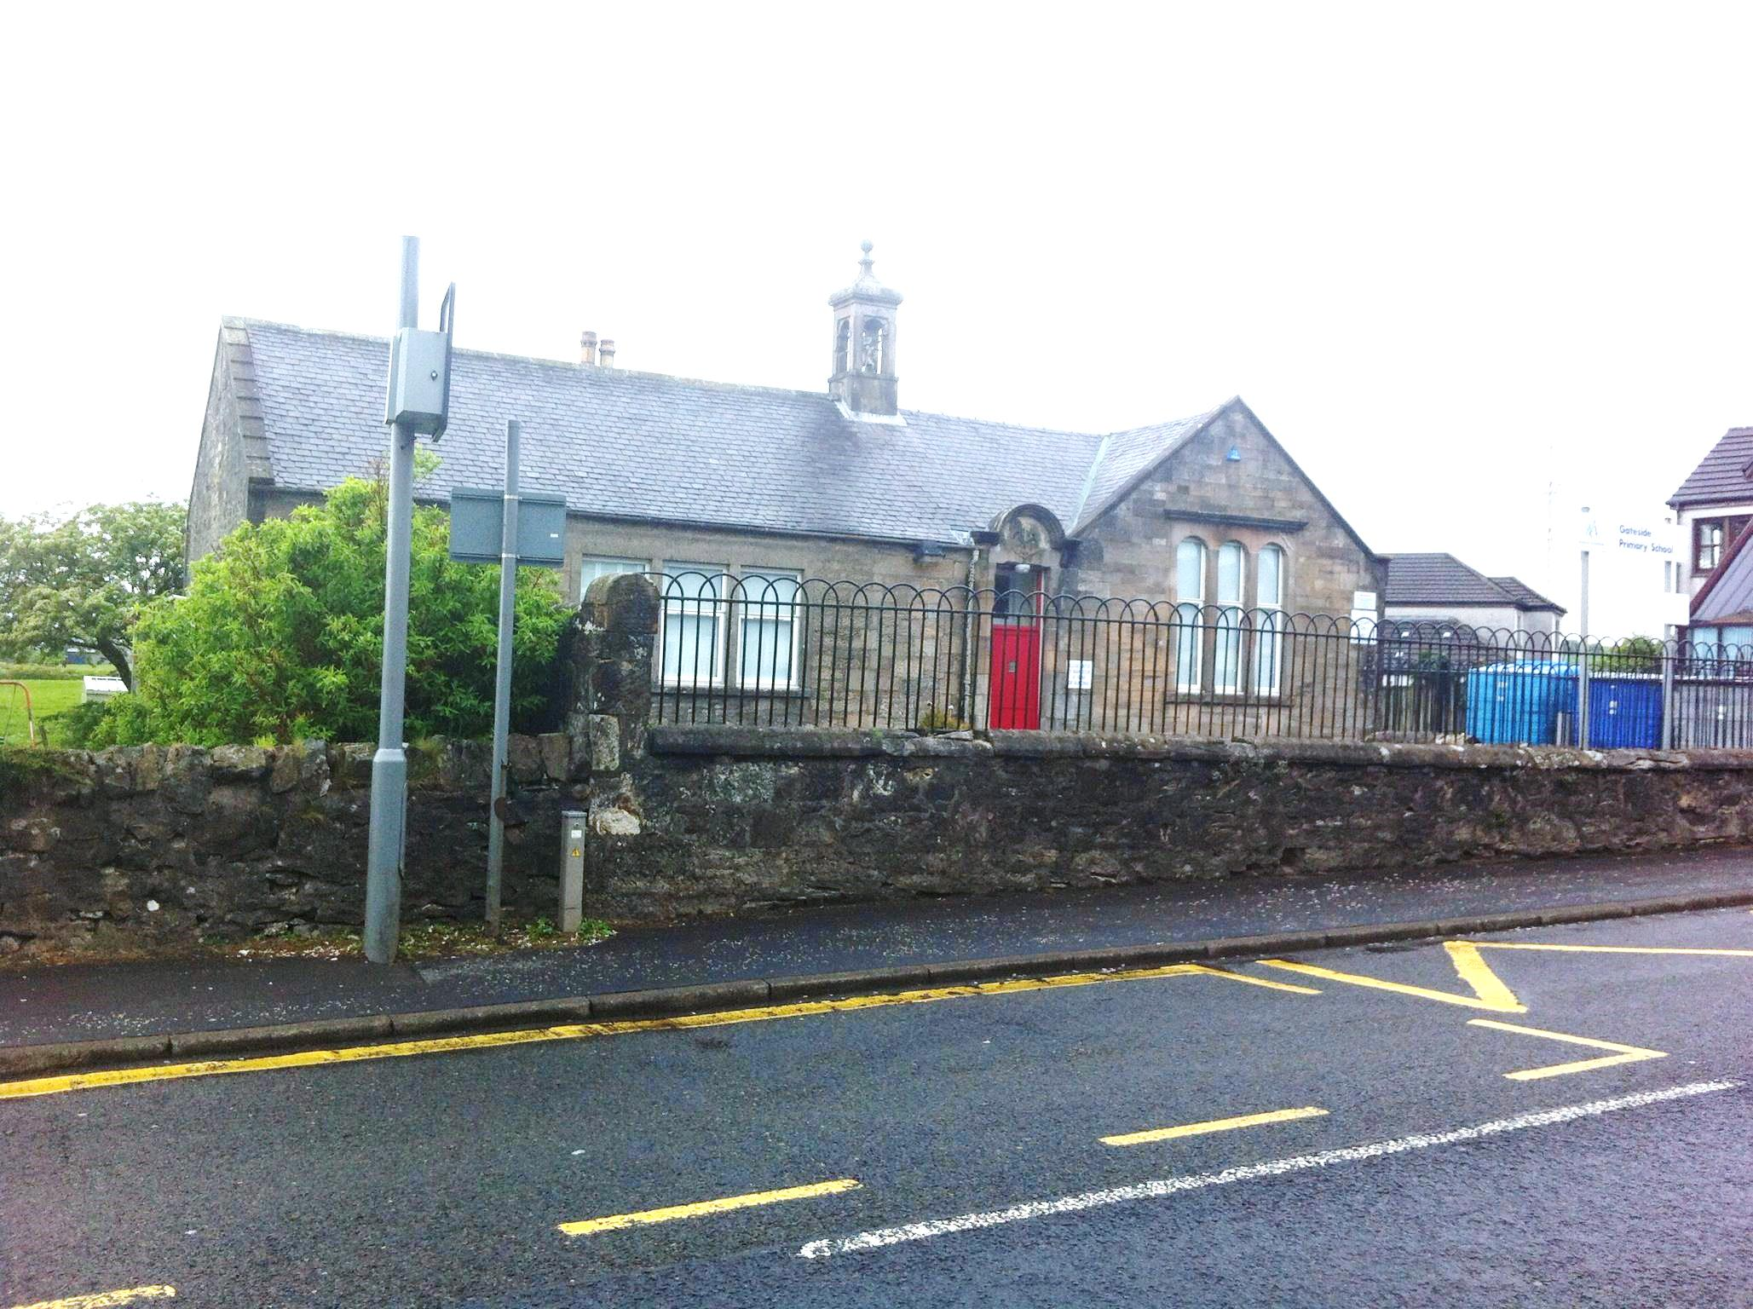
BROAD GENERAL EDUCATION (BGE)
Which
“brings the real world into our classrooms and
takes our classrooms out into the real world”
2017-18

GATESIDE PRIMARY SCHOOL – SUPPORTING OUR PUPILS
Session  2017-18 | Pupils Involved |  | Other Partners Involved |  | Details of Activity/Event
August | Whole School  Whole School  Whole School  P6/7  P1  P1-3  P4-7  P4-7  P6/7 |  | Mr Young  Pupils, Staff  Pupils, Staff  Mrs McGowan, Mrs Logan, Mrs Kelly  Ardrossan & Saltcoats Herald Photographer  Mrs Kelly-Class Teacher, Pupils  Mrs Logan & Mrs Wylie, Pupils  Miss Erin Hill, Pupils  Mrs Reid-Class Teacher, Pupils |  | Assembly  House Captain Elections  Committees  Badminton World Championships  Photograph taken of P1’s for newspaper  Afterschool Activity-Team Sports/Games-Tues  Afterschool Activity-Netball-Mon  After School Activity-Football-Thurs  After School Garden Club-Tues
September | Whole School  Whole School  Whole School  Whole School  Whole School  P4-7  P4-7  P4-7  P6/7  Whole School  Whole School |  | Rev McDonald, Staff, Pupils  Parents/Pupils/Staff  All pupils  All pupils/Emily Farquhar  Roald Dahl Day  Miss Erin Hill, Pupils  Mrs Logan & Mrs Wylie, Pupils  Mr Jordan Richards/Mr Stuart McCall, Pupils  Pupils/Mrs Kelly/Robin  NSPCC/All pupils/Staff  Pupils/Staff/Parents |  | Assembly  Open Evening – Focus on Literacy  Entries for Flower Show  Scooter Sessions  Children to wear PJs  Afterschool Mixed Sport - Wed  Afterschool Activity-Netball-Mon  Afterschool Activity-Football-Thurs  Rugby lessons  NSPCC Presentation  MacMillan Coffee Afternoon
GATESIDE PRIMARY SCHOOL – SUPPORTING OUR PUPILS
Session  2017-18 | Pupils Involved |  | Other Partners Involved |  | Details of Activity/Event
October  November | Whole School  P6/7 Pupils  Whole School  P6/7  P6/7  Whole School  Whole School  Whole School  P1/2/3  Whole School  P6/7  P3/4/5  Whole School  Whole School  P5 & P6  Whole School  Whole School  P4-7  P1-3  P4-P7  P1-P7  P7  Whole School  Whole School  Whole School  Whole School  P4-P7  Whole School  P4-P7  P6 & P7  P4-P7  P1-P7  P4-P7  Whole School  Selection of Pupils  Girls Football Team  P6 & P7  Choir  P1  P4-P7  Whole school |  | Mr Young  NSPCC, Mrs Kelly  Zoolab  Ranger Pete, Mrs Kelly  Mrs Kelly, Robin  Parents/Pupils/Teachers  Pupils/Teachers  West FM/Pupils/Zoe Kelly  Pupils/Mrs McGowan/Miss Krawczyk  Emily Farquhar/Pupils  Pupils/Mrs McGowan/Mrs Taylor  Ranger Pete/Mrs Reid/Miss Dunlop/Pupils  Pupils/Staff  Pupils/Staff/Parents/Rev. McDonald  Pupils/Mrs McGowan/Jordan Thomson  NHS/Pupils  Pupils/Staff/Mrs McFarlane  Mrs Logan & Mrs Wylie, Pupils  Miss Erin Hill, Pupils  Mr Jordan Richards/Mr Stuart McCall, Pupils  Mrs Jennifer Stamp – Beith Trust  Pupils/Mrs McGowan  Richard McGurn/Staff/Pupils  Mr Young / Rev. McDonald  Mrs Logan/Pupils  Fiona Cameron/Jackie  Mrs Logan/Mrs McGowan/Mrs Kelly  Emily Farquhar – iBike Officer  Jordan Richards/Stuart/McCall & Mrs McGowan, Pupils  Lauren Gilbert  Mr Jordan Richards/Mr Stuart McCall, Pupils  Mrs Jennifer Stamp – Beith Trust  Mrs Logan & Mrs Wylie, Pupils  Emily Farquhar  Parents/Pupils  Pupils/Mrs McGowan/Mr Turner  Pupils//Mrs McGowan/Mrs Kelly  Mrs Logan and Pupils  Mrs Logan and Pupils/Beith Library  Football Team/Mrs McGowan/Parents  Pupils and Staff |  | Assembly  Talk  Eco Investigators/Animals  Discussion  Rugby lessons  Learning Conversations  Eco Week  School of the Week on West FM Radio  Beach Park, Irvine to Litter Pick  Bike Confidence Sessions  Girls Football Match  Visit to Dalry Community Farm/Litter Picking-Barrmill  Global Goals Showcase  Harvest Service  Basketball Tournament  Flu Immunisation  Halloween Party  Afterschool Activity – Netball – Mon  Afterschool Activity – Mixed Sports-Wed  Afterschool Activity –  Football-Thurs  Afterschool Activity -Cookery Class - Wed  Rotary Quiz @ G.C.C.  Cycling Day-Bicycles through the ages  Assembly  Nativity Practice  Road Safety Workshop  Netball Tournament-Dalry  Bike Confidence Sessions  Football Match against Logan PS.  Sports Leader Training Afterschool Activity –  Football-Thurs  Afterschool Activity -Cookery Class - Wed  Afterschool Activity – Netball - Mon  Be Bright, Be Seen Day  Young Musician @ G.C.C.  Football Match  Day of Dance  Gateside Yule Tide  Beith Library to receive Book Bags  Football Tournament G.C.C.  St Andrews Day Celebration
GATESIDE PRIMARY SCHOOL – SUPPORTING OUR PUPILS
Session  2017-18 | Pupils Involved | Other Partners Involved |  |  | Details of Activity/Event
December  January | Whole School  Choir  Choir  Choir  Choir  Choir  Whole school  Whole School  Whole School  Whole School  EYC  Choir  Whole School  Whole School  Whole School  P6 & P7  P2 & P3  P4-P7  P4-P7  P1-P3  P3-P7  Whole School  P6 & P7 | Assembly /SSPCA Visit  Beith Town Centre  Princes Square  Rivergate, Irvine  Dalry Trinity Church – 2 o’clock club  Garnock Academy  Pace Theatre Company, Paisley  Dinner Hall staff/teachers/support staff/Pupils  Parents/Carers  Beith Parish Church  Mr Young  P1 Registration/Early Years  Emily Farqhuar iBike Officer  Jamie – Beith Trust  Carol Young – Family Learning Team  Mrs Logan & Mrs Wylie, Pupils  Mr Jordan Richards/Mr Stuart McCall  Miss Erin Hil  Mrs Reid & Mrs Kelly  Mr Gordon Wilson/Staff/Pupils  Ewan Jamieson /Mrs Logan/Mrs McGowan |  |  | SSPCA Talk  Singing at Beith Lights & Laughter  Singing  Singing  Singing to Seniors  Tesco Charity Concert  Pantomime – SnowWhite  Christmas Lunch  Nativity in the village hall  Christmas Parties  Christmas Party  Singing  Assembly  Registration Week  Worst Weather Walk  Play Leader Development  Read, Write & Count  Afterschool Activity – Netball – Mon  Afterschool Activity – Football - Thurs  Afterschool Activity – Football - Thurs  Afterschool Activity – Coding Club - Tues  Burns Supper  Handball Taster Session & Tournament
GATESIDE PRIMARY SCHOOL – SUPPORTING OUR PUPILS
Session  2017-18 | Pupils Involved | Other Partners Involved |  |  | Details of Activity/Event
February  March | P4-P7  Whole School  P1 & P7  Whole School  Whole School  P4-P7  P4-P7  P1-P3  P3-P7  P6 & P7  P6 & P7  P5 & P6  Whole School  P6 & P7  Selection of Pupils  Whole School  Whole School  Whole School  Burns Winners  Whole School  Choir  P6  Whole School  P6 & P7  P4-P7  P4-P7  P1-P3  P3-P7  P1-P3  P4-P7  Choir  Choir  P6  P6 & P7  P7 & EYC  P6  Whole School  P1/2/3  Whole School  P6 & P7 | Mr Jordan Richards/Mr Stuart McCall/Mrs McGowan  Staff/Parents/Pupils  North Ayrshire Dental  Staff and Pupils  Staff and Pupils  Mrs Logan & Mrs Wylie, Pupils  Mr Jordan Richards/Mr Stuart McCall  Miss Erin Hil  Mrs Reid & Mrs Kelly  Jamie – Beith Trust  Robin – Garnock Rugby  Catriona Robb  Pupils & Staff  PC C. Duffy  Beith Orr Park Neighbourhood Watch  H Tempest  Mr Longridge, Mr Edmunds, Mr Wilson  World Book Day  Mrs Logan/Mrs Coia @ Beith PS.  Teachers/Parents/Pupils  Royal Concert Hall  4 Pupils & Mrs McGowan  Zoolab  Robin – Garnock Rugby  Mrs Logan & Mrs Wylie, Pupils  Mr Jordan Richards/Mr Stuart McCall  Miss Erin Hil  Mrs Reid & Mrs Kelly  Miss Krawczyk  Netball Team/Mrs McGowan/Mrs Kelly  2 O’Clock Club, Trnity Church, Dalry/Mrs Logan  Ayrshire Music Festival/Mrs Logan  4 Pupil/Mrs McGowan/G.C.C.  Mrs McGowan/Mr Jordan Richards/Mr Stuart McCall  Ardrossan & Saltcoats Hearld  Mr Colin Kay – Road Safety Officer  Rag Bag  Miss Krawczyk/Mrs McGowan  Rev McDonald, Fiona Blair, Parents  Lochshore/Mrs McGowan/Mrs Poole |  |  | Football Match against St.  Palladius PS.  Learning Conversations  Dental Inspections  Dailty Fit Fifteen  Finance/FairTrade  Afterschool Activity – Netball – Mon  Afterschool Activity – Football - Thurs  Afterschool Activity – Football - Thurs  Afterschool Activity – Coding Club - Tues  Play Leader Development  Rugby Sessions  Kitbag Training  Class Burns Competition  Internet Safety Talk  Uvveilling of the Beith Bear  Photogrpahs  School Burns Competion  Paired Reading, Book Sale  Local Schools Burns Competition  Open Evening - STEM  “The Big Sing”  Euroquiz at Greenwood  MiniBeasts/Biodiversity & Habitats & Adaptions  Rugby Sessions  Afterschool Activity – Netball – Mon  Afterschool Activity – Football - Thurs  Afterschool Activity – Football - Thurs  Afterschool Activity – Coding Club - Tues  Afterschool Activity – Engineering Club-Mon  Garnock Valley Netball League  Singing to seniors  Singing Competition  K.Nex Challenge  Corey Cup Football Match  Photograph for paper  Bike checks  Rag Bag Collection  Trip to Dundonald Castle  Easter Service  Rugby Tournament
GATESIDE PRIMARY SCHOOL – SUPPORTING OUR PUPILS
Session  2017-18 | Pupils Involved | Other Partners Involved |  |  | Details of Activity/Event
April | Whole School  Whole School  P6  P7  Whole School | Mr Young  Mrs Logan  Emily Farquhar iBike Officer  Garnock Community Campus – Isobel Milne  Beith Show |  |  | Assembly  Auditions for School Show  Puncture Repair Session  P7 Transition Talk  Poster Competition
May | Whole School  P3/4/5  2 x P7 Pupils  Girls Football Team  P3/4/5  P6/7  P7  2 x P6 Pupils  Whole School  Whole School  P1-P4  P4-P7  P4-P7  P1-P3  P5-P7  Girls Football Team  Whole School  P6 & P7  P3 & P4  P4-P7  Girls Football Team | Blue Cross Presentation  Ranger Pete  Mrs Logan, Digital Schools Award  Beith Astro Turf, Mrs McGowan, Mrs Addies  Jennifer Stamp – Beith Trust  Jennifer Stamp – Beith Trust  Garnock Community Campus  Ayrshire College, Kilmarnock  Mr Young  Staff and Pupils, Parents  Mrs Poole  Simon Webster  Mr Jordan Richards/Mr Stuart McCall  Miss Erin Hil  Emily Farquhar – iBike Officer/Mrs McGowan  Garnock Community Campus  Parents, Staff and Pupils  St Palladius P.S./Mrs Wylie  St Matthews Academy, Mrs McGowan  Garnock Community Campus, Mrs McGowan, Mr Jordan Richards, Mr Stuart McCall  Kilwinning Sports Club, Mrs McGowan, Mr Jordan Richards |  |  | Jade’s Campaign, Being safe around dogs assembly  Animals & Habitats  Presentation of Certificate  Football match against Moorpark PS.  Wild Flower Seed Dispersal  Bee Hunt  Transition Day  K’nex Finals  Assembly  Afterschool Activity – School Show Club-Mon  Afterschool Activity – Athletics – Tues  Aftershool Activity – Hockey – Wed  Afterschool Activity – Football - Thurs  Afterschool Activity – Football – Thurs  LED Bike Rides  Girls Football League 3  Sports Day  Rugby Tournament  Athletics Festival  Garnock Valley Football League 3  Festival of Girls Football
GATESIDE PRIMARY SCHOOL – SUPPORTING OUR PUPILS
Session  2017-18 | Pupils Involved |  |  | Other Partners Involved | Details of Activity/Event
June | Whole School  Early Years  P7 Pupils  P6 & P7  P2 & P3  P4-P7  EYC  Whole School  P6  Whole School / Early Years  P6  P5 & P6  P7  Whole School  P7  Whole School / Early Years  Whole School |  |  | Mr Young  Parents/Early Years/Staff  P7 Pupils/Mrs McGowan  Pupils/Mrs Kelly/Mrs Logan  Carol Young – Family Learning  Mrs Logan/Mrs Wylie/GCC  KA Leisure  Rev. McDonald  Pupils/Colin Kay Road Safety  Pupils/Staff/EYC  Beith Community Gardens/Mrs McGowan  Dundonald Links to Golf  Parent Council/P7 Pupils  Staff/Parents/Pupils/Beith Parish Hall  Pupils/Mrs Poole  Pupils/Staff/EYC/Parents/Carers  Pupils/Staff | Assembly  Transition Talk  Transition Days to Garnock  Community Campus  Sexual Health Talks  Read, Write, Count Session  Netball Tournament  Mini Kickers  Visitors from Malawi  P6 Bike Test  School trip to Ayr Farm Park  Helping with garden  Golf training  Leavers Trip-The Experience  School Show – “The Amazing Adventures of SuperStan”  Gateside Gazette  Prize Giving in Gateside Hall  Soccer Aid Challenge

GATESIDE PRIMARY SCHOOL
MAIN ROAD
GATESIDE
KA15 2LF

TEL: 01505 502776

Email: gateside@ea.n-ayrshire.sch.uk

Aug 2017 – June 2018

