

Elderbank Primary, Early Years, Supported Learning and Enhanced Deaf Provision

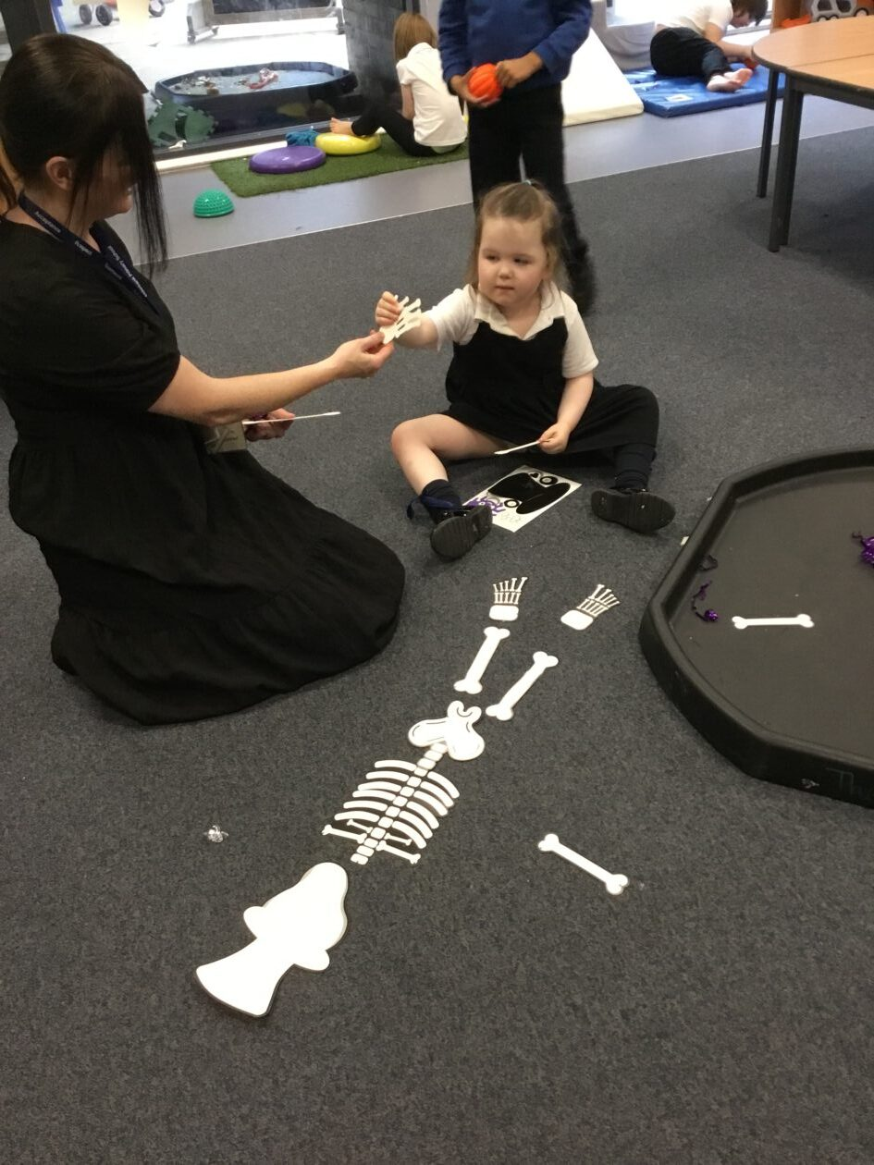
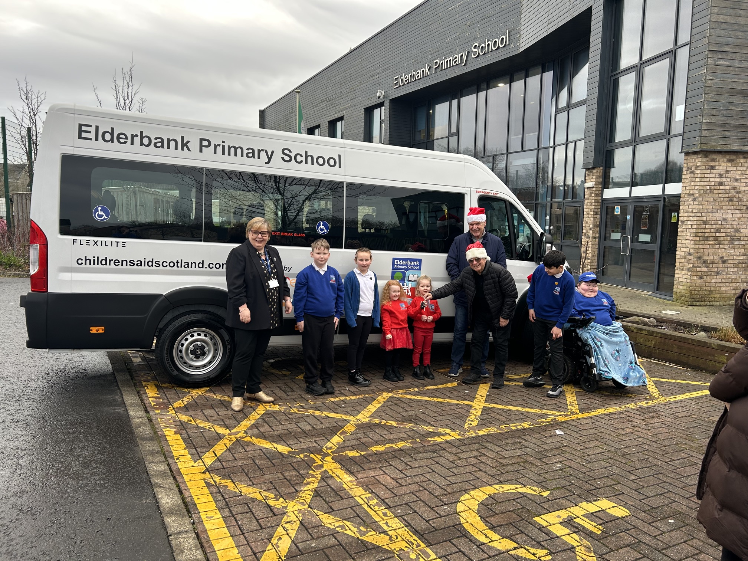
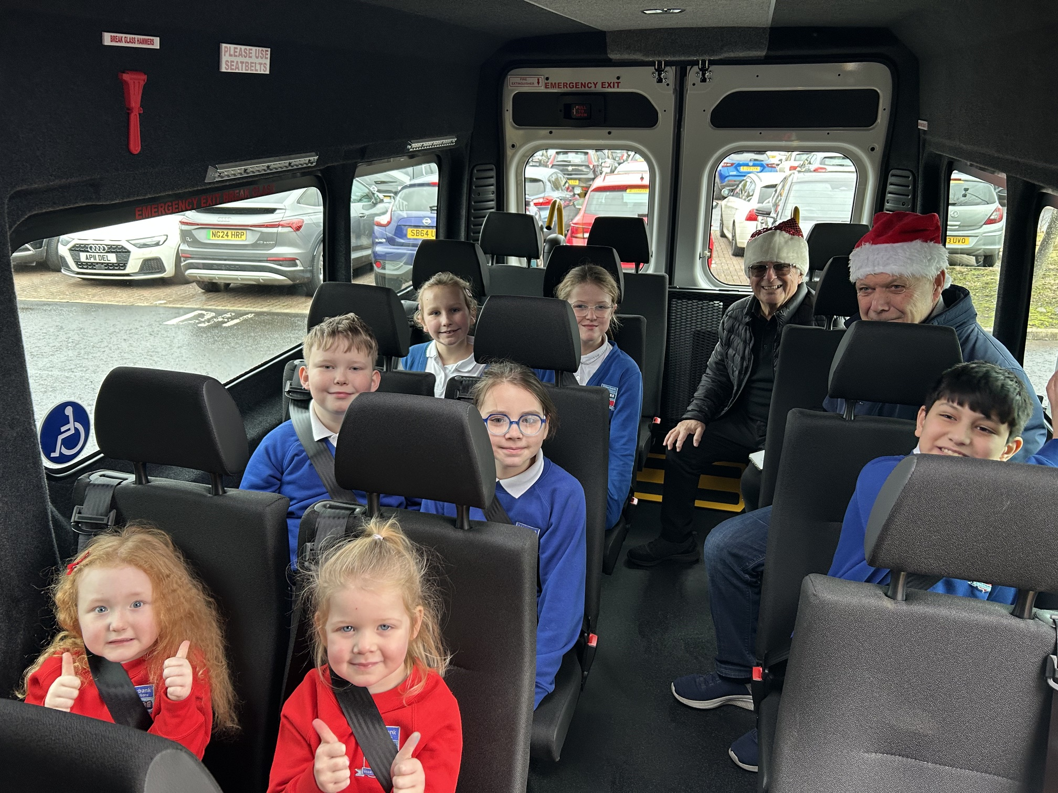

STANDARDS AND QUALITY REPORT
June 2026
This report will inform you of the school’s progress and achievements in the last session and let you know about our plans for 2025-2026.
I hope that you find it helpful and informative.


Jacqueline G Robertson
Head Teacher

OUR SCHOOL
Elderbank is situated in the east of Irvine and serves the communities of Broomlands and Bourtreehill. Our school comprises of a mainstream primary, an early years which caters for 48 pupils from 09:00 – 15:00 each day, an Enhanced Deaf Provision which provides specialist support for a maximum of 12 pupils and a Supported Learning Provision, which supports children with a range of Additional Supports Needs. Pupils are placed in the specialist provisions by the local authority placement groups. We encourage positive relationships with pupils, staff, parents, carers, partners and the wider community. Our aim is to equip all of our learners to be successful in an ever changing world.

OUR VISION, VALUES AND AIMS
Vision
At Elderbank we grow and learn together; learners, staff, families and our local community, in a culture of mutual respect to enable all to thrive and reach their full potential in an ever changing and challenging world.

Values
Building our school community is a work of ART…
Acceptance
Respect
Teamwork

Aims
To provide a fully inclusive, safe, welcoming and nurturing learning environment which encourages learners to take responsibility for their learning.
To encourage positive interactions and mutual respect.
To build a curriculum framework that recognises, supports and meets the needs of every child through appropriate, high quality active learning opportunities.

ATTAINMENT & ACHIEVEMENT
The combined attainment in the Mainstream for Primary 1, Primary 4 and Primary 7 for the session 2024-2025 was:
Reading – 72.4%
Writing – 60.3%
Listening and Talking – 80.4%
Numeracy – 69.2%

This session has seen a drop in attainment within writing and numeracy despite accurate use of tracking data, increased staff confidence in professional judgement and strategic approaches to improve attainment within these areas of the curriculum. We acknowledge that a number of factors contributed to this drop in attainment and we made a robust plan to tackle this decline, which was mapped out in detail within the 2025-26 SIP. An update of the data for session 2025-2026 will be shared in September 2026 once verified by the Scottish Government.
Attainment in Supported Learning and the Early Years is based on progress through appropriate milestones. Within Supported Learning, pupils continue to make progress with their individual attainment which is closely monitored. Most pupils have achieved their individual targets.
Within the Early Years, children continue to make progress through the milestones or individual targets. The number of children achieving their milestones has been in decline this session, but this can be qualified through the increase in number of pupils within the cohort who have additional support needs, with 27% of pupils with individual support plans in place.

Attendance continues to be below the national average. Although there are indivisal case studies of significantly improved attendance through targeted intervention. Attendance is included in the School Improvement Plan for the session 2026-2027, to address the inconsistencies across the school. This is linked to the Building Positive Relationships improvement priority.
There are no recorded exclusions from Elderbank staff this session.

WIDER ACHIEVEMENT
All pupils across the school are actively involved in leadership opportunities through a structured approach where classes are paired and take responsibility for key leadership groups including Library, Eco, JRSO, Sports Leaders, Signing Group, Infant Play Leaders, and Events and Charity. This collaborative model strengthens relationships across stages and promotes teamwork, responsibility and pupil voice.
Leadership opportunities are varied and inclusive. Pupils lead on whole-school initiatives such as coffee mornings, charity events, outdoor learning and participation in national programmes including the Cash for Kids School Challenge. House Captains and Vice Captains further enhance pupil voice and representation across the school.
Personalisation and Choice is delivered through two blocks (P3–4 and P5–7), offering a wide range of learner-led experiences. Activities such as escape rooms, crocheting, British Sign Language, and cooking have been developed in response to pupil feedback. Learners report high levels of engagement and value opportunities to learn new skills and work with different staff, supporting confidence and independence.
A focus on Developing the Young Workforce is evident through careers events, visiting speakers, assemblies and targeted programmes such as Skills for Bills. These experiences support pupils in developing key employability skills and understanding future pathways.
Wider achievement is enriched through a range of opportunities including Reading Buddies, Sports Ambassadors, focussed weeks, learning cafés led by pupils, and inclusive events such as Sportability. The school actively removes barriers to participation by providing free access to school visits and utilising the newly acquired school minibus to extend learning into the local community.
Supported Learning and Early Years pupils are fully included in leadership and participation opportunities. This includes leading assemblies, community visits, family learning sessions, and targeted support programmes. Partnerships with parents and external agencies further enhance outcomes for learners and families. Improved parental engagement will be a priority for session 2026-2027.
Overall, the school demonstrates a strong commitment to wider achievement, ensuring that all learners are given meaningful opportunities to contribute to the life and work of the school while developing skills for life, learning and work.

HOW SUCCESSFUL HAVE WE BEEN IN IMPROVING OUR ESTABLISHMENT?
PRIORITY 1 – Deaf Learner - SmiLE (Strategies and methods in Language Education) Therapy Parental Engagement
- Positive Impact for learners in all modules which is evidenced through in individual planning and tracking
- Increased parental engagement with 88% participation which is an increase of 22% from the previous session
PRIORITY 2 Raising attainment in Numeracy
- Increase in attainment of 3.6%
- Increased pupil engagement and leadership of learning
- Increased staff capacity.
- Transfer of skills acquired across the curriculum
- Consistent planning approaches and delivery
Early Years
- Increased staff confidence in delivering numeracy activity in small group opportunities
- Most staff can resource an environment in order to encourage children to engage in numeracy experiences
- Robust numeracy planning framework supports staff in the planning and delivery of numeracy experiences that meet the needs of all
PRIORITY 3 - Raising attainment and improving consistency in writing for all pupils in Primary 1 to 7
- Increased pupil engagement
- Increase in pupil attainment by 6.5%
- Increased staff confidence in teaching of writing lessons
- Consistent structured approach to writing, including Daily Write
- Successful participation of Primary 4 staff in CYPIC programme
- Consistent approaches to assessment and moderation
PRIORITY 4 – Meeting individual pupil needs through the SCERTS framework and Sensory Profiling
- SCERTS - Increased staff confidence to assess baseline and identify appropriate targets. All children who require
- Language targets achievements increased by 15%
- Educational Psychologist and Occupational Therapist worked collaboratively with the staff team to produce the Sensory Profile for pupils who require this.
- Involvement of some parents and carers with information sharing in relation to Sensory Profiling which will be developed in session 2026-2027.
PRIORITY 5 – Improving Pupil attainment and achievement
- Increased pupil attainment in numeracy and literacy
- Strengthened approaches to pupil attainment tracking procedures.
- Developed an interim planning format for IDL which will be trialled and evaluated in session 2026-2027 to measure impact.
- Consistency in delivery of environments and positive relationships to support the needs of all to be developed further in 2026-2027
Early Years
- 67% of families engaged in the Fantastic Families sessions with the focus agreed on parent and carer feedback
Areas for development from this priority are incorporated into the Improvement Plan for session 2026-2027.

QUALITY INDICATORS
Provide your evaluation & brief summary statement for each of the 4 core QIs
QI 1.3 Leadership of Change | Evaluation | 5 Very Good
Our Improvement Priorities are clearly linked to the needs of our whole school and its community. Leadership is encouraged, supported and demonstrated at all levels. All staff are actively involved in the evaluation and creation of the School Improvement Plan. The need for change is clearly communicated to all stakeholders. The pace of change is now more aligned to the needs of learners using a positive 3-year cycle.
QI 2.3 Learning, Teaching & Assessment | Evaluation | 5 Very Good
Learning, teaching and assessment across all provisions are consistently well-planned and effective, resulting in positive progress for almost all learners. Practitioners use a range of engaging approaches that promote active participation and support learners to develop increasing independence. Assessment information is used purposefully to identify next steps, and staff demonstrate a growing confidence in analysing data to inform planning. Tracking systems are used regularly and reliably, enabling staff to monitor progress and intervene when required. While approaches are strong and improving, there remains scope to further develop consistency in moderation and to strengthen learners’ involvement in evaluating their own progress.
QI 3.1 Ensuring Wellbeing, Equality & Inclusion | Evaluation | 5 Very Good
Our school demonstrates a deep and sustained commitment to wellbeing, equality and inclusion, elements which sit at the heart of everything we do. Staff are committed to building strong, trusting relationships with learners and families, enabling early identification of needs and ensuring timely, well-coordinated support. Staff use assessment information and professional dialogue effectively to plan personalised support. Partnership working with external agencies is highly effective, enhancing the setting’s capacity to meet a wide range of needs.
QI 3.2 Raising Attainment & Achievement | Evaluation | 5 Very Good
Our school demonstrates a strong culture of high aspiration, with almost all learners making very good progress from their individual prior levels. Staff use assessment information effectively to track attainment, identify gaps and plan targeted support that leads to improvement. Almost all learners are confident, engaged and achieve well across the curriculum and wider activities. Barriers to learning are actively reduced, ensuring equity for all groups. As a result, attainment and achievement continue to show a positive and sustained upward trend.

PUPIL EQUITY FUNDING
Pupil Equity Funding has been used strategically to target the poverty-related attainment gap through a combination of targeted staffing, robust data analysis, inclusive practice and improvements to learning environments.

A key focus has been the provision of targeted literacy and numeracy support for pupils identified through a triangulation of data, professional judgement and assessment evidence, particularly those within SIMD 1–2 and the lowest attaining 20% across the school. This has resulted in clear improvements in attainment for targeted learners, with strong evidence of a narrowing gap between SIMD 1–2 and SIMD 3–10. Most notably, the attainment gap in writing has reduced significantly and is now almost fully closed.

Time investment in assessment and data has strengthened the school’s ability to identify need early, track progress effectively and ensure that interventions are responsive and evidence informed. As a result, staff confidence in analysing data and planning targeted support has increased, contributing to improved attainment across literacy and numeracy and greater consistency in teacher judgement.

Targeted interventions have supported a sustained recovery in attainment following the impact of Covid, with improvements seen across reading, writing, listening and talking, and numeracy. Writing attainment in particular has shown significant improvement, providing strong evidence of the effectiveness of targeted approaches this year.

Pupil Equity Funding has also contributed to improving learner engagement, wellbeing and inclusion. The development of Supported Learning outdoor learning environments has increased pupil participation, improved behaviour and strengthened learning behaviours such as teamwork, communication and problem solving.

Within Supported Learning, PEF funding supported staffing to maintain safe and effective provision during periods of absence, ensuring continuity of care and support for pupils with complex needs, although some planned therapeutic interventions such as Rebound Therapy were unable to take place.

Overall, the strategic use of PEF has resulted in measurable improvements in attainment, increased equity of outcomes for disadvantaged learners and strengthened whole-school approaches to targeted intervention, tracking and inclusion. This provides a strong foundation for further reducing the poverty-related attainment gap in future sessions.

IMPROVEMENT PLAN PRIORITIES 2026-2027
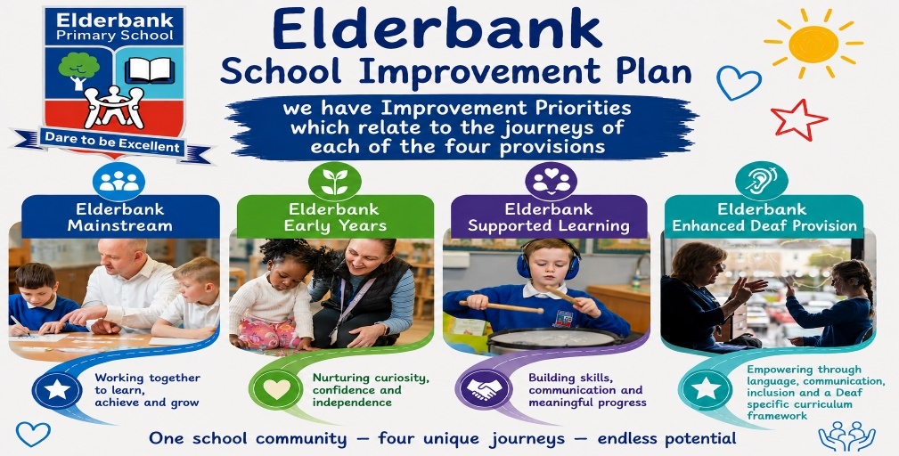

Priority 1 - Raising attainment in numeracy
- To raise attainment in numeracy and mathematics through the implementation of consistent, high-quality pedagogical approaches, underpinned by clear progression pathways and effective use of contextualised problems.
PRIORITY 2: Improving learning outcomes for all in literacy (Early Years)
- To strengthen early literacy by ensuring all children experience high-quality, language-rich learning that builds secure foundations for writing and aligns with the school’s writing journey and moderation processes.

Priority 3 - Deaf Learners – Embed the Specialist Deaf Curriculum Framework into Planning and Assessment
- To Enhance Independence, Communication, and Deaf Identity through the Specialist Deaf Curriculum Framework
PRIORITY 4: Supporting needs, wellbeing, equality and inclusion (Early Years)
- To realise our new Early Years vision through thoughtfully designed environments that inspire curiosity, promote wellbeing and support high-quality interactions throughout the extended day
Priority 5 - Raising attainment and improving consistency in writing for all pupils in Primary 1 to 7
- To build staff confidence and capability in teaching, assessing and moderating writing.
- To Enhance staff use of data to inform planning, track progress and support learner achievement.
Priority 6- Supporting needs, wellbeing, equality and inclusion through Building Positive Relationships
- To increase attendance levels through the development and embedding of New Authority as a universal, whole-school approach informed by the principles of Building Positive Relationships (BPR). This programme forms an important aspect of North Ayrshire’s Relationships and Behaviour Policy from 2026 onwards. This priority will support a consistent, relational response to behaviour across the establishment, with a focus on strengthening adult presence, reducing escalation, and promoting repair and connection.
Priority 7: Supporting needs, wellbeing, equality and inclusion through SCERTs planning and Sensory Profiling for Learners
- To improve learners' communication through the consistent use of individual SCERTS plans for identified learners.
- To develop staff understanding and capacity to plan appropriately using the SCERTS framework
- To meet pupil needs through the appropriate identification and implementation of sensory profiling.
Priority 8: Supporting needs, wellbeing, equality and inclusion through the development of emotional regulation (Supported Learning)
- To improve pupil self-regulation strategies and consistency of de-escalation strategies for all.

