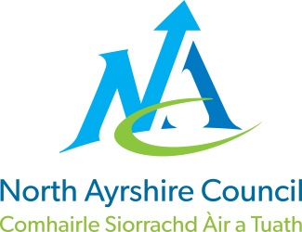
EDUCATION DIRECTORATE
Head of Service: Andrew McClelland
Cunninghame House, Irvine KA12 8EE
Tel: 01294 310000
www.north-ayrshire.gov.uk

Elderbank Primary School, Early Years, Supported Learning
and Enhanced Deaf Provision
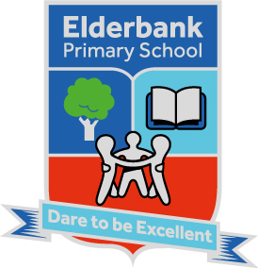
Head Teacher: Miss Jacqueline Robertson
St Kilda Bank, Irvine. KA11 1LA
Tel: 01294-218632
E-Mail: gw14elderbankelderba@ea.n-ayrshire.sch.uk

Date: 27^{h} May 2026

Dear Parents and Carers,
We are delighted to let you know that Elderbank Primary School and Early Years are Finalists for Cash for Kids School Challenge, a fundraising initiative that supports schools to raise money for their pupils and wider school community.
I have attached a grid of all the activities the children have been planning with the staff team. It is FUNDRAISING TIME!

To start the fun, we will have a Dress Down Day this Friday 29th May and we ask all children to bring a bottle. This will set us up for the Coffee Morning which is planned for Friday 5th June.

We know there is not a lot of notice, but the Cash for Kids Briefing only took place last night at 4p.m.!

This will be great fun. Please encourage all friends and family to support our cause.

We will be sharing a link to the fundraising page for any donations, so any families that can raise money can enter this directly. We know we have some very keen and supportive families who can help our worthwhile cause.

Thank you in advance for your support.

Kind regards,

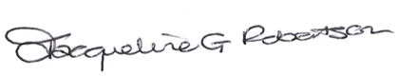
Jacqueline Robertson
Head Teacher

