
Elderbank Primary School Newsletter - February 2025
Dear parents and carers,
January has been an exciting and busy month at Elderbank Primary School. We’ve had a wonderful range of activities across all provisions, with pupils and staff enjoying the many events that took place.
Supported Learning and Enhanced Deaf Provision Activities Our pupils in Supported Learning and Enhanced Deaf Provision have had a fantastic time participating in dance lessons, karate classes, and music tuition. These activities have been thoroughly enjoyed by everyone and have allowed pupils to develop new skills and confidence in a fun and supportive environment.

Focus on Scotland and Scots Language Throughout the school, our focus since the return to school in January has been on Scotland and Scots language. Pupils have been engaged in a variety of activities, including verse speaking, which has allowed them to explore Scotland's rich cultural heritage. Primary 6 pupils enjoyed a visit to the Wellwood Centre, where they learned more about Scotland’s traditions and history. All pupils had a wonderful time, and we are so proud of their enthusiasm and involvement.
Verse Speaking Competition A special congratulations to all of the pupils who participated in the Verse Speaking Competition on Wednesday 5th February. Well done to our class finalists, and a big shout-out to the class winners! Leon Johnstone (P7) and James Findlay (P2) will now go on to represent Elderbank Primary at the Champion of Champions competition at the Wellwood Centre, organised by the Irvine Burns' Club.

Burns Supper The Burns Supper on Thursday 6th February was a great success. Hosted by our Primary 7 pupils, the event was attended by Primary 6, the Leadership Team, and invited guests, including our school Chaplain, Mr. Milliken, Chair of the Parent Council, Mr. Milligan, and Mrs. McHolland, our Family Care Worker. The event featured scottish dancing, verse speaking, and musical performances that entertained everyone. The formal elements of the Burns Supper, included the Address to the Haggis, The Immortal Memory, and toasts to the Lads and the Lassies, were performed by our talented pupils. A special thank you to the Primary 7 pupils who also demonstrated their culinary skills by baking shortbread for the event!
Primary 7 Residential The Primary 7 Residential was a huge success! Pupils from Mainstream, Enhanced Deaf Provision, and Supported Learning attended, enjoying both indoor and outdoor activities. They had a wonderful time socialising, experiencing the facilities, and even enjoying a treat at Nardinis for ice cream on the final evening. We are grateful to all staff members who volunteered their time to accompany the pupils.

Transition to Greenwood Academy Primary 7 pupils are busy with their transition visits to Greenwood Academy. These will take place as follows:
- P7H and P7/6: Wednesday, 12th February
- P7Y: Thursday, 13th February
Please ensure all children arrive at school by 09:00 a.m., as they will be leaving promptly at that time to walk to Greenwood Academy. The second round of visits will be on Thursday 27th March for P7Y and Friday 28th March for P7H and P7 of P7/6.
Early Years News

Early Years pupils had a fantastic time exploring road safety with the Ziggy Roadshow. This was an invaluable learning experience for all of our younger learners. Additionally, the children have been enjoying outdoor learning, exploring the area beyond the school grounds. We’re also excited to announce that the transition programme for new Primary 1 pupils in August 2025 will be starting soon. More details will be shared by Miss Auld shortly. Pupils who are not in the Elderbank catchment area but have registered for their catchment school will receive transition information directly from their new school.
British Deaf Association – 12th February 2025
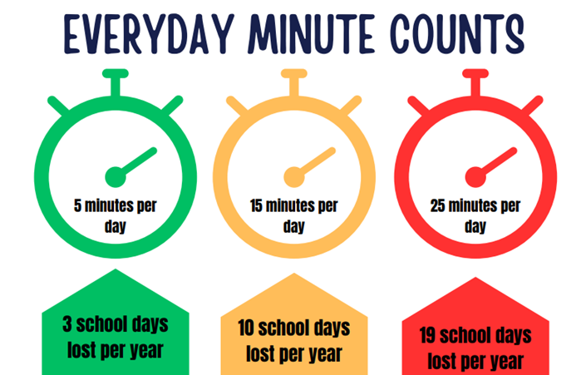
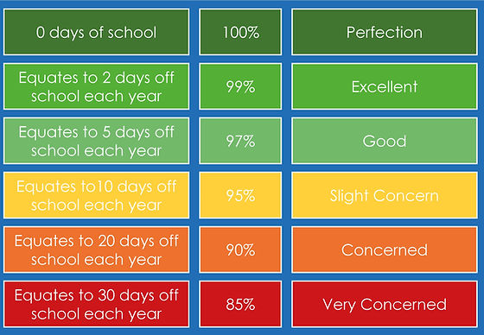
We are looking forward to welcoming our colleagues from the British Deaf Association to Elderbank to work with our Deaf learners with a Dance Workshop. We are also delighted that Sophie Carruthers will be presented with the Francis Dolan, Endeavour Award from the West of Scotland Deaf Children Society. We are all very proud of her achievements.

Attendance We would like to congratulate all pupils who have maintained good attendance. It is important for every child to attend school regularly and arrive on time. To support families, we offer a range of services including our Breakfast Club each day from 08:10, informal entry from 08:50, nurture groups, and pastoral support through our Pupil Equity Fund, with Mrs. Stewart available to assist. We also offer an 8-week L.I.A.M. programme for individual pupils to help children manage anxiety. We will be contacting parents and carers this week, where required, to offer support for attendance and late coming.

Social Media: While we’ve had support from our local Police Officers and have offered parent/carer workshops, there continue to be concerns about the misuse of social media and messaging apps. If any issues arise outside of school, we encourage parents and carers to seek advice from Police Scotland if required and the matter cannot be resolved between families. We are happy to provide support for any matters that impact our school community. Please continue to monitor social media usage, as many of these apps have age guidelines that our pupils may not fully understand. Inappropriate use can affect friendships and school life.

Elderbank’s 10th Anniversary Elderbank Primary is celebrating its 10th Anniversary! We will mark this special milestone with a performance on 25th and 26th March 2025. Both performances will start at 1:30 p.m., and each family will be offered two tickets with a ballot for any additional tickets. The performance on Wednesday 26th March will have a British Sign Language Interpreter. All pupils from Primary 1–7, from the Mainstream and the Enhanced Deaf Provision will be involved. Supported Learning classes will be involved in the celebration, with those pupils from Supported Learning who can manage performing to a large audience participating as appropriate.
The format for preparing for the Mainstream Show will be similar to the Personalisation and Choice sessions, allowing children to select a format that suits them best, ensuring that all pupils are included. This event is part of the pupils' learning as they reflect on the school's journey and key events over the past 10 years. We want to ensure that every child has an opportunity to showcase their work and involvement in Elderbank's history.
Early Years Celebrations
On Friday, 28th February, from 1:30 p.m. – 2:30 p.m., Early Years will celebrate with an interactive Play and Stay event in the Main Hall. There will be cake and juice, and it promises to be a fun and engaging time for children and families alike. Further details will be distributed by Mrs. Carruthers, so please keep an eye out for more information.

Planning Ahead – Parent/Carer Engagement
We are pleased to offer an opportunity for parents and carers to come into class and view all the wonderful Elderbank is 10 work within the mainstream setting. This will take place on Friday 2nd May from 09:30 – 11:30– details to follow.
Supported Learning Coffee Morning
On Thursday 1st May, we will host a Supported Learning Coffee Morning from 09:30 a.m. – 10:30 a.m. This will provide a chance for parents and carers to get together while also enjoying the opportunity to view the pupils' work on display in the hall. It will be a lovely time for connection and celebration of the pupils' hard work.
Important Reminders
- Car Park Use: Please note that parking is not allowed in the school car park unless you have a school permit or a blue badge.
- Yellow Permit Holders: If you are a yellow permit holder, please remember that you should not enter the car park before 08:55 a.m. in the morning or before 2:55 p.m. in the afternoon.
- Health Guidelines: If your child has been unwell with sickness or diarrhoea, they must stay at home for 48 hours after the last episode to prevent the spread of illness. As we have some children with compromised immune systems, we need to be extra vigilant in these cases as it can be life-threatening.
- New Rashes or Spots: If your child develops a new rash or spots, please seek medical advice and inform the school so we can take any necessary precautions to protect our vulnerable pupils.

Breakfast Club
Our Breakfast Club is available for Primary 1-7 Mainstream and EDP pupils. It is not a childcare facility, and all children must adhere to the rules independently. Please note that children attending the Breakfast Club must be fully toilet trained as there is no additional adult support available during this time. If a child requires adult assistance, they should arrive at school during the usual drop-off time from 08:50 a.m., as the Breakfast Club does not provide this level of support.
Lost Property: We are concerned about the number of items that children are misplacing. We know this puts financial pressure on families. To help us return items to their owner, please put your child’s name on every item of clothing and all lunch boxes and water bottles. Your assistance with this is much appreciated.
Thank you all for your continued support. We look forward to what promises to be another exciting term ahead!
Kind regards,
Miss Robertson
Head Teacher

