P3G Termly Higlights

Maths Week Scotland
We enjoyed participating in Maths Week Scotland. We learned about 2D and 3D shapes and had great fun using a variety of shapes to make our own pictures.

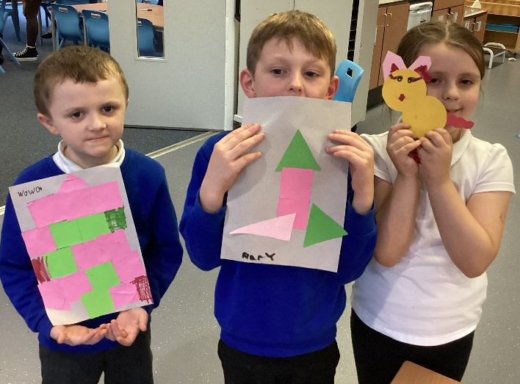

Big Breakfast Event
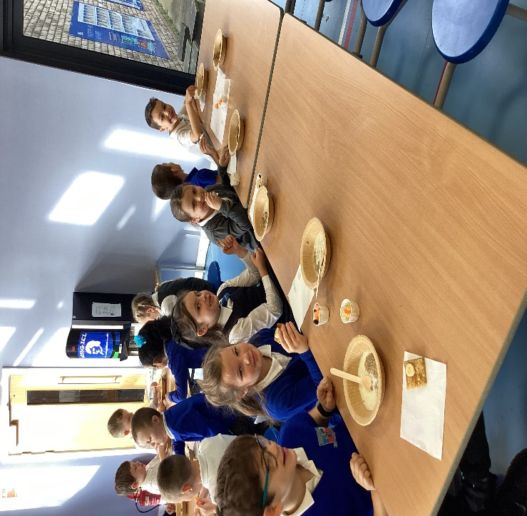
We had a lovely morning with the Welby Breakfast Club sampling different healthy breakfasts. We were able to try a small pot of fruit, toast and banana and Weetabix. We also learned about the importance of a healthy breakfast and received a goody bag to take home.

