MCj04398430000[1]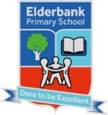MCj04404280000[1]

Miss Drummond

Primary 4 Term 2

Session 2023-2024

Elderbank Primary School

Home / School Info.

Health and Wellbeing

Our P.E. days are Tuesday and Thursday.

We will focus on gymnastics, rugby and social dancing.

As part of our Health and Wellbeing topic we will use Emotion Works to visit the orange emotion words cog. We will also explore the green cog focussing on emotion behaviours and the red cog focussing on body sensations. As part of SHANARRI we will focus on healthy bodies and nutritional needs.

Topic

We will be studying the Vikings next term. Our aim will be to learn about where they came from and their place in history. We will also learn about their major practices and traditions.

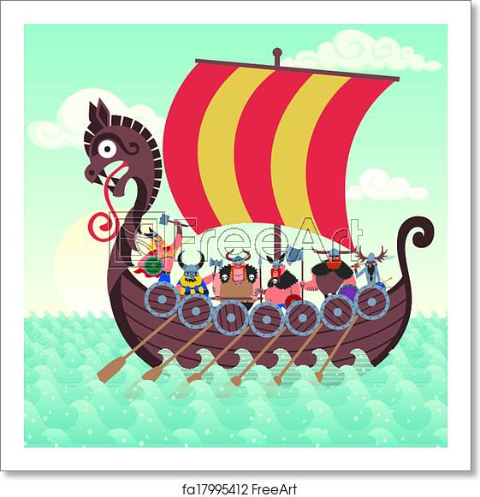

Numeracy :

The Squares group will continue to explore multiplication and division of all times tables using 2 and 3 digit numbers. We will also explore right angle turns.

The Circle group will continue to focus on building up all times table facts. We will use our multiplication facts to help us divide. We will also explore right angle turns.

The Triangle group will continue adding and subtracting using carrying and exchange. We will also explore understanding and recognising the terms grams and kilograms through a variety of activities.

Expressive Arts

Music – We will listen to and play music from different cultures related to our Viking topic. We will also learn how to sign a variety of Christmas songs using B.S.L.

Art - We will be doing a variety of art activities based around our topic of the Vikings. We will focus on using the visual elements of line, shape, texture, tone and pattern

Drama - In Drama we will take on different roles. We will use movement, expression and voice to do this and link it to our Viking topic.

MCj04404160000[1]

RME : We will be exploring the Hindu festival of Diwali. We will also explore religious stories about Christmas and how Christmas is celebrated throughout the world.

Science : The children will participate in a variety of S.T.E.M challenges. We will focus on choosing appropriate materials to solve design challenges.

Homework

Homework will be issued on a Monday through SeeSaw. Homework activities will be discussed in class. Outdoor learning will take place weekly on a Friday. Please make sure your child has an appropriate jacket and footwear.

How to Help Your Child- Encourage your child to:

* read a variety of texts
* identify where we use numbers in real life contexts
* discuss their learning

MCj04380040000[1]MCj04404240000[1]

Literacy

Reading – This term we will explore SHORS reading comprehension strategies. We will also further develop our reading comprehension skills through our novels and PM reading books.

Writing – This term we will be focussing on writing a description and an information report using our PM writing resource.

Talking and Listening – This term we will be focussing on active listening and creating and responding to open and closed questions.