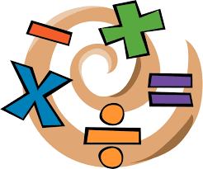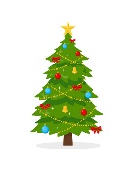MCj04398430000[1]MCj04404280000[1]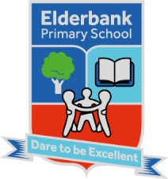MC900351306[1] 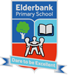

Elderbank Primary School

Home / School Info.

Topic:

We will complete our work based on Natural disasters before moving on to finding out all about how Christmas is celebrated in France.

Health and Wellbeing:

Our **P.E.** days are Tuesday and Thursday. We will focus on gymnastics, rugby then Social Dance.

We will focus on learning about how to live a healthy lifestyle including healthy food choices, especially around the holidays. We will also celebrate each other’s achievements.

**Outdoor learning** will take place every Tuesday. Please ensure appropriate clothing and footwear is worn. We will be learning different trees and animals that grow/live in our environment.

Numeracy:

We will be consolidating our four functions using function machines and order of operations.

We will be learning about how to read/interpret from charts and graphs, as well as developing our own surveys to create a chart/graph. We will use ICT software to display information on charts and graphs.

We will also be measuring and converting in centimetres and metres to calculate lengths.

Mrs Swan/Miss Rose

Primary 5 Term 2

Session 2023-2024

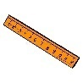

ICT:

In ICT, we will be developing our skills to manipulate texts and images using a variety of software. These will be used during class presentations.

 

Expressive Arts:

Music – We will sing and play instruments to Christmas songs whilst learning to follow a tune/beat. We will also be learning to read simple musical notations.

Art - Based around our topic, we will create different crafts for both Halloween and Christmas.

Drama - We will practice our drama skills throughout our Christmas performance.

French:

Our French lessons will focus on consolidating days of the week and numbers to 50. We will also learn holiday themed words for Halloween and Christmas.

MCj04404160000[1]

MCj04404240000[1]

Science:

In Science, we will explore reflections, light and shadow.  We will investigate what light is/does, different sources of light, how shadows change and how light changes colour.

Literacy:

Reading – This term we will further develop our

reading comprehension skills through SHORS and group reading materials.

Writing – This term, we will be learning about the features of description texts and information reports, and trying to write some of our own. We will focus on the use of punctuation for direct speech and the use of an apostrophe for possession. We will also be developing our spelling skills by investigating different letter patterns/sounds.

Talking and Listening – We will research and deliver a short presentation linked to our topic. We will also develop a class talking contract and develop our oracy skills.

MCj04380040000[1]

MCj04420260000[1]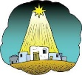

RME:

In RME we will learn about Christmas customs and symbols around the world, with a focus on France.

Homework

Homework activity grids will be available on Seesaw. Please complete a task each week and send it on.