**Communities and Education Directorate**

**Elderbank Primary School and Enhanced Deaf Provision**

**Improvement Plan 2021-2022**





**Vision, Values and Aims**

**Values**

Respect, Inclusion, Equality, Excellence

**Vision**

Elderbank will provide a stimulating, supportive, secure learning environment which enables **all** learners to reach their full potential through quality learning and teaching, while nurturing and supporting the school community to participate actively in the life and work of the whole school, which will equip learners to thrive in an ever changing and challenging world.

**Aims**

* To provide all learners with a consistent framework for positive interactions while promoting self-esteem, positive behaviour, pride and self-discipline.
* To build a curriculum framework based on breadth, balance, challenge, progression, cohesion, personalisation and choice, and which recognises, supports and meets the needs of every child through appropriate, quality active learning opportunities.
* To provide a fully inclusive, safe, welcoming and nurturing learning environment which encourages learners to take responsibility for their learning.
* To effectively encourage and support leadership at all levels.

**The North Ayrshire Annual Improvement Plan**

The North Ayrshire Education annual improvement plan sets out our priorities for the year ahead in pursuit of the joint aims of achieving excellence and equity for our learners. It takes account of the feedback from consultation with our stakeholders across the Council and community and ensures the delivery of the locally agreed priorities of the Council Plan and the nationally agreed priorities of the National Improvement Framework. In the delivery of this plan, we will work in close partnership across the Council and communities of North Ayrshire and as part of the South West Educational Improvement Collaborative (SWEIC).

The COVID-19 pandemic has presented us with a fresh set of challenges and this plan reflects this new evolving context. Therefore, this is a plan like no other previously devised. However, as well as the context, it draws on the rigorous self-evaluation undertaken in establishments and across the service of the progress towards the previous year’s plan. The process of arriving at the service level priorities and strategic actions included engagement of Head Teachers and the service leadership team in evaluation and planning sessions. At school level, this exercise was repeated with pupils, staff, parents/carers and key partners.

**Council Priorities:**

The Council strategic priorities for 2019-24 are detailed below:

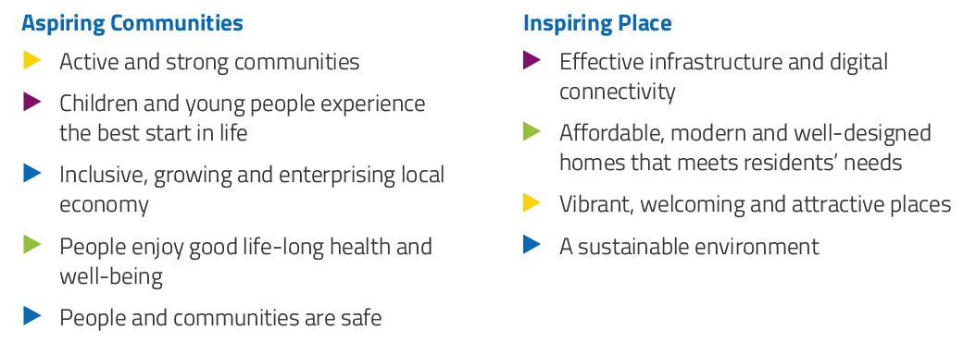

**National Improvement Framework:**

The National Improvement Framework for Education is designed to help us deliver the twin aims of excellence and equity; galvanising efforts and aligning our collective improvement activities across all partners in the education system to address our key priorities. These priorities remain as:

* Improvement in attainment, particularly in literacy and numeracy
* Closing the attainment gap between the most and least disadvantaged children
* Improvement in children and young people’s health and wellbeing
* Improvement in employability skills and sustained, positive school-leaver destinations for all young people

Alignment to Local and National Plans

This plan is aligned to local and national plans as follows:

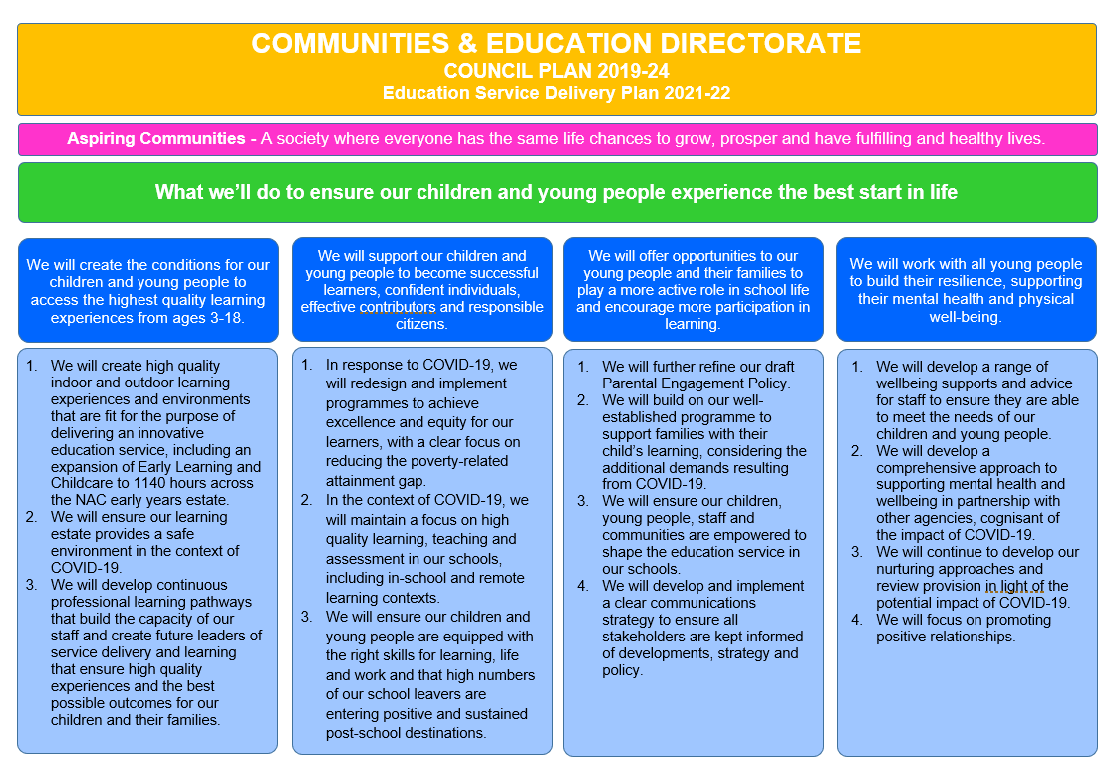

**Strategic Plan 2021-22: Elderbank Primary School and Enhanced Deaf Provision**

|  |  |  |  |  |
| --- | --- | --- | --- | --- |
| **School Priorities** | **To raise attainment in literacy with a specific focus on writing.** | **To continue to develop and embed opportunities for Outdoor Learning across all four provisions within the school and develop skills, knowledge and understanding of Loose Parts Play** | **To ensure a consistent approach to Staged Intervention procedures** | **To embed a whole school approach towards supporting positive relationships.** |
| **High Level Objectives** | *Learners will have increased skills, knowledge and understanding of key strategies to support their learning in writing.*  *Teachers and EYPs will have increased knowledge, skills and confidence in effective approaches to delivering the teaching of writing.* | *Learners will continue to benefit from increased staff confidence in delivering high quality outdoor learning experiences.*  *Learners will have increased skills, knowledge and understanding of Outdoor Learning and Loose Parts Play.*  *Raise attainment and achievement through innovative approaches towards Outdoor Learning.* | *Teachers will have increased knowledge, skills and confidence in effective approaches to staged intervention procedures. They will make appropriate use of assessment data to provide high quality teaching and learning experiences.*  *Learners will have appropriate support in place to ensure progress and achievement.* | *Learners will have increased opportunity for positive experiences across the whole school establishment and community.*  *Teachers will use a whole school approach to managing behaviour and will be supported by Nurture staff.*  *Attainment will be raised through the development of positive relationships strategies for all learners.* |

**Strategic Plan 2021-22: Elderbank Primary School and Enhanced Deaf Provision**

Here is an overview of how we intend to use our Pupil Equity Funding to support improvement:

**Detailed Action Plan 2021-22: Elderbank Primary School and Enhanced Deaf Provision**

|  |  |  |  |  |  |  |  |
| --- | --- | --- | --- | --- | --- | --- | --- |
| **Establishment Strategic Priority:** | | **To raise attainment in literacy with a specific focus on writing.** | | | | | **Linked to Directorate Priority:** *1,2* |
| **High Level Objectives** | **HGIOS 4**  **HGIOELC**  **NIF** | **Supported through PEF?**  **Y/N** | **How will we achieve this?** | **Timescale / Assigned to:** | **Pupil Outcomes**  *What will change for our learners?* | **Measurement**  *How will we measure impact?* | |
| Learners will have increased skills, knowledge and understanding of key strategies to support their learning in writing.  Teachers and EYPs will have increased knowledge, skills and confidence in effective approaches to delivering the teaching of writing. | 1.1  1.2  2.2  2.3  3.2 | Yes | ***Teacher Professionalism***  All SMT, teachers and EYPs will participate in collegiate sessions to introduce the new PM Writing resource.  Team teaching writing lessons will allow staff to embed their learning, share knowledge and best support all learners across the school.  Our focus will be   * Evaluating and enhancing a literacy rich environment across the school. * Adapting the whole school writing consistency guide to incorporate new PM Writing resource. * Incorporating previous improvement work on Talk into Writing. * Enriched opportunities for reading skills to support writing development and vice versa. * Determining progression in skills for effective writing. * Meeting the needs of all children through differentiation. * Focusing on significant aspects of learning to assess children’s progress – planning for assessment will be key and we will evaluate and enhance current processes.   **School Leadership**  Class teacher who was involved in leading the Talk into Writing development work in 2017/2018 will work with DHTs to introduce the new resource and to team teach with senior classes.  Staff will be invited to be part of a working party to support the development of our school writing framework and consistency guide.  **School Improvement**  All staff will be involved in evaluating the impact of improvements. Staff will bring evidence of change/improvement to follow-up sessions to engage in professional evaluation of impact.  All teaching staff will enhance skills in moderation of writing skills and development  **Performance Information**  Focus meeting dialogue will reflect the increase in confidence of pupils in applying writing skills.  Tracking and attainment data will demonstrate an overall increase in attainment within writing. Data will also demonstrate a reduced attainment gap in relation to pupil SIMD status and gender. | Term 1  DHTs to deliver training  Terms 1 -4  DHTs and CTs to team teach  *Terms 1-4*  *CT*  *DHT*  *Terms 1-2*  *Term 4*  *All staff*  *Terms 1-4*  *All CTs* | There will be an enriched literacy environment evident across the school and playroom with a clear focus on linking oral language, reading and writing.  There will a clear rationale for the school’s approach to writing including whole school and class expectations which will result in consistency of practice for pupils. Pupils will report an increase in confidence in their writing skills.  Almost all pupils will use the language of learning to articulate the skills they are using, their relevance and application to other contexts, and personal strengths and next steps in writing. They will make links and use writing skills across other areas of the curriculum.  Staff and pupil will demonstrate an increased understanding of the reciprocal gains of reading and writing.  Teachers will articulate an increase in confidence in the teaching of writing using the new PM Writing resource and subsequent positive impact on pupils.  Pupils will experience breadth, depth & challenge in lessons with enhanced opportunities for application.  *Most or almost all* pupils will attain appropriate levels in writing and reading and a few will exceed these.  There will be equity for all by ensuring differentiation and clear identification of pupils’ needs. | Discussion will take place re. rationale and impact during Senior Manager Visits.  A sample group of pupils from across the school will reveal an increase in confidence in approaching writing.  Evaluation of impact of improvements will show:   * Teachers feeling more empowered to provide a literacy rich curriculum, with agreed minimal yet effective recording for a clear purpose. * Increased confidence of staff in meeting needs through implementation of strategies to raise attainment   Progress and Achievement tracking system and evidence to support professional judgements will highlight improvements.  Pupils focus group will:   * articulate an increase in engagement in writing lessons * share success in writing * demonstrate an understanding of the different types of writing * demonstrate the application of skills learners across all aspects literacy.   Moderation of writing will show:   * a consistent approach to the teaching of writing * a robust understanding of writing skills * a progression of skills across the levels.   Professional dialogue with staff during focus meetings will show the impact of professional learning and team teaching linked to a raise in pupil attainment. | |

**Detailed Action Plan 2021-22: Elderbank Primary School and Enhanced Deaf Provision**

|  |  |  |  |  |  |  |  |
| --- | --- | --- | --- | --- | --- | --- | --- |
| **Establishment Strategic Priority:** | | **To continue to develop and embed opportunities for Outdoor Learning across all four provisions within the school and develop skills, knowledge and understanding of Loose Parts Play** | | | | | **Linked to Directorate Priority:** *1,3* |
| **High Level Objectives** | **HGIOS 4**  **HGIOELC**  **NIF** | **Supported through PEF?**  **Y/N** | **How will we achieve this?** | **Timescale / Assigned to:** | **Pupil Outcomes**  *What will change for our learners?* | **Measurement**  *How will we measure impact?* | |
| *Learners will continue to benefit from increased staff confidence in delivering high quality outdoor learning experiences.*  *Learners will have increased skills, knowledge and understanding of Outdoor Learning and Loose Parts Play.*  *Raise attainment and achievement through innovative approaches towards Outdoor Learning.* | HGIOS 4  *1.3 2.2, 2.3,2.5, 2.6, 3.1, 3.2*  HGIOSELC  2.2, 2.3, 2.5, 2.6, 2.7, 3.1, 3.3  NIF 1-6 | *Yes* | **Teacher Professionalism**  Building on the work from 2020/21, all teachers will continue to be provided with training in-house and from external agencies in relation to Outdoor Learning and Loose Parts Play from Early Years to Primary 7.  Our focus will be:   * To develop a clear skills progression for all aspects of Outdoor Learning from Primary 1 to Primary 7 * Ensure progression of skills across all levels * To create a robust policy and rationale for Outdoor Learning incorporating Loose Parts Play * Support staff to facilitate loose parts play during break times through training opportunities * To raise attainment across all curricular areas. * To embed Outdoor Learning in our practice * To embed purposeful play indoors and outdoors through the use of Outdoor Learning experiences and Loose Parts Play.   **School Leadership**  DHT’s will be responsible for supporting the development and implementation of the skills progression for Outdoor Learning across all levels and monitoring and evaluating its impact.  DHT’s to link in with other agencies to provide training for support staff in Outdoor Learning and Loose Parts Play.  **Assessment of Children’s Progress**  Teachers will use a range of strategies to assess children’s progress in outdoor learning and the impact on attainment.  This will be through:   * Staff evidencing in weekly evaluations * Specific observations of children * Professional discussions with staff during termly focus meetings * Photographic evidence for each individual child   **Performance Information**  Tracking and attainment data will demonstrate an overall increase in attainment within literacy, numeracy and health and wellbeing enhanced through Outdoor Learning experiences.  Tracking of interactions with children within the playground through the use of Loose Parts Play will show an increase in understanding of Loose Parts Play.  **School Improvement**  All staff will be involved in evaluating the impact of improvements through:   * Professional discussions * Focus meetings * Collegiate meetings * Microsoft Forms   Staff will bring evidence of change and improvements to focus meetings.  **Parental Engagement**  All staff will continue to keep parent/carers informed of outdoor learning experiences through:   * Newsletters * Termly overviews * Meet the teacher opportunities * Parent Evenings * Google Classrooms * Sharing the Learning opportunities   There will be opportunities for some parent helpers to support with Outdoor Learning in and around the school grounds and beyond.  Links with Family Learning Team will continue and there will be opportunities for some families to work with the Family Learning Team on Outdoor opportunities that support the development of Outdoor Learning within the school.  All staff will continue to set homework tasks on Google Classrooms in line with outdoor learning for the whole family. Evidence of this will come from photographs shared by families. | Aug 2021– June 2022  All staff  N Collins  L MacFarlane  August 2021 – June 2022  SMT  All teaching staff  August 2021 – June 2022  SMT  August 2021 – June 2022  Classroom Assistants  All Teaching Staff  August 2021 – June 2022  All Teaching Staff  Classroom Assistants  August 2021 -June 2022  All Teaching Staff  SMT  August 2021 - June 2022 | There will be a clear policy and rationale for embedding Outdoor Learning into practice for staff. This will incorporate the development of Loose Parts Play within the playground which will allow consistency for all pupils.  Pupils will report an increase in engagement within core curricular areas resulting in improved attainment and achievement for all.  Pupils participating in regular Outdoor Learning and Loose parts play opportunities will have increased skills, knowledge and understanding that will impact positively on the attainment and achievement of key curricular areas.  Teachers will articulate an increase in confidence as well as skills, knowledge and understanding of how to deliver appropriate Outdoor Learning experiences for all pupils.  Improved interactions with home and school through the use of Outdoor Learning tasks set as part of homework and this being shared through our digital platform.  Both staff and pupils will have the opportunity to lead Outdoor Learning and Loose Parts Play development through small groups within the school capturing the voice of all and ensuring equity and equality for all within Elderbank Primary School. | Recent self-evaluation tasks indicate that staff require further support in developing confidence in delivering Outdoor Learning. Regular self-evaluation activities will take place throughout the school year to monitor the impact of training provided to support the implementation of Outdoor Learning. This will show increased confidence in staff and positive outcomes for children as well improving attainment in literacy and numeracy.  Pupil views will continue to be sought throughout the school year with the pupil focus group for Outdoor Learning leading this. This will show improved opportunities for all and improved confidence in participating in Outdoor Learning and Loose Parts Play activities.  Teachers will demonstrate an increased level of confidence and effectiveness in delivery of Outdoor Learning demonstrated during learning walks and peer observations.  Professional dialogue during focus meetings will reveal an increase in teacher confidence as well as improved consistency in the delivery of key skills of Outdoor Learning for all learners.  Support staff will report an increase in pupil engagement in loose parts play resulting in a reduction in behaviour incidents within the playground through regular meetings and online surveys.  Parental online surveys through Microsoft Forms will demonstrate parents improved awareness and understanding of their child’s progress through Outdoor Learning. | |

**Detailed Action Plan 2021-22: Elderbank Primary School and Enhanced Deaf Provision**

|  |  |  |  |  |  |  |  |
| --- | --- | --- | --- | --- | --- | --- | --- |
| **Establishment Strategic Priority:** | | **To ensure a consistent approach to Staged Intervention procedures** | | | | | **Linked to Directorate Priority: 4** |
| **High Level Objectives** | **HGIOS 4**  **HGIOELC**  **NIF** | **Supported through PEF?**  **Y/N** | **How will we achieve this?** | **Timescale / Assigned to:** | **Pupil Outcomes**  *What will change for our learners?* | **Measurement**  *How will we measure impact?* | |
| *Teachers will have increased knowledge, skills and confidence in effective approaches to staged intervention procedures. They will make appropriate use of assessment data to provide high quality teaching and learning experiences.*  *Learners will have appropriate support in place to ensure progress and achievement.* | 1.1  1.2  2.1  2.2  2.3  2.4  3.1  3.2 | Yes | ***Teacher Professionalism***  All SMT and CTs will participate in collegiate sessions to explore data collection and moderation procedures, with a focus on writing, with Jamie Farquar (Attainment Advisor).  All SMT and teaching staff will participate in collegiate sessions with a focus on ensuring a consistent understanding and approach to all staged intervention paperwork.  Our focus will be   * Identification of pupil needs. * Identification and application of appropriate assessment procedure. * The creation of a reference guide/flow chat to support consistency of approach. * Ensuring all plans contain SMART targets. * Moderation of procedures at cluster level.   **School Leadership**  Staff will be invited to be part of a working party to support the development of staged intervention consistency procedures.  **School Improvement**  All staff will be involved in evaluating the impact of improvements. Staff will bring evidence of change/improvement to follow-up sessions to engage in professional evaluation of impact.  All teaching staff will enhance skills in moderation techniques.  **Performance Information**  Focus meeting dialogue will reflect the increase in confidence of staff around staged intervention levels and associated planning and assessments.  TAC meetings with have robust paperwork around action plans and wellbeing assessments with clear links to assessments and planning for success. | Term 1 and 2  SMT  CTs  Terms 1-4  SMT  CTs  Terms 1-4  DHT  PT  CTs  Terms 1-4  SMT  CTs  Terms 1-4  DHTs  PTs | Assessment data will be better used to underpin approaches to teaching and learning.  Set targets for pupils will be better matched to individual needs, as a result, specific needs of individual learners will be better met.  Pupils will experience a curriculum tailored to their needs which will support pace and promote challenge.  Children will experience achievement through SMART targets.  Pupils will benefit from greater consistency in approaches to teaching and learning.  Children will be better supported in all aspects of their social and academic development.  Pupils will receive appropriate input and support from key adults / agencies, dependent on their level of need.  Pupils will experience a consistent approach to support which will be responsive to their needs.  Pupils Health and Wellbeing will sit at the centre of all plans and will form the commonality across planning documents.  Key documentation shared between professionals will be consistent, ensuring all aspects of pupil development are considered and appropriately supported. | Assessment data will be scrutinised and used to underpin planning and future teaching and learning. Impact will be reviewed at focus meetings.  Teachers planning will reflect use of data in response to pupil need.  Increased attainment observed across all stages  Reduced gender gap in attainment.  Reduced gap in attainment observed for SIMD 1& 2 vs. SIMD 3 – 10.  Focus on improved attainment in Writing.  Staff will demonstrate increased confidence and improved consistency in completion of staged intervention documents.  Moderation of documents will demonstrate improved consistency and better matched SMART targets.  Learning Plans will demonstrate link to current assessment and have a clear overall aim, underpinned by achievable key steps in learning.  Moderation of quality across cluster planning and implementation will demonstrate improved consistency and impact of the Staged Intervention process. | |

**Detailed Action Plan 2021-22: Elderbank Primary School and Enhanced Deaf Provision**

|  |  |  |  |  |  |  |  |
| --- | --- | --- | --- | --- | --- | --- | --- |
| **Establishment Strategic Priority:** | | **To embed a whole school approach towards supporting positive relationships.** | | | | | **Linked to Directorate Priority:** 2,4 |
| **High Level Objectives** | **HGIOS 4**  **HGIOELC**  **NIF** | **Supported through PEF?**  **Y/N** | **How will we achieve this?** | **Timescale / Assigned to:** | **Pupil Outcomes**  *What will change for our learners?* | **Measurement**  *How will we measure impact?* | |
| Learners will have increased opportunity for positive experiences across the whole school establishment and community.  Teachers will use a whole school approach to managing behaviour and will be supported by Nurture staff.  Attainment will be raised through the development of positive relationships strategies for all learners. | **1.2**  **1.3**  **1.5**  **2.2**  **2.3**  **2.4**  **2.5**  **3.2**  **3.3**  **NIF: 2,3** | YES  **NURTURE/ POSITIVE RELATIONSHIPS TEACHER 1.0FTE** | **Teacher Professionalism**  Building on the work from session 2019/20, support staff to implement positive behaviour strategies.  Staff will actively participate in a working group to review the school approach to recognising positive behaviour and achievements.  Create a robust policy on positive relationships across the school community.  EP to support staff development and training opportunities.  Pastoral Support teacher will support staff to use consistent approaches across the school community.  **School Leadership**  Working with pupils to develop trust, resilience and support using nurture and restorative approaches individually or group.  Leading a staff and pupil working group and liaising with Ed Psychologist.  Monitoring and evaluating progress and feeding back to SMT.  Organising and leading Parent groups  **School Improvement**  Consistency in approaches across the school community.  Staff will be involved in evaluating impact of improvements.  Evidence of changes to delivery will be noted within planning and impact discussed during focus meetings.  Pupils’ views will be sought and consistency in approaches monitored during learning walks and moderation activities.  **Assessment of Children’s Progress**  Weekly teacher evaluations of learning  Professional discussions during Focus Meetings with SMT  **Performance Information**  During focus meetings, staff will articulate the extent to which improvements have impacted on pupils’ learning and the factors which have contributed to this.  Termly evaluations and tracking information will be used to support teacher judgements.  Tracking of peer interactions in and around the school community will show an increase in positive relationships.  **Parental Engagement**  Use of Seesaw for individual pupils who require additional support to recognise achievements  Parenting workshops/training  Parental involvement in recognition of achievements  Regular parental communication via Parent/Teacher meetings, /TAC Meetings, Seesaw and Google Classroom. | All staff  Aug 21-Jun 22  DHTs L MacFarlane and N Collins  Aug 21-Jun 22  All staff  Aug 21-Jun 22  All teaching staff  Aug 21-Jun 22  All SMT  Aug 21-Jun 22  All SMT  Aug 21-Jun 22 | Almost all pupils will be more resilient  Almost all pupils will be more engaged in learning within the classroom  Most pupils will show respect for diversity and have an increased understanding, knowledge and skills through their behaviour and actions.  All pupils’ achievements will be celebrated through recognition boards  All pupils will experience a consistent school approach to managing behaviour through a robust policy for positive relationships.  Most pupils will be more confident in dealing with conflict through increased skills in restorative approaches.  Most pupils will show improved interactions between their peers and staff in and around the school.  Pupils will play an active role in the creation and implementation of the positive relationships policy. | Increase in attendance for vulnerable groups and individuals tracked through attendance monitoring  Monitoring of Support Staff in playground will demonstrate a consistent approach to positive interactions and use of restorative practice  Peer observation of Support Staff will recognise good practice and areas for improvement  Record of pupil achievement will demonstrate an increase in pupil recognition from Term 1 – Term 4  Class Displays will reflect the key principles of a nurturing school’s approach.  Class displays in every classroom will incorporate a recognition board which is updated daily.  Pupil engagement evaluations through tracking meetings will evidence a decrease in negative behaviour and an increase in positive relationships    Staff focus meeting dialogue will reflect the impact of positive relationship approaches.    Parental online surveys, via Microsoft Forms, will demonstrate improved awareness and understanding of positive relationships. | |