GARETH CALDWELL
gw09caldwellgareth@ea.n-ayrshire.sch.uk
Summary
Elderbank Primary and Early Years continues to receive a significant amount of Government funding as part of the Pupil Equity Funding Initiative. The purpose of this money is to help reduce the poverty related attainment gap. This document illustrates the impact of interventions across the school and provides a summary of progress to date.
Elderbank Primary
and early years
Pupil Equity Funding Impact Review – October 2019

Elderbank Primary and Early Years
Pupil Equity Funding

Overarching Statement

Our aim within Elderbank Primary and Early Years is to provide all pupils with the highest quality learning experiences. The Pupil Equity Funding Initiative recognises that for some pupils, extrinsic barriers to their learning may exist. We are fully committed to breaking down these barriers, ensuring equity and equality for all. Through targeted interventions, investment in learning and teaching resources and commitment to supporting families, we will continually strive to close the poverty related attainment gap.

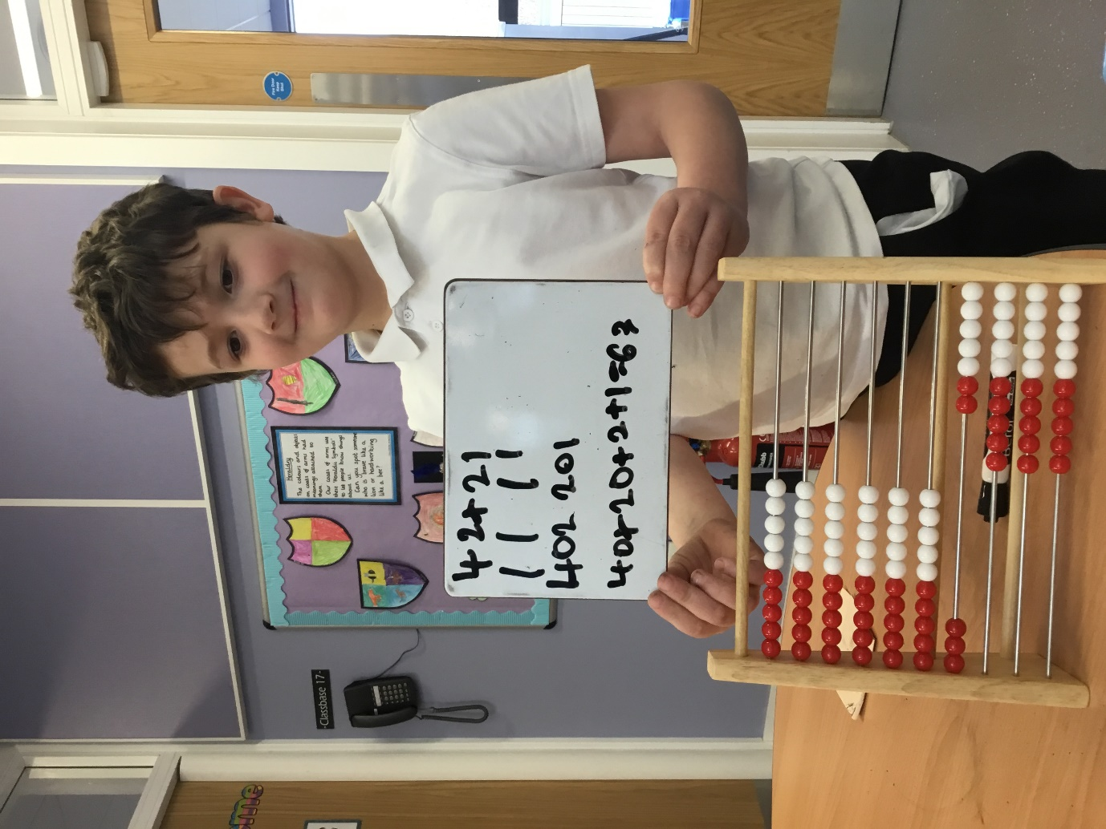

Elderbank Primary and Early Years
Pupil Equity Funding

Within Elderbank Primary, we run targeted support interventions across the school, the focus of which is primarily on key literacy and numeracy skills. Pupils are initially identified by staff, based on classroom performance, assessment evidence and tracking data.

We also have a duty to focus on pupils within SIMD 1 & 2 as part of the Scottish Government Pupil Equity Funding initiative to close the poverty related attainment gap.

A bidding system is in place whereby suggested pupils who would benefit most from targeted interventions are put forward. These pupils and suggested targets are then reviewed by SMT before a final decision is made on the format of intervention i.e. by class teacher / classroom assistant / targeted support teacher.

Target Sheets

Pupils receiving direct teaching from a targeted support teacher will have a personal target sheet. Targets are initially set by the class teacher and will make appropriate reference to any Pupil Learning Plan (PLP) targets already in place.

Targets will be shared with pupils prior to intervention and pupil views will be sought. Following this, targets will also be shared with parents and their views recorded. Targets will be regularly reviewed and evaluated before new targets are set.

Individual target sheets will be provided by targeted support staff and kept in class Staged Intervention folders. Targeted Support staff will keep a working group sheet and all material will be available to staff via One Drive.

Delivery of Interventions

Targeted support staff are timetabled across the week for all stages. They will regularly liaise with teaching staff to discuss targets, strategies and progress. This professional dialogue between staff will ensure consistency in approach.

In the first instance, pupils should be supported in class unless:

a) They are part of a targeted support group made up of pupils from different classes
b) They have difficulty with concentration and focus, displaying a preference for working within their designated open area

When Targeted Support is occurring, class teachers should be delivering the same area of the curriculum to the remainder of the class. This may not always be possible due to timetabling restrictions but teaching staff should try to accommodate this as much as possible and where this is not possible it will be discussed with the link SMT.

Evidence

There should be triangulation of evidence between PLP and Targeted Intervention targets, classroom planning and practice and targeted intervention planning and practice. Observations, pupil comments, written evidence and formal assessment data will all contribute to the judgment on progress and attainment.

Elderbank Primary and Early Years
Pupil Equity Funding

Near Targets

*Ensure that the poverty related attainment gap does not increase
* Improve use of assessment and tracking data to identify pupils and better inform targeted interventions
* Implement a streamlined and robust system of intervention to support those in greatest need
* Improve consistency and collaboration between intervention staff and class teachers
* Improve communication with parents and guardians with a focus on target sharing and supporting pupils at home
* Improve support for families for both education and socio-economic purposes

Far Targets

* Close the poverty related attainment gap
* Embed a robust and proven tracking and assessment system which identifies those “most at risk” at the earliest possible stage
* Provide parents / guardians with a bespoke support network focussed on improving their socio-economic status
*Embed K2L as the basis of the Early Years and Infant curriculum
* Develop and deliver a curriculum with a greater focus on skills for life
* Increase parent engagement to improve consistency between school and home, upskilling parents in their ability to better support pupils

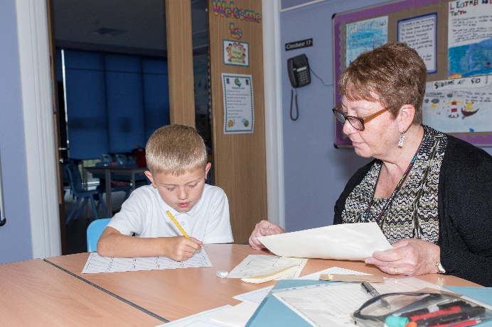

Elderbank Primary and Early Years
Pupil Equity Funding

In session 2017/2018, PEF interventions focussed solely on pupils form SIMD 1 or 2. Targeted interventions ran in parallel to this approach. In 2018/19, we reviewed this to allow for a more streamlined approach, supporting all pupils across the school. As a result the overall numbers looked to have increased by 36 although the number of SIMD 1 & 2 pupils has dropped by 10.

 | August  2017/18 | August  2018/19 | August  2019/20
Targeted Support Pupils | 105  (22% of school role) | 141  (32% of school role) | 103  (28% of school role)
SIMD 1 & 2 Pupils | 105 | 95 | 64
SIMD ≥ 3 Pupils | 0 | 46 | 39

Comparing this year to last, there is a 4% decrease in pupils currently being supported in literacy
and / or numeracy. This reflects the progress being made by the interventions in place.

Elderbank Primary and Early Years
Pupil Equity Funding

Elderbank Attainment Summary 2017 / 2018
 |  | R | W | L/T | N
P1 | ‘16 | 77% | 81% | 86% | 91%
 | ‘17 | 79% | 79% | 98% | 92%
 | ‘18 | 80% | 79% | 86% | 94%
 | ‘19 | 75% | 75% | 88% | 79%
P4 | ‘16 | 77% | 63% | 77% | 80%
 | ‘17 | 87% | 83% | 91% | 90%
 | ‘18 | 81% | 78% | 83% | 86%
 | ‘19 | 81% | 76% | 83% | 81%
P7 | ‘16 | 42% | 33% | 58% | 40%
 | ‘17 | 80% | 69% | 90% | 88%
 | ‘18 | 75% | 65% | 86% | 88%
 | ‘19 | 83% | 64% | 81% | 81%

How well are you doing? What is working well for your learners? | How do you know? What evidence do you have of positive impact on learners? | What are you going to do now? What are your improvement priorities in this area?
*P1, P4&P7 perform ahead of quartile 1 schools in Reading and Numeracy and almost all in writing and L&T.  * Increased attainment in LIT & NUM in Early Years  * In EYs Numeracy and Literacy permeates across the various playroom areas  *In P1 there has been a slight decline in Reading and Writing but an increase in L&T  *Decline in Numeracy in P1 is due to an increased number of pupils with ASN  *In P4 there has been a gradual increase in Literacy but decline in Numeracy however still comparable with NA average.  *In P7 there has been an increase of 8% in Reading but maintained above average in L&T and Writing. A decrease in Numeracy but above NA average. | *Assessment results in LIT and NUM  * SNSA in P1  * Targeted Support Evaluations  * Monitoring – Focus Meetings, Tracking information, Classroom Observations & Learning Walks  * Milestones Data in EY show good progress in all groups  Pupil focus groups - Pupil views show increased confidence  * Target setting – pupils can talk about their targets and take ownership for their learning.  * In EYs Listening and talking Assessments, ‘I Can’ trackers and Milestones Tracker | *Reading Recovery Teacher trained to identify P2 pupils to raise attainment in Reading.  Development group to create progression framework in Reading.  * Talk Boost training to develop L&T skills in P2&3 v Attention and Listening groups to improve L&T in EYs  * Attention and Listening intervention P4&5  * Targeted Support in P2 focus on Numeracy to improve Numeracy skills.  * Consistency frameworks in comprehension and grammar skills progression framework to improve literacy across the school.  * ORT Reading Programme to engage readers.  *Story Grammar approach to develop story telling techniques and writing skills through sequencing , retelling, and role play.  *Develop problem solving skills through STEM

CFE Level Achieved Comparison
Reading
Stage | Elderbank | NAC | Quartile 1 Schools
Primary 1 | 75% | 82% (-7%) | 73% (+2%)
Primary 4 | 81% | 79% (+2%) | 75% (+6%)
Primary 7 | 83% | 80% (+3%) | 73% (+10%)

Writing
Stage | Elderbank | NAC | Quartile 1 Schools
Primary 1 | 75% | 78% (-3%) | 69% (+6%)
Primary 4 | 76% | 74% (+2%) | 71% (+5%)
Primary 7 | 64% | 74% (-10%) | 66% (-2%)

Listening and Talking
Stage | Elderbank | NAC | Quartile 1 Schools
Primary 1 | 88% | 87% (+1%) | 78% (+10%)
Primary 4 | 83% | 87% (-4%) | 81% (+2%)
Primary 7 | 81% | 88% (-7%) | 82% (-1%)

Numeracy and Maths
Stage | Elderbank | NAC | Quartile 1 Schools
Primary 1 | 79% | 84% (-5%) | 76% (+3%)
Primary 4 | 81% | 77% (+4%) | 76% (+5%)
Primary 7 | 81% | 78% (+3%) | 71% (+10%)

Elderbank Primary and Early Years
Pupil Equity Funding

SNSA Results (2018 / 2019 Comparison)
Primary 1 SNSA Literacy

Session 2017/18 | Session 2018 / 19
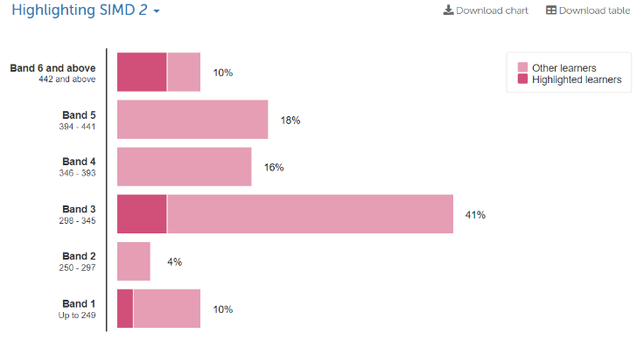 | 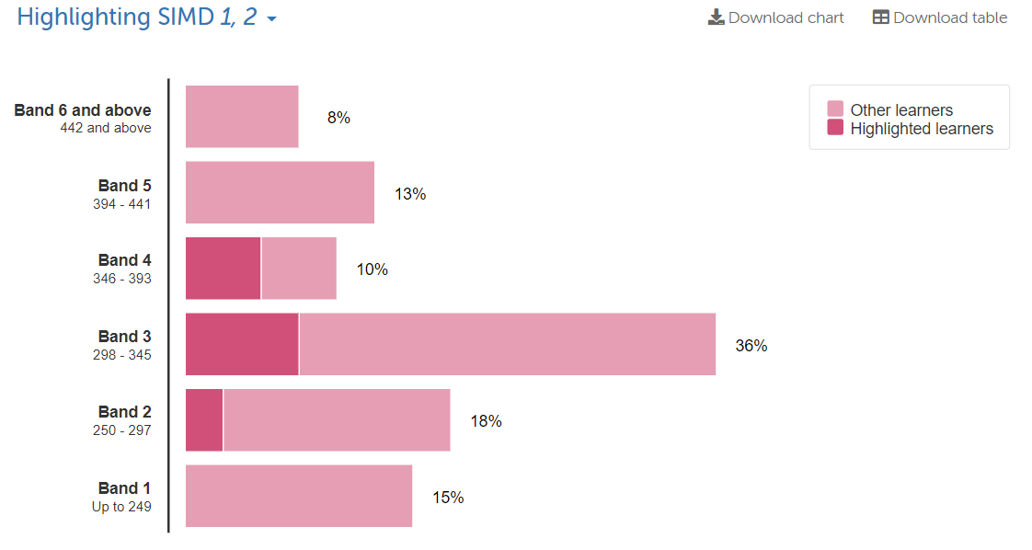
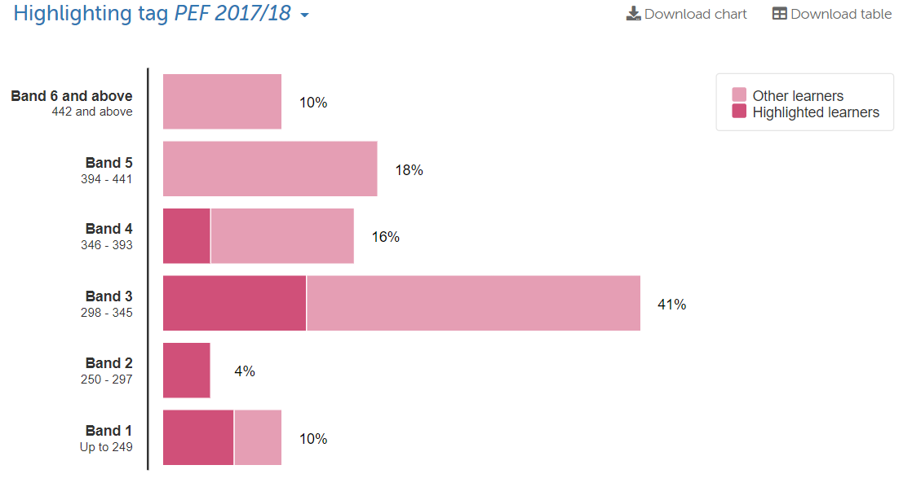 | 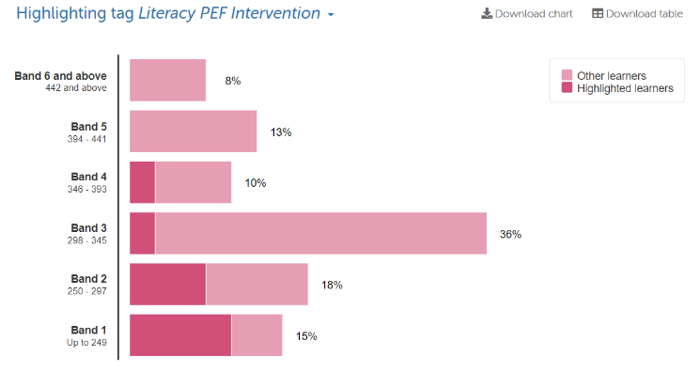
Elderbank Primary and Early Years
Pupil Equity Funding

SNSA Results (2018 / 2019 Comparison)
Primary 1 SNSA Numeracy
Session 2017/18 | Session 2018 / 19
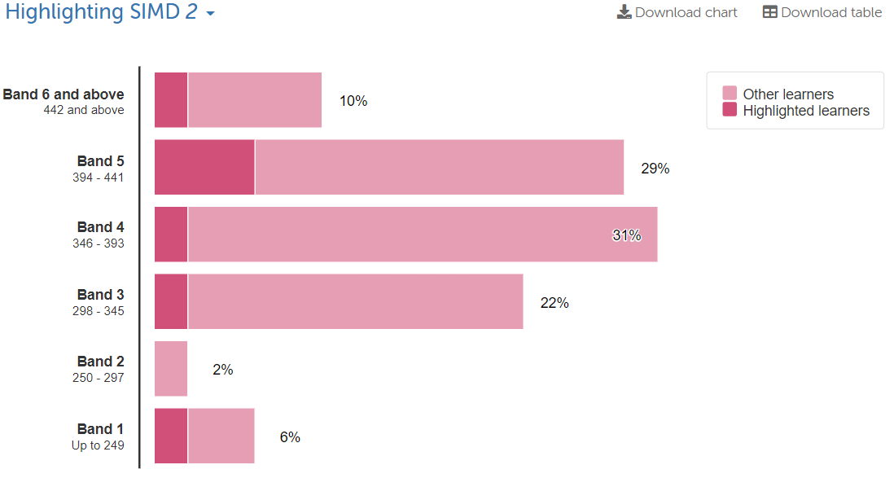 | 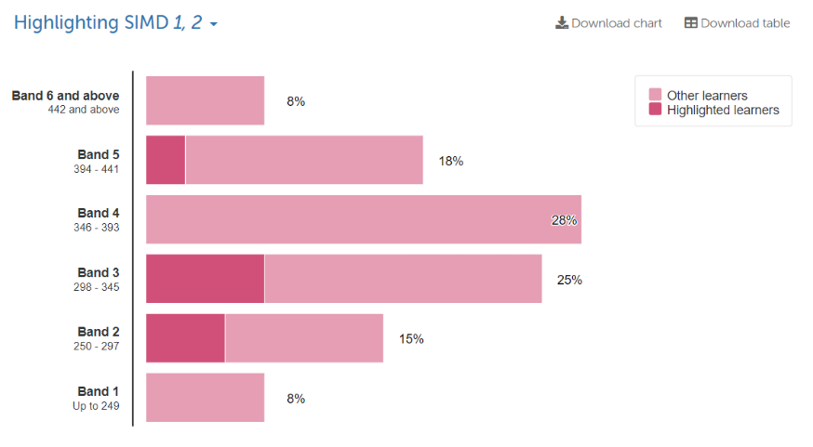
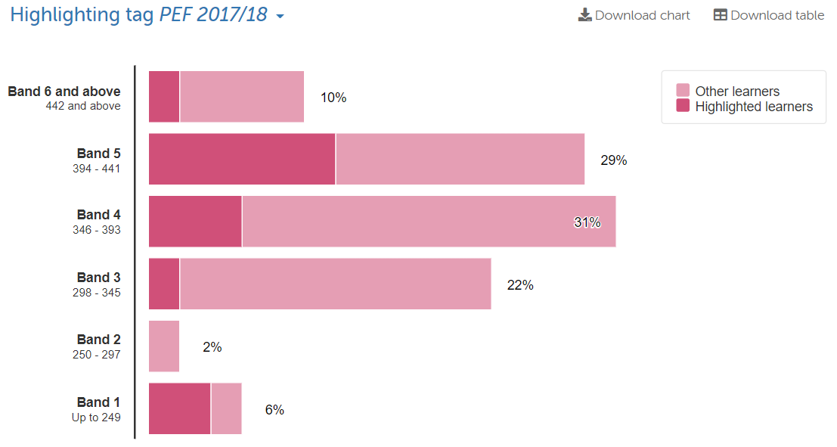 | 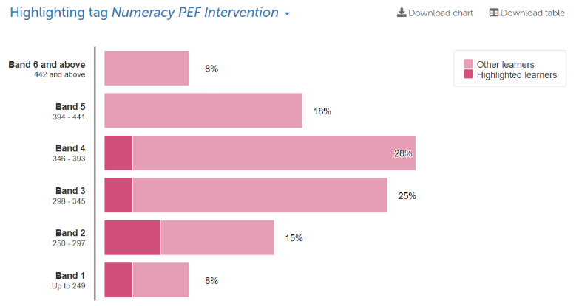

Elderbank Primary and Early Years
Pupil Equity Funding

SNSA Results (2018 / 2019 Comparison)
Primary 4 SNSA Literacy
Session 2017/18 | Session 2018 / 19
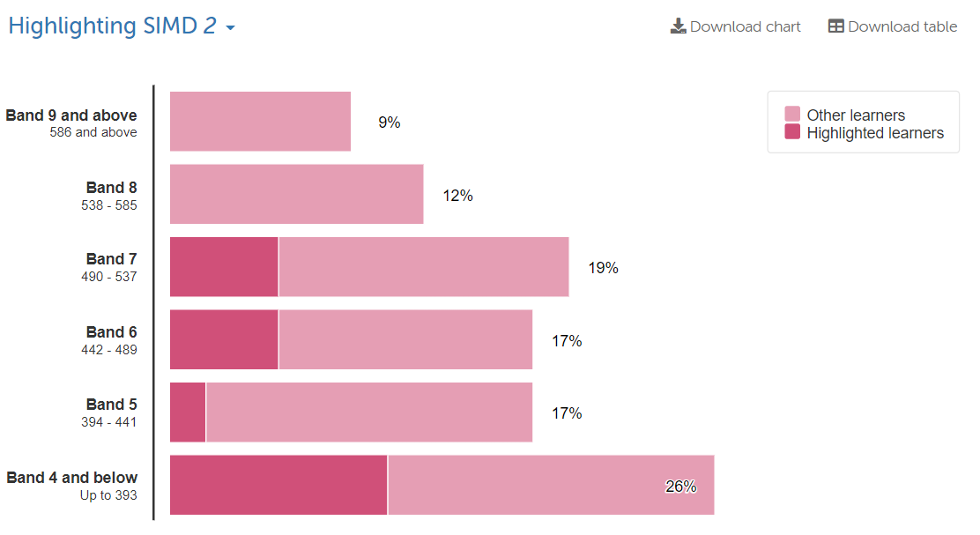 | 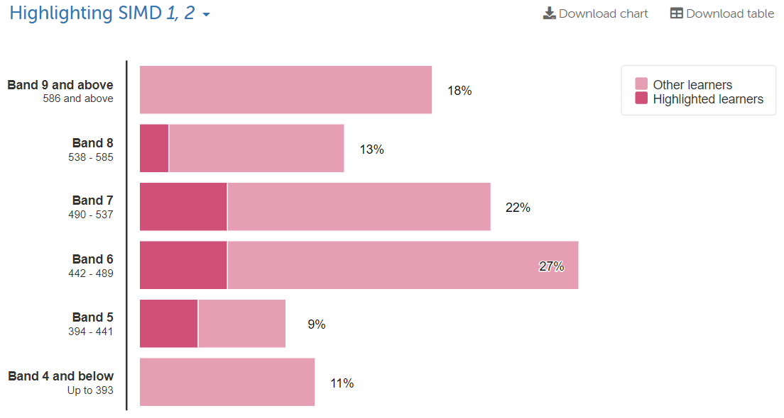
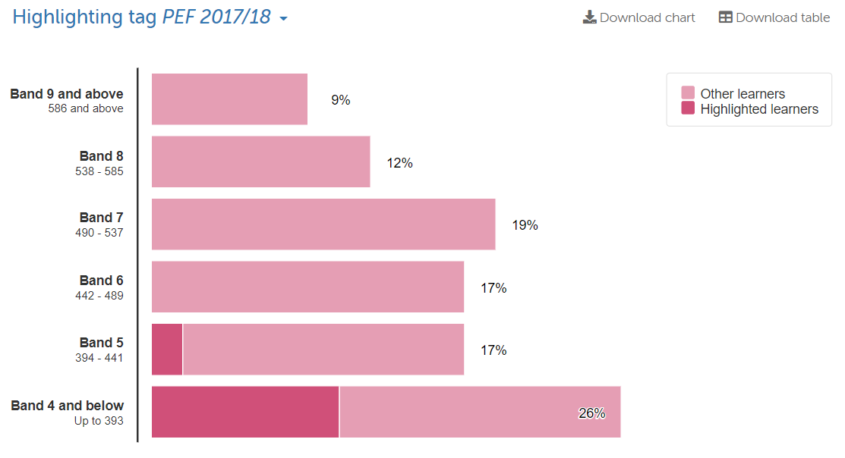 | 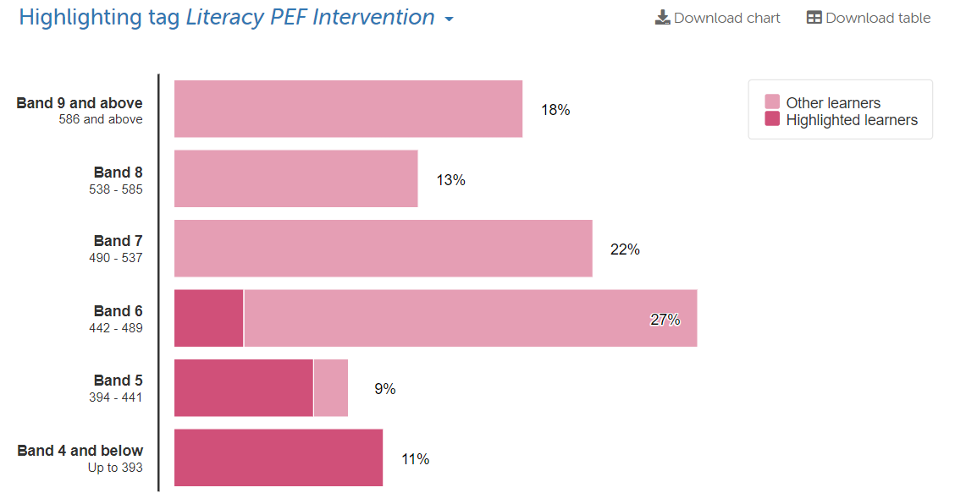

Elderbank Primary and Early Years
Pupil Equity Funding

SNSA Results (2018 / 2019 Comparison)
Primary 4 SNSA Writing
Session 2017/18 | Session 2018 / 19
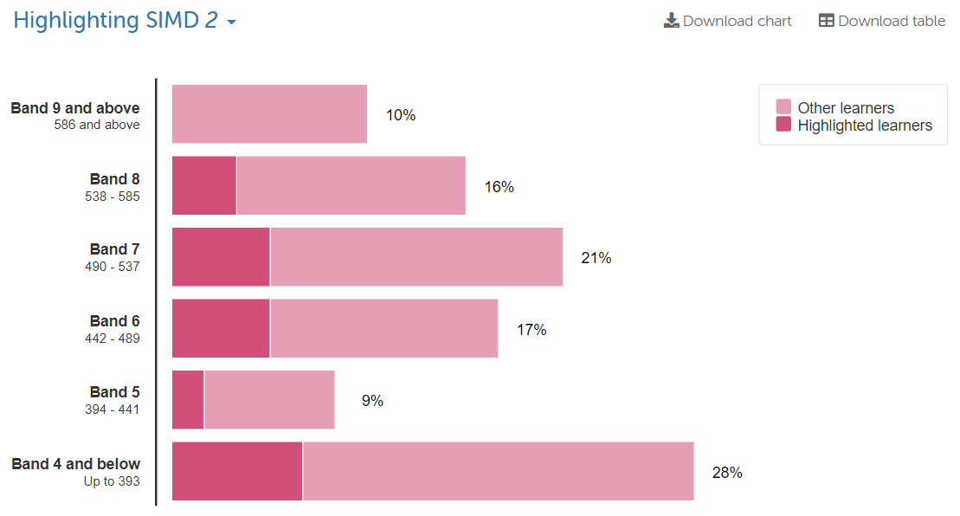 | 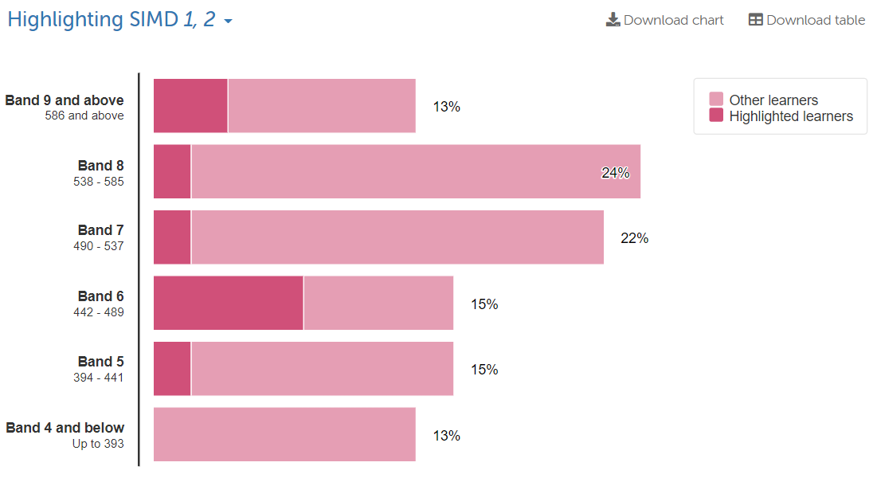
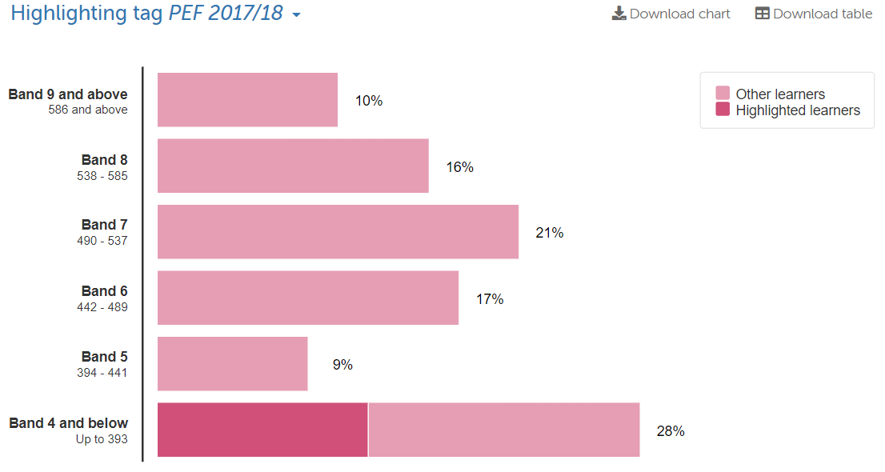 | 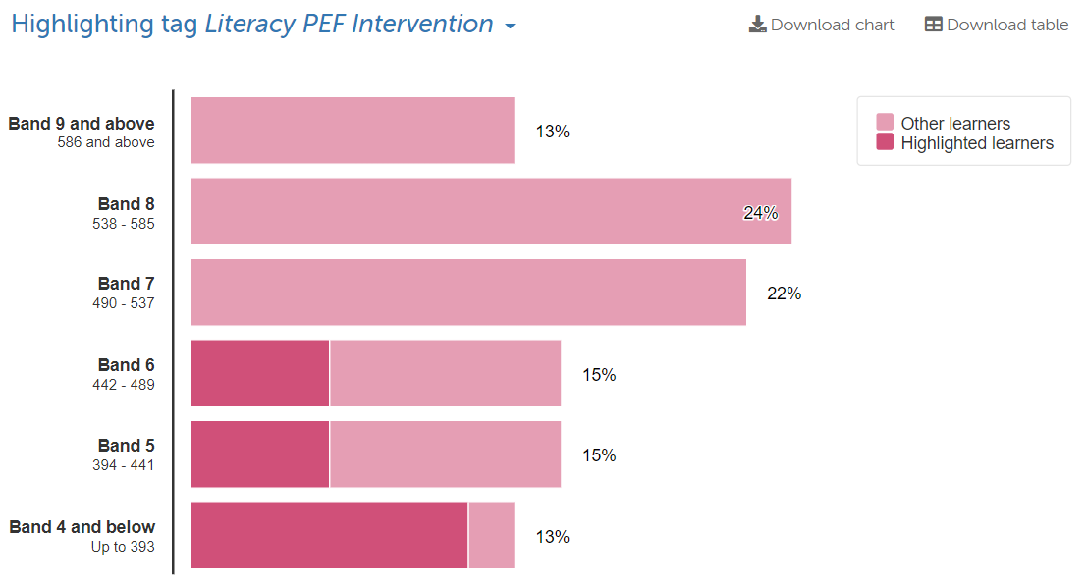

Elderbank Primary and Early Years
Pupil Equity Funding

SNSA Results (2018 / 2019 Comparison)
Primary 4 SNSA Numeracy
Session 2017/18 | Session 2018 / 19
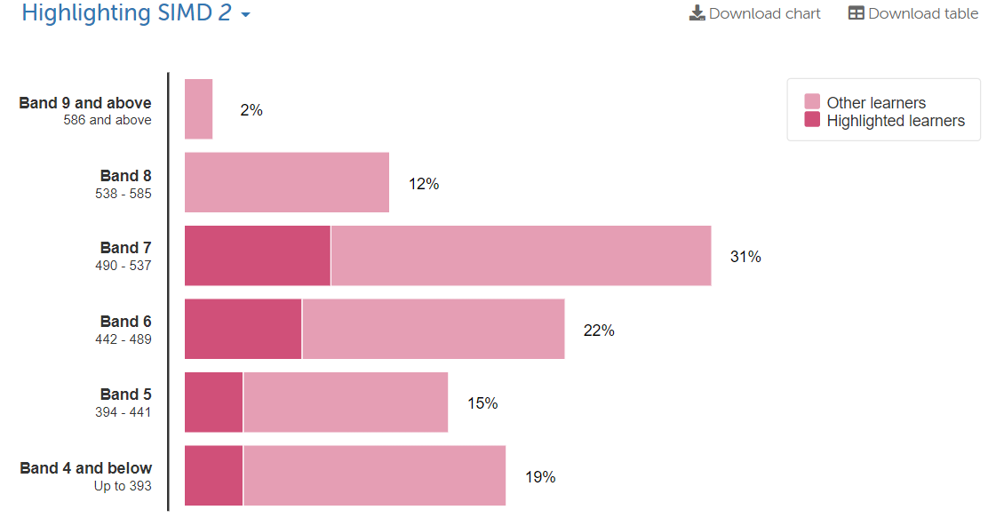 | 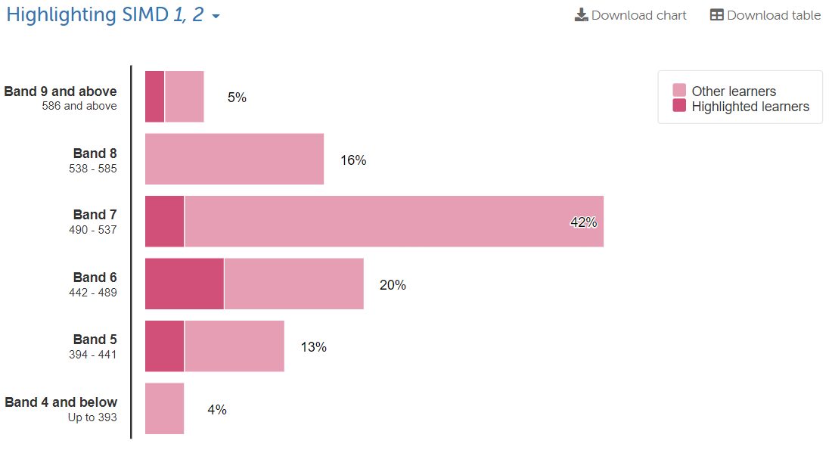
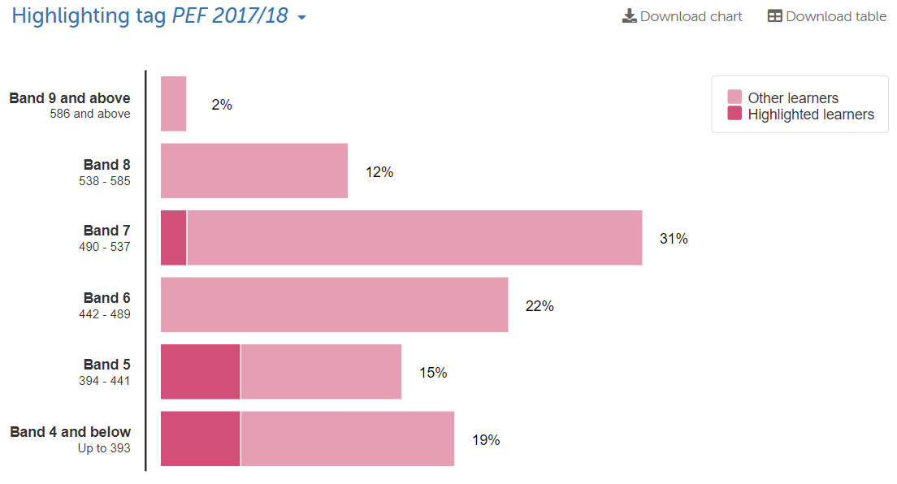 | 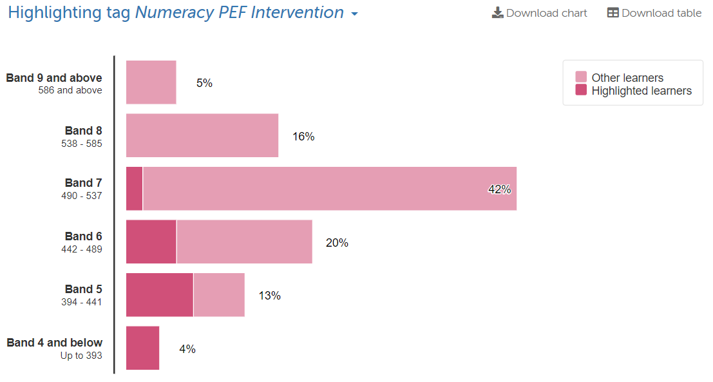

Elderbank Primary and Early Years
Pupil Equity Funding

SNSA Results (2018 / 2019 Comparison)
Primary 7 SNSA Reading
Session 2017/18 | Session 2018 / 19
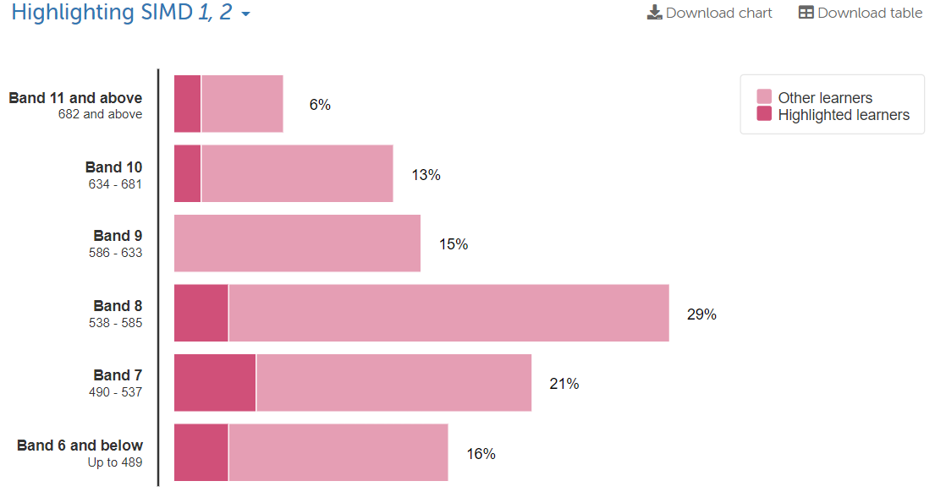 | 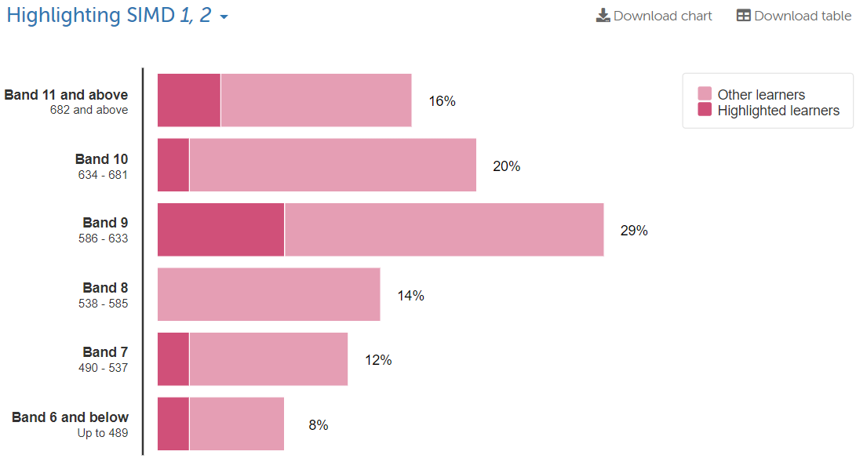
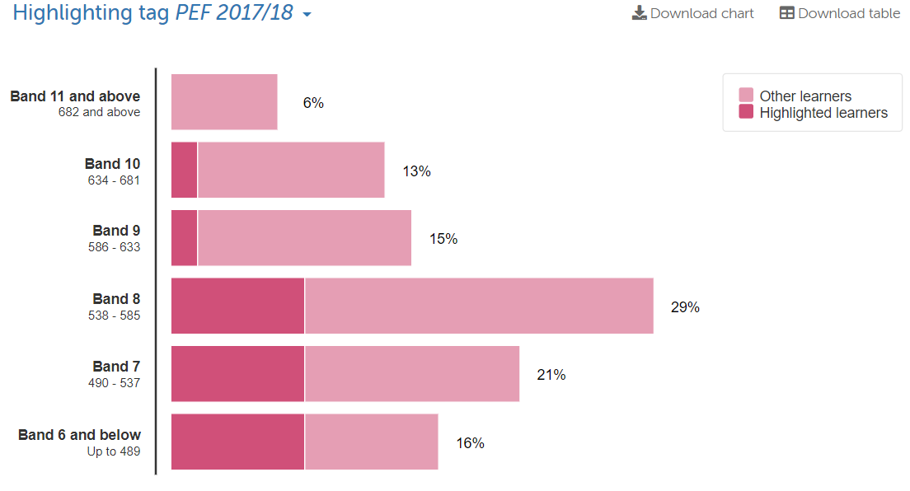 | 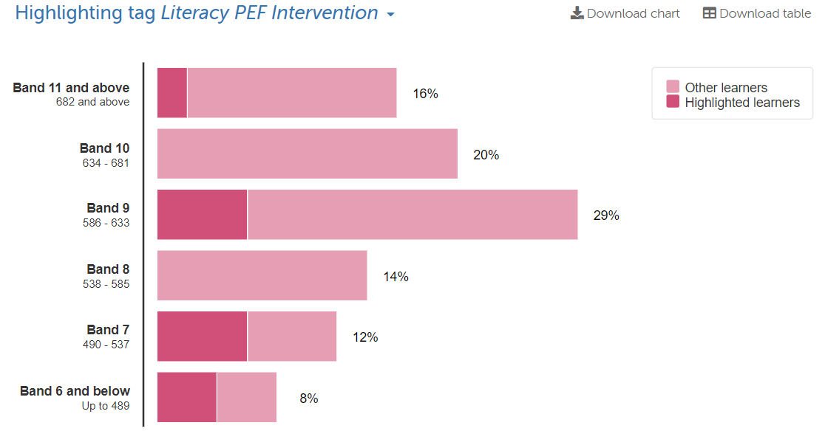

Elderbank Primary and Early Years
Pupil Equity Funding

SNSA Results (2018 / 2019 Comparison)
Primary 7 SNSA Writing
Session 2017/18 | Session 2018 / 19
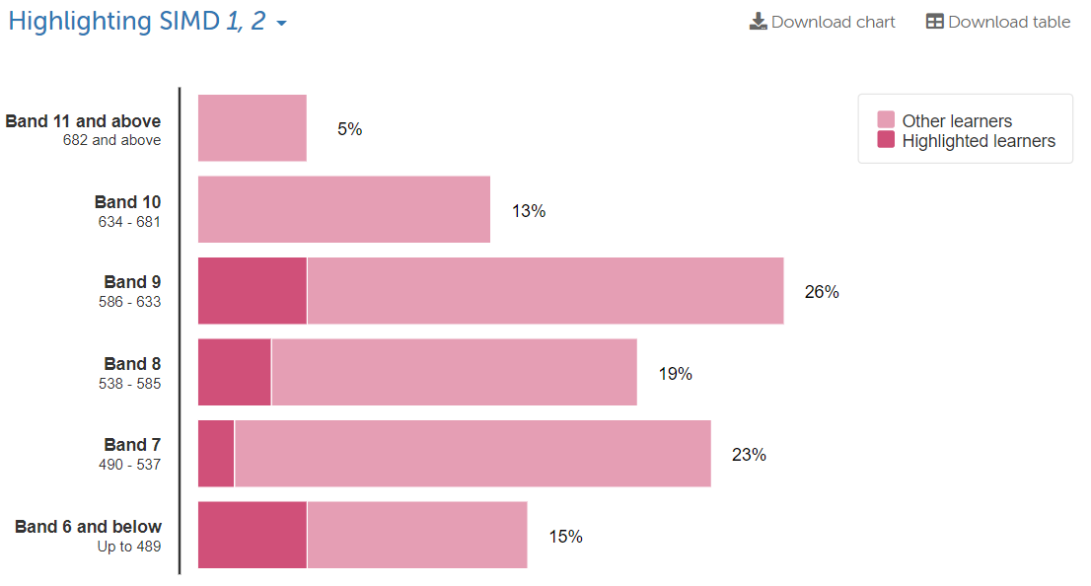 | 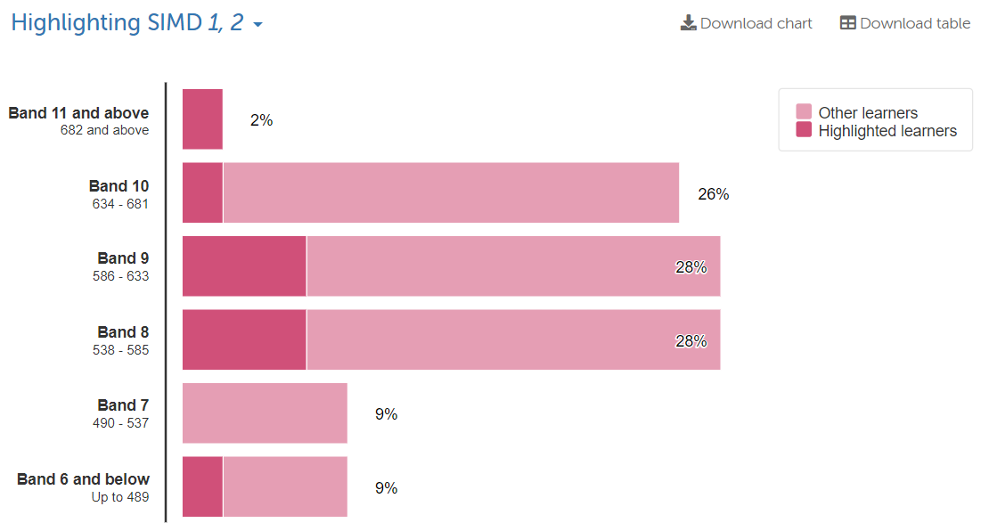
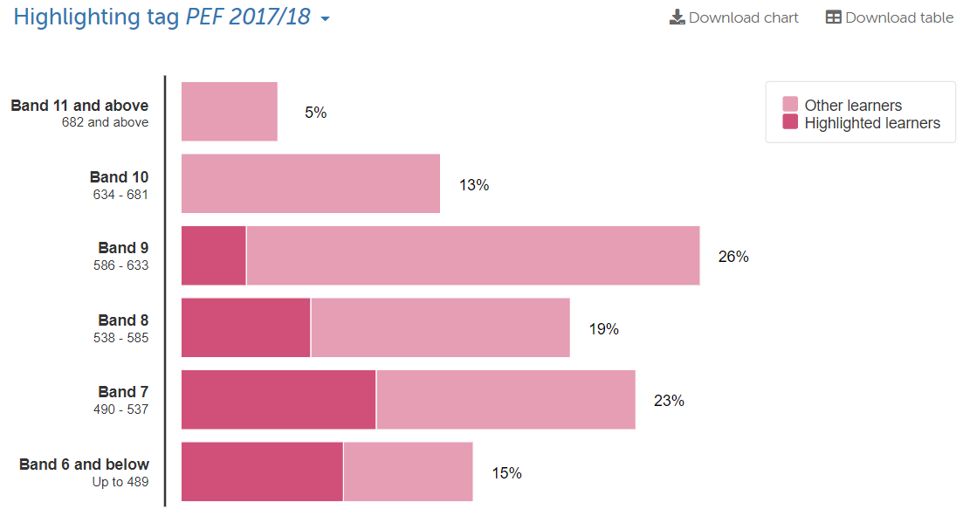 | 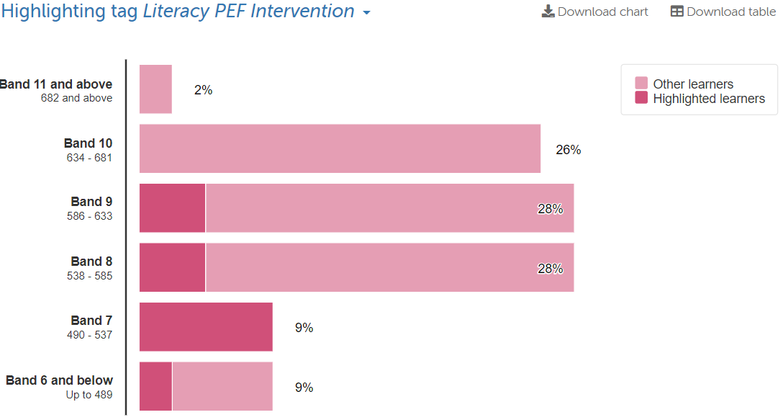

Elderbank Primary and Early Years
Pupil Equity Funding

SNSA Results (2018 / 2019 Comparison)
Primary 7 SNSA Numeracy
Session 2017/18 | Session 2018 / 19
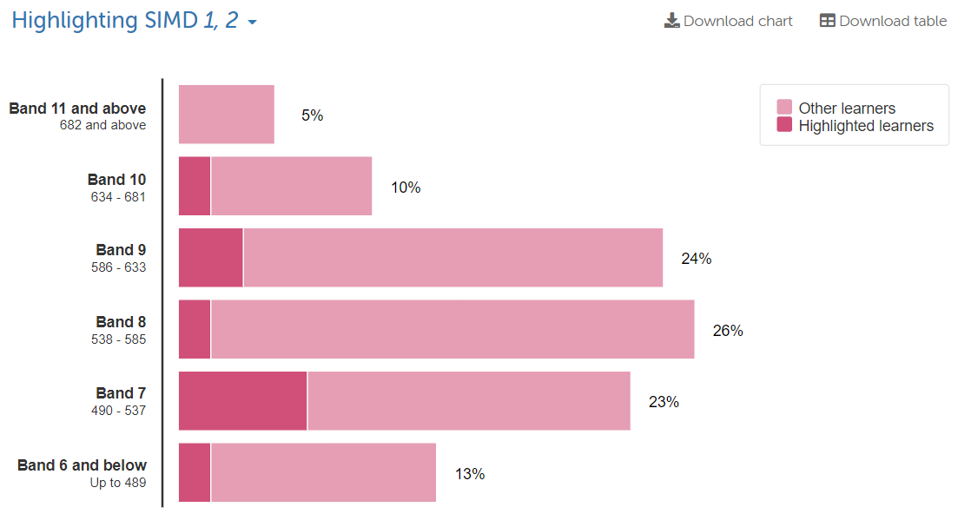 | 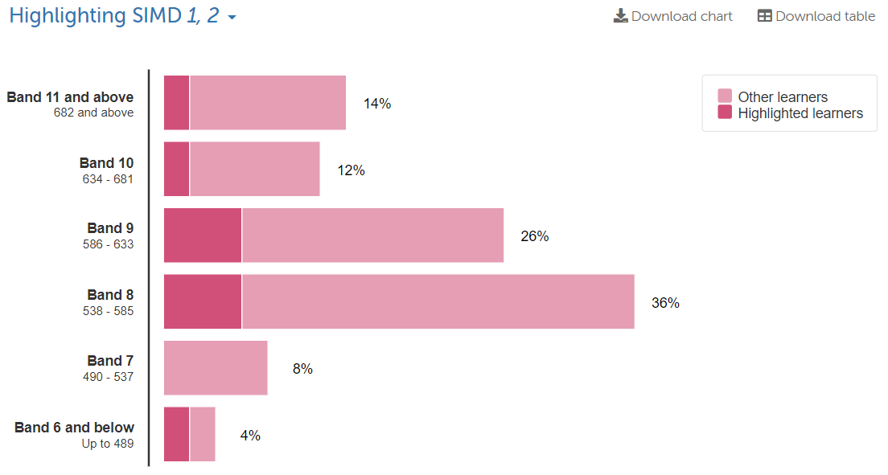
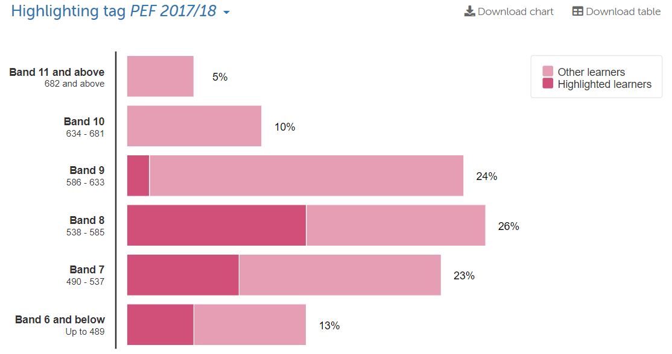 | 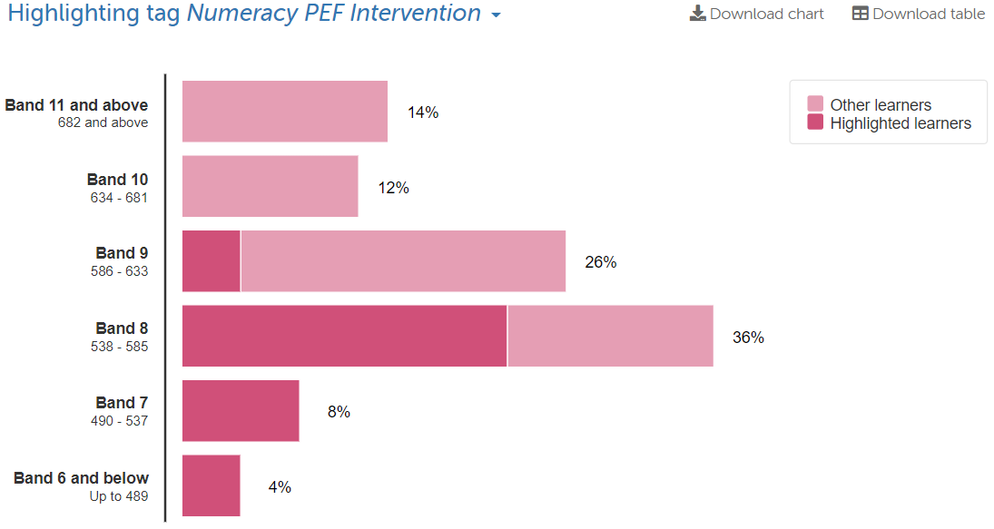

Elderbank Primary and Early Years
Pupil Equity Funding

Trends from SNSA Results
* In almost every assessment in 2018-19, there is an improved spread of SIMD 1&2 pupils within the bandings
* In almost every assessment in 2018-19, there is an improvement in the average banding achieved by pupils receiving targeted support
* In most assessments in 2018-19, the distribution curve is closer to, or more positive than, the expected average distribution curve
* The results achieved through SNSA testing validate the improving accuracy of teacher judgement when tracking attainment

Assessment | Average 2017/18 Score | Average 2018/19 Score | Increase / Decrease

Primary 1 Literacy | 349 | 323 | -26
Primary 1 Numeracy | 371 | 343 | -28

Primary 4 Reading | 461 | 496 | +35
Primary 4 Writing | 459 | 500 | +41
Primary 4 Numeracy | 467 | 499 | +32

Primary 7 Reading | 560 | 609 | +49
Primary 7 Writing | 565 | 586 | +21
Primary 7 Numeracy | 566 | 603 | +37

Elderbank Primary and Early Years
Pupil Equity Funding

Impact of PEF Interventions – Parent Responses
A series of parent surveys were carried out to capture parent / carer opinion on the impact of interventions within Elderbank Primary and Early years. The average response to each question is noted below.
1 = Strongly Disagree 2= Disagree 3 = Undecided 4 = Agree 5 = Strongly Agree

Children 1st

Question | Average Response
I believe that the input from Children 1st has had a positive impact on my child’s self-esteem | 3
I believe that as a result of Children 1st interventions, my child has become more resilient during social interactions | 3.5
I believe that due to support from a Children 1st worker, my child displays greater emotional well-being | 3.5
I believe that having input from a Children 1st worker, my child finds it easier to make and maintain friendships | 3.5
I believe that Children 1st support has helped to strengthen family relationships | 3
I believe that as a result of Children 1st interventions, my child has a more positive outlook towards school | 3.5
I believe that due to the support of a Children 1st worker, my child displays improved interactions within the local community | 3

Summer Holiday Programme

Question | Average Response
I believe that the summer holiday programme has had a positive impact on my child’s self-esteem | 5
I believe that on completion of the summer holiday programme, my child has become more resilient during social interactions | 4.57
I believe that as a result of the summer holiday programme, my child displays greater emotional well-being | 4.57
I believe that having participated in the summer holiday programme, my child finds it easier to make and maintain friendships | 4.71
I believe that the summer holiday programme has helped to strengthen family relationships | 4.71
I believe that having participated in the summer holiday programme, my child has a more positive outlook towards school | 4.43
I believe that due to the summer holiday programme, my child displays improved interactions within the local community | 4.57
I believe that my child would greatly benefit from engaging in any future family holiday activities - Easter and/or Summer - that may planned | 4.86
Elderbank Primary and Early Years
Pupil Equity Funding
Targeted Support

Question | Average Response
I believe that the targeted support programme has had a positive impact on my child’s self-esteem | 4.27
I believe that due to targeted support in school, my child has become more resilient | 4
I believe that as a result of the targeted support programme, my child displays greater emotional well-being | 3.91
I believe that due to the targeted support programme, my child is making greater progress in literacy and / or numeracy | 4.73
I believe that due to the sharing of targets between school and home, I am able to better support my child | 4.18
I believe that having participated in the targeted support programme, my child has a more positive outlook towards school | 4.36
I believe that due to the targeted support programme, my child displays greater confidence in school and within their community | 4

Changes to Assessment
The impact of PEF interventions is tracked across the year for each individual pupil. We have altered our approach to assessment based on the feedback from staff, the efficiency of testing and the quality of data received and utilised from specific assessments

* Ongoing assessment throughout the year has changed and we are now assessing online using Sumdog (Numeracy) and NGRT / NGST (Literacy)
* Data is collated as part of the whole school assessment approach – this is used to inform teacher judgement and track progress
* Progress will be measured based on the results gained SNSA assessments in May / June
* Impact will look at the change in average SNSA scores for targeted intervention learners in literacy and numeracy compared to their mainstream counterparts
