

**Education and Youth Employment**

**Elderbank Primary School and Early Years**

**Improvement Plan 2019-20**

School logo?

**Vision, Values and Aims**

**Values**

Respect, Inclusion, Equality, Excellence

**Vision**

Elderbank will provide a stimulating, supportive, secure learning environment which enables **all** learners to reach their full potential through quality learning and teaching, while nurturing and supporting the school community to participate actively in the life and work of the whole school, which will equip learners to thrive in an ever changing and challenging world.

**Aims**

* To provide all learners with a consistent framework for positive interactions while promoting self-esteem, positive behaviour, pride and self-discipline.
* To build a curriculum framework based on breadth, balance, challenge, progression, cohesion, personalisation and choice, and which recognises, supports and meets the needs of every child through appropriate, quality active learning opportunities.
* To provide a fully inclusive, safe, welcoming and nurturing learning environment which encourages learners to take responsibility for their learning.
* To effectively encourage and support leadership at all levels.

**Council Priorities:**

The Council strategic priorities for 2019-24 are detailed below:

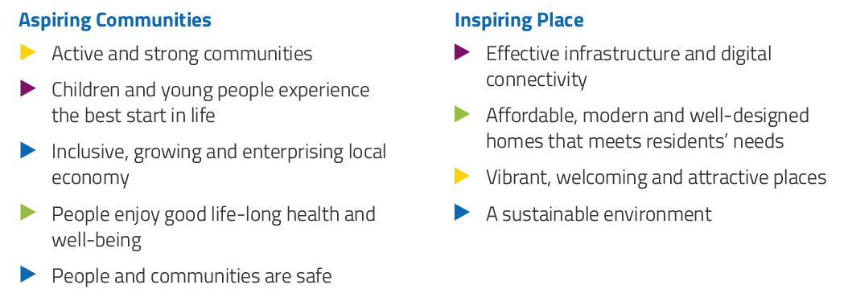

**National Improvement Framework:**

The National Improvement Framework for Education is designed to help us deliver the twin aims of excellence and equity; galvanising efforts and aligning our collective improvement activities across all partners in the education system to address our key priorities. These priorities remain as:

* Improvement in attainment, particularly in literacy and numeracy
* Closing the attainment gap between the most and least disadvantaged children
* Improvement in children and young people’s health and wellbeing
* Improvement in employability skills and sustained, positive school-leaver destinations for all young people

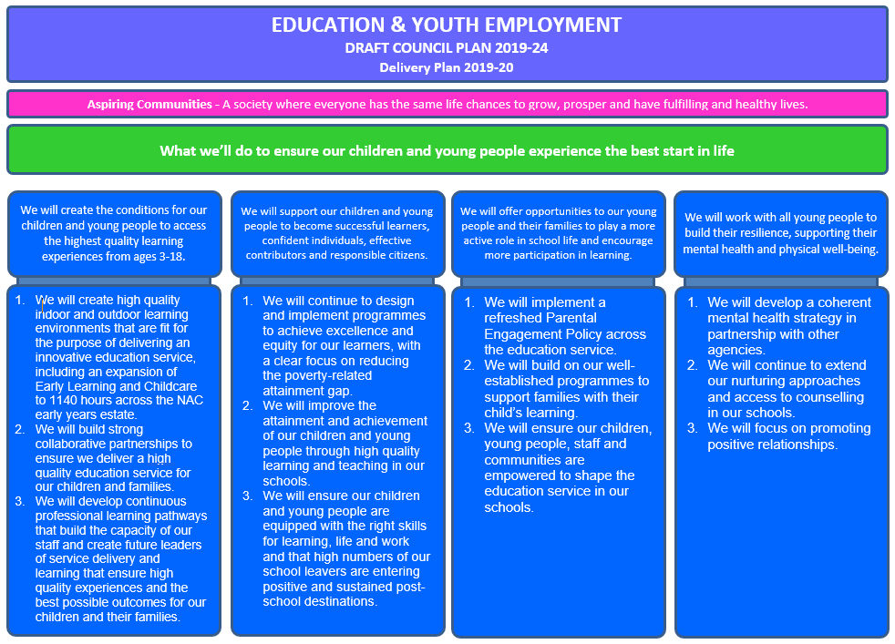

**Strategic Plan 2019-20: Elderbank Primary School and Early Years**

|  |  |  |  |  |  |  |
| --- | --- | --- | --- | --- | --- | --- |
| **School Priorities** | **To raise attainment in literacy with a specific focus on Reading Skills using Reading Recovery strategies.**   |  | | --- | |  | | **To embed a whole school approach to supporting behaviour through consistency in Nurture and Restorative practices** | **To improve communication and listening skills through developing strategies to engage learners.** | **To enhance learning across the curriculum by developing problem solving approaches closely linked through STEM and Key to Learning.** | **To explore effective feedback through a consistent Whole School Visible Learning Approach** |
| **High Level Objectives** | Learners will have increased skills, knowledge and understanding of key strategies to support their learning in reading  Reading Recovery teacher will become a highly skilled literacy expert who can share their knowledge with the whole school staff and will be able to use detailed diagnostic assessment that will help to determine the learning needs of the few children who need longer term literacy support | Learners will develop skills in restorative practices to resolve conflict and capacity for self-regulation.  Learners will have increased opportunity for positive experiences across the whole school establishment and community through careful planning of appropriate learning opportunities to match their needs.  Teachers will use a whole school approach to managing behaviour and will be supported by Nurture staff. | Learners will develop their language and communication skills  Learners will increase their ability to listen and focus and increase their confidence.  Teachers and Early years Practitioners will have increased knowledge in developing opportunities for talking and listening and teach strategies to improve learners engagement | Developing the Young Workforce:  Learners will have increased skills, knowledge and understanding of key strategies to support their learning in maths and science and Technology.  Learners will develop and apply their maths concepts and problem-solving skills in a science context.  Learners EY-P2 will develop the ability to analyse objects and events, see their “invisible” sides, identify their most essential characteristics’, think sequentially, draw conclusions, classify and systematize information through Key to Learning.  Teachers will have increased knowledge, skills and confidence in effective approaches to delivering learning in maths and science | Practitioners will increase their knowledge and understanding and skills in giving highly effective feedback.  Leadership team will have increased confidence and be highly skilled in ensuring clear and consistent pedagogical practice across the school through robust approaches to quality assurance |

**Strategic Plan 2019-20: Elderbank Primary School and Early Years**

Here is an overview of how we intend to use our Pupil Equity Funding to support improvement:

**Detailed Action Plan 2019-20: Elderbank Primary School and Early Years**

|  |  |  |  |  |  |  |  |
| --- | --- | --- | --- | --- | --- | --- | --- |
| **School Strategic Priority:** | | **To raise attainment in literacy with a specific focus on Reading Skills using Reading Recovery strategies.** | | | | | **Linked to Directorate Priority: 1, 2** |
| **High Level Objectives** | **HGIOS 4**  **HGIOELC**  **NIF** | **Supported through PEF?**  **Y/N** | **How will I achieve this?** | **Timescale / Assigned to:** | **Pupil Outcomes** | **Measurement** | |
| ***From Priority 4***  *Raise attainment and achievement throughout the BGE and Senior Phase through innovative approaches to learning and teaching.*  *Maintain a specific focus on reducing the poverty related attainment gap and maximise the learning potential of specific groups of learners including LAC.:*  Learners will have increased skills, knowledge and understanding of key strategies to support their learning in reading  ***From Priority 2***  *Support and strengthen the professional capacity of staff:*  Reading Recovery teacher will become a highly skilled literacy expert who can share their knowledge with the whole school staff and will be able to use detailed diagnostic assessment that will help to determine the learning needs of the few children who need longer term literacy support | **HGIOS 4**  *2.4*  *NIF: 1* | *YES*  *£12,746*  *0.6 FTE*  *Reading*  *Recovery Teacher* | **Teacher Professionalism**  *Identified teacher to be trained as Reading Recovery teacher (0.6fte – 0.4fte is PEF funded)*  *OSELA (Observation Survey of Early Literacy Assessment) training for RR teacher.*  *Sharing practice collegiate time for staff (teachers & classroom assistants)*  *Link teacher trained in OSELA Read Aloud event Mid-point data collated & shared with CT, HT & wider staff team.*  **School Leadership**  *Mid-point data collated & shared with CT, HT & wider staff team.*  *Final combined data collated, analysed & shared with CT, HT & wider team.*  **School Improvement**  *All P2 staff will be involved in evaluating the impact.*  **Assessment of Children’s Progress**  *4 pupils identified from P.2 cohort & permission from parents/families sought. (lowest performing learners from cohort)*  *First cohort of learners begin Reading Recovery (16-20 weeks)*  *First cohort of readers discontinued and second cohort of learners begin Reading recovery (16-20 weeks)*  All teachers will record pupil attainment and opportunities for Reading and discuss progress as part of Focus Group Sessions with SMT.  **Performance Information**  *Tracking, monitoring and observation*  **Parental Engagement**  *Evaluations collated from learners, families & teachers.*  *Reading Recovery training complete & ‘Celebrating Success’ event.* | *Training starts: August 2019*  *Shared with HT/CT: August 2019*  *Mrs Gourlay*  *September 2019*  *Cohort runs September 2019 – Feb./March 2019.*  *November 2019*  *Check in with HT/CT:*  *Weekly update HT/CT.*  *January 2020*  *April 2020*  *May 2020*  *June 2020* | *Learners with difficulties in reading will benefit from early identification & targeted support.*  *Learners will be supported in their literacy attainment by a fully trained and qualified Reading Recovery teacher.*  *2 cohorts of learners in Primary 2 will be identified for support using the OSELA. These learners will then be supported in their literacy attainment through Reading Recovery.*  *Learners with the most significant needs in reading will have these addressed through expert intervention.*  *Learners across the school will benefit from being taught by staff who have a greater understanding of the complexities of learning to read. Staff will be more confident in addressing reading difficulties as part of their approach to the pedagogy of reading.*  *Those learners who require longer term intervention and support will benefit as a result of staff being able to access detailed diagnostic assessment.*  *Learners whose wellbeing was being negatively impacted by their difficulties in reading will experience success and will be able to re-integrate with their peers in literacy based learning experiences.* | *OSELA (Observation Survey of Early Literacy Assessment) used to identify learners within the P.2 cohort who are experiencing the greatest difficulties in reading – group taken from the lower 20% of learners based on TJS. AUGUST 2019 – analysed SEPTEMBER 2019.*  *Observation survey completed for 4 identified children SEPTEMBER 2019. Teacher Leader will analyse with Reading Recovery Teacher OCTOBER 2019.*  *Views of teachers and classroom assistants measured using self-report questionnaire to gather data on their confidence in meeting the needs of young people experiencing difficulties in learning to read. AUGUST 2019 & MAY 2020.*  *Semi-structured interviews with parents & carers pre and post intervention. SEPTEMBER 2019-MARCH 2020, MARCH 2020 – JUNE 2020.*  *Progress through PM books used to measure impact of Reading Recovery intervention. WEEKLY – main collation MARCH 2020 & JUNE 2020.*  *OSELA used to measure impact prior to a child being discontinued.*  *Post intervention focus group discussion with learners and their families DECEMBER 2019 & MAY 2020.* | |

**Detailed Action Plan 2018-19: Elderbank Primary and Early Years**

|  |  |  |  |  |  |  |  |
| --- | --- | --- | --- | --- | --- | --- | --- |
| **School Strategic Priority:** | | **To embed a whole school approach to supporting behaviour through consistency in Nurture and Restorative practices** | | | | | **Linked to Directorate Priority: 2,4** |
| **High Level Objectives** | **HGIOS 4**  **HGIOELC**  **NIF** | **Supported through PEF?**  **Y/N** | **How will I achieve this?** | **Timescale / Assigned to:** | **Pupil Outcomes** | **Measurement** | |
| *Learners will develop skills in restorative practices to resolve conflict and capacity for self-regulation.*  *Learners will have increased opportunity for positive experiences across the whole school establishment and community through careful planning of appropriate learning opportunities to match their needs.*  *Teachers will use a whole school approach to managing behaviour and will be supported by Nurture staff.* | ***1.2***  ***1.3***  ***1.5***  ***2.2***  ***2.3***  ***2.4***  ***2.5***  ***3.2***  ***3.3***  ***NIF: 3*** | ***YES***  ***NURTURE/ POSITIVE RELATIONSHIPS TEACHER 1.0FTE (£31,867)*** | ***Teacher Professionalism***  *Staff will actively participate in a working group to review the school approach to recognising positive behaviour and achievements.*  *NPR teacher will support staff to use consistent approaches across the stages:*  *Provide staff dev and training sessions*  *Support staff in class to implement positive behaviour strategies*  ***School Leadership***  *Teacher appointed and responsible for managing behaviour across stages.*  *Providing training and information sessions for all staff.*  *Working with pupils to develop trust, resilience and support using nurture and restorative approaches individually or group.*  *Leading a working group*  *liaising with Ed Psychologist*  *monitoring and evaluating progress*  *feeding back to SMT*  *Organising and leading Parent groups*  ***School Improvement***  *Consistency in approaches across the stages.*  *Staff will be involved in evaluating impact of improvements. Evidence of changes to delivery will be noted within planning and impact discussed during focus meetings. Pupils’ views will be sought and consistency in approaches monitored during learning walks and moderation activities.*  ***Assessment of Children’s Progress***  *Ongoing assessment and tracking of pupil progress*  *Benchmarks, POLAAR, SENA, GL and SNSA assessments will all be utilised to gauge children’s progress.*  *Professional discussions during Focus Meetings with SMT*  ***Performance Information***  *During focus meetings, staff will articulate the extent to which improvements have impacted on pupils’ learning and the factors which have contributed to this.*  *Termly evaluations and tracking information will be used to support teacher judgements.*  ***Parental Engagement***  *Identify opportunities for parents to support pupils in class*  *Use of Evisense for individual pupils who require additional support to recognise achievements*  *Parenting workshops/training*  *Parental involvement in recognition of achievements*  *Calendar of parent meetings – TAC, review, parent/teacher.* | *1.0 FTE Class Teacher*  *(Session 2019/20)*  *Term 1:*  *Inservice Day Behaviour input – evaluation planning and next steps in whole school approach to managing behaviour.*  *September 2019*  *Working Group*  *Identified*  *Calendar for Parent workshops /training*  *Termly Focus meetings*  *Assessmnent calendar*  *On-going 2019-2020* | *Almost all pupils will be more resilient*  *Almost all pupils will be more engaged in learning within the classroom*  *Most pupils will show respect for diversity and have an increased understanding, knowledge and skills through their behaviour and actions.*  *All pupils’ achievements will be celebrated through recognition boards*  *All pupils will experience a consistent school approach to managing behaviour.*  *Most pupils will be more confident in dealing with conflict through increased skills in restorative approaches.* | *. Prior to intervention, pre intervention assessment of pupil evaluation – Boxall Profile.*  *PASS Survey September P4-7*  *Increase in attendance for vulnerable groups and individuals tracked through attendance monitoring*  *Pupil evaluations of diversity programmes*  *Teacher evaluations will reflect increased pupil understanding of diversity*  *Staff evaluations of programmes of study will reflect an increase in pupil understanding of equality and equity.*  *Monitoring of Support Staff in playground will demonstrate a consistent approach to positive interactions and use of restorative practice*  *Peer observation of Support Staff will recognise good practice and areas for improvement*  *Record of pupil achievement will demonstrate an increase in pupil recognition from Term 1 – Term 4*  *PASS Survey Results will demonstrate an increase in positive pupil attitude from 2017-2018 results.*  *Class Displays will reflect the key principles of a nurturing school’s approach.*  *Class displays in every classroom will incorporate a recognition board which is update daily.*  *Pupil engagement evaluations through tracking meetings will evidence a decrease in negative behaviour and an increase in pupil mediation.*  *Staff focus meeting dialogue will reflect the positive impact of Kitbag input.*  *Parental evaluations of parental engagement opportunities.* | |

**Detailed Action Plan 2019-20: Elderbank Primary and Early Years**

|  |  |  |  |  |  |  |  |
| --- | --- | --- | --- | --- | --- | --- | --- |
| **School Strategic Priority:** | | **To improve communication and listening skills through developing strategies to engage learners.** | | | | | **Linked to Directorate Priority: 1,2,3** |
| **High Level Objectives** | **HGIOS 4**  **HGIOELC**  **NIF** | **Supported through PEF?**  **Y/N** | **How will I achieve this?** | **Timescale / Assigned to:** | **Pupil Outcomes** | **Measurement** | |
| *Learners will develop their communication and listening skills*  *Learners will increase their ability to listen and focus and increase their confidence.*  *Teachers and Early years Practitioners will have increased knowledge in developing opportunities for talking and listening and teach strategies to improve learners engagement* | *HGIOS 4*  *2.2*  *2.4*  *3.1*  ***NIF: 1, 3*** | *NO* | ***Teacher Professionalism***  *Staff will engage in professional learning*  *Pre-intervention training session at the PLA –Wednesday 27th November 2019 3.30pm – 5.30pm*    *CT to complete Listening Skills Rating Scale to identify children with attention & listening difficulties (8 per class)*  *PLA staff to complete Pupil Voice Focus Groups (8 children) from P2, P3 and P4 classes*  *Week 1 – Tuesday 14th January 2020 led by Eileen, Thursday 16th January led by CT*  *Week 2 – Tuesday 21st January 2020 led by Eileen, Thursday 23rd January led by CT*  *Week 3 - Tuesday 28th January 2020 led by Eileen, Thursday 30th January led by CT*  *Week 4 - Tuesday 3rd February 2020 led by Eileen, Thursday 5th February led by CT*  *Week 5 – Tuesday 11th February 2020 HOLIDAY, Thursday 13th February led by Eileen, CT to repeat before next week*  *Week 6 - Tuesday 18th February 2020 led by Eileen, Thursday 20th February led by CT*  *CT to complete Listening Skills Rating Scale post intervention for targeted children with A/L difficulties*  *Children from P5, P6 and P7 up to complete post-intervention Attention & Listening questionnaire*  *PLA staff to complete Pupil Voice Focus Groups (8 children) from P2, P3 and P4 classes*  *Post-intervention session at PLA Tuesday 21st April 2020 4:00pm – 5:00pm*  *Visit next term for each class to be arranged with schools to gather impact data*  ***School Leadership***  *SMT to ensure that key pedagogical approaches to reading, writing, talking and listening are in place and being delivered to a consistently high standard across their establishment.*  *Monitoring to ensure consistency – observations, peer observations.*  ***School Improvement***  *Key staff to engage in training and cooperative teaching with PLA colleagues.*  ***Assessment of Children’s Progress***  *Staff will be involved in monitoring and tracking the progress and development of individuals.*  *PLA pre and post intervention assessment and questionnaire.*  ***Performance Information***  *During focus meetings, staff will articulate the extent to which improvements have impacted on pupils’ learning and the factors which have contributed to this.*  *Termly evaluations and tracking information will be used to support teacher judgements.*  ***Parental Engagement***  *Use of Evisense for individual pupils who require additional support to recognise achievements* | *PLA staff & school staff*  *27.11.19*  *Class Teacher*  *13.1.20*  *Eileen TBC*  *Eileen &*  *CT 16.1.20*  *Eileen &*  *CT 23.1.20*  *Eileen &*  *CT 30.1.20*  *Eileen &*  *CT 5.2.20*  *Eileen &*  *CT 13.2.20*  *Eileen & CT 20.2.20*  *CT 28.2.20*  *Eileen &*  *CT 28.2.20*  *Eileen*  *28.2.20*  *PLA staff & school staff 21.4.20*  *PLA staff TBC* | * *Pupils will have increased skills, knowledge and understanding of key strategies to support their learning in reading, writing, listening and talking as a result of clear and consistent learning experiences.* * *Increased confidence for pupils.* * *Increased engagement* | * *Pre-training intervention assessment*   *-Listening Skills Rating Scale assessment completed by class teacher of target group*  *PLA visit to video groups and whole class activities*   * *Post-training intervention assessment*   *-Listening Skills Rating Scale assessment completed by class teacher of target group*  *PLA visit to video groups and whole class activities*   * *Qualitative evaluation*   *-Focus group of 6-8 children from each P2, P3 and P4 class involved for Pupil Voice*  *-P5, P6 and P7 classes to complete attention and listening skills self-rating scale and questionnaire*  *-Pre and post intervention Attention and Listening questionnaire for class teachers*   * *Monitoring –SMT observations, Peer observations records and actions* | |

**Detailed Action Plan 2018-19: Elderbank Primary and Early Years**

|  |  |  |  |  |  |  |  |
| --- | --- | --- | --- | --- | --- | --- | --- |
| **School Strategic Priority:** | | **To enhance learning across the curriculum by developing problem solving approaches closely linked through STEM and Key to Learning.** | | | | | **Linked to Directorate Priority:** 1,2 |
| **High Level Objectives** | **HGIOS 4**  **HGIOELC**  **NIF** | **Supported through PEF?**  **Y/N** | **How will I achieve this?** | **Timescale / Assigned to:** | **Pupil Outcomes** | **Measurement** | |
| *Learners will have increased skills, knowledge and understanding of key strategies to support their learning in maths and science.*  *Learners will develop and apply their maths concepts and problems-solving skills in a science context.*  *Teachers will have increased knowledge, skills and confidence in effective approaches to delivering learning in maths and science.* | HGIOS 4  1.2  1.3  1.5  2.2  2.3  2.7  3.2  3.2  NIF 1, 4 |  | **Teacher Professionalism**  Teachers and Early Years Practitioners in establishments will have increased knowledge, skills and confidence in effective pedagogical approaches to delivering learning in STEM, numeracy, mathematics.  **School Leadership**  Establishment leadership teams and Senior Managers will have increased knowledge to be able to effectively quality assure strategies and approaches are being implemented in classes and across schools in a consistent manner.  **School Improvement**  PLA team will develop high quality programmes of training and intervention in order to impact upon the learning experiences and attainment of learners.  **Assessment of Children’s Progress**  Learners within all establishments who participate in interventions will have increased skills, knowledge and understanding of key strategies to support their learning in numeracy and mathematics and STEM.  **Performance Information**  Focus meeting dialogue will reflect the increase in confidence of pupils in applying mathematical concepts within a scientific context.  Tracking and attainment data will demonstrate an increase in attainment within numeracy and maths  **Parental Engagement**  Online homework will reflect cooperative maths within science, providing parents with the opportunity to support pupils with this work.  Sharing The Learning events may be used to showcase learning of maths within science and provide parents and carers with the opportunity to work alongside pupils on maths/science related activities. | All staff  Aug - Jun  G. Caldwell  A. Bigham  PLA Staff  Aug – Dec  G. Caldwell  A. Bigham  PLA Staff  Aug – Dec  SMT  Aug – Jun  All staff  Aug - Jun | Pupils will develop their problem solving skills within discrete lessons and apply taught strategies within a science context.  Pupils will form links between mathematical concepts and their application to areas of science.  Pupils will demonstrate an improved ability to select the best strategy to apply when manipulating scientific data to arrive at a desired outcome.  Pupils will apply knowledge of averages when investigating data sets within a scientific context linked to fair testing.  Fractions, percentages and decimals will all be utilised effectively and accurately to give the most appropriate end result during scientific investigations.  Data handling will be used effectively to display information in the most efficient way following a range of scientific investigations.  Pupils will demonstrate increased confidence in articulating their approach to scientific testing and the mathematical strategies which will produce the best set of results.  Almost all pupils will demonstrate an increase in attainment through monitoring and tracking of numeracy and maths progress. | Pre intervention assessments of learners via purpose created mathematics assessment. The assessment specifically measures learners knowledge of the range of aspects of mathematics developed across the lesson sequence.  Post intervention assessments of learners via purpose created mathematics assessment. The assessment specifically measures learners knowledge of the range of aspects of mathematics developed across the lesson sequence.  Pre and post-intervention teacher confidence questionnaire.  The questions will be both closed and short open response, with potential to generate quantitative and a small amount of qualitative data.  Teachers will demonstrate an increased level of confidence and effectiveness in delivery of the numeracy and mathematics curriculum, demonstrated during learning walks and peer observations.  Professional dialogue during focus meetings will reveal an increase in teacher confidence as well as improved consistency in the delivery of key skills and strategies.  Performance and tracking data will demonstrate increased attainment results in numeracy and maths. | |

**Detailed Action Plan 2018-19: Elderbank Primary School and Early Years**

|  |  |  |  |  |  |  |  |
| --- | --- | --- | --- | --- | --- | --- | --- |
| **School Strategic Priority:** | | **To explore effective feedback through a consistent Whole School Visible Learning Approach** | | | | | **Linked to Directorate Priority: 1,***2* |
| **High Level Objectives** | **HGIOS 4**  **HGIOELC**  **NIF** | **Supported through PEF?**  **Y/N** | **How will I achieve this?** | **Timescale / Assigned to:** | **Pupil Outcomes** | **Measurement** | |
| To increase staff capacity and critical reflection to raise attainment in Numeracy, Literacy Health and Wellbeing through a consistent Whole School Visible Learning Approach | **2.3**  **Learning and teaching**  3.2  Raising Attainment and Achievement  Nif 1 | Yes  Supported through purchase of resources as identified in other priorities for Numeracy and Literacy. | **Teacher Professionalism**  All staff to participate in collegiate activities to upskill and improve the quality of learning and teaching which will have a significant impact on pupil achievement:  CPD   * Introduction to Strand 4 at PLA Qualitative Questionnaire completed by participants. * Strand 4 key focus area to be developed by school. * Strand 4 Coaching Session 1 at PLA. * Strand 4 identification of key needs and proposed training by school to support implementation of key focus areas. * Strand 4 Coaching Session 2 at PLA. * Strand 4 next steps identified. * Strand 4 Coaching Session 3 at PLA. * Complete Visible Learning Progress Tracker Form and Qualitative Questionnaire for Strand 4.   Next steps identified and shared by schools  Completed Visible Learning Progress Tracking Form and Qualitative Questionnaire for Strand 4 submitted to PLA  **School Leadership**  Lead staff in developing learning and teaching approaches through Visible Learning pedagogy.  Training for staff  Regular staff collegiate meetings to plan and evaluate and to share good practice.  Monitoring to ensure consistency – observations, peer observations.  **School Improvement**  All staff to engage in training and collegiate activity and plan activities which encompass the theories and approaches of Visible Learning.  All staff share a sense of collective efficacy and consistency to allow greater likelihood of positively impacting pupil learning and raising attainment.  **Assessment of Children’s Progress**  All staff will be involved in monitoring and tracking the progress and development of individuals  PLA Progress tracking format  **Performance Information**  Regular collegiate meetings to discuss progress and plan next steps.  Progress tracking information  **Parental Engagement**  Sharing visible learning with parents:  ‘Sharing the Learning’ events,  ‘Stay and Play’  Parent information sessions  FLZ involvement with parents | Session 2019/20  All Staff  27th Jan 9.30-15.30  27th Jan– 25th Feb  25th Feb 4.00- 5.00  25th Feb – 24th Mar  24th Mar 4.00-5.00  24th Mar – 5th May  5th May 4.00-5.00  15th May  All Staff  DHT/PT  All Staff  All Staff  All Staff  SMT  All staff  SMT  FLT | * Raised attainment and achievement for all pupils * Pupils across the school will demonstrate key skills of being Successful learners * Increased confidence for pupils * Improved problem solving and critical thinking skills * Increased creativity * Pupils will develop key skills for learning life and work. | Pre and Post Intervention Questionnaires to determine a baseline and the impact of interventions.  Records of quality professional discussions between staff  Improvements evidenced in Monitoring and Tracking Visits  Increased attainment and achievement for most pupils across the establishment recorded through Progress Trackers and Teacher Focus Meetings  Assessment data to reflect improvement in attainment – Pupil Progress Tracker  Monitoring –SMT observations, Peer observations records and actions  Pupil Focus Group Feedback  Parental engagement records | |