

**Education and Youth Employment**

**Elderbank Primary Supported Learning and Enhanced Deaf Provision**

**Improvement Plan 2019-20**

School logo?

**Vision, Values and Aims**

**Values**

Respect, Inclusion, Equality, Excellence

**Vision**

Elderbank will provide a stimulating, supportive, secure learning environment which enables **all** learners to reach their full potential through quality learning and teaching, while nurturing and supporting the school community to participate actively in the life and work of the whole school, which will equip learners to thrive in an ever changing and challenging world.

**Aims**

* To provide all learners with a consistent framework for positive interactions while promoting self-esteem, positive behaviour, pride and self-discipline.
* To build a curriculum framework based on breadth, balance, challenge, progression, cohesion, personalisation and choice, and which recognises, supports and meets the needs of every child through appropriate, quality active learning opportunities.
* To provide a fully inclusive, safe, welcoming and nurturing learning environment which encourages learners to take responsibility for their learning.
* To effectively encourage and support leadership at all levels.

**Council Priorities:**

The Council strategic priorities for 2019-24 are detailed below:

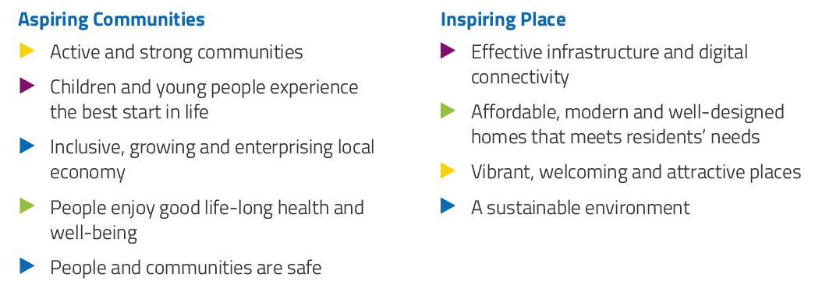

**National Improvement Framework:**

The National Improvement Framework for Education is designed to help us deliver the twin aims of excellence and equity; galvanising efforts and aligning our collective improvement activities across all partners in the education system to address our key priorities. These priorities remain as:

* Improvement in attainment, particularly in literacy and numeracy
* Closing the attainment gap between the most and least disadvantaged children
* Improvement in children and young people’s health and wellbeing
* Improvement in employability skills and sustained, positive school-leaver destinations for all young people

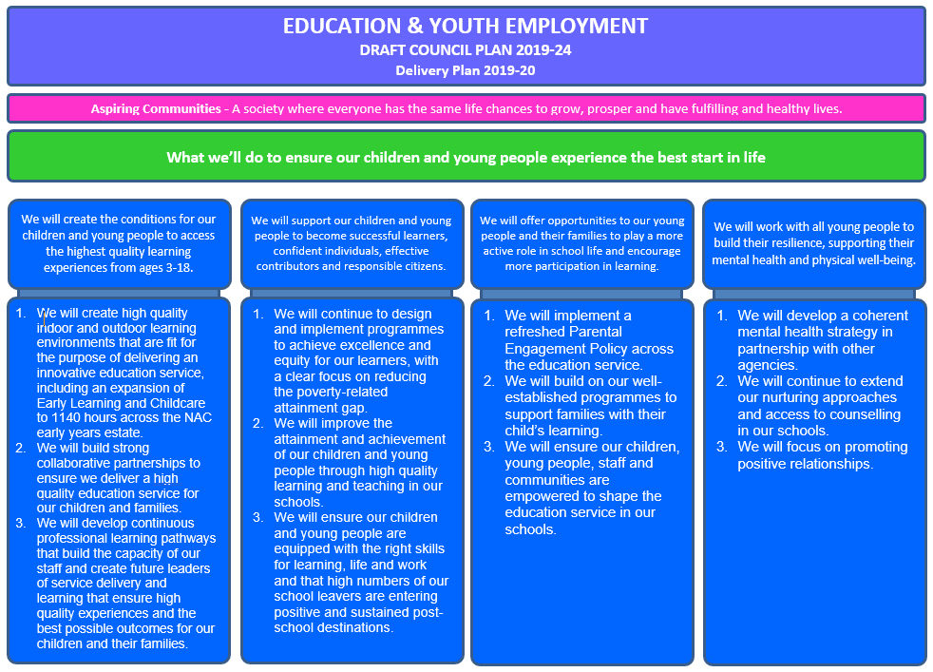

**Strategic Plan 2019-20: Elderbank Primary Supported Learning and Enhanced Deaf Provision**

|  |  |  |  |  |  |
| --- | --- | --- | --- | --- | --- |
| **School Priorities** | To strengthen and enhance Supported Learning’s coverage of curriculum through the development of a thematic approaches to learning. | To strengthen and enhance Supported Learning’s Health and Wellbeing provision through the development of sensory aspects to the curriculum. | To strengthen and develop Enhanced Deaf Provision’s inclusion practices and experiential learning to increase language acquisition. | To strengthen and develop Enhanced Deaf Provision’s communication strategy and develop across the school pupil communication champions. | To explore effective feedback through a consistent Whole School Visible Learning Approach |
| **High Level Objectives** | Pupils’ learning and development will be enhanced through termly and seasonal focussed thematic learning experiences.  Pupils’ learning and development will be enhanced through their coverage of experiences across the full curriculum.  Teachers and Early Years Practitioners will strengthen consistency in their practice through collaborative development of approaches to facilitate effective thematic planning, assessment, evaluation and recording of curriculum coverage.  Teachers and Support Staff will have increased knowledge, skills and confidence in delivering / supporting thematic approaches to learning.  Parents will have increased confidence and awareness of pupils’ learning experiences. | Pupils’ sensory development, engagement with learning experiences and self-regulation will be developed through the enhanced provision of sensory aspects to the curriculum.  Teachers and Early Years Practitioners will strengthen consistency in their practice through collaborative development of approaches to facilitate effective planning, assessment and evaluation of sensory experiences and its integration across curriculum experiences.  Teachers and Support Staff will have increased knowledge, skills and confidence in delivering sensory experiences across the curriculum.  Parents will have increased confidence and opportunity to engage in pupil learning activities. | Pupils’ learning and development will be enhanced through increased collaborative learning and teaching experiences with peers across the whole school community.  Pupils’ learning, progression and acquisition of language will be developed through the enhancement of experiential learning practices.  Teachers and Early Years Practitioners across the school community will develop their collaborative practices in planning and delivering to pupils effective inclusive learning and teaching experiences.  Teachers and Support Staff will strengthen consistency in their practice through collaborative development of approaches to enhance the effective delivery of experiential learning opportunities. | Learners across the whole school will have increased skills, knowledge and understanding of British Sign Language.  Learners across the whole school will be empowered to enhance their own experiences and experiences of peers through opportunities to become communication champions.  Teachers and Early Years Practitioners will have increased knowledge, skills and confidence in supporting all learners across the school to enhance their deaf awareness and understanding British Sign Language.  Parents will have increased confidence and opportunity to engage in pupil learning activities. | Practitioners will increase their knowledge and understanding and skills in giving highly effective feedback.  Leadership team will have increased confidence and be highly skilled in ensuring clear and consistent pedagogical practice across the school through robust approaches to quality assurance |

**Strategic Plan 2019-20: Elderbank Primary School, Early Years, Supported Learning Provision and Enhanced Deaf Provision**

Here is an overview of how we intend to use our Pupil Equity Funding to support improvement:

**Detailed Action Plan 2019-20: Elderbank Primary Supported Learning and Enhanced Deaf Provision**

|  |  |  |  |  |  |  |  |
| --- | --- | --- | --- | --- | --- | --- | --- |
| **School Strategic Priority:** | | **To enhance Supported Learning’s coverage of the curriculum through the development of a thematic approaches to learning.** | | | | | **Linked to Directorate Priority: 1 and 2** |
| **High Level Objectives** | **HGIOS 4**  **HGIOELC**  **NIF** | **Supported through PEF?**  **Y/N** | **How will I achieve this?** | **Timescale / Assigned to:** | **Pupil Outcomes** | **Measurement** | |
| Pupils’ learning and development will be enhanced through termly and seasonal thematic learning experiences.  Pupils’ learning and development will be enhanced through their coverage of experiences across the full curriculum.  Teachers and Early Years Practitioners will strengthen consistency in their practice and curriculum coverage through collaborative development of approaches to facilitate thematic planning, delivery, assessment, evaluation and recording of curriculum coverage.  Teachers and Support Staff will have increased knowledge, skills and confidence in delivering / supporting thematic approaches to learning.  Parents will have increased confidence and awareness of pupils’ learning experiences. | HGIOS:  1.2  1.3  2.2  2.3  2.4  3.1  3.2  NIF 1 | *YES*  *£2,250*  *B*  *Squared*  *Assess’*  *&*  *Progress*  *Tracker*  *And*  *Evisense*  *Online*  *Platform* | **Teacher Professionalism**  Teachers and Early Years Practitioners will strengthen consistency in their practice through collaborative development supported by department working group to facilitate effective thematic planning, delivery, assessment, evaluation and recording to ensure a balanced coverage of the curriculum.  **School Leadership**  Lead staff in the development of thematic approaches in learning and teaching.  Facilitate staff visiting ASN Schools that exemplify good practice.  Regular staff collegiate meetings to plan and evaluate and to share good practice.  Monitoring to ensure consistency – Focus Meetings, Observations, Learning Walks and Peer Observations.  **School Improvement**  Teachers and Support Staff will deliver consistency in approaches across the department. They will have increased knowledge, skills and confidence in effective thematic planning, delivery of experiences, assessment, evaluation and recording to ensure a balanced coverage of the curriculum.  Staff will be involved in evaluating impact of improvements. Evidence of improvements will be monitored through Focus Meetings, Observations, Learning Walk and Peer Observations.  **Assessment of Children’s Progress**  Staff will be involved in monitoring and tracking the progress, development and curriculum coverage of individuals. BSquared Assessment and progress tracker will be augmented through working party’s thematic evaluation, assessment and BGE coverage tools.  **Performance Information**  Termly evaluations and progress tracking information will be used to support judgements on curriculum coverage and progression in pupils’ skills.  During focus meetings, staff will articulate the extent to which thematic approaches have impacted on pupils’ learning experiences and the factors which have contributed to this.  Regular collegiate meetings to discuss progress and plan next steps.  **Parental Engagement…**  **Parental Engagement**  Termly communication to parents of planned thematic experiences, highlighting curriculum coverage.  Subsequent termly reporting of experiences and achievements.  Weekly communication facilitated through Evisense.  Parental views sought at termly meetings and through the development of termly reports.  Parent information during informal parental sessions. | 2019-20  DHT  PT  CTs  EYPs  2019-20  DHT  PT  CTs  EYPs  CAs  2019-20  DHT  PT  CTs  EYPs  CAs  2019-20  DHT  PT  CTs  EYPs  2019-20  DHT  PT  CTs  EYPs  2019-20  Parents  DHT  PT  CTs  EYPs | Pupils’ learning and development will be enhanced through the delivery of experiences through a consistent thematic approach within their classroom and across the whole department.  Pupils’ learning and development will be enhanced through the even coverage of experiences across the breadth of the whole curriculum and across breadth of each curriculum area.  Pupils’ will benefit from consistency in experiences through Teachers and Support Staff applying consistency in their practice in planning, delivery, assessment, evaluation, recording and communication of their experiences.  Parents increased confidence and awareness of pupils’ learning will enhance consistency and reinforcement of pupils’ learning experiences. | Planning, assessment, evaluation, reporting and CPD documents  Timetables  Termly communication to parents of planned thematic experiences, highlighting curriculum coverage. Subsequent termly reporting of experiences and achievements.  Professional Dialogue  Working Party Minutes  Review Minutes  SMT observation of practice  SMT learning walks  SMT focus meetings with staff  BSquared Assessment / Progress Trackers  BSquared Evisense online visual Evidence platform  Pupils views  Parental engagement record | |

**Detailed Action Plan 2019-20: Elderbank Primary Supported Learning and Enhanced Deaf Provision**

|  |  |  |  |  |  |  |  |
| --- | --- | --- | --- | --- | --- | --- | --- |
| **School Strategic Priority:** | | **To enhance Supported Learning’s Health and Wellbeing provision through the development of sensory aspects to the curriculum** | | | | | **Linked to Directorate Priority: 1 and 2** |
| **High Level Objectives** | **HGIOS 4**  **HGIOELC**  **NIF** | **Supported through PEF?**  **Y/N** | **How will I achieve this?** | **Timescale / Assigned to:** | **Pupil Outcomes** | **Measurement** | |
| Pupils’ sensory development, engagement with learning experiences and self-regulation will be developed through the enhanced provision of sensory aspects to the curriculum.  Teachers and Early Years Practitioners will strengthen consistency in their practice through collaborative development of approaches to facilitate effective planning, assessment and evaluation of sensory experiences and its integration across curriculum experiences.  Teachers and Support Staff will have increased knowledge, skills and confidence in delivering sensory experiences across the curriculum.  Parents will have increased confidence and opportunity to engage in pupil learning activities. | HGIOS:  1.2  1.3  2.2  2.3  2.4  3.1  3.2  NIF 1  NIF 3 | *YES*  *£2,250*  *B*  *Squared*  *Assess’*  *&*  *Progress*  *Tracker*  *And*  *Evisense*  *Online*  *Platform* | **Teacher Professionalism**  Teachers and Early Years Practitioners will strengthen consistency in their practice through collaborative development supported by department working group to facilitate effective planning, assessment, evaluation of sensory experiences and their integration across curriculum experiences.  Staff will undertake professional learning through working group’s identification of appropriate CPD, professional literature and visiting establishments exemplifying good practice.  **School Leadership**  Lead staff in the development of sensory approaches in learning and teaching experiences.  Facilitate staff undertaking CPD and visiting ASN Schools that exemplify good practice.  Regular staff collegiate meetings to plan and evaluate and to share good practice.  Monitoring to ensure consistency – Focus Meetings, Observations, Learning Walks and Peer Observations.  **School Improvement**  Teachers and Support Staff will deliver consistency in approaches across the department. They will have increased knowledge, skills and confidence in delivering sensory experiences across the curriculum  Staff will be involved in evaluating impact of improvements. Evidence of changes to delivery will be monitored through Focus Meetings, Observations, Learning Walk and Peer Observations.  **Assessment of Children’s Progress**  Staff will be involved in monitoring and tracking the sensory development of individuals. BSquared Assessment tools will track assessment information.  **Performance Information**  BSquared Assessment and progress tracker will be augmented by working party’s evaluation and assessment tools.  During focus meetings, staff will articulate the extent to which sensory approaches have impacted on pupils’ experiences and the factors which have contributed to this.  Regular collegiate meetings to discuss progress and plan next steps.  Collaborative impact statement will be collated to review developments in respect of sensory planning, assessment, evaluation and integration across curriculum experiences.  **Parental Engagement**  Parents will have increased confidence and opportunity to engage in pupils’ sensory experiences.  Parent information sessions during informal parental sessions.  Weekly communication facilitated through Evisense  Parental views sought at termly meetings. | 2019-20  DHT  PT  CTs  EYPs  2019-20  DHT  PT  CTs  EYPs  CAs  2019-20  DHT  PT  CTs  EYPs  CAs  2019-20  DHT  PT  CTs  EYPs  2019-20  DHT  PT  CTs  EYPs  CAs  2018-19  Parents  DHT  PT  CTs  EYPs | Pupils’ sensory development, engagement with learning experiences and self-regulation will be developed through the enhanced provision of sensory aspects to their curriculum.  Pupils’ will benefit from consistency in experiences through Teachers and Support Staff applying consistency in their practice through collaborative development of approaches that facilitate effective planning, assessment and evaluation of sensory approaches and its integration across curriculum experiences.  .  Parents increased confidence and awareness of pupils’ learning will enhance consistency and reinforcement of pupils’ learning experiences. | Planning, assessment, evaluation, reporting and CPD documents  Timetables  Professional Dialogue  Working Party Minutes  Review Minutes  SMT observation of practice  SMT learning walks  SMT focus meetings with staff  BSquared Assessment / Progress Trackers  BSquared Evisense online visual Evidence platform  Pupils views  Parental engagement record | |

**Detailed Action Plan 2019-20: Elderbank Primary Supported Learning and Enhanced Deaf Provision**

|  |  |  |  |  |  |  |  |
| --- | --- | --- | --- | --- | --- | --- | --- |
| **School Strategic Priority:** | | **To strengthen and develop Enhanced Deaf Provision’s inclusion practices and experiential learning to increase language acquisition.** | | | | | **Linked to Directorate Priority: 1, 2 and 4** |
| **High Level Objectives** | **HGIOS 4**  **HGIOELC**  **NIF** | **Supported through PEF?**  **Y/N** | **How will I achieve this?** | **Timescale / Assigned to:** | **Pupil Outcomes** | **Measurement** | |
| Pupils’ learning and development will be enhanced through increased collaborative learning and teaching experiences with peers across the whole school community.  Pupils’ learning, progression and acquisition of language will be developed through the enhancement of experiential learning practices.  Teachers and Early Years Practitioners across the school community will develop their collaborative practices in planning and delivering to pupils effective inclusive learning and teaching experiences.  Teachers and Support Staff will strengthen consistency in their practice through collaborative development of approaches to enhance the effective delivery of experiential learning opportunities.  Parents will have increased confidence and opportunity to engage in pupil learning activities. | HGIOS:  1.2  1.3  2.2  2.3  2.4  2.7  3.1  3.2  NIF 1  NIF 3 | Y  £1000  Family  Experien-tial  Learning  Opportun-ities | **Teacher Professionalism**  Teachers and Support Staff within the Enhanced Deaf Provision will work collaboratively with mainstream colleagues in planning, delivering, evaluating and maximising collaborative learning and teaching experiences for deaf learners with peers across the whole school community.  Teachers and Support Staff within the Enhanced Deaf Provision will work collaboratively to strengthen and enhance experiential learning opportunities to increase pupils’ language acquisitions and enhance their knowledge and understanding of learning experiences.  Teachers and Support Staff will reflect on National and NAC inclusion policies to underpin and enhance their inclusion practices.  **School Leadership**  Quality inclusion practices will be enhanced through collective leadership at all levels – HT, CT, and CA. All staff will engage in professional dialogue and self-reflection on current practice in order to look forward in identifying, planning, leading and maximising consistent meaningful inclusion for Deaf Pupils.  **School Improvement**  HT and CTs will lead, with collaborative contributions from all staff members, the drafting of an Inclusion Policy, Procedures and Practice document. All staff within Enhanced Deaf Provision will be involved in evaluation of the impact of improvements.  **Assessment of Children’s Progress**  Teachers will participate in quality professional dialogue to assess and plan appropriate learning and teaching experiences for Enhance Deaf Provision pupils which facilitates meaningful inclusion. They will work collaboratively to contribute to improvements to systems, processes and documentation in relation to assessment, planning, partnership working and communication of pupil progress, ensuring that improvements contain explicit connections to inclusive learning and teaching experiences of pupils.  **Performance Information**  Documentation in relation to quality assurance, self-evaluation, curriculum assessment, curriculum planning, partnership working, target setting and communication of pupil progress will contain explicit connections to inclusion practices that enhance the learning and teaching experiences of pupils. The inclusion thread that will run through all principal documents will strengthen the triangulation of evidence on how effective inclusion experiences impacts on pupil performance. Teacher’s professional dialogue with HT will enrich performance evidence reviewed at termly focus meetings.  **Parental Engagement**  Parental engagement will be enhanced through staff collaborating with parents to review inclusion approaches for pupils. Newsletters and websites will be utilised to share with parents the inclusion experiences being undertaken to enrich their children’s learning and teaching experiences. | 2019-20  HT  CTs  CAs  2019-20  HT  CT  CA  2019-20  HT  CTs  CAs  2019-20  HT  CTs  2019-20  HT  CTs  2019-20  Parents  HT  CTs  CAs | Enhanced Deaf Provision pupils will benefits from regular consistent inclusion experiences that are well planned and delivered to meet their needs.  Enhanced Deaf Provision pupils will benefits from committed professionals working in collaboration to maximise meaningful inclusion experiences.  The meeting of all pupils’ needs will be enhanced through a consistent approach applied by all members of staff.  Enhanced Deaf Provision pupils will benefit from quality assessment of their progress through the collaborative practices of staff.  Continuous cycle of staffs’ reflective practices, consultation with partners and triangulation of evidence will consistently seek to ensure the most appropriate inclusion experience for all pupils.  Triangulation of evidence of all pupil progress will enhance the identification and delivery of effective inclusion experiences for pupils and will strengthen stronger pathways for all pupil learning and progress.  All pupils will benefit from increased parental involvement in reviewing inclusion approaches. | Planning, assessment, evaluation, reporting and CPD documents  Timetables  Professional Dialogue  Review Minutes  SMT observation of practice  SMT learning walks  SMT focus meetings with staff  Pupils views  Parental engagement record | |

**Detailed Action Plan 2019-20: Elderbank Primary Supported Learning and Enhanced Deaf Provision**

|  |  |  |  |  |  |  |  |
| --- | --- | --- | --- | --- | --- | --- | --- |
| **School Strategic Priority:** | | **To strengthen and develop Enhanced Deaf Provision’s communication strategy and developing across the school pupil communication champions** | | | | | **Linked to Directorate Priority: 1, 2 and 4** |
| **High Level Objectives** | **HGIOS 4**  **HGIOELC**  **NIF** | **Supported through PEF?**  **Y/N** | **How will I achieve this?** | **Timescale / Assigned to:** | **Pupil Outcomes** | **Measurement** | |
| Learners across the whole school will have increased skills, knowledge and understanding of British Sign Language.  Learners across the whole school will be empowered to enhance their own experiences and experiences of peers through opportunities to become communication champions.  Teachers, Support Staff and Pupils will have increased knowledge, skills and confidence in supporting all learners across the school to enhance their deaf awareness and understanding British Sign Language.  Parents will have increased confidence and opportunity to engage in pupil learning activities. | HGIOS:  1.2  2.2  2.3  2.7  3.1  3.2  NIF 1  NIF 3 | N | **Teacher Professionalism**  Teachers and Support Staff within the Enhanced Deaf Provision will work collaboratively with mainstream colleagues to enhance the promotion of British Sign Language to maximise learning and teaching experiences across the whole school community.  Teachers and Support Staff within the Enhanced Deaf Provision will work collaboratively with mainstream colleagues to empower learners across the whole school to enhance their own experiences and experiences of peers through opportunities to become communication champions  **School Leadership**  Lead staff to enhance the promotion of British Sign Language to maximise learning and teaching experiences across the whole school community.    Support pupils to undertake SVQ opportunities to enhance British Sign Language skills and provide them with the skill set to take forward their role as a Communication Champion.  Regular staff collegiate meetings to plan and evaluate and to share good practice.  Regular meeting with Communication Champions to support their work.  **School Improvement**  Teachers, Support Staff and Communication Champions will deliver consistency in approaches across the school. They will have increased knowledge, skills and confidence to enhance the promotion of deaf awareness and British Sign Language across the whole school community.  **Assessment of Children’s Progress**  Teachers will participate in quality professional dialogue to assess and plan appropriate learning and teaching experiences for Enhance Deaf Provision pupils which facilitates the promotion of deaf awareness and British Sign Language across the whole school community. Pupils will benefit from SVQ assessment and qualification.  **Performance Information**  Monitoring at Focus Meetings, Observations, Learning Walks, Peer Observations and pupil voice will be used  Collaborative impact statement will be collated to review developments in respect of increased knowledge, skills and confidence in supporting all learners across the school to enhance their deaf awareness and understanding British Sign Language.  **Parental Engagement**  Parents will have increased confidence and opportunity to engage in pupil learning activities | 2019-20  HT  CTs  CAs  2019-20  HT  CT  CA  2019-20  HT  CTs  CAs  Comm’  Champions  2019-20  HT  CTs  2019-120  HT  CTs  CAs  Comm’  Champions  2018-19  Parents  HT  CTs  CAs | Pupils across the whole school will have increased skills, knowledge and understanding of British Sign Language  Pupils across the whole school will be empowered to enhance their own experiences and experiences of peers through opportunities to become communication champions  Pupils’ will benefit from enhanced experiences through Teachers and Support Staff applying consistency in their practice supported through their increased knowledge, skills and confidence in supporting all learners across the school.  Pupils will have increased knowledge, skills and confidence to support peers across the school to enhance their deaf awareness and understanding British Sign Language.  Parents increased confidence and awareness of pupils’ learning will enhance consistency and reinforcement of pupils’ learning experiences. | Planning, assessment, evaluation, reporting and CPD documents  Timetables  Professional Dialogue  Working Party Minutes  Review Minutes  SMT observation of practice  SMT learning walks  SMT focus meetings with staff  Pupils views  Parental engagement record | |

**Detailed Action Plan 2018-19: Elderbank Primary School, Early Years, Supported Learning Provision and Enhanced Deaf Provision**

|  |  |  |  |  |  |  |  |
| --- | --- | --- | --- | --- | --- | --- | --- |
| **School Strategic Priority:** | | **To explore effective feedback through a consistent Whole School Visible Learning Approach** | | | | | **Linked to Directorate Priority: 1,***2* |
| **High Level Objectives** | **HGIOS 4**  **HGIOELC**  **NIF** | **Supported through PEF?**  **Y/N** | **How will I achieve this?** | **Timescale / Assigned to:** | **Pupil Outcomes** | **Measurement** | |
| To increase staff capacity and critical reflection to raise attainment in Numeracy, Literacy Health and Wellbeing through a consistent Whole School Visible Learning Approach | **2.3**  **Learning and teaching**  3.2  Raising Attainment and Achievement  Nif 1 | Yes  Supported through purchase of resources as identified in other priorities for Numeracy and Literacy. | **Teacher Professionalism**  All staff to participate in collegiate activities to upskill and improve the quality of learning and teaching which will have a significant impact on pupil achievement:  CPD   * Introduction to Strand 4 at PLA Qualitative Questionnaire completed by participants. * Strand 4 key focus area to be developed by school. * Strand 4 Coaching Session 1 at PLA. * Strand 4 identification of key needs and proposed training by school to support implementation of key focus areas. * Strand 4 Coaching Session 2 at PLA. * Strand 4 next steps identified. * Strand 4 Coaching Session 3 at PLA. * Complete Visible Learning Progress Tracker Form and Qualitative Questionnaire for Strand 4.   Next steps identified and shared by schools  Completed Visible Learning Progress Tracking Form and Qualitative Questionnaire for Strand 4 submitted to PLA  **School Leadership**  Lead staff in developing learning and teaching approaches through Visible Learning pedagogy.  Training for staff  Regular staff collegiate meetings to plan and evaluate and to share good practice.  Monitoring to ensure consistency – observations, peer observations.  **School Improvement**  All staff to engage in training and collegiate activity and plan activities which encompass the theories and approaches of Visible Learning.  All staff share a sense of collective efficacy and consistency to allow greater likelihood of positively impacting pupil learning and raising attainment.  **Assessment of Children’s Progress**  All staff will be involved in monitoring and tracking the progress and development of individuals  PLA Progress tracking format  **Performance Information**  Regular collegiate meetings to discuss progress and plan next steps.  Progress tracking information  **Parental Engagement**  Sharing visible learning with parents:  ‘Sharing the Learning’ events,  ‘Stay and Play’  Parent information sessions  FLZ involvement with parents | Session 2019/20  All Staff  27th Jan 9.30-15.30  27th Jan– 25th Feb  25th Feb 4.00- 5.00  25th Feb – 24th Mar  24th Mar 4.00-5.00  24th Mar – 5th May  5th May 4.00-5.00  15th May  All Staff  DHT/PT  All Staff  All Staff  All Staff  SMT  All staff  SMT  FLT | * Raised attainment and achievement for all pupils * Pupils across the school will demonstrate key skills of being Successful learners * Increased confidence for pupils * Improved problem solving and critical thinking skills * Increased creativity * Pupils will develop key skills for learning life and work. | Pre and Post Intervention Questionnaires to determine a baseline and the impact of interventions.  Records of quality professional discussions between staff  Improvements evidenced in Monitoring and Tracking Visits  Increased attainment and achievement for most pupils across the establishment recorded through Progress Trackers and Teacher Focus Meetings  Assessment data to reflect improvement in attainment – Pupil Progress Tracker  Monitoring –SMT observations, Peer observations records and actions  Pupil Focus Group Feedback  Parental engagement records | |