Curriculum for Excellence: What are we learning this term? | Term 2 October - December 2026
Context for Learning: Extinct Animals | Teacher: Mrs McDiarmid & Mrs Cairns  Primary 5
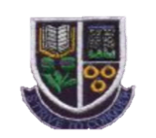
  Language and Literacy  Spelling- Spelling phonemes will continue to be taught through a variety of active and written spelling activities.  Grammar- We will learn about Bossy and past tense verbs, up-level our poetry using onomatopoeia and improve our story writing using adjectives and indirect speech.  PM Writing- PROCEDURE, POETRY and RECOUNT genres will be taught, following a structured approach to creating texts.    Spanish- We will introduce new vocabulary for body parts. Classroom nouns and instructions as well as colours will be revised. We will continue to practise previous taught vocabulary during daily routines. | Numeracy and Maths  All maths groups will continue to develop different mental maths strategies.  Number Processes – including addition and subtraction (mental and written methods), multiplication and division facts through times tables.  Fractions, Decimals and Percentages – use equivalent forms of fractions, decimals and percentages, simplifying fractions, calculating simple fractions of a quantity.  Expressions and Equations – solving simple algebraic equations.   | Health and Wellbeing (HWB)  P.E lessons will be on a Monday and Friday. The focus is on floor Gymnastics and Golf. We will also further develop our Social Dancing skills by learning different Scottish Country Dances.  Participation in Champions for Change programme with KA Leisure, exploring effects of substance misuse.  We will have one outdoor learning session each week on a Tuesday. If pupils could come prepared for being outdoors in all weathers.    We will also explore positivity by “Looking at the Bright Side” with Bounce Back. | IDL (Interdisciplinary Learning)  This term we will be exploring our pupil choice topic of Extinct Animals. Pupils will participate in a range of cross-curricular learning.  Activities will include –  Social Subjects – saving endangered species, studying of fossils, natural vs human causes of extinction, researching extinct animals.  Expressive Arts – paper folding and cutting, collage animals, printing.  Science – using loose parts to create models outdoors.  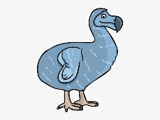  Digital – using search engines, coding, designing logos.
Learning at home- Literacy |  | Learning at home- Numeracy
Spelling- Phonemes, common words, tricky words (see back)  Online games:  Spelling - https://spellingframe.co.uk/ (free games only)  Modern Languages- https://www.spanish-games.net/  https://www.french-games.net/ |  | Mental Maths, Fractions, Multiplication/ Division facts:  Online activities -  https://www.topmarks.co.uk/maths-games/daily10.  https://www.topmarks.co.uk/maths-games/hit-the-button  https://mathsframe.co.uk/en/resources/resource/289/KS2_Maths_Invaders  https://nrich.maths.org/problems/matching-fractions-decimals-and-percentages
Sumdog link https://www.sumdog.com/user/sign_in

At Dykesmains Primary School we are working to Get It Right For Every Child (GIRFEC). This means we are working to support our children to grow develop and reach their full potential. The children are currently looking at the SHANARRI indicators which are Safe, Healthy, Achieving, Nurtured, Active, Respected, Responsible and Included. For more information: http://www.girfecna.co.uk/
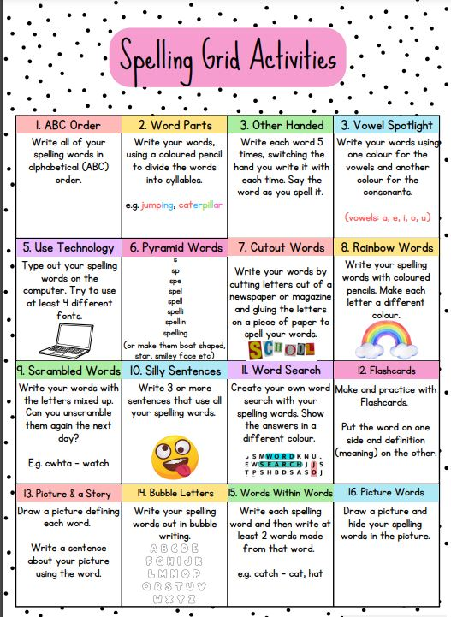
Phoneme Grids (to practise spelling words)
A phoneme is a sound letters make when you put them together.
It focuses on the sound not the letter pattern.
The children will generate the word lists.
Here are some examples.
sh | ti | ch | sh
should  shoe | nation  collection | chef  chalet | should  shoe

Phoneme – sh

Phoneme – ch
ch | tch | ch
chair  chance | kitchen  catch | picture  creature

Common/tricky words
Days of the week
Months of the year
Number names –eleven, twelve, thirteen, fourteen, fifteen, sixteen, seventeen, eighteen, nineteen, twenty, thirty, forty, fifty, sixty, seventy, eighty, ninety, hundred

Jotters have been provided for your child to use if and when required when learning at home, there is no expectation for them to be handed in weekly. Children are always welcome to share any work they are proud of. Work can be uploaded onto the SEESAW platform.

