Curriculum for Excellence: What are we learning this term? | Term 2- October-December 2026
Context for Learning: Under the Sea & Enterprise (Christmas Fayre) | Teacher name: Mrs Pike Primary 4

  Language and Literacy  Spelling- All spelling patterns will continue to be taught through active and written spelling strategies.  Grammar- We will identify different parts of speech within a text and up-level our sentences to create complex sentences which include time and sequence words, connectives, nouns, adjectives, verbs and adverbs.    Writing- We will learn about the purpose and features of a recount, narrative and procedure, developing the skills required to write this type of text independently.  Spanish- We will be learning vocabulary for family and classroom objects whilst reinforcing vocabulary learned during term 1. | Numeracy and Maths  This term, children will be focusing on:  - We will continue to develop mental maths strategies.  - Number and number processes (addition, subtraction, multiplication and division).  - Expressions and Equations (comparing and describing number relationships and finding the value of missing numbers).  - STEM Space lessons  - Maths Topic- Measuring: using cm and metres.  - Weight: using kg and grams. Practical weighing, reading scales. |   Health and Wellbeing (HWB)  PE: In PE this term our focus is floor gymnastics skills, golf and dance.  We are also taking part in Fit Fifteen.  PE days: Wednesday, Some Thursdays to accommodate golf and Friday (If no golf)  HWB: We are continuing to reinforce our Rights Respecting School ethos and are adhering to our class charter.  We will be looking at ways in which we can build our resilience and develop a Growth Mindset.  We will continue to look at the Zones of Regulation and embed Dykesmains Right Pathway | IDL (Interdisciplinary Learning)  Topic :  This term is our pupil choice topic. The class voted for Under the Sea to be their class topic. The children will be involved in the planning of this topic and will be encouraged to suggest activities to complete as part of their learning.  Art & Design- We will be completing a variety of art activities linked to our topic as well as Christmas Crafts for our enterprise work to be sold at the Christmas Fayre.    Music – We will be playing games to develop our sense of rhythm, keeping the beat using different parts of our body. We will also be learning and performing songs.  Drama – We will be developing our use of improvisation through a variety of games and drama techniques.  Digital- Coding, Word Processing Skills
Learning at home- Literacy |  | Learning at home- Numeracy
Phonics/Spelling- Taught phonemes ae,ee,maths shape words, common words  Online games: English KS1 - reading, spelling and punctuation games plus stories (roythezebra.com) https://www.topmarks.co.uk/  Languages-https://www.spanish-games.net  Sumdog link : https://www.sumdog.com/ |  | The following websites have activities to reinforce numeracy concepts covered in class e.g. Number bonds/ Place Value/Addition & Subtraction/Tables/Time/Money/Shapehttps://www.topmarks.co.uk/  https://www.sumdog.com/
At Dykesmains Primary School we are working to Get It Right For Every Child (GIRFEC). This means we are working to support our children to grow develop and reach their full potential. The children are currently looking at the SHANARRI indicators which are Safe, Healthy, Achieving, Nurtured, Active, Respected, Responsible and Included. For more information: http://www.girfecna.co.uk/

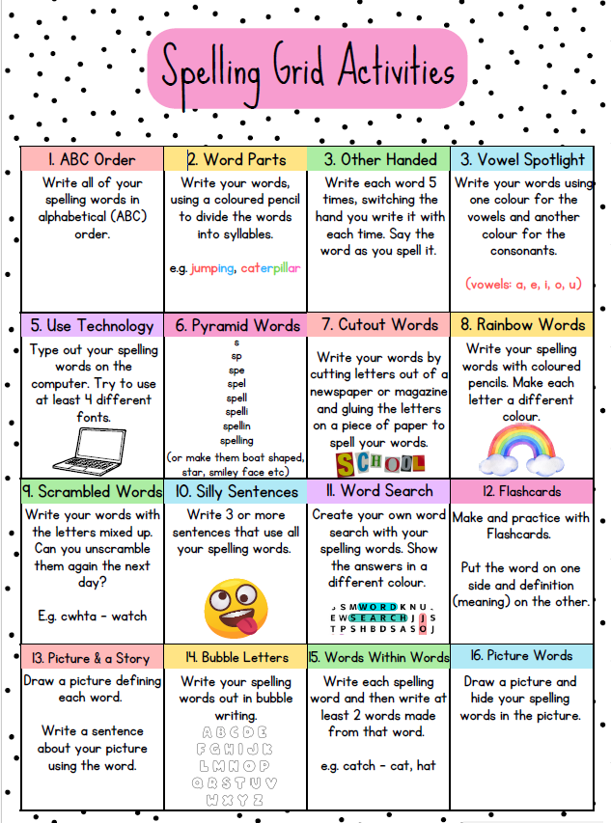

Spelling covered in term 1
Common words, days of the week, months of the year, seasons, shape words,
homophones :they’re, their, there, to,too,two
Spelling Phonemes covered in term 1
A phoneme is the “sound” letters make when put together.
It focusses on the “sound” not the letter pattern (grapheme)
Here are examples ,the children generate their own words.
ee | ea | e | ie | e-e
meet  street | teach  beach | she  he | thief  brief | these  complete
Unit 2 ee

Unit 3 ie
igh | i-e | ie | y
right  high | ice  spine | tie  lie | myself  why

Jotters have been provided for your child to use if
and when required when learning at home,
there is no expectation for them to be handed in weekly.
Children are always welcome to bring and share any work they are proud of.

