Curriculum for Excellence: What are we learning this term? | Term 2 October – December 2026
Context for Learning: The Zoo | Mrs Butler Primary 2

Language and Literacy    Phonics/Spelling: a-e, e-e, i-e, o-e, u-e, igh & ay  Common Words: all, are, as, at, be, but, can, came, for, had, have, him, his & my  Reading: We are working on fluency (reading without stopping and starting) and re-reading a sentence if we pause at a word.  Writing: We will learn to write instructions and describe a person or object in detail.  Languages    We will be learning to use Spanish calendar vocabulary and responding to classroom commands. | Maths and Numeracy  This term, we will be focusing on:  - Addition and Subtraction strategies  - Counting in 2’s, 5’s and 10’s  - Recognising coins and notes up to £5, making amounts and giving change  - Recognising the tens and ones in a number  We will also continue to work on our mental maths skills, counting on and back and from a given number. |   Health and Wellbeing (HWB)  PE: In PE this term we are focusing on:  - Bat & Ball skills  - Social Dancing  We are also taking part in Fit Fifteen each day.  PE days: Tuesday & Friday  Kit: Shorts, t-shirt & socks  (no jewellery)  HWB  In HWB, we will look at relationships, similarities, and differences between us as individuals. We will also be learning about safety, as the nights get dark. | IDL (Interdisciplinary Learning)  Our Topic chosen by Primary 2 this term is The Zoo. We will investigate the following:  - The role of a zoo in conservation of endangered animals  - The duties of a zookeeper and how to care for different animals  - Animals from around the world  - The different needs of animals  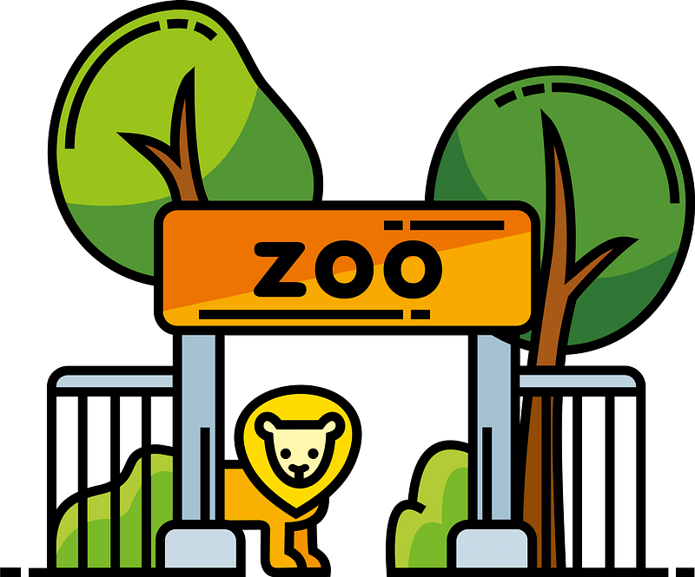  - Why some animals are cared for in a zoo.      In Music, we will be learning songs for our Christmas Nativity show and look forward to presenting it to you. In Art, we will be exploring different techniques using a variety of materials to create pattern and colour.  This term we will develop our ICT skills with laptops, accessing a programme. We will work on word processing skills using capital letters, simple punctuation and changing font. In Science, we will investigate Materials and sort them according to living, non-living, and their different properties.  
At Dykesmains Primary School we are working to Get It Right For Every Child (GIRFEC). This means we are working to support our children to grow develop and reach their full potential. The children are currently looking at the SHANARRI indicators, which are Safe, Healthy, Achieving, Nurtured, Active, Respected, Responsible and Included. For more information: http://www.girfecna.co.uk/
Jotters have been provided for your child to use if, or when, required when learning at home, there is no expectation for them to be handed in weekly. Children are always welcome to bring and share any work they are proud of.
Learning at home - Literacy | Learning at home – Maths & Numeracy
Phonics/Spelling:  Key words and common words are on the separate grid  Some of these activities may be helpful to learn the sounds and words.  - Create spelling pyramids  - Write the key words out twice and then the third time, write the word backwards. Example: back back kcab  - Practice the key words aloud playing spelling tennis  - Write the key words as spelling flowers – one petal for each letter  - Write the key words twice normally and the third time, mix the letters up Example: smile smile semli  - Connect the dots – Write your key words using dots. Connect the dots you have drawn by tracing over them with a writing or coloured pencil.  Online game links:  https://www.topmarks.co.uk  Search for the following: Phonics  Choose from: Phase 2 Phonics, Balloon Phonics, Phase 3 Phonics, Phonics Songs and Forest Phonics  Bug club: https://www.activelearnprimary.co.uk/login?c=0 | Number Bonds:  Practice recalling number bonds up to 10 and then extend this to 20, e.g. 0 + 10 = 10, 1 + 9 = 10, 2 + 8 = 10, 3 + 7 = 10…10 + 0 = 10.  Number Order:  - Adult says a number, misses the next one and then says the number after that, e.g. 15 ? 17  - Give any number up to 100; ask which one comes before and after that number, e.g. ? 35 ?  Days of the Week and Months of the Year:  - Practice saying and spelling the days of the week and months of the year. Remember Capital letters.  Time:  - Practice reading the time starting with o’clock  - What time will it be 5 hours later, 3 hours before?  Money  - Identify and order coins from lowest value to highest  - Make totals up to £5  Online game links:  https://www.topmarks.co.uk/  Search for the following games: Addition to 10, Caterpillar Ordering, Coconut Ordering, Coins Game, Hit the Button (Number Bonds), Mental Maths Train, Place Value Basketball, Place Value Charts, Robot Addition and Subtraction Grids
Sumdog link: https://play.sumdog.com/student/sign_in

