Curriculum for Excellence: What are we learning this term? | Term 2 - October – December 2026
Context for Learning: New York | Mrs Cowan - P7

  Language and Literacy  Spelling / Grammar - We will work through phonemes – constructing spelling lists together. We will be looking at homophones, Similes, Adverb phrases and Proper Nouns  Reading- We will continue to work through appropriate levels on Bug Club and will also be learning the SHORS Comprehension strategies of Monitoring and Summarising.  Writing- We will be continuing with our PM Writing, focussing on Narrative Prose, Poetry and Procedural writing. We will be using our IDL to produce different pieces of writing for our classroom display.    Languages- In French, we be learning weather vocabulary and in Spanish, we will be learning vocabulary associated with clothing and hobbies. | Numeracy and Maths  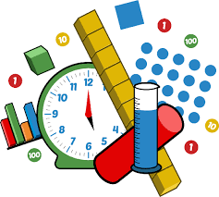  This term, children will be focusing on:  - Time  - Measurement  - Data & Analysis  - Number Patterns & Relationships  As always, we will continue to build upon the skills required for the four numerical processes; learning a variety of mental numeracy strategies to help us solve problems with more ease and accuracy. Pupils will also continue to use their Retrieval Practise booklets regularly to strengthen their memory of key concepts across all areas of numeracy and maths.  Children will be participating in STEM Space project, in association with Glasgow University, to develop children’s special awareness. | Health and Wellbeing (HWB)    PE: In PE this term, our topics will be Gymnastics, Golf and Social Dance. We will be participating in Champions of Change this term too.  We are also taking part in Fit Fifteen each day.  PE days: Monday & Wednesday (first 4 weeks of term PE will be Thursday instead of Wednesday)  Kit: Shorts and indoor PE shoes. Tape for any earrings that cannot be removed.  HWB: We will be continuing to look at Zones of Regulation this term, as well as areas of self-esteem, self-belief and growth mindset. We will also continue to further embed our knowledge of the UNCRC during the focus weeks and daily across the curriculum. | IDL (Interdisciplinary Learning)  Our IDL Topic this Term is New York and was voted for by the pupils. We will explore the city of New York, landmarks and famous sightseeing activities. The children will also learn about significant events that have occurred in New York within recent years.  Science – Material Changes  Digital - We will be using our ICT skills to research and present our findings in various ways.  Outdoor Learning – We will be focussing on Engineering. Children design, construct, test and modify a bridge using only loose parts. Xmas Fayre – We will be participating in Enterprise activities to decide upon a compnay name, logo and decide and produce different crafts to sell.
Learning at home- Literacy |  | Learning at home- Numeracy
Spelling- active spelling games  Online games:  https://www.bbc.co.uk/bitesize/topics/zkbkf4j/articles/zbm8scw  Sumdog grammar & spelling challenges – access through sumdog link below  Bug club- https://www.activelearnprimary.co.uk/login?c=0  Languages-https://www.spanish-games.net/  https://www.french-games.net/ |  | Timetables: https://www.topmarks.co.uk/maths-games/daily10  https://www.topmarks.co.uk/maths-games/hit-the-button  Time: https://mathsframe.co.uk/en/resources/resource/116/telling-the-time  https://www.bbc.co.uk/bitesize/topics/zkfycdm/articles/zpxbydm#zkjfcxs  Measure:  https://www.transum.org/Maths/Activity/Reading_Scales/Default.asp?Level=1
https://www.sumdog.com/
At Dykesmains Primary School we are working to Get It Right For Every Child (GIRFEC). This means we are working to support our children to grow develop and reach their full potential. The children are currently looking at the SHANARRI indicators which are Safe, Healthy, Achieving, Nurtured, Active, Respected, Responsible and Included. For more information: http://www.girfecna.co.uk/
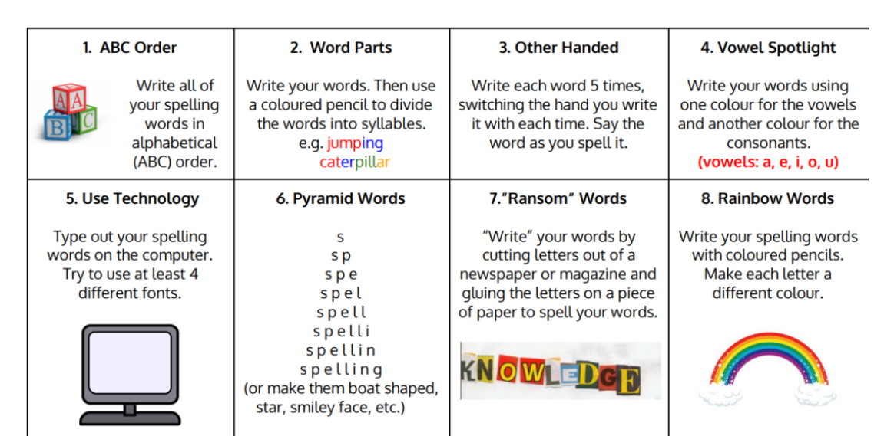
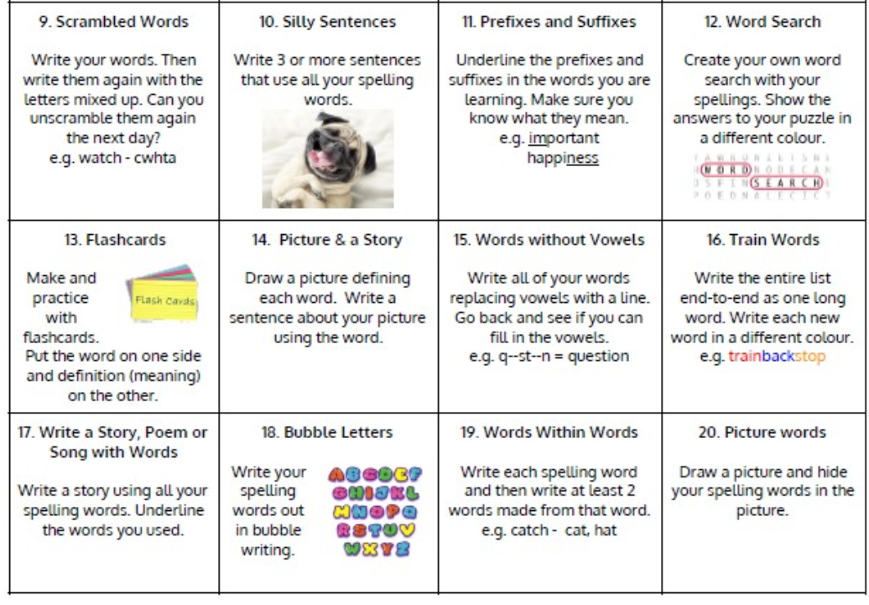
Active Spelling Ideas:

Jotters have been provided for your child to use if and when required when learning at home, there is no expectation for them to be handed in weekly. Children are always welcome to bring and share any work they are proud of.

